ASHRAE TC 5.5 Air-to-Air Energy Recovery
ASHRAE 2024 Annual Meeting, Indianapolis, IN
June 25, 2024

Events | Time | Location
TC 5.5 Air-to-Air Energy Recovery Subcommittees Meeting | Wednesday, June 12 10:30 AM– 12 PM  Eastern Time | Virtual  Join the meeting now
TC 5.5 Air-to-Air Energy Recovery | Tuesday, June 25 3:30 PM - 5:30 PM  Eastern Time | Indianapolis  Join the meeting now

Agenda TC 5.5 Full Meeting

Hybrid Meeting
- If you are unable to attend in person you can join virtually by using the links above.

Launch [20 minutes total]
- Call to Order / Welcome

ASHRAE Code of Ethics:
“In this and all other ASHRAE meetings, we will act with honesty, fairness, courtesy, competence, inclusiveness and respect for others, which exemplify our core values of excellence, commitment, integrity, collaboration, volunteerism and diversity, and we shall avoid all real or perceived conflicts of interests.
(Code of Ethics: https://www.ashrae.org/about/governance/code-of-ethics)
(Core Values: https://www.ashrae.org/about/ashrae-s-core-values)”
Recent CHANGES to the TC MOP requiring BALANCE for the voting membership removes the appearance of bias and conflict of interest. The most recent MOP can be found here: https://www.ashrae.org/technical-resources/technical-committees in the Procedures, Forms & Information for TCs/TGs/MTGs and TRGs section about half way down the page.

ASHRAE Commitment to Care
The health and safety of all ASHRAE conference attendees is a top priority. Out of respect for our fellow attendees, we commit to wear masks indoors, monitor our health, seek medical attention if symptoms development and adhere to all ASHRAE Commitment to Care protocols. We are committed to the well-being of one another.

ASHRAE Value Statement – In ASHRAE meetings, we will act with honesty, fairness, courtesy, competence, inclusiveness and respect for others, which exemplify our core values of excellence, commitment, integrity, collaboration, volunteerism and diversity, and shall avoid all real or perceived conflicts of interest. Our culture is one of inclusiveness, acknowledging the inherent value and dignity of each individual. We celebrate diverse and inclusive communities, understanding that doing so fuels better, more creative and more thoughtful ideas, solutions and strategies for the Society and the communities our Society serves. We respect and welcome all.

- TC Scope
TC 5.5 is concerned with air-to-air heat exchangers, their application and cost benefit relationship. It includes consideration of the needs and procedures for standardization and testing, rating and terminology applicable to air-to-air energy recovery.

- Introduction & Sign up (current email & updates)
- Roll Call of Voting Members (exhibit 2)
- Agenda Review and Adoption
- Approval of Minutes
  - Winter Meeting, Hybrid, January 23, 2024
  - Minutes were tabled. Chair suggested a letter ballot.
- Chair’s Report
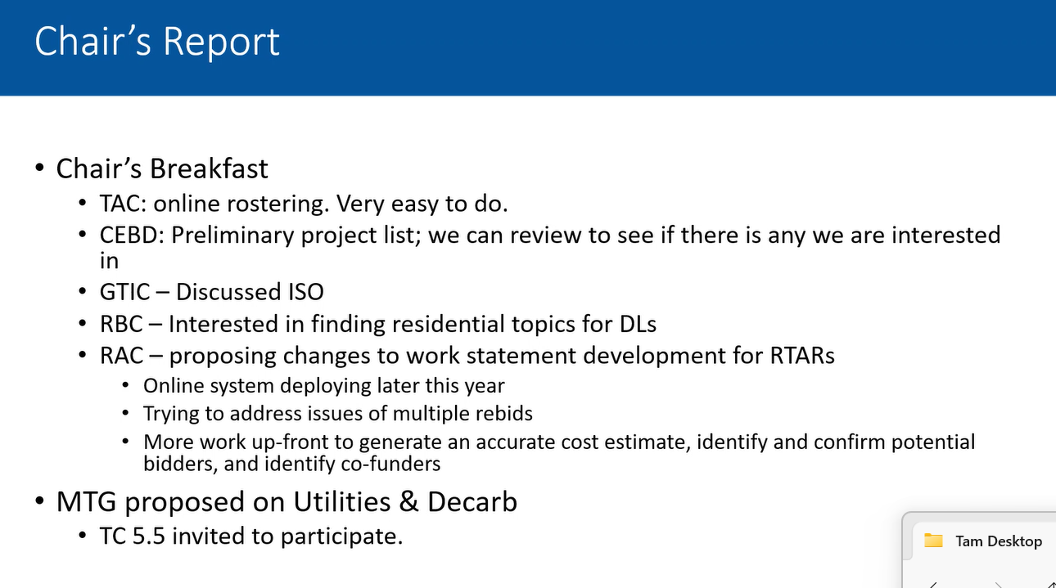
Drake expanded on need for more people to step up and join the ISO effort

Liaison Reports [45 minutes total]
- ASHRAE Learning Institute (Paul Pieper)
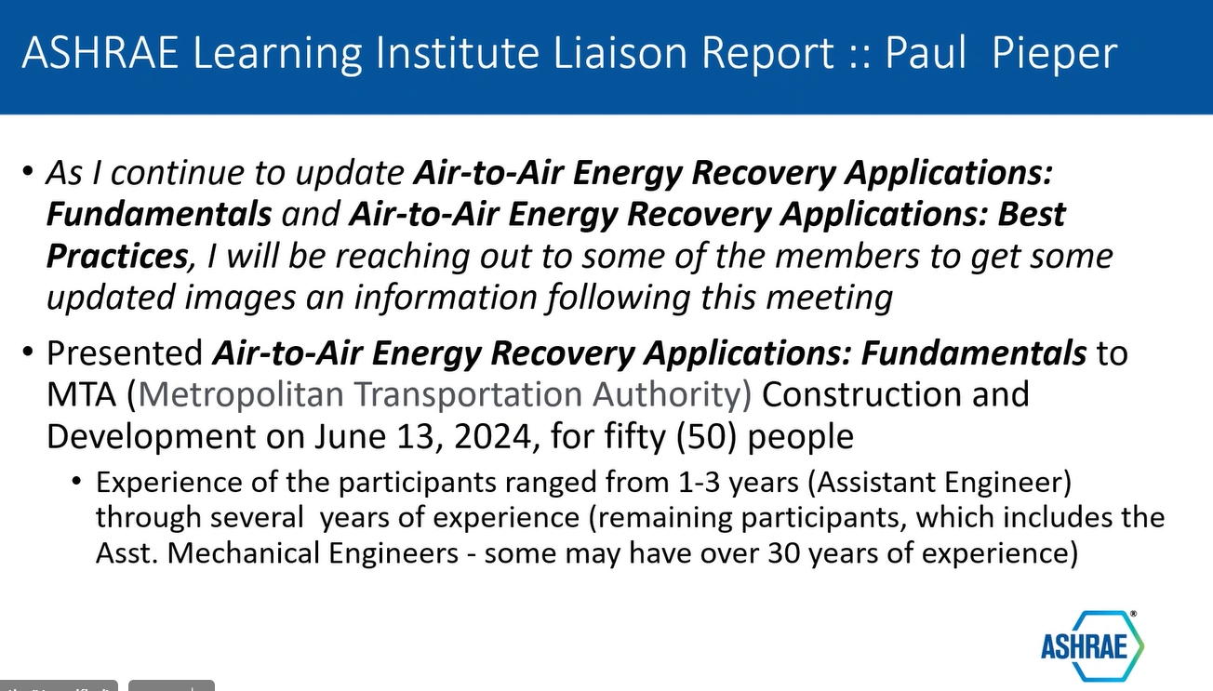
- SSPC 90.1
  - SSPC 90.1 Activities –
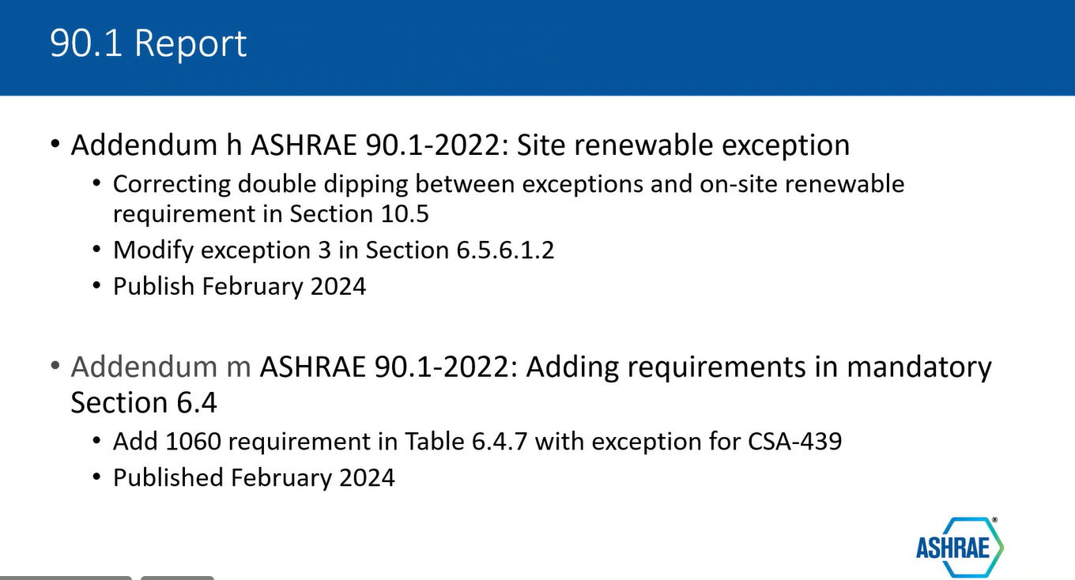
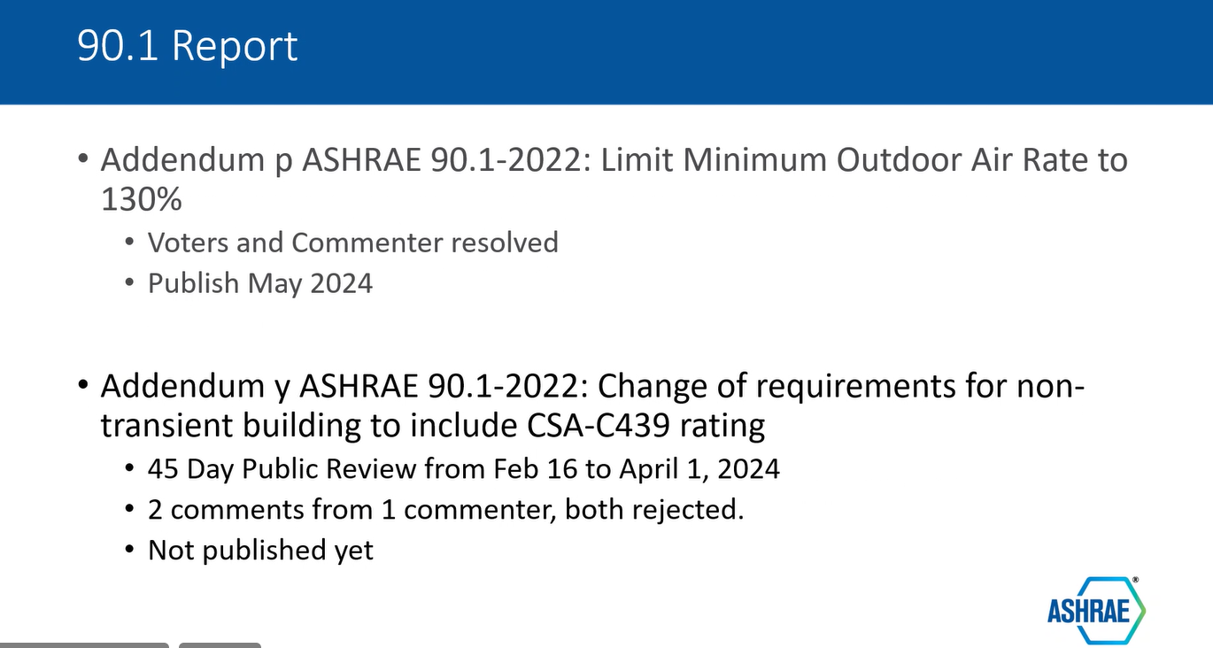
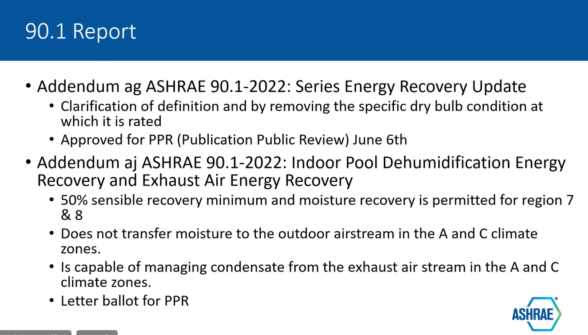
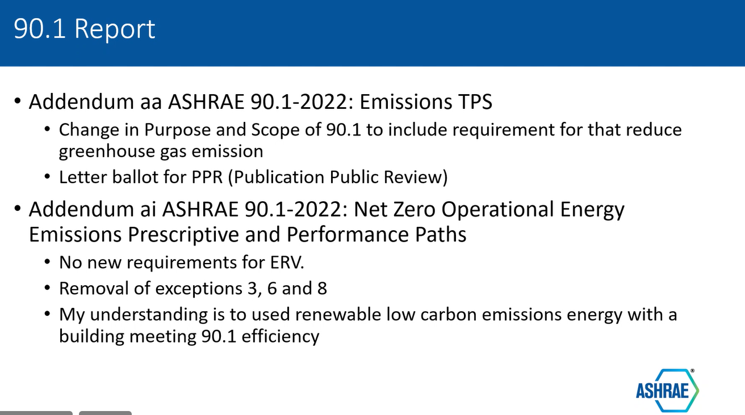
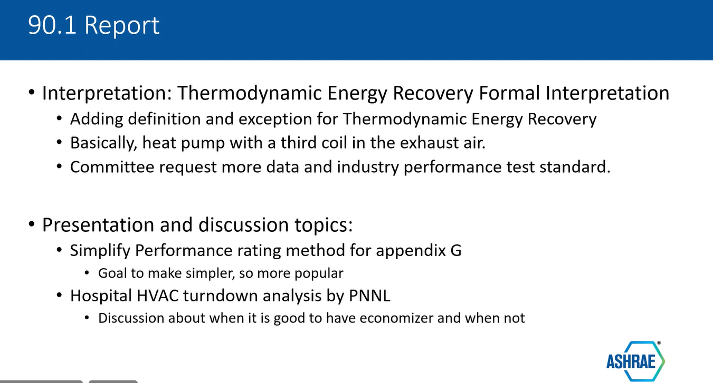
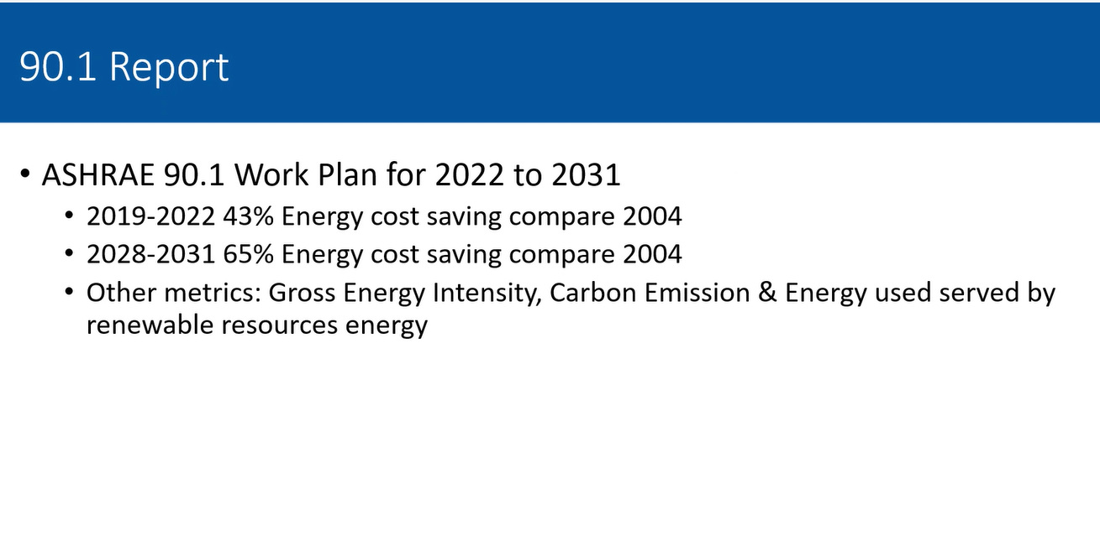
- Standard 62.1 (Alkis)
Alkis is not in the meeting and we did not have a 62.1 report. We need to identify a new 62/1 liaison.
- Standard 205 Working Group (Kristin Sullivan)
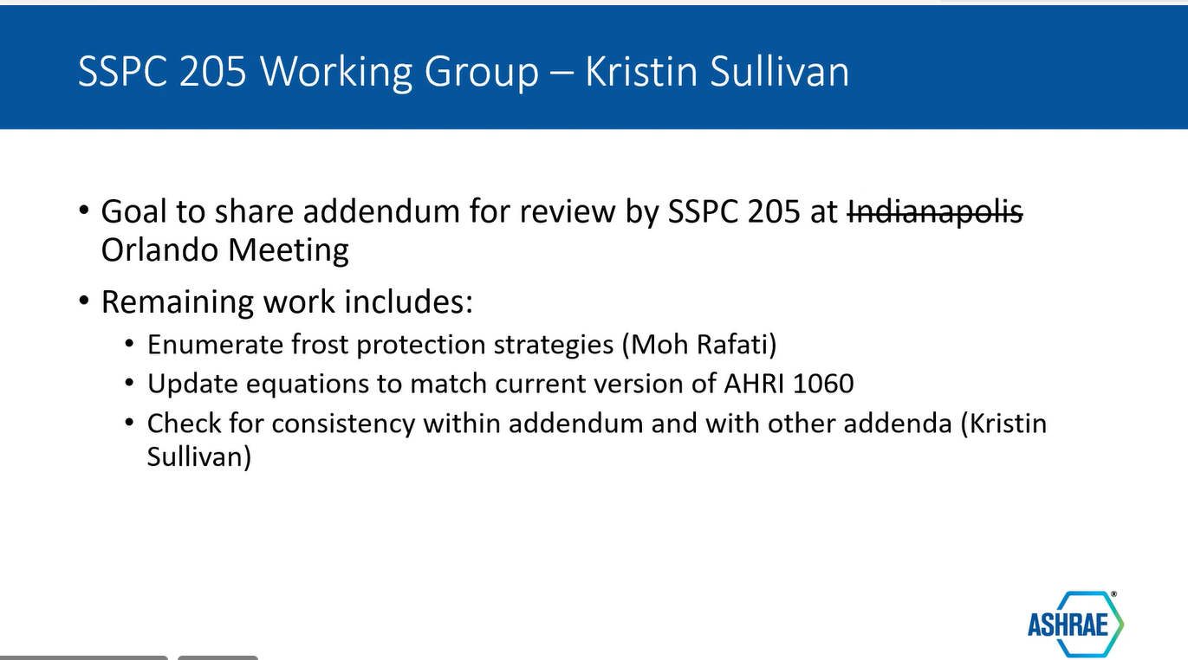
- Technical Activities Council (TAC) Liaison Presentation (Kevin Marple) [30 minutes]
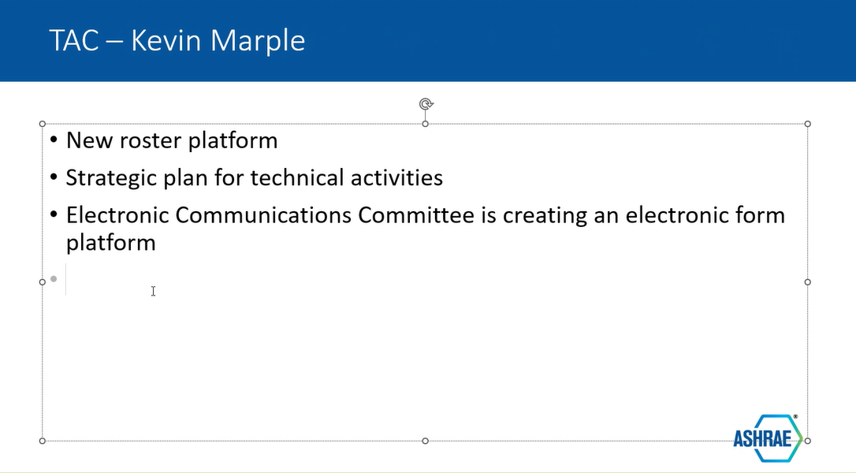

Subcommittee Reports [45 min total]
- Handbook (G.D. Mathur)
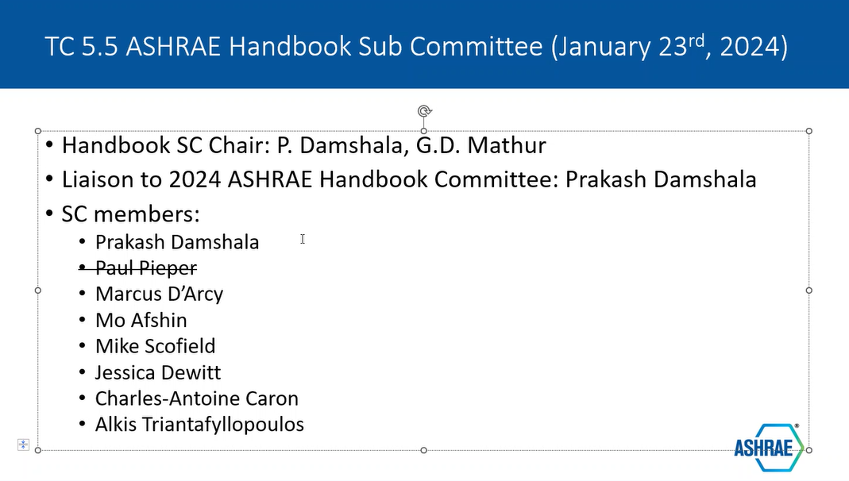
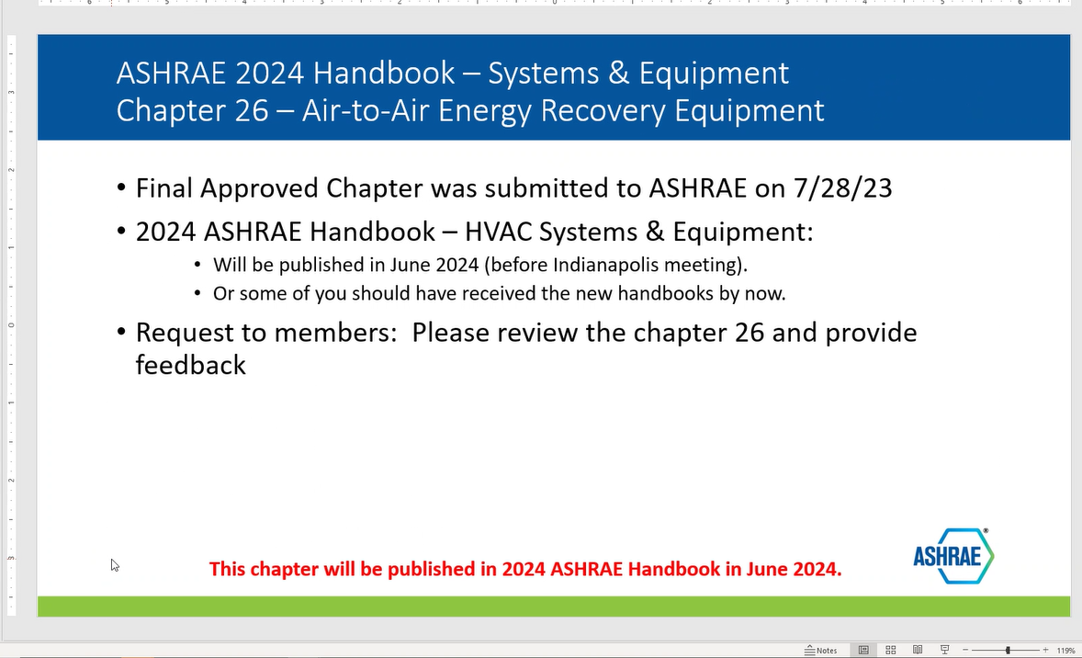
- Program (Paul Pieper)
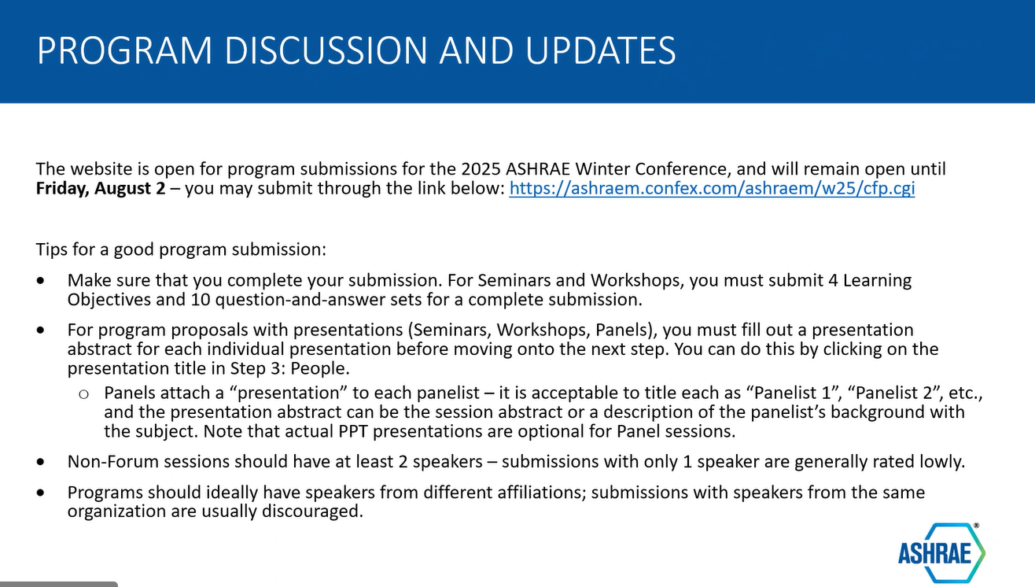
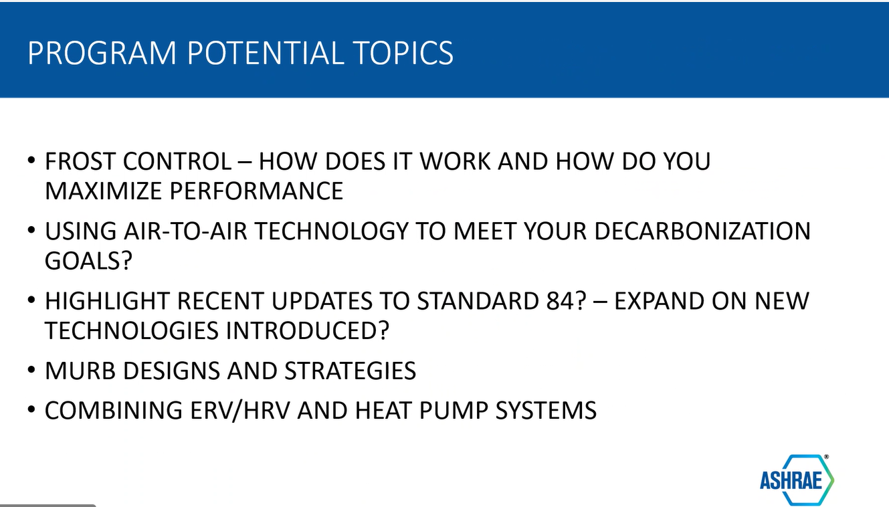
- Research (Marc Tardif):
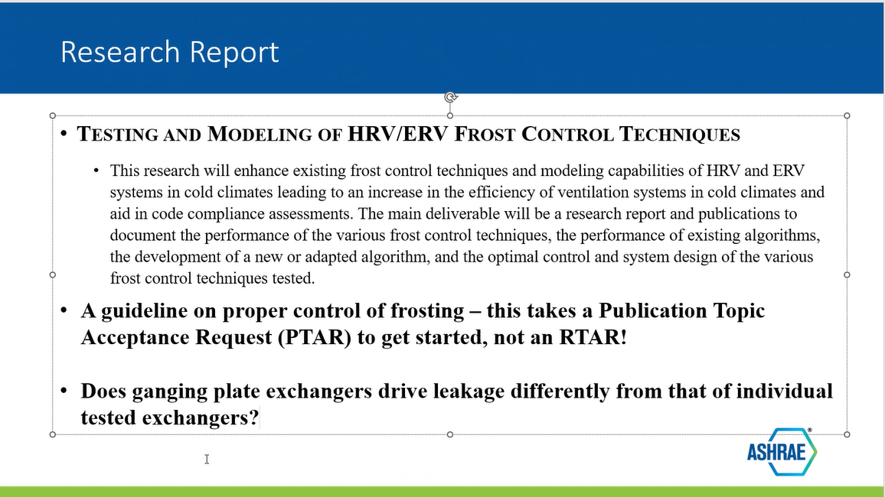
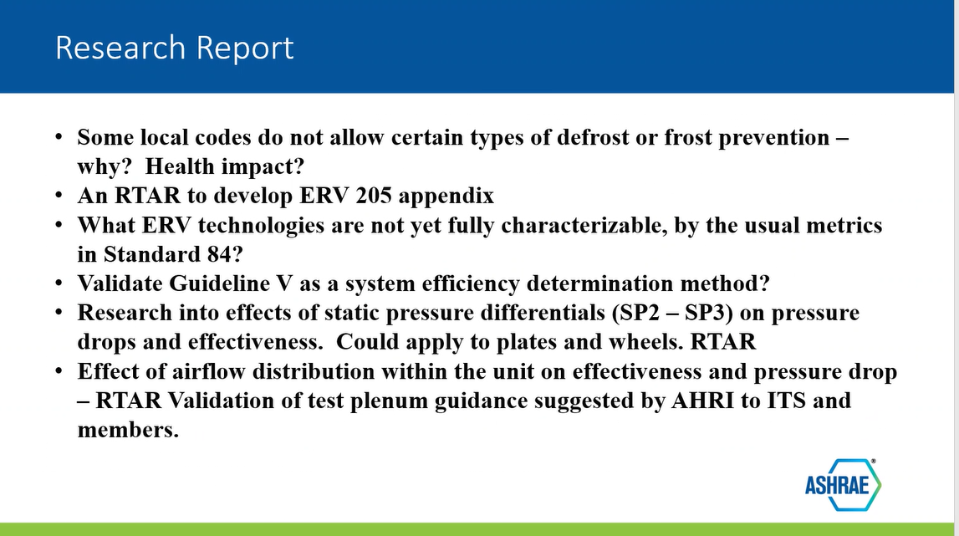
- Standards (Matthew Friedlander)
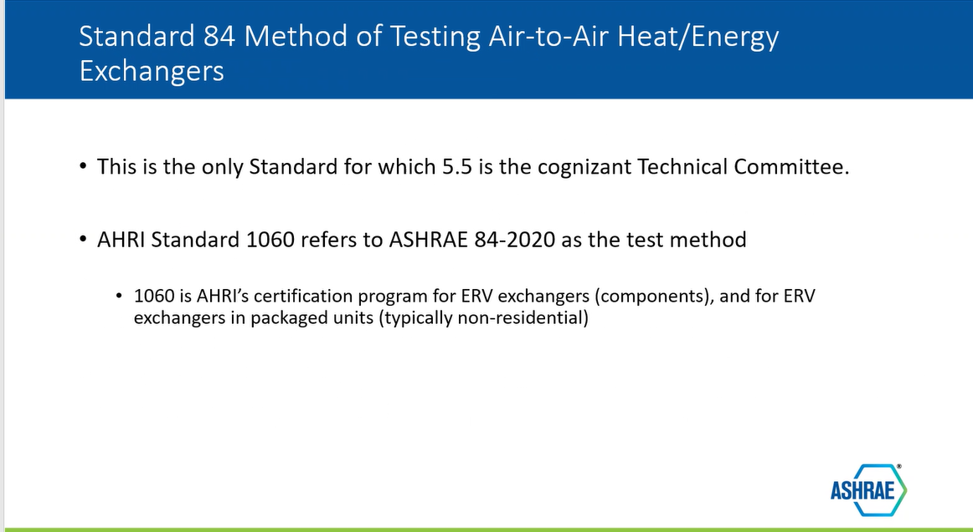
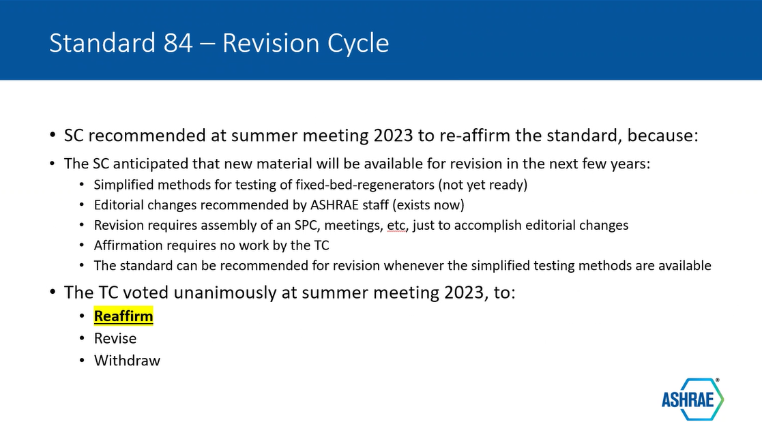
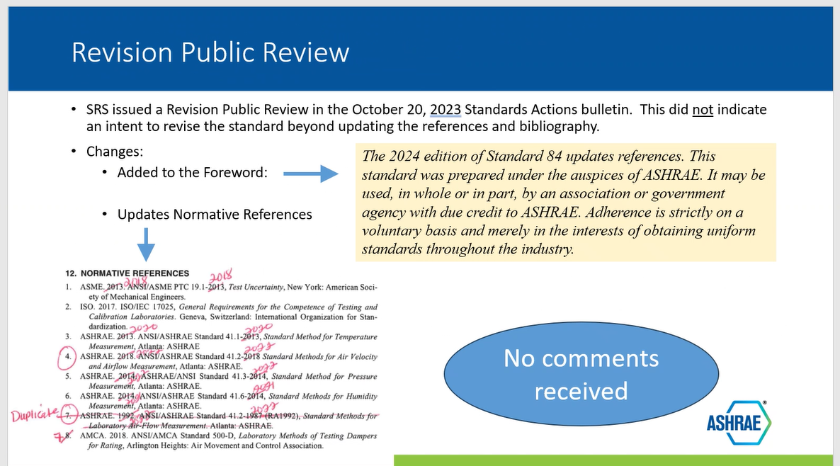
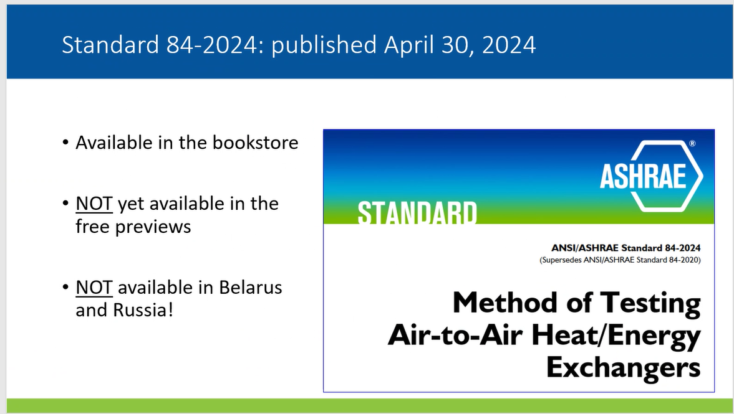
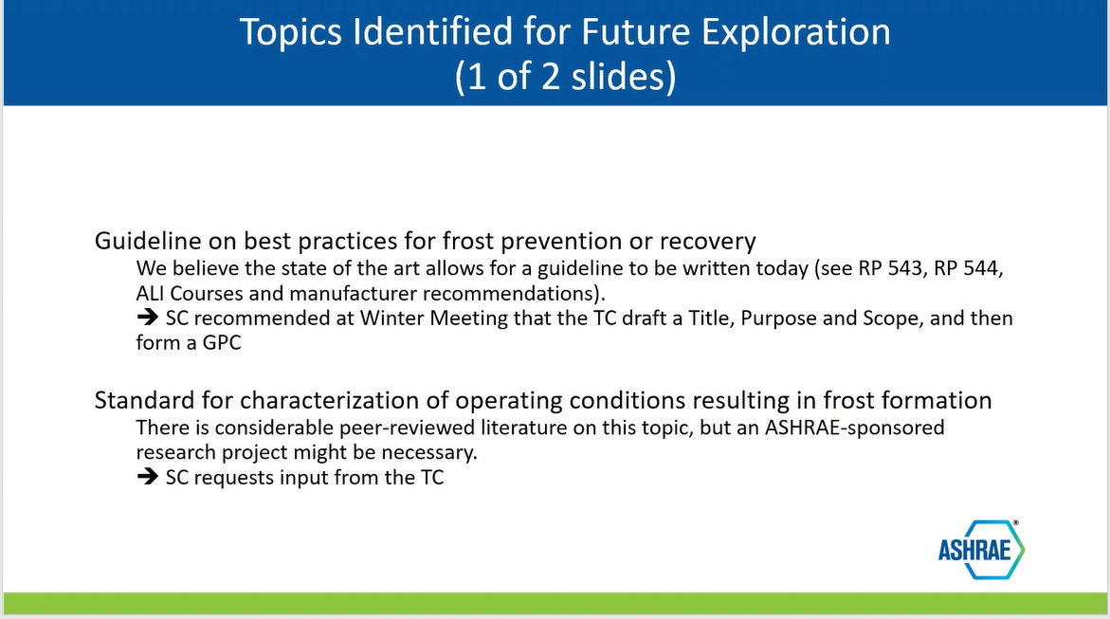
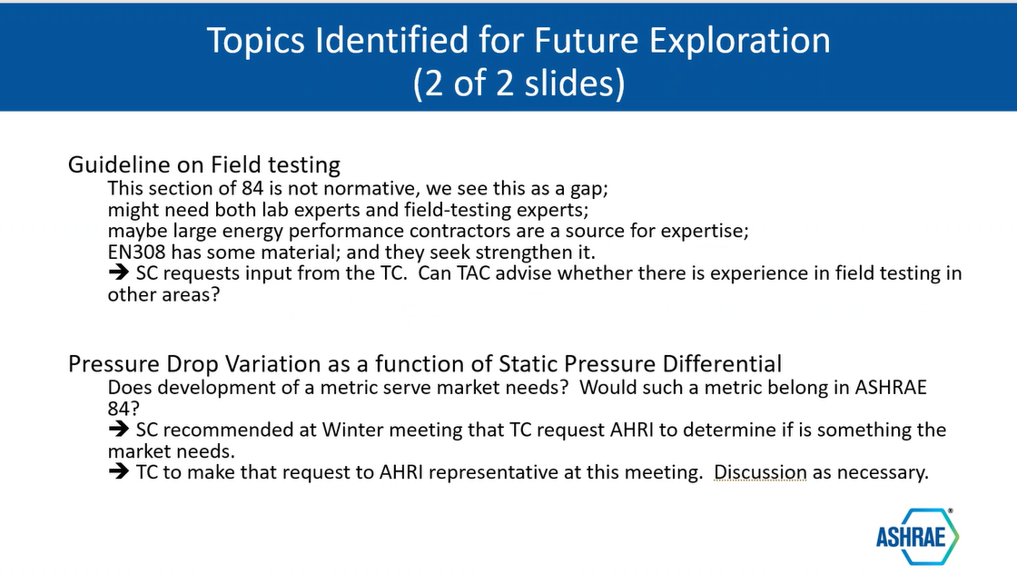
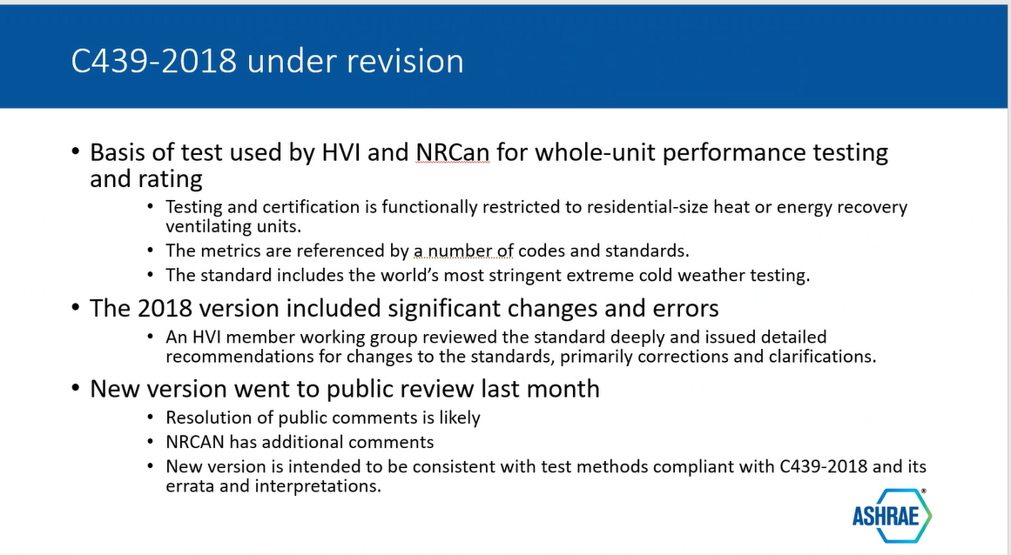
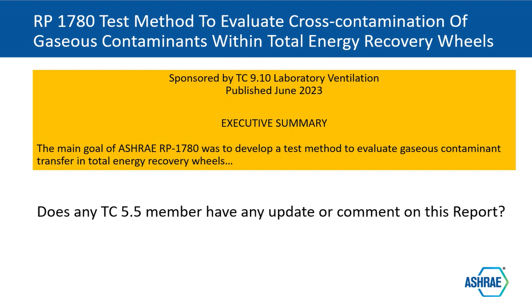
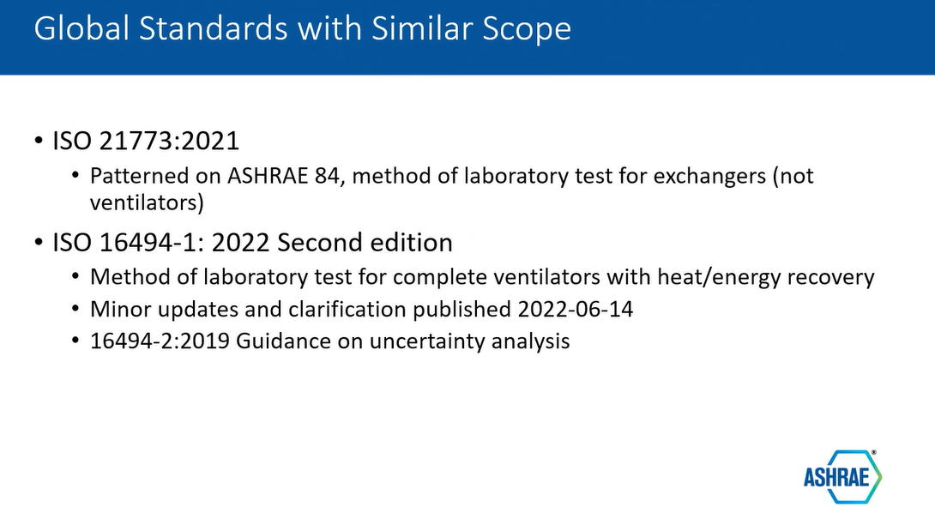
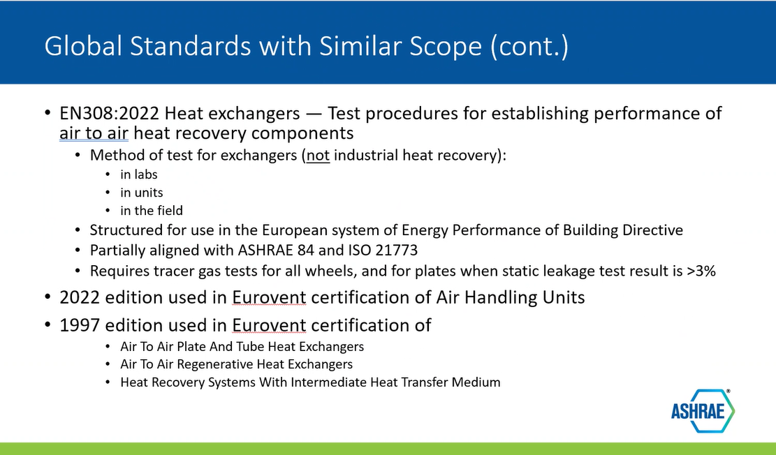
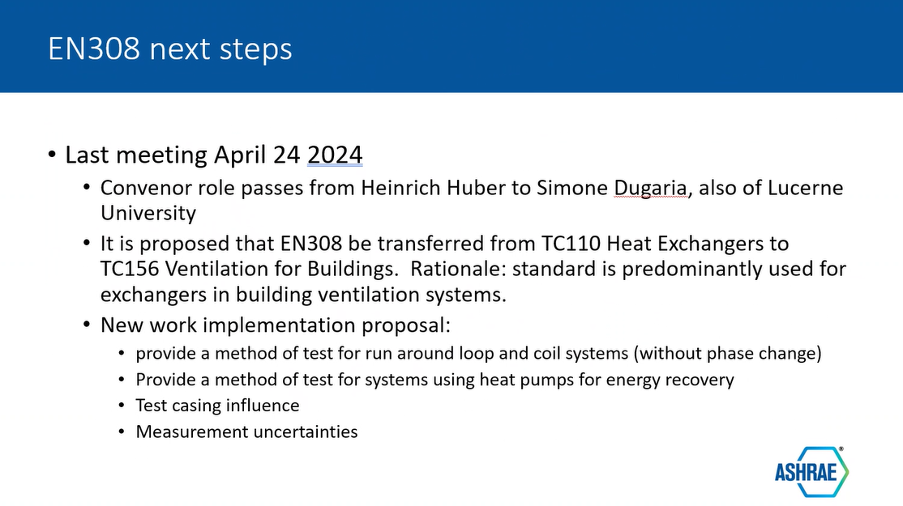
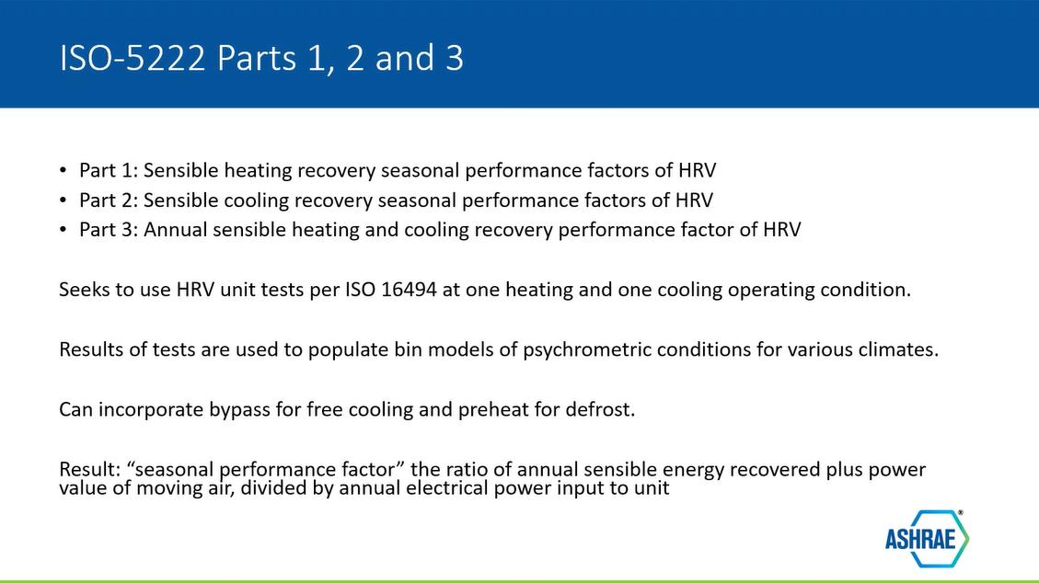
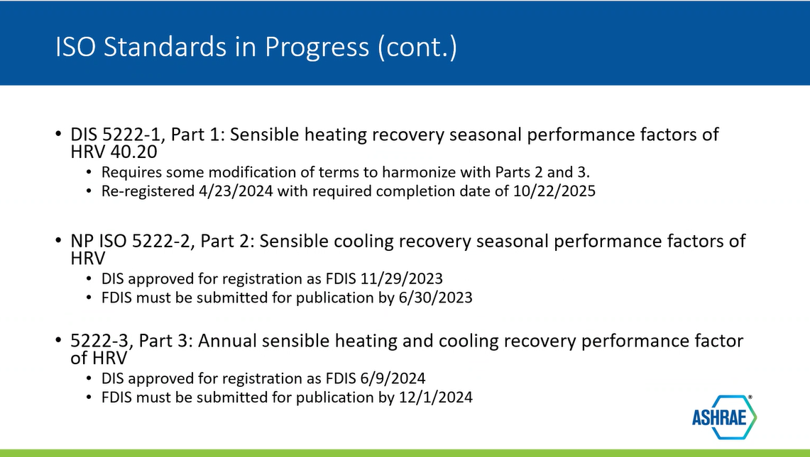
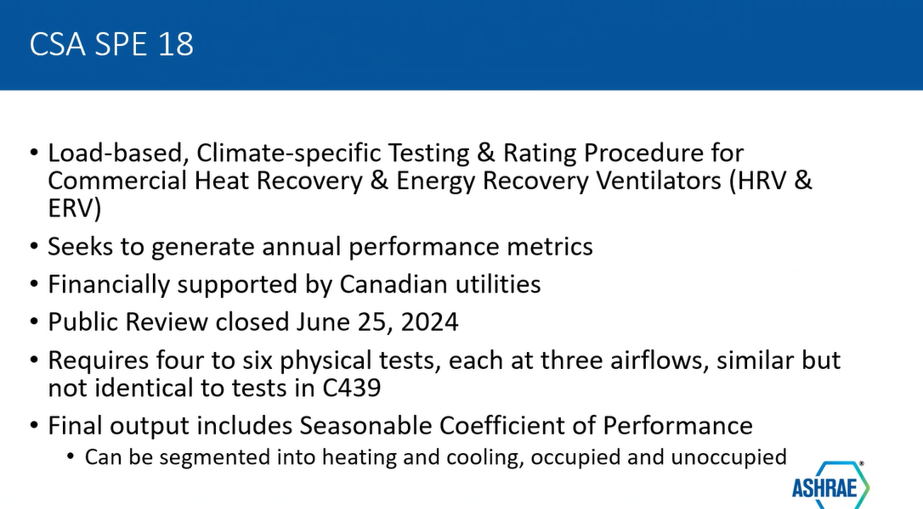
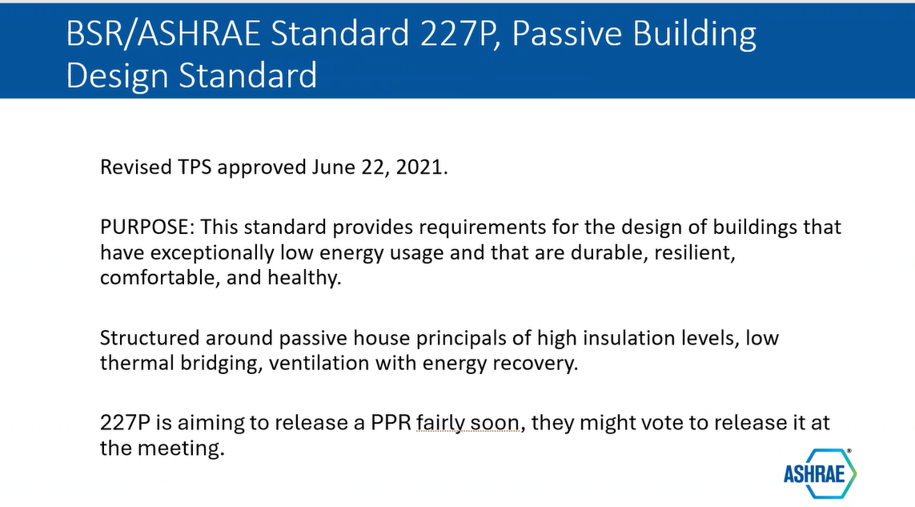
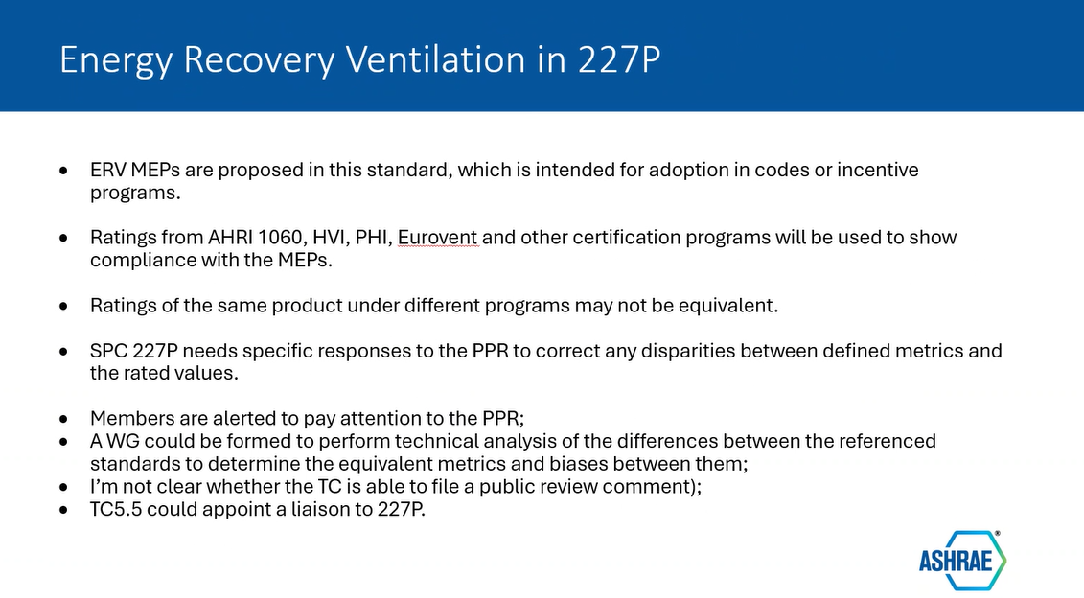

We voted to have Matthew Friedlander as liaison to 227P. Paul Piper proposed and Drake was the second. No objections or abstentions
- Website http://tc0505.ashraetcs.org/ (Brandon Damas)
- Membership (Chair)
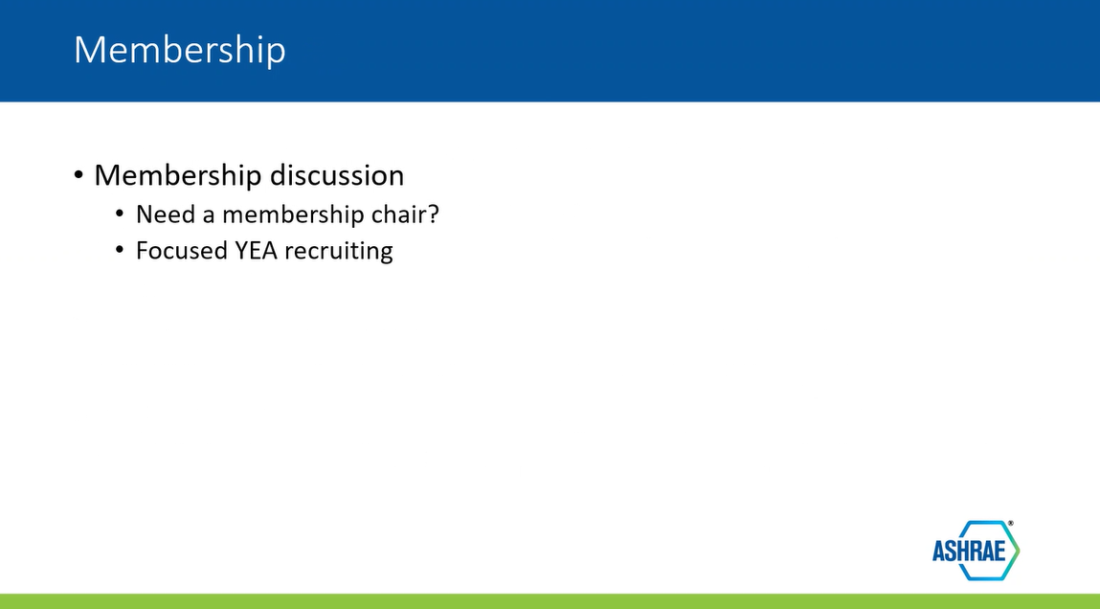

New Business
None

Next Meeting

Next face-to-face meetings will be at the 2025 Annual Meeting, January 2025, in Orlando, FL
- Kristin Sullivan, Chair TC 5.5
25 June 2024

Exhibit 1:
ASHRAE Code Of Ethics
(Approved by ASHRAE Board of Directors January 30, 2013)
1.140.001.1 As members of ASHRAE or participants in ASHRAE committees, we pledge to act with honesty, fairness, courtesy, competence, integrity and respect for others in our conduct.
A. Efforts of the Society, its members, and its bodies shall be directed at all times to enhancing the public health, safety and welfare.
B. Members and organized bodies of the Society shall be good stewards of the world’s resources including energy, natural, human and financial resources.
C. Our products and services shall be offered only in areas where our competence and expertise can satisfy the public need.
D. We shall act with care and competence in all activities, using and developing up-to-date knowledge and skills.
E. We shall avoid real or perceived conflicts of interest whenever possible, and disclose them to affected parties when they do exist.
F. The confidentiality of business affairs, proprietary information, intellectual property, procedures, and restricted Society discussions and materials shall be respected.
G. Each member is expected and encouraged to be committed to the code of ethics of his or her own professional or trade association in their nation and area of work.
H. Activities crossing national and cultural boundaries shall respect the ethical codes of the seat of the principal activity.

Exhibit 2: Voting Members and Officers as of 5/24/2024 (does not reflect changes effective July 1, 2024)
Full Name | Company | Position | Start Date | End Date
Ms Kristin Rice Sullivan | Trane Technologies | Chair | 07/01/2023 | 06/30/2025
Mr John Bade | 2050 Partners | Secretary | 07/01/2023
Dr Gursaran D Mathur, PE | Highly Marelli North America | Hndbk Subcom Chair | 07/01/2020
Mr Marc Tardif | Innergytech Inc | Program Subcom Chair | 07/01/2023
Mr John T Dieckmann | TIAX LLC | Resrch Subcom Chair | 07/01/2022
Mr Brandon Damas | Texas AirSystems | Webmaster | 07/01/2019
Mr Paul L Pieper, Eng, PE | The Master Group | ALI Coordinator | 07/01/2022 | 06/30/2026
Mr Marcus D'Arcy | Desert Aire | Member | 07/01/2022 | 06/30/2026
Mr Drake H Erbe | Airxchange Inc | Member | 07/01/2022 | 06/30/2026
Matthew Friedlander | Renewaire LLC | Member | 07/01/2022 | 06/30/2026
Dr Mohammad Rafati |  | Member | 07/01/2021 | 06/30/2025
Mr Triantafyllos Andreas Triantafyllopoulos |  | Member | 07/01/2022 | 06/30/2026

