TC 1.13 Optimization
Agenda for ASHRAE 2025 Annual Conference
Sunday, June 22, 2025
Phoenix, AZ, and hybrid-remote
http://tc0113.ashraetcs.org/

TC 1.13 meetings this meeting:

Main Committee Meeting (hybrid)
Sunday, June 22nd, 2025, 1:00 – 3:00 PM MST
Sheraton Phoenix Downtown
Room: Laveen A (Level 2)
MS Teams

1.13 program activities this meeting:

Seminar 23: Systematic Approaches to Minimize Charge for Flammable Refrigerants in Refrigerators and Heat Pumps
Chair: Vikrant Aute, Ph.D.
8:00 - 9:30 AM MST
- A Survey of Numerical Studies on Refrigerant Charge Optimization
Presenting Author: Rohit Dhumane, Trane Technologies
- Working with Flammable Refrigerants: Tradeoff between Safety and Performance
Presenting Author: Omar Abdelaziz, The American University in Cairo
- Optimal Dynamic Charge Management of Heat Pumps
Presenting Author: Jie Cai, Purdue University

Seminar 32: Physics-Informed Machine Learning in HVAC
Applications
Chair: Rohit Dhumane
Mon, Jun 23 9:45-10:45 AM MST
- Review of Techniques and Applications of Using Machine Learning Models for Automatic Discovery of Physics from Data
Presenting Author: Rohit Dhumane, Trane Technologies
- Using Physics-Constrained Machine Learning for State Estimation of Vapor Compression Systems
Presenting Author: Vedang Deshpande, Mitsubishi Electric Research Laboratories
- Automated Discovery of HVAC and Thermo-Fluid Systems from Data Using Julia
Presenting Author: Ranjan Anantharaman, JuliaHub Inc
- LLM-Driven Data Extraction for Physics-Enhanced Building Equipment Modeling
Presenting Author: Hanlong Wan, Pacific Northwest National Laboratory

Seminar 38: Optimization Methods for Components, Systems, and Grid-Interactive Buildings
Chair: Cheng-Min Yang
Mon, Jun 23 11:20-11:40 AM MST
- Optimization of Chilled Water Systems, Including AHUs, Chillers, Pumps and Cooling Tower Operations for Reduced Utility Use and Increased Reliability Using Adaptive and Feed Forward Control Processes Using the Existing BMS
Presenting Author: Duane Warren, Engineering Director, Jones Lang LaSalle
- Demand Flexibility Optimizations for Building Energy Systems with an Ice Thermal Energy Storage Tank in a Commercial Building
Presenting Author: Zheng O'Neill, Texas A&M University

Co-sponsoring:
(none for this Phoenix meeting)

Agenda:

1. Call to Order and welcome all members and visitors Zhenning Li

2. Roll Call / Introductions / Record Attendance Zhenning Li
Record attendance use this link by PC, or use QR code by phone


3. ASHRAE Code of Ethics Commitment Zhenning Li
In this and all other ASHRAE meetings, we will act with honesty, fairness, courtesy, competence, integrity and respect for others, and we shall avoid all real or perceived conflicts of interests. (See full Code of Ethics: https://www.ashrae.org/about-ashrae/ashrae-code-of-ethics.)

3. Introduction of ASHRAE Liaisons on Arrival Zhenning Li
Our Section Head is Jason Atkisson; welcome, Jason.

4. Establishment of Quorum Zhenning Li
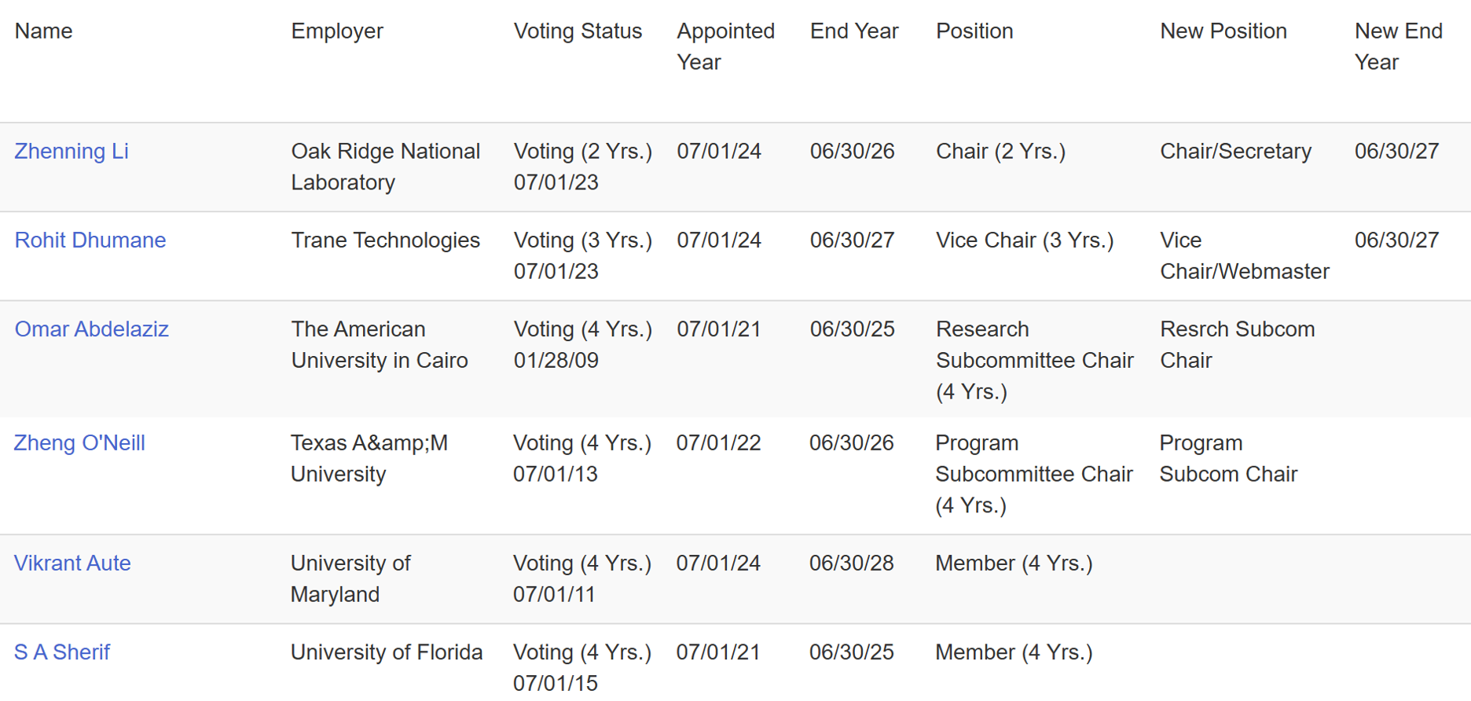
Voting members for this meeting (Orlando)
Position | Present | Voting member | Proposed interest category
Chair | ✓ or X | Zhenning Li | Gov & Res
Vice chair |  | Rohit Dhumane | Industry
Handbook |  | Khaled Saleh | Industry
Program |  | Zheng O’Neill | Academic
Research |  | Omar Abdelaziz | Academic
Standards |  | Vikrant Aute | Academic

Vikrant has a conflict to chair a seminar and will be absent.
X of 6 voting members presented.
Quorum is established?

Look for new voting members to replace Omar and S A sherif?

The TC presently has 6 voting members. Submitted the new roster updates on 03/03/2025 and is effective as of 07/1/2025.
Until June 22nd 2025, we have 63 members in total. Since 2025 March, 2 more members requested to join this TC through TC’s website. We would like to actively invite more members to join.

5. TC 1.13 Purpose Statement Zhenning Li
TC 1.13 is concerned with identifying, developing, and disseminating optimization techniques that enhance the performance of HVAC&R components, systems, and building systems that are not application or tool specific. The committee is focused on the fundamentals of optimization techniques including mathematical formulation, constraints handling, multi-objective optimization, approximation techniques, and robust optimization. These fundamentals are the foundation of data-driven, machine learning (ML), and artificial intelligence (AI) methods.

6. Approval of previous meeting minutes Zhenning Li
Previous meeting minutes was uploaded to website and sent to members via email.

7. Chairman’s Overview and Report Zhenning Li
We should be more active in submitting RTAR (Research Topic Acceptance Request).
1. Identify Key Research Gaps and Industry Needs
- Is there any emerging research needs in HVAC&R optimization? (TES-HP optimized control etc.)
- Engage with other relevant ASHRAE TCs, e.g. energy modeling (TC 4.7), controls (TC 1.4), and building performance (TC 7.5), Thermal energy storage (TC 6.9)
- Set a goal for a certain number of RTAR submissions per year and track progress.
2. Potential topics
- HVAC design optimization (covering energy efficiency, cost reduction, and sustainability)
- Machine Learning and AI for Building Optimization (applying data-driven techniques)
- Model-Based Optimization for Smart Building Operation (integration of physics-based and data-driven models)
- Energy and Cost Optimization in Decarbonization Strategies
- Advanced Controls and Optimization for HVAC&R Systems

8. Subcommittee Reports

a. Program Zheng O’Neill

Brainstorm TC 1.13 Seminars for 2026 Las Vegas Winter Conference.

2026 Las Vegas tracks:
https://www.ashrae.org/conferences/2026-winter-conference/2026-winter-conference-technical-program

- Fundamentals and Applications (Track Chair: Kevin Brown, kevin@kbsquared.net)
- HVAC&R Systems and Equipment (Track Chair: Ng Yong Kong, nyk@nyk.com.my)
- Refrigeration & Refrigerants (Track Chair: Haotian Liu, sjtulht@hotmail.com)
- Research Summit (Track Chair: Li Song, lsong@ou.edu)
- Energy Storage and Grid Resiliency (Track Chair: Jon Cohen, jonjcohen1@gmail.com)
- Pathways to Building Decarbonization (Track Chair: Ehab Mamdouh, ehab.mamdouh@ipec-eg.net)
- Artificial Intelligence (Track Chair: Joshua Vasudevan, joshuavasudevan2011@gmail.com)
- Indoor Environmental Quality & Healthy Buildings (Track Chair: Joe Chow, joe.ashrae@gmail.com)
- Future-Proofing the Built Environment (Track Chair: Joe Chow, joe.ashrae@gmail.com)
Friday, August 1, 2025: Debate, Panel, Seminar, Forum, Workshop, and Debate proposals for Las Vegas are due.

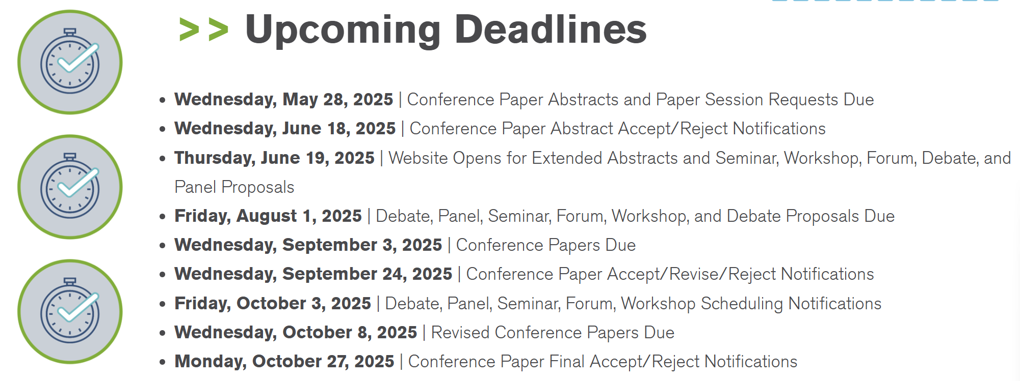

b. Research Omar Abdelaziz
Discussed RTAR with TC 4.7 data-driven modeling, but no active or proposed RTARs were identified for co-sponsorship. Potentially work with TC 1.4 and TC 7.5. RTAR 8.11 in unitary products.

c. Handbook Zhenning Li

d. Standards David Yashar

e. Membership Zhenning Li
Zhenning, Ivy and Rohit are currently YEA.

f. TC Website Zhenning Li

9. Old Business All
Request approval for previous meeting minutes

10. New Business All

11. Next subcommittee and committee meetings Zhenning Li
February 1st, 2026. 1-3 pm Las Vegas Local Time

12. Adjourn All

