Minutes
TC 5.3 Room Air Distribution
2022 Annual Meeting Agenda
1:00-3:00 PM EST, Tuesday June 28, 2022
Hybrid Meeting – Pine East (M) Sheraton Centre

- Call to Order/Welcome C. Peters

- Review Scope:

  - TC 5.3 is concerned with the distribution, diffusion and conditioning of air within rooms and similarly treated spaces. It includes consideration of the principles of air distribution, air diffusion and performance characteristics of all types of air terminal devices, fan coils, chilled beams and high/low pressure assemblies (boxes) or components, including associated or related accessories for both supply and extract air.

- ASHRAE Code of Ethics Commitment C. Peters

In this and all other ASHRAE meetings, we will act with honesty, fairness, courtesy, competence, integrity and respect for others, and we shall avoid all real or perceived conflicts of interests. (See full Code of Ethics: https://www.ashrae.org/about-ashrae/ashrae-code-of-ethics.)

- ASHRAE Health and Safety
  - ASHRAE is committed to the health and safety of our members and conference attendees:
    - Registration required
    - Masks strongly recommended while indoors
    - Color-coded lanyards available to indicate personal comfort level
    - If you feel sick, join virtually

- Introductions/Attendance C. Peters

  - Verify Quorum (1/2 + 1 for a Quorum) D. Johnson

Member | Present? | Stakeholder Interest
Curtis Peters | x | Manufacturer
Chris Lowell |  | Manufacturer
Brandon Bates |  | Manufacturer/ User
Bob Persechini | x | Consulting Engineer
Ryan Johnson | x | Manufacturer
Krishnan Viswanath | x | Manufacturer
David John | x | Retired
Frank Cuaderno |  | Manufacturer
David Johnson |  | Manufacturer
Kishor Khankari | x | Consulting Engineer
Zacc Poots | x | Sales Rep
Total | 6
Quorum (Y/N) | Y

In attendance:
Kevin Gebke (DuctSox) CM | Gus Faris (Nailor) CM
Ace Desai (Metallaire) CM | Nick Searle (Titus) PM
Andre Livchak (Halton) CM | Solomon Yin (ULL) G
Ben Arikpo (Price) G | Yusuf Bhetasi G
Bob Persechini (NV5) VM | Zacc Poots (DMG) VM
Brian Rock (Kansas) CM | Andrew Jenkins (Trane) G
Bryron Hagan (Nailor) CM | Randy Zimmerman (Titus) CM
Chad Huggins (ASC) – G | Ken Loudermilk (Titus) CM
Chao Ding – (Berkley) PM | Mike Koupriyanov (Price) CM
Chris Burroughs (Price) PM-Y | David John (Retired) VM
Craig Wray (Retired) CM | Ian Cavanaugh (Linx Ind) G
Drew Lewis (AHRI) G | Tom Smith (Brieflo) G
Eric Li – G | Alexander Zhivov (USACE) G
Kevin Marple (Section 5) G | Julian Rochester (Nailor) CM
Kishor Khankari (AnSight) VM | Mike Carl (RWDI) PM
Krishnan V (Dynacraft) VM | Ryan Johnson (Price) VM
Larry Smith (TAC Chair) CM
Yiteng Ma (Swegon) G
Zara Sardoueinasab (Nailor) G

- Announcements and Section 5 discussion C. Peters/K Marple

  - Toronto Statistics
    - 249 Total Presentations
    - 16 Conference Paper sessions (54 papers)
    - 3 Poster sessions (19 posters)
    - 2 Virtual Paper sessions
    - 50 Seminars
    - 1 Workshop
    - 2 Debate
    - 3 Forums
    - 4 Panel Sessions
    - 10 Livestream sessions
  - TC/TG/TRG MOP split from MTG MOP
  - FG MOP updates
    - Balance required
    - ASHRAE membership required for Chair/Vice Chair/Voting Members
  - MTG MOP
    - Structure determined by MTG leadership
    - No requirement for in-person meeting
    - 4-6 meetings per year
    - Quarterly report to TAC required
  - FG Motions
    - New form to submit to TAC for consideration. Intent to give FG’s a method to require TAC response. www.ashrae.org/TCs & Basecamp
  - asktac@ashrae.net – Resource for all TAC related questions/comments
  - Interim TC Meeting Procedures
    - ASHRAE will maintain a list of interim meetings http://www.ashrae.org/technical-resources/technical-committees
    - E-Mail shammerling@ashrae.org at least 2-weeks before meeting
    - Notice in ASHRAE journal
  - Kevin Marple
    - Activity form due today
    - TAC leadership tutorials now available – https://www.ashrae.org/communities/committees/standing-committees/technical-activities-committee
    - Ventilation conference just occurred. Next conference in 3-years. Looking for volunteers to get involved.
- Membership Report C. Peters
  - Leadership change after summer 2022 meeting
Ryan Johnson – Chair/Webmaster
David Johnson – Vice-Chair/Research
Frank Cuaderno – Secretary
Mike Koupriyanov - Handbook
  - Mike K accepted handbook sub-committee chair position
  - Upcoming roster changes

Member | Rolling Off? | Rolling On? | Roll Date | Stakeholder Interest
Andrey Livchak |  | X | 6/30/2022 | Manufacturer
Nick Searle |  | X | 6/30/2022 | Manufacturer
Brian Rock |  | X | 6/30/2022 | Academics
Chris Lowell | X |  | 6/30/2022 | Manufacturer
Curtis Peters | X |  | 6/30/2022 | Manufacturer

- Research Subcommittee Report R. Johnson
- Completed Research Projects
    - RP-1741 - Understanding Fan Coil Components And How They Relate To Energy Consumption And Energy Modeling (Solomon Yin)
More papers coming out – missed deadline for Winter 2023, but will be Summer 2023 (either transactions or research journal paper)
Handbook Applications has been updated to include this
Will send slides to members of committee on load-based testing in psychrometric chamber. Preliminary data from lab. Will forward to Curtis/Ryan to post in basecamp.
ACTION STEP: Request Solomon to give a presentation to 5.3 on a separate call. Schedule with a Doodle Poll through Basecamp. Solomon will send slides next week.

- Active Research Projects
  - N/A

- Current RTAR’s & Work Statements
  - RTAR-1882 - Procedure for Estimating Occupied Space Sound Levels in the Application of UFAD Air Terminals and Air Outlets
Nick Searle put together revised RTAR.
Still updates to make at WS phase.
This will be sponsored by 2.6. 5.3 will be co-sponsor.
Purely sound-based, no airflow. 2.6 is to vote on sponsoring.
WS due by July 2023.
Priority of WS is to prove to ASHRAE that research is valuable, get it approved by deadline, worry about sponsorship later.
Nick was not present if there was a vote from 2.6 on this.

  - RTAR-1936 – Evaluating the Impact of ACH on Ventilation Effectiveness for Indoor Spaces (Kishor K, David J, Duncan P)
Price Industries agreed to co-fund (Will be CO-RP1936)
WS is in draft (need vote of approval from MTG)
Kevin is voting member so no sponsorship req’d by 5.3, as it is implicit with Kevin’s membership

- New research
David John will keep 5.3 updated on TG2.RAST and SPC129 and potential research needs.

Kevin Gebke developing RTAR for Spiral Duct Grille Performance with TC 5.2. Will keep 5.3 updated. (RP-1335 to be used as a foundation)

Kishor: ACTION STEP: 5.3 should approach ETF to assert that all research related to Air Distribution go through 5.3. Curtis and Ryan to communicate on this and reach out to ETF. At the very least, 5.3 should be cognizant of these research initiatives.

- Standards Subcommittee report R. Zimmerman
  - Standard 70 MOT Diffusers (D. John)
    - Reaffirmed to maintain ANSI
    - 3 comments to address new revision
    - SPC not responsive at first
      - Now have responses from all but one VM
      - Will roll off that VM and vote to approve in July
      - Will then go out for public review
  - Standard 79 MOT Fan Coils (B. Hagan)
    - Public review complete
    - No substantial comments, just clarifications
    - Once reformatted with minor updates it should be ready for publication
  - Standard 113 MOT Room Air Diffusion (R. Johnson)
    - Public review complete
    - Already approved for publications
  - Standard 129 Air Change Effectiveness (D. John)
    - Momentum
    - Tom Smith going to author field testing with isopropyl alcohol
    - Kishor/Mike to develop CFD procedure
    - Atila to conduct further research
  - Standard 130 MOT Terminal Units (R. Zimmerman)
    - Technical issues. Next meeting in July
  - Standard 200 MOT Chilled Beams (M. Koupriyanov)

- Handbook Subcommittee Report D. Johnson
  - Sub-committee approved Applications chapter 58
  - Bob moved to approve Applications chapter 58 and Krishnan seconded
  - 6-0-0-CNV

- Programs Subcommittee Report B. Persechini

  - Seminar 52 – MTG.ACR in Toronto
  - Ken, Kevin, Gus, Kishor, Byron all interested in pursuing these seminars
  - Kevin – Prioritize Air Dist for Indoor Grow Facilities and move Textile Air Dist Sys to future conference
    - Conf Paper 18 on grow facilities

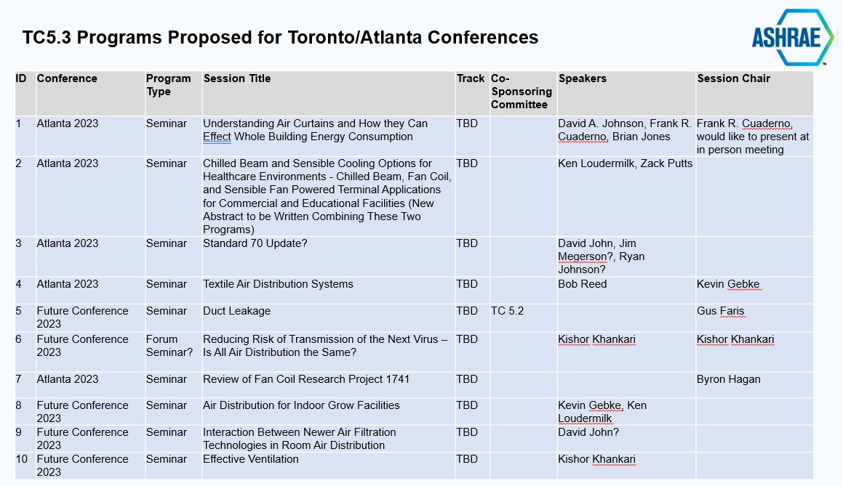

- Webmaster Report C. Peters
  - Website is up to date, including awards for Toronto

- Honors and Awards C. Peters

  - Two Technical Paper Awards in Toronto: Dennis L. O’Neal, Ph.D., P.E., Fellow Life Member, Jessica Cramer, and Peng Yin, Ph.D., received an award for “Part-Load Airflow and Power Model of Multi- Speed Fan-Coil Units with Electronically Commutated Motors” and “A Simple Airflow and Power Analysis of Fan- Coil Units with Electronically Commutated Motors”

- Historian D. John
  - No progress since pandemic

- Liaison Reports C. Peters
  - Standard 55 Thermal Comfort (M Koupriyanov)
    - No issues relating to 5.3
    - Heat stress
    - Updated research on clothing insulation value (more global)
  - Standard 62.1 Ventilation (K. Shifflett)
    - No liaison present
  - Standard 90.1 Energy (Need new liaison – volunteers?)
    - Updated revision coming out soon
  - Standard 170 Healthcare Facilities (Need new liaison – volunteers?)
    - How to apply std 55 to 170?
  - Standard 215 Air Leakage (C Wray)
    - No liaison present
  - TC 2.6 Sound and Vibration (R. Zimmerman)
    - RTAR for 5.3 UFAD
  - TC 5.2 Duct Design (K. Gebke) – TUES @ 3:30 p.m. EST
    - Putting together plan for seminars to get Duct Design Guide some PR
    - Duct fitting data base continues to evolve
  - AHRI Terminal Units (Akshaya)
    - 885 needs to be completed
    - Compliance mtg for VAV TU’s
  - AHRI Fan Coils (Sarp Hamamcioglu)
  - AHRI Chilled Beams (Sarp Hamamcioglu)
  - AHRI STE (TCOS) (R. Zimmerman/K. Peterman)
  - GPC 36 High Performance Seq of Op for HVAC Sys (Need new liaison – volunteers?)
    - Solomon – Will start attending in future
    - Applied AHRI group – Trying to push all groups into GPC36 & 205
    - Add 205 to Liaison list with Solomon as liaison
  - TC 9.6 (Zacc Poots)
    - A lot of active research including infectious diseases
  - MTG.ACR (K Gebke)
    - Seminar 52
    - Research – WS-1936 in progress, RP-1833 almost complete
    - Special Publication – Air Change Rates
  - MTG.CEA (J. Megerson)
  - ETF (D Phillips)

- Old business C. Peters

- New business C. Peters
  - TC 5.3 strategic plan
    - Gus F, Mike K, Kevin G
    - Curtis volunteered
    - Kishor – Suggest creating ‘Emerging Issue Brief’ to get more exposure within ASHRAE and externally
      - Write abstract and send to Environmental Health Committee
      - Form EIB committee
      - Search ASHRAE website for examples
      - Reach out to Steve Hammerling
      - Kishor, Kevin, Curtis, Solomon willing to help
      - Co-Chairs – Gus/David
      - **Need meeting to discuss scope**

  - USACE Guide for Air Supply Strategies in Spaces
    - Alexander Zhivov
    - Alexander.M.Zhovov@usace.army.mil
    - Create sub-committee to review paper and provide feedback
      - Chair: Kevin G
      - Curtis P, Gus F, David J, Dan Int-Hout, Ken L, Bob P,
        - Brian Rock – Will review and provide feedback
      - Curtis to confirm guidance with Mark Owen

  - DoD Design Guides (UFC) and Specifications (UFGS)
    - No action required

  - ETF
    - Winding down – All future room air distribution activities should come to TC 5.3

- Adjournment C. Peters

