MINUTES
ASHRAE TC 4.2 | Climatic Information
2026 ASHRAE Winter Meeting | Las Vegas, NV
Tuesday, Feb 03 2026 | 1:00 – 3:00pm PST
https://tc0402.ashraetcs.org/meetings.php
Remote Participation Link: https://us06web.zoom.us/j/81353194671?pwd=alyszXilev0zUJPUFDEbabDUrca8Bh.1
Meeting ID: 813 5319 4671 Passcode: 592904
SUMMARY
::ACTION ITEMS::
  - Roster
    - Committee is seeking a Program Subcommittee Chair.
    - Volunteers were invited to participate as Voting Members; four positions are expected to roll over. Anastasia Milona from CIBSE volunteered.
  - Standards / Handbook
    - Standard 169 update has been published.
    - GPC 49 has launched and CIBSE co-sponsorship is being developed.
    - TC 6.7 requested review of solar-related references in HVAC Applications Chapter 36.
  - Research
    - RP 1874 and RP 1923 advanced by Research Committee motions; each vote was recorded as 7-3-0-0.
    - Juan Carlos volunteered to serve on the PES for 1939.
    - TC to review the 1990 RTAR and proceed toward Work Statement acceptance.
    - 1999 is expected to go out to bid in October.
These minutes drafted Sunday 1st Feb 2026 by Secretary, Sagar Rao (NeuMod Labs)
- Call to order 1-1:02 pm Rastogi
- Review Scope Rastogi
“TC 4.2 identifies, researches, analyzes, and disseminates climatic data for design of sustainable built environments.”
- ASHRAE Value Statement Rastogi
In ASHRAE meetings, we will act with honesty, fairness, courtesy, competence, inclusiveness and respect for others, which exemplify our core values of excellence, commitment, integrity, collaboration, volunteerism and diversity, and shall avoid all real or perceived conflicts of interest. Our culture is one of inclusiveness, acknowledging the inherent value and dignity of each individual. We celebrate diverse and inclusive communities, understanding that doing so fuels better, more creative and more thoughtful ideas, solutions and strategies for the Society and the communities our Society serves. We respect and welcome all.

Code of Ethics: https://www.ashrae.org/about/governance/code-of-ethics
Core Values: https://www.ashrae.org/about/ashrae-s-core-values
Diversity Statement: https://www.ashrae.org/about/diversity-equity-and-inclusion-dei
- Introductions All
  - Determination of a quorum (attendance by 7 Voting Members)
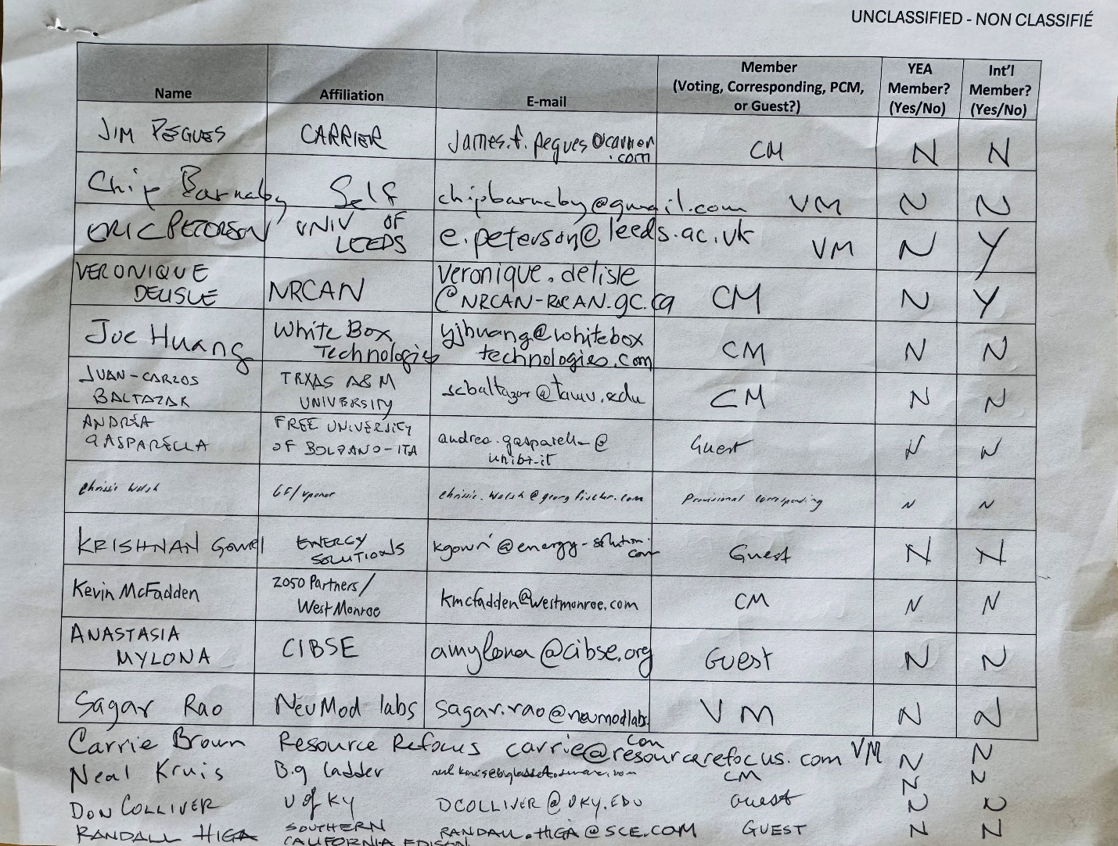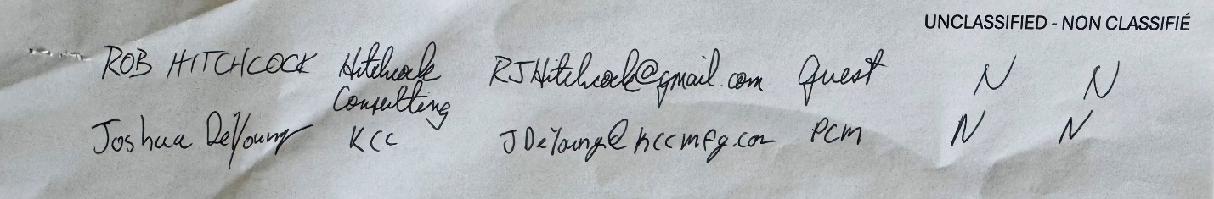
- Agenda additions All
No agenda additions offered.

- Approval of minutes from Phoenix Rastogi
Chip Barnaby moved to approve the minutes from Phoenix. Carrie Brown seconded the motion. The vote was recorded as Yes-Absent-Abstain-No, 6-4-0-0. The motion carried and the Phoenix minutes were approved.
- Research Proposals 1:05 PM
  - RP 1874
  - RP 1874 was brought forward by the Research Committee. The motion was moved by the Research Committee. Riad joined during this portion of the meeting. The vote was recorded as 7-3-0-0. The motion passed.
  - RP 1923
  - RP 1923 was brought forward by the Research Committee. The motion was moved by the Research Committee. The vote was recorded as 7-3-0-0. The motion passed.
- Chair’s Report 1:24 PM Rastogi
  - Announcements and Highlights from TC Chairs Breakfast Meeting
  - Government Affairs is urgently seeking additional volunteers. Members were encouraged to consider supporting this effort.
  - TAC will distribute a survey because it is considering cancellation of all on-site Subcommittee meetings. Survey responses will inform future meeting structure decisions.
  - Eric will share notes from the Chairs Breakfast with Sagar to support continuity.
- Liaison reports 1:25 PM
  - Center of Excellence for Building Decarbonization (CEBD)
  - New technical guides are being developed for AI data centers and grocery stores. Additional guides for healthcare facilities and other building types are also in progress.
  - Resilience
  - The Resilience group has been disbanded. No additional action was recorded.
  - Section Head
  - The Section Head was absent. No report was given.
  - Climate Change (TC 2.5 Global Climatic Change and Ozone Depletion) Jarrett
  - Phil Jarrett reported that the TC 2.5 Position Document has been finalized.
- Membership/Roster 1:30 PM Brown
  - The Chair discussed upcoming roster changes. Volunteers were invited to participate as Voting Members, with four positions expected to roll over. Anastasia Milona from CIBSE volunteered to participate.
- Subcommittee Reports
  - Program 1:33 PM
  - The committee is seeking a Program Subcommittee Chair. Members were encouraged to identify potential candidates.
  - Research 1:35 PM
  - The committee reviewed the Research Report and discussed four of the forty-one current active research projects.
  - 1850-TRP: Status noted. No additional action was recorded at this time.
  - 1939: Juan Carlos volunteered to serve on the Project Evaluation Subcommittee.
  - 1990: The TC will review the RTAR and proceed toward acceptance of the Work Statement.
  - 1999: The project is expected to go out to bid in October.
  - California Design Data: Southern California Edison is seeking to update California design data and requested TC support. The expected level of effort is approximately two hours per week for the first three months, followed by quarterly meetings thereafter. The TC will return a list of TAG members to assist with review.
  - Climate zone redefinition for the Global South was discussed. Eric volunteered to support this effort.
  - TC 6.5 Snowmelt RTAR: The committee discussed review of an RTAR for a snowmelt-related proposal. Key questions included whether the RTAR should continue and whether the scope requires refinement. Assistance from TC 6.5 was requested. Joe Huang volunteered to review the RTAR.
  - Eric requested that the hot climate research topic remain on the active research list.
  - Standards 1:58 PM
  - Standard 169: The update to Standard 169 has been published.
  - GPC 49: GPC 49 has launched. Several contributors are from CIBSE, and co-sponsorship from CIBSE is being developed.
  - Handbook 2:05 PM
  - The project for the 2029 Handbook update has not yet begun.
  - Chapter 36 in HVAC Applications includes references to solar-related content. TC 6.7 is seeking review of the relevant sections.
- Presentation 2:07 PM
  - FutureWeather.co / RadBridge Schmidt
  - Rowan Schmidt of FutureWeather.co provided an introduction to RadBridge and future weather data services.
  - The presentation described use of 23 Global Climate Models that include the ten variables needed for design applications. The cost structure was described as $25 per job.
  - Discussion included an approximately 2080-centered future period, corresponding to 2065-2095.
  - A question was raised regarding whether obtaining an input file from OneClimate changes the resulting output file.
  - Joe advocated for a morphing methodology rather than dynamic downscaling, citing practicality for design workflows.
- IBPSA-USA Update 2:50 PM
  - The IBPSA-USA design information data model specification is expected to be published shortly.
- ASHRAE Power Updates 2:52 PM
  - Power updates for ASHRAE were shared. No formal actions were recorded.
- Adjourn 2:52 PM
Eric moved to adjourn. The meeting adjourned at 2:52 PM PST.
Next Meeting: To be confirmed

