

1791 Tullie Circle, N.E./Atlanta, GA 30329
404-636-8400
DRAFT

TC/TG/MTG/TRG MINUTES COVER SHEET

(Minutes of all Meetings are to be distributed to all persons listed below within 60 days following the meeting.)

TC/TG/MTG/TRG No. TC 3.1 DATE February 1, 2021

TC/TG/MTG/TRG TITLE Refrigerants and Secondary Coolants

DATE OF MEETING January 1, 2021 LOCATION Virtual

 | MEMBERS PRESENT | YEAR APPTD | MEMBERS ABSENT |  | YEAR APPTD | EX-OFFICIO MEMBERS AND ADDITIONAL ATTENDANCE
 | Chris Seeton (Chair) | 2018-2020 | Greg Linteris |  | 2017-2021 | Steve Kujak (Program/Webmaster)
 | Julie Majurin (Vice Chair) | 2018-2022 | Lydia Dober |  | 2020-2024 | Kevin Connor  (Handbook Subcommittee)
 | Elyse Sorenson (Secretary) | 2018-2022
 | Bill Kopko | 2017-2021
Valerie Lisi
(Research Subcommittee)
 | Alice Riemer  (non-quorum) | 2019-2023
 | Marc Scancarello | 2020-2024
 | Kapil Chand Singhal | 2017-2021
DISTRIBUTION: All Members of TC/TG/MTG/TRG plus the following:
TAC Section Head: William Dols |  |  |  | SHx@ashrae.net  Where x is the section number
All Committee Liaisons As Shown On TC/TG/MTG/TRG Rosters (Research, Standards, ALI, etc.) |  |  |  | See ASHRAE email alias list for needed addresses.
Mike Vaughn,  Manager Of Research & Technical Services |  |  |  | MORTS@ashrae.net

Corresponding Members and Guests
Rashid Zakeri | Joshua Hughes | Samuel Yana Motta
Rosine Rohatgi | Guy Frankenfield | Thomas Leck
Carolina Cardenas | Bob Low | Casey Scruggs
Kelsey Carter | Morgan Herried | Greg Smith
Lauren Huffman | Ian Burton | Steve Baker
Shelby Kent | Jian Sun-Blanks | Scott Ayers
Marc Scancarello | Ryan Hulse | Joe Nigro
Morgan Leehey | NG Wen | Tyler Carter
Steve Kujak | Mark McLinden | Tom Watson
Akio Miyara | Stuart Dols | Steve Kujak
Alireza Behfar | Akio Miyara | Nidhi Rai Jain
Sarah Kim | Bill Walter | Michelle Hull
Rob Yost | Bridgett Rakestrae | Joe Karnaz
Matt Archey | Georgi Kazachki | Drew Welch
Jay Kohler | Osami Kataoka | Amir Jokar
Ankit Sethi | Doug Tucker | Brad Boggess
Anthony Wang | Ivan Rydkin | D. Rodowski
Brian Fricke | Xudong Wang | Harrison Skye

KEY CONTACTS

Liaisons:
William Dols, NIST, Section 3 Head
CheeSheng Ow, RAC Liaison
Michael Vaughn, ASHRAE Staff Liaison
Guy Frankenfield, DN Tanks, 2021 Handbook Liaison
Theresa Weston, Holt Consultancy, Standards Liaison

MEETING MINUTES

      - CALL TO ORDER (C. Seeton, Chair)

- Chair, Chris Seeton, called the meeting to order at 7:03 AM (EST). Members and guests were capture via Zoom, and meeting was held virtually.

  - Establishment of a quorum, 8 out of 11 voting members were present.

2. AGENDA REVIEW

No corrections were noted.

Motion to approve the Chicago draft agenda was made by Mark S and seconded by Valerie L
Motion passed: 7 / 0 / 0 /10 / CNV. (For / Against / Abstain / Total [Chair Voting [CV] or Chair Not Voting [CNV]])

3. APPROVAL OF CHICAGO, JUNE 2020 VIRTUAL MEETING MINUTES

No corrections were noted.

Motion to approve the Chicago draft minutes was made by Julie and seconded by Alice
Motion passed: 6 / 0 / 1 / 10 / CNV. (For / Against / Abstain / Total [Chair Voting [CV] or Chair Not Voting [CNV]])
Bill Kopko did not receive minutes, abstained from voting.

4. ROSTER REVIEW AND ANNOUNCEMENTS (C. Seeton, Chair)

4.1 Roster Review

Voting Members for this meeting (committee terms expire June 30 of year listed):
Christopher Seeton, Shrieve Chemical, Chair (2021)
Julie Majurin, AHRI, Vice-Chair (2023)
Elyse Sorenson, Trane Technologies, Secretary (2022 online roster is incorrect)
Valerie Lisi, Carrier, Research Subcommittee Chair
Alice Riemer, Danfoss (non-quorum) (2023)
Marc Scancarello, Emerson (2024)
Lydia Dober, Calumet (2024)
Bill Kopko, JCI (2021)
Greg Linteris, NIST (2021)
Kapil Chand Singhal, BP Refcool (2021)

Other committee officers (non-voting):
Stephen Kujak, Trane Technologies, Webmaster & Program Subcommittee Chair
Casey Scruggs, Metalloid, Standards Subcommittee Chair
Kevin Connor, Dow Chemical, Handbook Subcommittee Chair??

Liaisons & Other:
William Dols, NIST, Section 3 Head
CheeSheng Ow, RAC Liaison
Michael Vaughn, ASHRAE Staff Liaison
Guy Frankenfield, DN Tanks, 2021 Handbook Liaison
Theresa Weston, Holt Consultancy, Standards Liaison

4.2 Section 3 Meeting Report

Liaison Updates:
  - William “Stuart” Dols
  - “New” – Evaluation workbook – to help TCs evaluate, gauge performance.

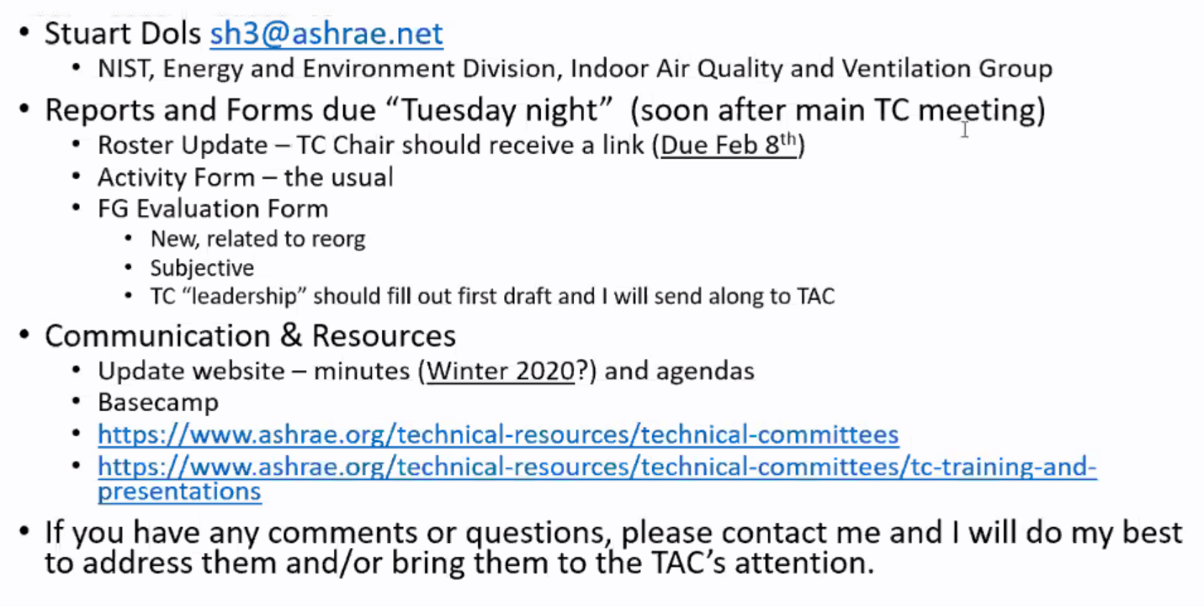

4.3 TC Reaffirmation of Scope (yearly at summer meeting)
ACTION: NO action, in future do at winter meeting.

4.4 TC Chair and Vice Chair Breakfast
  - TC reorg. 3.2/3.3 noted 1 of 5 mergers that has occurred to date.
  - “George Hightower Technical Achievement Award.
  - Interim meeting procedure reviewed.
  - 2019-2024 Strategic Plan – highlights Resilient Buildings and Communities, IEQ, Organizational Streamlining, and Improved Chapter Engagement/Capacity/Support.

- RESEARCH SUBCOMMITEE (Valerie Lisi)

5.1 Report from Research Subcommittee Chairs Meeting (0:05)

To be held in future. Primary takeaway – decreased research funding, given lack of conference/expo. Projects are getting funded, but less (~50% decline, due to loss of EXPO matching)

5.2 Ongoing Research Projects—Status Reports (0:02)

None at this time.

5.3 ASHRAE/AHRI/DOE Collaboration on Flammable Refrigerants Research (0:20)
Three ASHRAE lead projects have been developed to work statement phase and funded by ASHRAE. Here is an update on all projects
ARTI 9015 starting mid-2020 - Understanding ability of sensor to respond and drive effective mitigation process. Relates to flammable refrigerant dispersion in reach-in coolers (R290, R454C), to understand charge amount for safety standards. Moving on to residential air conditioning products. Have tested ducted unit in crawl space setting. Now testing vertical ducted system in utility closet setup. This work in ongoing, and will quickly go on to ductless minisplit unit, and also include a multi split VRF type product, for safety shut off valve application. All based on similar principle, release refrigerant into occupied space, study dispersion of room, to assess mitigation effectiveness.
Sensor Project ARTI 9014 – Look into method of test for refrigerant sensors required by 60335-2-40, safety standard for AC/HP. Looked into sensor response time, and different requirements from different standard (IEC 2-40, UL 2-40, ASHRAE 15). Tested several sensors to see whether they can meet requirements. Second phase and third phase, look into robustness of sensors. Contractor designed test stand and method, to go through accelerated testing of sensors, to understand impact to response (i.e. exposure to high temps, freezing, lubricants, etc). Around 5 sensing technologies are being tested. Around 80% of testing is completed, hoping to publish to report by summer 2021.

5.4 Proposed Research Projects (0:40)
The following items are on the TC Research Plan:
Item | ACTION NEEDED | Recent Notes
1791-WS HUMIDITY EFFECTS ON BURNING VELOCITY | Chris and Julie to submit to RAC  ACTION: No Action | Julie Majuring (ldead)  Richard, Leck, Flohr, Wang (AHRI)
1797-WS ASSESSMENT OF THE A/B TOXICITY CLASSIFICATION USED IN STANDARD 34 | Queued to go out to bid  ACTION: No Action | G. Jepson (lead)  PMS: G Rusch, G Jepson, C Seeton, S Kujak.
1851-WS  Electrical Properties of New Refrigerants | Ivan and Josh to regroup.  ACTION: No Action | PMS: Ivan Rydkin and Josh Hughs.  Schultz, Johnson, Baker, Leyderman
No RTAR  Re-evaluate Calibration of 200L to 12 L flammability limits for borderline cases | Needs to be sent to MORTS (Lisi and Seeton), Kopko to send latest version.  ACTION: No Action | Bill Kopko (lead)  Ivan Rydkin  Potential addition/Bob Replacement to be provided by Samuel Yana Motta.
1884-WS  Incorporation of odorants in refrigerants to improve leak detection – Phase II Exp. Study | Working with Consume Products Safety Commission to fund phase I. Phase II with ASHRAE. Working to understand and make decision on contractor, and pending results of Phase I, will move on to ASHRAE-funded Phase II.  ACTION: No Action | Marc Scancarello (Lead)  Julie Majurin, Valerie Lisi, Elyse Sorenson
Quenching Distance (Translation from Japanese) | Val to reach out to Kenji on status | Kenji
Constant Volume vs Constant Pressure (Translation from Japanese) | Val to reach out to Kenji on status. | Kenji
Hot Surface Ignition Temperature | Interest in this information being provided as a table | Seeton, Scancarello, Yana Motta

No new ideas shared.
Question was brought up regarding potential PFAS regulations, and the impact on chemicals used in refrigeration. Noted to be a good topic for Gov’t Affairs, or the MTG-LGWP group.

5.5 Update of TC Research Plan
A spreadsheet summarizing the TC research plan will be posted on the TC web page.

6. HANDBOOK (FUNDAMENTALS) SUBCOMMITTEE (Kevin Connor)

TC 3.1 is responsible for Chapters 29 (Refrigerants), 30 (Thermophysical Properties of Refrigerants),
and 31 (Physical Properties of Secondary Coolants) in the Handbook of Fundamentals.

Revisions for the 2020 edition will be coming due quickly!
Chapter 29- Refrigerants (Lead—Steve Kujak) -
Made updates on the website. Need to update a few tables with data. Can be voted on in 1 month of so (Was needed by May 3, 2020).

Chapter 30- Thermophysical Properties of Refrigerants (Lead—Mark McLinden)
Chapter 31- Physical Properties of Secondary Coolants (Lead—Kevin Connor)
Both chapter 30 and 31 were completed at summer 2020 meeting.

7. PROGRAM (Steve Kujak)

7.1 Programs at the Virtual Meeting:
None

7.2 Future program plans
Roll over to summer.

Seminar Ideas:

TC 3.1 – Kevin Connor – Hot Topics for Secondary Coolants (Brines):

- TITLE: Aqua-Ammonia, is More Than Just a High Efficiency Secondary Refrigerant
SPEAKER: Art Sutherland (Accent Refrigeration)
- TITLE: Combatting Corrosion Problems Caused by Calcium Chloride Brines
SPEAKER: Kathleen Neault (Refri-Ozone Inc)
- TITLE: Know the Facts behind Effective Use of Glycol Secondary Coolants
SPEAKER: Kevin Connor (Dow)

TC 3.1 – Steve Kujak – Emerging Low GWP Refrigerant Innovations and Technologies

- Review of ultra-low GWP molecules – thermodynamics properties and their characteristics for use in HVAC&R - Steve Kujak
- Speaker 2 – Ken Schultz R-23 or R410A replacements?
- Speaker 3
- Speaker 4
- Speaker 5

New Ideas – None.

Other TCs – co-sponsorship

Motion to co-sponsor the TC 3/4 seminar The Seminar for Working Fluids and Application Consideration for Low Temperature Refrigeration for Pheonix Conference.
Mark S, Georgie K – 7-0-0-10-CNV Yes-No-Abstain-Total
Chris Campo Seminar Chair, originates in 3.4
Steve K – speaker from TK
Bob Low – Speaker from Koura

8. STANDARDS (Casey Scruggs)

- ASHRAE Standard 34, Designation and Safety Classification of Refrigerants (S. Kujak)

- Approved 3 refrigerants in recent meeting, out for public review. Blends of standard refrigerants. One application required further work, and was not approved.
- Multiple continuous maintenance items reviewed to further align SSPC 34 with ISO 817.

- ASHRAE Guideline 6, Refrigerant Information Recommended for Product Development and Standards. (Lauren Huffman)

- In process of updating items identified in 2018 public comments. Primarily references.
- Next steps, Lauren to review edits with committee (Chris Seeton, Casey Scruggs, Steve Kujak, Rosine Rohatgi, Denis Dawe, +Shelly Porter). This committee can then vote for approval, to go to public review.
- 3.2 (Shelly Porter) to join, given section 3.2 interests for involvement.
- Reminder – need to apply for membership to be a part of this committee.

- ASHRAE Guideline 39p (formerly SPC-177P), MOT Fractionation Measurement of Refrigerant Blends (R. Richard)

- Need to reform the committee and work on some of the informational wording.
- Ankit Sethi volunteered to Chair.
- Josh H, Rosine R, Julie M, Sarah K, Denis Dawe

ACTION: Julie M, Georgie – 7-0-0-10-CNV Yes-No-Abstain-Total
Voted to approve Ankit Sethi the chair of Guideline 39P

9. WEB SITE (Steve Kujak)

https://tc0301.ashraetcs.org

Website is up to date.

10. OLD BUSINESS

Roster review - Rosine Rohatgi, Dennis Dawe, Mark M, Sarah Kim interested in rolling on as voting member.

- NEW BUSINESS

Change of meeting time: Will move to 2:15 on Mondays whenever we start meeting in person

YEA Attendees – Michelle Hull, Elyse, Ankit, Valerie, Sarah, Kelsey Carter, Casey S, Morgan.

Change of meeting time – may enable more participation in 3.8. For awareness.

- NEXT MEETING

Pheonix or virtual, TBD.

- MEETING ADJOURNED at 10:50 am (EST). Moved by Bill K

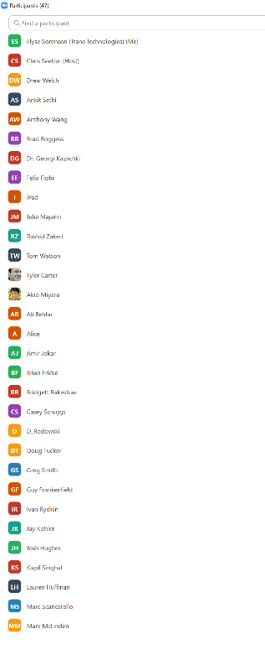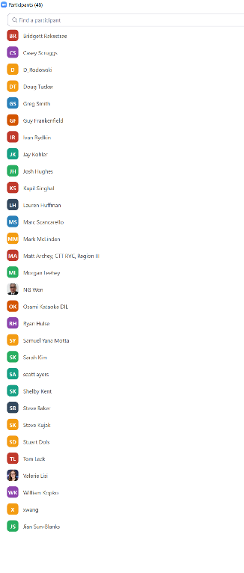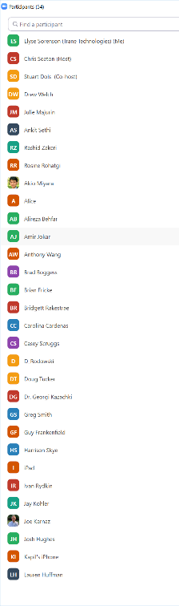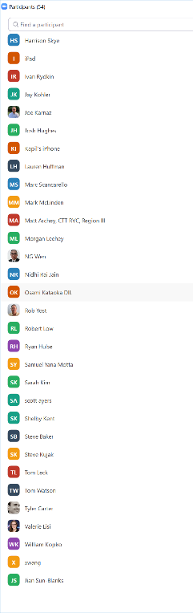

Chat sign in captured @ meeting completion:
Rashid Zakeri - Circle Prosco, Inc
Rosine Rohatgi (rohatgi@mindspring.com)
Casey Scruggs c.scruggs@metalloidcorp.com
carolina Cardenas ccardenas@shrieve.com
Kelsey Carter Kelsey.carter@lubrizol.com
Valerie Lisi - val.lisi@carrier.com
Morgan Leehey; Morgan.Herried@tranetechnologies.com
Ian Burton - ian.burton@lubrizol.com
skent@shrieve.com Shelby Kent
Jian Sun-Blanks (jian.sun-blanks@chemours.com)
Scott Ayers - US CPSC - scottayers@hotamil.com / sayers@cpsc.gov
Joe Nigro Jnigro@shrieve.com

