Monday, January 31, 2022 2:41 PM – 4:30PM PST
TC 9.08 Specialized Building Applications
Minutes
(DRAFT, 2/10/2021)

Meeting Date & Time: Monday, January 31, 2022, 2:41 PM – 4:30PM PST Hybrid Virtual/In Person Meeting
(Establish Quorum: # of voting members present exceeds ½ of the # of total voting members of the committee (10 VM))
6 voting members and 1 non-quorum
- Call to Order
  - Introduction of Members and Guests
  - Quorum established: 7 voting members plus 1 non-quorum member are present
  - Chair’s remarks and update (Richard Vehlow)
    - Channing Everett passed away suddenly on October 4, 2021 from a heart attack while mountain biking. The chair and committee had a moment of silence in his memory and he will be fondly remembered for his work on the committee.
    - Agenda was voted and unanimously approved. – Anthony York motioned and Scott Peach Seconded
    - Anthony York track chair for Airport Terminal Design presented by Kris Baker and Kasteny Knutson. Seminar had many good questions at the end and good participation at around 50 people.
- Previous Meeting Minutes
  - June 2021 meeting was voted and unanimously approved.
- Review of Handbook Chapter Update June 2022 – Frank Mills
  - Chapters that are not complete will be printed incomplete and will be updated in 2027.
  - What has been created must be submitted in June.
    - The ASHRAE Epidemic Task Force Covid Graphic can be referenced but does not need to be included in any chapter.
  - Epidemic Task Force will be sunsetting and current content needs to be transferred to a committee.
    - Contact - Luke Lung
    - Potentially TC 9.8 could take over this task force.
    - Request Luke Lung to give a presentation on the topic and what this would entail prior to a decision.
    - Would be beneficial for some of the existing Task Force members to be added to this TC for continuity.
  - Chapters are currently being worked on thru BASECAMP - See attached summary in appendix.
    - Timeline
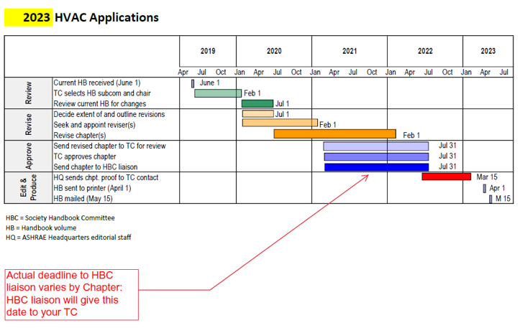
  - Handbook training is available.
    - Request that a later meeting be set up for review of how to use BASECAMP.
  - A standing monthly meeting for March, April and May to be set up by Richard Vehlow and Frank Mills.
  - Chapter 6 – Natatoriums – Ralph Kittler
    - Currently being developed.
    - Mark Scott may have something to add regarding building pressurization.
  - Chapter 7 – Hospitality - Heather Schopplein
    - Chapter will be reviewed and COVID items will be added.
  - Chapter 10 – Justice Facilities - Doug Fitts
  - Chapter 23 – Bogie Setty
    - Chapter under development but is not currently on the call.
  - New Chapter – Fire Stations – Doug Fitts
    - Include Scott Peach on distribution for review and comment.
  - Proposed New Chapter – Aviation Design – Currently working to get the outline approved.
    - Outline was too broad. Needs to be more specific content.
    - Looking to incorporate for print in 2027.
  - New Chapter - Atriums – Frank Mills
    - Doug Fitts to assist in review.
    - Will have draft in April.
  - New Chapter - Indoor Growth Facilities – Channing was working on this chapter.
    - Craig was working with Channing on the chapter.
    - Scott Peach will reach out to Craig to find the chapter work that had been done.
    - Also reach out to Nadia
  - Additional chapters we may consider adding in and covering.
    - Decarbonization
    - Covid
    - Operational Excellence
  - Special thank you to Frank Mills for heading up the effort of the Handbook revisions and updates.
  - Reminder: Use BASECAMP for posting and accessing information.
  - Interim virtual meetings – Will include programs agenda item as we continue to go thru the handbook chapter meetings.
  - ASHRAE would like to have 1week advanced notice to put the subcommittee meetings on the calendar and they will distribute the teams link.
- Subcommittee Reports
  - Programs (Jim Liston)
    - 8 Tracks For winter meeting
      - Tracks included: 44 Seminars, 22 conferences, 3 panel discussions, 4 forums, 3 workshops, 4 AHR Expo Sessions and 3 on-demand sessions.
    - 2023 Annual Meeting in Toronto: 8 Tracks
      - Fundamentals and applications
      - HVAC&R Systems and Equipment
      - Research Summit
      - Connected Buildings, Connected Communities
      - Cold Climate Building System Design, Operation and Resilience
      - IAQ, Energy Use, Comfort and Health of Sustainable Buildings
      - Professional Development and Education
      - Buildings in the Aftermath of COVID-19
    - Critical Dates
      - Thursday, February 17, 2022: Extended Abstract Paper Due
      - Friday, February 18, 2022: Conference and Technical Paper Final Accept/Reject Notifications
      - Tuesday, February 22, 2022: Program (Seminar, Forum, Workshop, Debate and Panel) Proposals Due
      - Friday, March 18, 2022: Extended Abstracts Accept/Reject Notifications
      - Friday, April 01, 2022: Debate, Panel, Seminar, Forum, Workshop Accept/Reject Notifications
    - TC 9.8 – new program for Toronto Meeting.
      - Abstract will be distributed for review and comment by Anthony York for new Seminar.
      - If there are other committee members that would like to participate in programs please let the committee chairs know.
    - Atlanta Draft Tracks and Timelines were reviewed.
      - Recommended to have Programs 1-2 months prior to committee meeting.
      - Hybrid meetings will continue for Toronto.
  - Congratulations on award of the Presidential Certificate of Honor to Brad Cochran.
  - 3 New Functioning committees:
      - MTG.RES – Building resilience
      - Task force on Building Decarbonization
      - TGREST – Reactive air and surface treatment – This was born out of the findings of the ETF.
          - Asktac@ashrae.net is one way to find information or SH9@ashrae.net and email will go straight to Brad Cochran.
  - Roster Chair (Kerion Nanan) – not currently present.
    - Roster Update was sent out, updates to rosters are Due Feb 15th.
    - Note: When submitting Roster, only hit save and let Brad Cochran review for final. Do not hit submit for final. The saved document must be reviewed prior.
  - Research (Andy Manos)
    - Will be submitted during the summer meeting 9.12 will sponsor and co 9.8, 4.8, 9.3 Shafts of Tall buildings.
    - Note preferred to have 2 meetings
    - Andy will provide a written updated
    - Members are encouraged to submit ideas for future research.
  - YEA (Frank Paradiso) – Increase social media activity.
  - Standards (Richard Hermans) - not present at meeting
  - ASHRAE Strategy (Bob Cox) - not present at meeting
  - Webmaster (Heather Anderson) - not present at meeting
  - International Liaisons (Keiron Nanan,) - not present at meeting
  - Justice facility subcommittee (Doug Fitts) - nothing significant to update.
  - TC 9.7 (Mark Long) - Drafting work to support schools on design guide for covid. Scope of 9.7 and update will include heating which was missing and the scope.
  - SPC 90.1 (Richard Vehlow) -Will follow up with Chonghui Liu for update.
  - Standard 180 – Practice for Inspection and Maintenance of Commercial Building HVAC Systems - no one present.
  - TC 5.6 – (Bill Webb) - nothing significant to update.
  - TC 8.10 Mechanical Dehumidifiers and Heat Pipes (Ralph Kittler) - DOAS standard manual will be coming out.
  - TC9.12 Tall Buildings (William Webb)- Reported efforts in infiltration and exfiltration from building façade and elevator shafts.
  - Meeting items with no report:
      - TC4.4 moisture transport through roof shingle systems.
      - SSPC 55 Thermal Environmental Conditions for Human Occupancy
      - SSPC 62.1 Ventilation and Acceptable IAQ in Commercial, Institutional and High-Rise Residential Buildings
      - SPC 100 Energy Efficiency in Existing Buildings
      - Standard 189.1
      - Residential Building Committee
      - If there is no active liaisons to above then we could drop them.
- Roll in of 9.1 Large Building Systems
    - TC 9.8 be interested in co-presenting on programs but roll in of the committees would not be applicable due to name change.
    - Discussed topics to be presented and co-sponsored in future conferences at upcoming Summer 2022 in Toronto
- Approved Name as Specialized Building Applications – Congratulations TC 9.8!
- Sunsetting of the Epidemic Task Force (Scott Peach)
  - ETF is looking for cognoscente committee to maintain that document.
    - ETF would like to give a presentation of what that may entail.
    - Guideline would need to be updated regularly; this may be too much to maintain.
    - Could ETF team join TC9.8 so that we had membership that has knowledge of this scope?
    - TC 2.10 may be a better fit which has members currently on that committee.
    - Luke Leung is main contact.
    - Review this topic as June Agenda Item.
- Design Guides
  - None.
- Unfinished Business
  - No additional unfinished business to follow up
- New Business
  - None.
- Adjournment
  - 4: 28 pm

