Minutes
TC 7.6 Monitoring and Energy Performance Subcommittee
Atlanta, GA — Monday, June 29, 2015
Dennis R. Landsberg, Chair

The meeting was attended by 3 members of the TC, 4 corresponding members and 19 guests.

- Introductions and Introductory Comments
- Update On Standards and Guidelines Related to Energy Performance
  - ASHRAE Standard 100 –in continuous maintenance.
    - Major modifications proposed deal with CHP and district heating and cooling
  - Standard 211 Commercial Building Energy Audits - Anticipate advisory draft by September
  - Standard 90.4P Energy Standard for Data Centers and Telecommunications Buildings.
  - Standard 214P – Methods for Measuring and Expressing Building Energy Performance in a Rating Program
  - GPC 14 – RTAR to test “Uncertainty” being developed by Joshua New and Jeff Haberl
  - GPC 34 Energy Efficiency in Historic Buildings out for Public Review

- Building Rating Disclosure and Benchmarking

http://www.imt.org/uploads/resources/files/IMT_USbenchmarking_060515HIGHRES.jpg
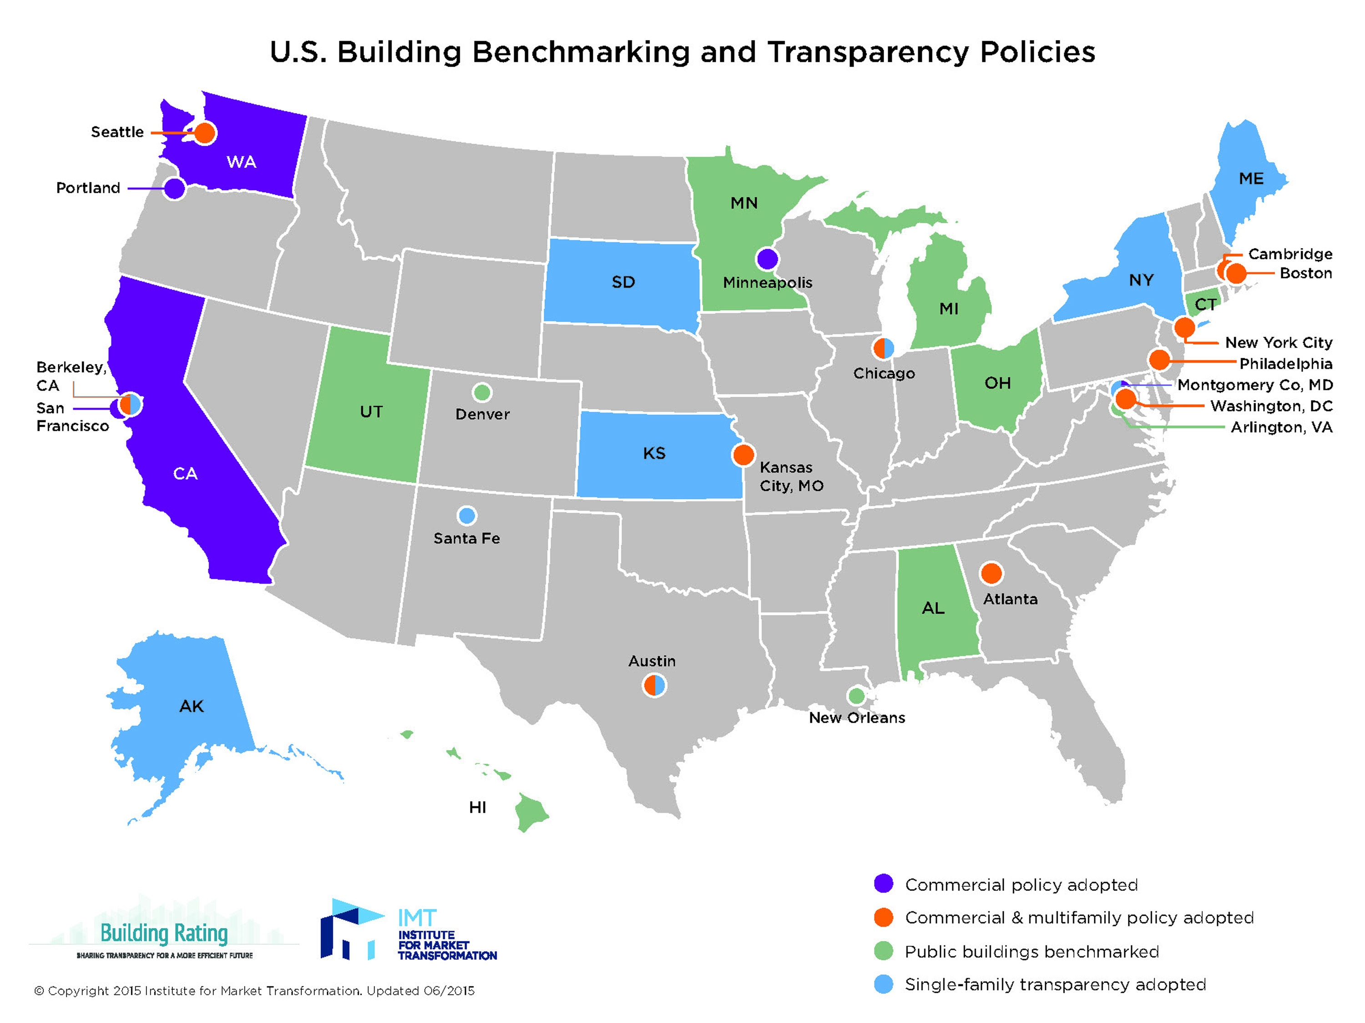

  - Should there be standard reporting linkages from local up to state-level up to country-level, up to world region level, and finally to world level? How should worldwide buildings energy performance be reported? Is this something ASHRAE should get involved in?
  - EERE Office of Efficiency and Renewable Energy – 2 Reports on NYC Benchmarking & Disclosure Ordinance
  - NYC doing virtual audits of buildings < 50,000 sf. Two evaluations of virtual audits to date – PG&E and SMUD
  - bEQ – 33 buildings to date – Orlando to add 35

- US Initiatives
  - The New York State Public Service Commission Reforming the Energy Vision (REV) – plans from NYSERDA and the IOUs due end of June 2015, with program implementation in the 2016-2018 period. Focus to include demand reduction and emissions. IOUs will be able to offer programs specific to load pockets. It is envisioned that a Distributed System Platform Provider (utility?) integrate Distributed Energy Resources (DER) as the primary means of meeting system needs. Where DER consists of Energy Efficiency, Demand Response and Distributed Generation.
http://www3.dps.ny.gov/W/PSCWeb.nsf/All/26BE8A93967E604785257CC40066B91A?OpenDocument
NYSERDA focus shifting from incentives to market transformation. Present emphasis on solar programs and New York Prize – community microgrids. About 85 Phase I awards of about 100k issued for feasibility studies. Phase II will be $1 million awards for design and Phase III will be $5-7 million for implementation.
  - Customer funded utility EE programs are functioning primarily at less than 2% of sales, with MA and VT above 2% before this year, but MA at least has to cut back a little in their latest plan
http://ma-eeac.org/wordpress/wp-content/uploads/2016-2018-DRAFT-Electric-Gas-Energy-Efficiency-Plan.pdf
  - According to LBNL, only MA, VT, MN, and WA are above 1.5%, but others are approaching that level http://emp.lbl.gov/sites/all/files/TR%20CSE_NARUC_111714_Final%20Release.pdf

- World Energy Initiatives
  - IEA Benchmarking of Building Metrics for 20 Largest Economies 2000-2012 – out July or August
  - UK F or G energy rating can’t rent after 2018
  - Mega Cities CO-Op on Climate Action – Large City Data Preliminary Report
  - Australia-Commercial Building Disclosure Initiative(energy use posted on rent sign)
  - European Union energy efficiency Directive - The Directorate General develops and implements innovative policies aimed at:
    - contributing to setting up an energy market providing citizens and business with affordable energy, competitive prices and technologically advanced energy services
    - promoting sustainable energy production, transport and consumption in line with the EU 2020 targets and with a view to the 2050 decarbonisation objective
    - enhancing the conditions for safe and secure energy supply in a spirit of solidarity between EU countries ensuring a high degree of protection for European citizens
– http://ec.europa.eu/energy/en
  - European Union 2020 Targets
    - The Directorate General develops and implements innovative policies aimed at:
    - contributing to setting up an energy market providing citizens and business with affordable energy, competitive prices and technologically advanced energy services
    - promoting sustainable energy production, transport and consumption in line with the EU 2020 targets and with a view to the 2050 decarbonisation objective
    - enhancing the conditions for safe and secure energy supply in a spirit of solidarity between EU countries ensuring a high degree of protection for European citizens
  - Netherlands – The Netherlands had a goal to reduce greenhouse gas emissions by 18% by 2020 as compared to a 1990 baseline. Citizens sued the government and the court ruled in their favor. The new goal is 25%.
- Energy Monitoring and Energy Audits
  - Lawrence Berkeley National Laboratory, QuEST, and the DOE’s Building Technologies Office are developing testing procedures that can be applied by energy efficiency project and program administrators to assess the performance of automated M&V methods. Procedure complete and testing almost finished.
- Energy Performance Databases
  - DASH – Bruce Hunn
  - BEDES has been implemented http://energy.gov/eere/buildings/building-energy-data-exchange-specification-bedes New version 2 months ago and another update in September.
  - SEED – Standard Energy Efficiency Database – web application
- EUI Task Group
  - Has become Working Group 5 under SSPC 100 – meeting Sunday 12PM-2:00PM
  - Two charges – stacked approaches for multi-use buildings and alternate expressions of EUI
  - Issue - Should we change the TPS of Standard 100 from energy efficiency to energy performance? Is Energy/sf the best metric? Should Standard 90.1 move toward a performance based approach? Current standard is very complex.
  - Should EUI be scrapped?
  - Developing RTAR for stacked EUIs for a number of building types and to test method.

ASHRAE Sessions of Interest
Sunday, 8:00 AM-9:00 AM Conference Paper Session 1
Advanced Energy Design Guides and Beyond
Sunday, 9:45 AM-10:45 PM Seminar 4
Energy Performance of Active Chilled Beam Installations
Sunday, 11:00 AM-12:30 PM Conference Paper Session 3
Energy Analysis in Buildings
Sunday, 11:00 AM-12:30 PM Seminar 6
BAS Data Analysis in Campuses
Sunday, 1:30 PM-3:00 PM Seminar 14
Real-Time Fault Detection and Diagnosis for Enhanced
Building Operations
Monday, 11:00 AM-12:00 PM Conference Paper Session 9
Fault Diagnosis and Commissioning Existing Buildings
Monday, 11:00 AM-12:00 PM Seminar 31
Big Data Analytics for Building Energy Management
Monday, 4:00 PM-5:30 PM Workshop 5
Energy Rating and Managing Your Commercial Building
Using ASHRAE Building Energy Quotient (bEQ)
Tuesday, 8:00 AM-9:30 AM Seminar 39
10 Years of Advanced Energy Design Guides from Practitioners’ Perspectives
Tuesday, 9:45 AM-10:45 AM Seminar 41
Energy Efficiency Monitoring and Assessment
in Industrial Facilities
Wednesday, 9:45 AM-10:45 PM Seminar 58
Energy Targets for Commercial Buildings, An Update on
1651-RP
Wednesday, 11:00 AM-12:30 PM Conference Paper 20
Important Factors for a High Performance Building

