Votes: Font is Bold, Black
Task Groups: Font is Bold, Blue
Action Items: Font is Bold, Red
Minutes: Font is Italic, Green, 52.2 Secretary: Jenny Berens
Additional comments in Italic, Orange

©2021 ASHRAE. All rights reserved. This is a draft document for review only by the cognizant ASHRAE groups and other designated reviewers and is not intended for distribution to any private interests, individuals, or third parties that are not designated as ASHRAE reviewers for this document. This document may not be distributed in whole or in part in either paper or in digital form without the express permission of the chair of the committee originating this document.
The appearance of any technical data or editorial material in this draft document does not constitute endorsement, warranty, or guaranty by ASHRAE of any product, service, process, procedure, design, or the like, and ASHRAE expressly disclaims same.

- Call to Order – 5 min
Meeting start was delayed due to WebEx issues. Chair had login problems that were never resolved. Members and public not present in person could regretfully not participate in the meeting.
- Chair Remarks – 10 min
  - Code of Ethics - “As members of ASHRAE or participants in ASHRAE activities, we pledge to act with honesty, fairness, courtesy, competence, integrity and respect for others in our conduct. We will avoid conflicts of interest, and behavior that is discriminatory and/or harassing.” For more, read here: https://www.ashrae.org/about/governance/code-of-ethics
  - MERV 17-20
Chair asks all participants to help educate the public regarding MERV ratings, specifically the fact that MERV 17-20 ratings do not exist. Please help find all the MERV 17-20 ratings circulating out in the public and reach out to sources to request correction.
- Roll call for voting committee members - 5 min
16/20 voting committee members present during roll call.
Tim Ahn shows up at 10: 27 AM. Christine Sun leaves meeting before final vote and adjournment.
- Review of this agenda – 1 min
- Review of “Draft” June Toronto 2022 Minutes and December 2022 Minutes – 5 min
  - http://sspc522.ashraepcs.org/ to find minutes, agendas
Motion to approve minutes: Marisa. Second: Bobby.
(Y-N-Abst-Absent-Tot) (14-0-2-3-19) CNV
- Membership – 10 min
4 rolling off before Summer meeting.
- Michael Corbat
- Chrystal Jolliffe
- Roberta MacGillivray (NAFA) – NAFA Spot will roll back on
- Tim Ahn

Need more Media Manufacturers:
Membership Distribution
General | 7
Media mfg | 2
Filter mfg | 9
User | 2

- Website – Todd McGrath – 3 min
- Liaison Report – Jerry Kettler gjkettler@air-engineer.com – 5 m
Jerry not present in room
- 62.2 & 62.1 Liaison report – Vijay / Wane Baker – 5 min
Liaisons not present in room
- PoF Presentation 10:00 am – 10 m
Kathleen awarded Pharaohs of Filtration award by Chair

- Open Action Items – 81 min
  - Charge Durability Index (CDI) WG: Jim, Vijay – 24 m
    - Group 1 - Chrystal, Jeni W, Mike, Jonathan, Keith, Rahul, Vijay, Tim, Bob, and Jim (blind-test) – look at collecting
    - Group 2 - Roberta & NAFA – look at application to filter
Jim Rosenthal: Purpose is to improve understanding of filtration media by adapting NIOSH test method for electret media. Proposal is to add CDI as an Informative Index, not necessarily in the standard.
Chair: Does CDI belong in 52.2? ASHRAE Feedback/guidance: “52.2 is the best committee to decide whether CDI belongs or not.
Gemma Kerr. CDI currently in standard. Need to make decision whether to let stay in or take back out.
Kathleen Owen: We can always add back in as an Informative Index.
Michael Corbat: Do we need a separate PBR before we republish? Suggests that we send up tp 2.4 standards.
- General response here is that 52.2 is the better place for CDI -
Chrystal Jolliffe: The Flat Sheet Media Testing chapter in the Handbook might be a good location after some slight changes.
Bob Burkhead: Not publish in standard if published in 52.2. How compare flat sheet media before and after? What is the math behind the CDR?
Jim Rosenthal: Can’t answer that.
Mark Tucker: Area seems too small for filter application. How can we upscale the test method?
Jim Rosenthal: How do we move CDI forward?
Chair: How do we roll out a standard (US or international) which generates an apples-to-apples comparison and is applicable? How do we apply the standard to filters?
Jim Rosenthal: We know that some electret media works better than others and Tim’s (Johnson) test data verified this. The feedback was that the test is good.
Bob Burkhead: We will vote on App J later in the meeting. If App J is approved, does the CDI still stand?
Chair: Good point.
Jenny Berens: Can we refer to the Handbook in the standard?
Bob Burkhead: Recommends not, since handbook is changing.
Chair: Recommends 2.4.
Don Thornburg: CDI does not fit scope of 52.2. ISO 16890 is working on flat-sheet media testing in pt. 5, but not published yet.
Jim Rosenthal: Distribution is calculated incorrectly in 16890.
Don Thornburg: Pt. 5 is a stand-alone.
Kathleen Owen: We seem to have the current options; add CDI to 52.2, 2.4 to new SSPC, nothing, or ISO.
Chair: Correct.
Jim Rosenthal: Proposes motion to turn over CDI to 2.4 Standards. Michael Corbat: Second.

Vote:
(Y-N-Abst-Absent-Tot) (15-0-2-3-20) CNV
Chair: CDI is to be pulled out of 52.2
Gemma Kerr: Yes, easiest option. No motion will be needed.

  - Revisions to Normative Appendices - 38
    - WG - Gemma, Don T, Zied D, Brian K, Vijay, Jon R, Mike C
    - Revisions sent out to VM and discussions to make final
Discussion:
Chair: Thanks to both WG for all their work. Any comments?
Jenny Berens: Why ‘glass & paper filaments’ in examples of filter media in definition section?
Gemma Kerr/Chair: State a proposal for change/Submit comment during PPR.
Gemma Kerr: Propose motion to approve draft which was circulated to VM after removing CDI.
Brian Craig: Second

Vote:
(Y-N-Abst-Absent-Tot) (15-0-2-3-20) CNV
Jenny Berens: Recommend 45 day PPR

  - YouTube videos. 1) Explain MERV table, 2) MERV 17-20 don’t exist WG: Zied D, Marisa J-S, - 7m
    - ASHRAE is looking to find the proper location for this
Chair: Still waiting for ASHRAE to come back with proper location for video
Video will be sent out by Chair to VM for review and feedback
Zied Driss: Version with and without background music exists – music could be cause issues from YouTube’s side
Chair: ASHRAE feedback is that video could contains too much information
Zied Driss: Do not agree. The video explains the MERV table, nothing else.

  - 5 Year ANSI Reprint Discussion – 22m
Gemma Kerr: 2 addenda to be included. Approved for PPR – Bio Aerosols (informative)
Chair: Asking previous Chairs for help. General suggestion is to read standard backwards.

- New Business – 41 min
  - Continuous Maintenance Proposal (CMP) – 31m
    - Mr. H. Cheng proposal is “Revise the standard to make the filter conditioning procedure described in Appendix J be a mandatory step in the MERV rating and eliminate the MERV-A rating”
H. Cheng: Proposal: Customers are looking for direction. Is a MERV 13 always a MERV 13 – no, no always. Filter reps do not know what the difference is between MERV & MERV-A. This is a concern. Better indication of performance of filter over life is needed. Extended life is a concern.
Scott Parris (to H. Cheng): What exactly are you looking for? Answer: Mandatory App J.
Jenny Berens (to H. Cheng): Are you familiar with ISO 16890. Answer: No. End user does not know either.
Zied Driss: Most sensitive topic; App J is elective and does exist.
H. Cheng: Clients cannot get MERV-A rated filters. Seems that this is not a practical option. MERV-A rated filters do not exist on the market.
Chair: This would be a substantial vote.
Paolo Tronville: HVAC designers do not care? Why not challenge designers to learn when carrying out their calculations so that they can choose a different filter capacity? Standard deviations exist; it is physics. There will never be a 100% guarantee, but the ratings are tool for designers to use.
Jenny Berens: Proposal states that economy will not be impacted, but this is not true. HVAC designers and architects may not be impacted, but media suppliers & filter suppliers will be directly impacted. In addition, electret media is specifically designed to keep the energy consumption low in the system. With the projected increase of HVAC use in certain countries (Brazil India, etc), this proposal will have a dramatic, negative, effect on future energy consumption.
Bob Burkhead: Appreciates that Mr. Cheng is asking for help. What do you really need?
Don Thornburg: App J is a conditioning method and cannot necessarily get the filter down to a fully discharged state. ISO 16890 utilizes a true discharge method. The purpose is to provide a standard, not a simulation of reality. Comparable to the fact that a car rated as 40 mph only truly performs at 40 mph under very specific test conditions.
Jenny Berens: Is there a need for further education?
Don Thornburg (?): Is there an acceptable way to get it close enough? Redo the standard? End-users are complaining. They do want the information on how filters actually perform. If we need to drop App J in, let’s do it ever if it is not the right thing, we are at least doing something.
Bobby Singer: From a testing POV, App J on every single filter would be a disaster. Only 2 Labs out of 8-10 labs provided App J testing. Many labs did not actually follow the test procedure either.
Jim Rosenthal: Only a small % of end-users are asking for the standard to be adopted in order to fit a very small section of applications.
Charlie Seyffer: 62.1 and 170 are dictating how the 52.2 standard is used. We will have the same conversation in Tampa and we have discussed it for 10 years. The end-users want the proper thing – what you do in 52.2 affects the other standards.
Jeff Siegel: A better standard won’t resolve the problem. The problem is the interpretation. Other factors impact the filter performance as well; face velocity, bypass, etc.
Roberta MacGillivray: NAFA has documents showing how to interpret the standards and how to correctly apply the filter in the system. The 52.2 standard is easy to interpret, but App J is difficult to interpret and difficult to carry out. Adding App J to keep moving is not the right approach. Education, NAFA certification, overall application are recommended paths.
Tom Justice: Should we look at publishing a User’s Guide? This was discussed years ago, the standard cannot lead us.
Zied Driss: The standard might not have been designed to the correct applications. Standards are designed to take into account specific aspects.
Michael Corbat: The standard was written 24 years ago. We have people on the committee who do not know how to use the standard.
Matt Middlebrooks: 3 labs managed to carry out App J – one of the labs submitted their data late.
Chair and Committee: Start discussing how voting works (see picture below) + how long time we have, are there new studies out there, do we need a new WG for further study & to help educate?

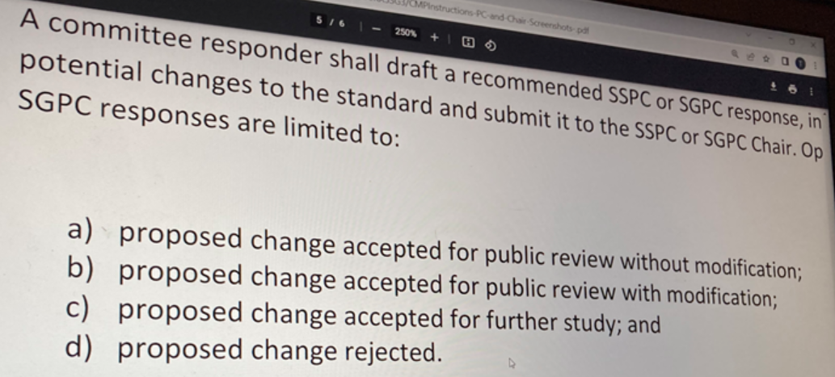

Michael Corbat: Motion to table the vote until Summer Meeting-23 in Tampa. During this period, form a Task Force chaired by Don Thornburg to evaluate other methods.
(This motion was not seconded and was subsequently withdrawn ~30 minutes later)
Gemma Kerr: Is there any reasonable test method out there? Can we get rid of App J or reduce cost & time?
Don Thornburg: Yes, we can take out the dust-loading steps. That will make the test cheaper.
Bob Burkhead: Agree.
Chair and Committee: Start discussing voting again. ASHRAE explains what option “c” means: “if ‘c’ is accepted, App Je will not go into the standard”.
This supposedly showed up to be incorrect, according to other ASHRAE staff; if option “c” had been voted through, App J would have gone into the 52.2 standard immediately. ASHRAE has promised to update the voting procedure in order to make it clear.
Gemma Kerr: Motion to adopt Option “c” for the CMP proposal OR accept/reject. Second: Sanjeev

Vote:
(Y-N-Abst-Absent-Tot) (5-8-2-5-20) CNV
Continuous Maintenance Proposal was disapproved.

Tom Justice: We have 12 months to respond to proposal or ~10 months to do nothing.
Don Thornburg: Do we table the response for now?
Paolo Tronville: 241 ASHRAE new committee. Would be nice to get feedback from the filtration committee.
Don Thornburg: Asks for cards from whomever would like to be involved in this WG.

A motion was proposed, “to generate a task force to work on clarifying H. Cheng’s needs and to help educate him and the community on how to get there”. A working group was voting to be formed.

*** The motion for the WG with Don was found out after the meeting as coming from someone who is not a voting member. The motion was removed.

  - ASHRAE Position Document on Filtration and Air-Cleaners
Bob Burkhead: Asks about ASHRAE position document. Jeff Siegel and Paolo Tronville are both involved.
Jeff Siegel: There was a meeting last year. The position document already exists, but it is getting revised. The document is a position document on filtration and air-cleaning. Other people involved are Marwa, Kathleen, Paula. The work started back in 2014-2015 and there is a meeting at 5 PM in Beechnut.

- Adjourn 52.2 Main meeting
Motion to adjourn: Bobby Singer
Second: Chrystal Jolliffe

Committee Attendance:
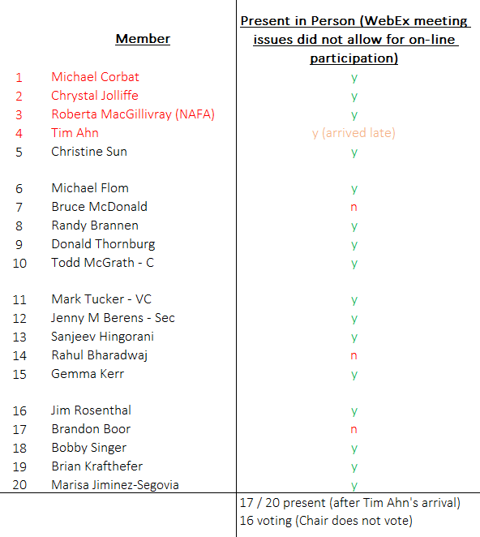
Public Attendance (73 total):

