TC 1.13 Optimization
Agenda for ASHRAE 2024 Summer Conference
Sunday, June 23, 2024
Indianapolis, IN, and hybrid-remote
https://events.rdmobile.com/Sessions/Details/2303237

TC 1.13 meetings this meeting:

Main Committee Meeting (hybrid)
Sunday, June 23rd, 2024, 1:00 – 3:00 PM EDT
Room: JW Marriott, 300 (3)
MS Teams

1.13 program activities this meeting:

Sponsoring (TC 1.13):
Seminar 43: Wednesday, June 26th ,8:00 – 9:30 AM EDT
Location: JW Marriott – Indianapolis, Grand Ballroom 4
“Seminar 42: Component and System Optimization for Lower-GWP Refrigerants”
Track: HVAC&R Systems and Equipment
Chair: Vikrant Aute, PhD
Speakers: Zhenning Li, PhD, Michael Petersen, and Henna Tangri, PhD
Co-Sponsors: MTG.LowGWP Lower Global Warming Potential Alternative Refrigerants

Sponsoring (TC 1.13):
Seminar 8: Sunday, June 23rd,11:00 AM – 12:30 PM EDT
Location: JW Marriott – Indianapolis, Grand Ballroom 2
“Seminar 8: Accelerating Thermal System Simulation with AI”
Track: Artificial Intelligence and the Built Environment
Chair: Rohit Dhumane, PhD
Speakers: Zheng O'Neill, PhD, Ransisi Huang, PhD, and Henna Tangri, PhD
Co-Sponsors: MTG.LowGWP Lower Global Warming Potential Alternative Refrigerants

Co-sponsoring:
(none for this Indianapolis meeting)

Agenda:

1. Call to Order and welcome all members and visitors Farhad Omar
Meeting was called to order 1:10 pm (EST)

2. Roll Call / Introductions / Record Attendance Farhad Omar

Record attendance

Voting members for THIS meeting (Indianapolis)
Present | Voting member | Voting member through | Proposed interest category
 | Farhad Omar
 | Rohit Dhumane
 | Zheng O’Neill
 | Zhenning Li

4 of 6 voting members presented. Quorum established at 1:39. Motion to pass previous meeting minutes proposed by Rohit. Approved by all. Meeting minutes approved.

3. ASHRAE Code of Ethics Commitment Farhad Omar
In this and all other ASHRAE meetings, we will act with honesty, fairness, courtesy, competence, integrity and respect for others, and we shall avoid all real or perceived conflicts of interests. (See full Code of Ethics: https://www.ashrae.org/about-ashrae/ashrae-code-of-ethics.)

3. Introduction of ASHRAE Liaisons on Arrival Farhad Omar

Our new Section Head is Jason Atkisson; welcome, Jason.
ASHRAE AI guideline described by Jason. Gen AI for multi disciplinary task force group. New year begin July 01. Deadline to approve roster midnight 30 June. Sh01@ashrae.net will get email directly to Jason. Activity form due Tuesday midnight. Farhad signing off, who will replace chair position?

4. Establishment of Quorum Farhad Omar

Roster: Voting members for THIS meeting (Chicago)
Present | Name | Voting Status | VM end Date | Committee Position | Proposed Interest Category
 | Farhad Omar | Voting | 6/30/2025 | Ch/membership Subc Ch | Government & Research
 | Sherif S. A. | Voting | 6/30/2025 | Member | Academic
 | Zheng O'Neill | Voting | 6/30/2026 | Program Subc Ch | Academic
 | Omar Abdelaziz | Voting | 6/30/2025 | Research Subc Ch | Academic
 | Rohit Dhumane | Voting | 6/30/2027 | Secretary | Industry
 | Zhenning Li | Voting | 6/30/2027 | Vice Ch/webmaster | Government & Research

The TC presently has 6 voting members.

Submitted the new roster updates on 03/25/2024 and is effective as of 01/15/2025 (I’m not certain about the effective date).

Recently, three more members requested to join the committee through TC’s website.

5. TC 1.13 Purpose Statement Farhad Omar
New Purposes Statement, approved by TAC and is updated on the TC website.
TC 1.13 is concerned with identifying, developing, and disseminating optimization techniques that enhance the performance of HVAC&R components, systems, and building systems that are not application or tool specific. The committee is focused on the fundamentals of optimization techniques including mathematical formulation, constraints handling, multi-objective optimization, approximation techniques, and robust optimization. These fundamentals are the foundation of data-driven, machine learning (ML), and artificial intelligence (AI) methods.

6. Approval of previous meeting minutes Zhenning Li
The Chicago meeting minutes are approved.

7. Chairman’s Overview and Report Farhad Omar

Farhad provided details of updates to RTAR process. Committee may teach course for ASHRAE by co-sponsoring with ALI. Vikrant provided information from his previous courses. Difficult to decide coursework to cater to audience.

Zhenning to become Chair. Vikrant is eligible to attend. Dave Yashar is another potential candidate. Elevate Vikrant for now and then check with Dave. Rohit to become vice chair/secretary. Check with Khalid. Maybe potential to merge with TC 1.5 if not able to fill in the roles.

8. Subcommittee Reports

a. Program Zheng O’Neill
Submission by Dave did not get through. Ivy did not submit.

Possible TC 1.13 Seminars for Orlando. The following seminars were proposed for the Indianapolis conference but were either not accepted, we couldn’t find enough speakers, or not submitted.

- (Indianapolis, 2024 Summer) “Optimization of refrigerant blends and its impact on HVAC&R component design” ), Chair: Vikrant. (Narrative molecules -> blends -> components. Start with molecular discovery, then blend optimization (with and without specific applications), designing components.) Got rejected, there were similar seminars. Overlap with other seminars.
  - NIST – new molecules, refrigerant blend – note Peter Domanski retired. Mark McLinden or someone could do this. (David to reach out to folks in Boulder)
  - Zhenning – Multi-objective optimization of low-GWP mixture composition and heat exchanger circuitry configuration for improved system performance and reduced refrigerant flammability.
  - (Rohit to identify) – optimization of system performance with recently introduced refrigerant blends.
  - Vikrant as backup, if needed: lit survey of all blend optimization studies that have been done so far
  - Co-sponsorship from MTG Low GWP (Vikrant to pursue co-sponsorship), 3.1 Refrigerants (David to pursue co-sponsorship)
- (Indianapolis, 2024 Summer) Khaled proposed: “Optimization methods for components, systems, and grid-interactive buildings.” Chair: David (Unfortunately, got rejected again because there were numerous programs addressing similar topics. Not sure if David Yashar is interested in resubmitting.)
  - Component-level
    - (speaker from Vikrant) optimization of shape and topology of components (HX)
    - Or (speaker from David Yashar) chiller tube bundle
  - HVAC system-level:
    - Duane, Chilled water system optimization
  - whole-Building-level
    - (Zheng, or speaker from Zheng, TC 7.5) Building-to-grid, or community level integration
- (Indianapolis, 2024 Summer) “Optimal Resources Allocation for Energy and Decarbonization”. Chair: Ivy (also will find a speaker for carbon optimization). Sherif S. A is a speaker. Rohit is another speaker.
  - Address the bigger picture. Heat transfer inventory. Bigger context with other presentation. Absorption refrigeration. System. 4 heat exchangers. $100 to produce efficient absorption refrigeration. TC 10.2. Chair of TC 1.5.
    - Reach out to Track Chair and ask about the seminar applicability:
      - Pathways to Building Decarbonization (Track Chair: Joe Chow)

2025 Orlando tracks:
https://www.ashrae.org/conferences/2025-winter-conference-orlando/2025-winter-conference-technical-program

Technical Program Chair: Som Shrestha (shresthass@ornal.gov)

      - Fundamentals and Applications (Track Chair: Erik Sanchez, esanchez@prmech.com)
      - HVAC&R Systems and Equipment (Track Chair: Li Song, lsong@ou.edu)
      - Refrigeration & Refrigerants (Track Chair: Jon Cohen, jonjcohen1@gmail.com)
      - Energy Storage and Grid Resiliency (Track Chair: Robin Bryant, RBryant@bandiflorida.com)
      - Pathways to Building Decarbonization (Track Chair: Joe Chow, joe.ashrae@gmail.com)
      - Artificial Intelligence (Track Chair: Suzanne LeViseur, sleviseur@haddadeng.com)
      - Industrialized Construction: Opportunities and Challenges (Track Chair: Stephanie Mages, s_mages@yahoo.com)
      - Ventilation and Indoor Environment Quality (Track Chair: Ehab Mamdouh, Joshua Vasudevan, joshuavasudevan2011@gmail.com)
      - Future-Proofing the Built Environment (Track Chair: Joshua Vasudevanm joshuavasudevan2011@gmail.com)

Friday, August 2, 2024: Debate, Panel, Seminar, Forum, Workshop, and Debate proposals for Orlando are due.

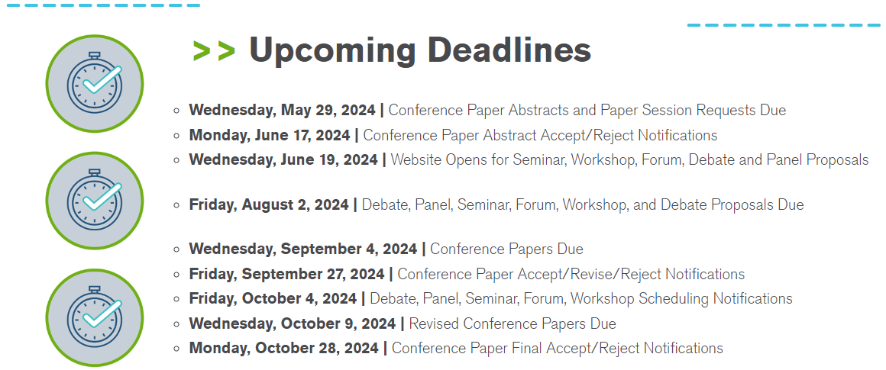

b. Research Omar Abdelaziz
Summary of notes that may serve as a useful starting point:
- To date we haven’t investigated RTARs in this TC.
- TC1.13 is in a great position to support research by other TCs.
- Optimization that is agnostic of application is outside ASHRAE scope.
- Other committees relevant to data-driven models, AI, ML, etc.,
    - TC 4.7 has subcommittee on data driven modeling, and
    - TC 4.10 has a subcommittee regarding machine learning.
Co-sponsorship with other TCs
Discussed RTAR with TC 4.7 data-driven modeling, but no active or proposed RTARs were identified for co-sponsorship. Potentially work with TC 1.4 and TC 7.5. RTAR 8.11 in unitary products. Tomorrow 8.11.

c. Handbook Khaled Saleh
Omar suggested that we create a new subcommittee meeting. I did not ask for 2 h subcommittee meeting this conference. Khaled was busy finishing up his MBA (Congrats!) and I wanted to check with him before doing anything. We could poll members to get the date/time. Outlines (by Vikrant) for the handbook was approved.

d. Standards David Yashar

e. Membership Farhad Omar
Promote in YEA, Ivy and Rohit. Any updates.

f. TC Website Zhenning Li Zhenning will follow up with Tara and Steve to get access to the website.

9. Old Business All

10. New Business All

11. Next subcommittee and committee meetings Farhad Omar

12. Adjourn All
Rohit motion to adjourn at 2:06. Seconded by Dr Zheng.

