Technical Committee Meeting Minutes
Technical Committee, TC 1.10 Combined Heat & Power Systems
Tuesday, June 27 2:30 PM – 4:00 PM

Location: Tampa Marriott Waterside, Florida Salon II (2)
Meeting Format: Hybrid

Chairs and Voting Members:

Position | Term | Name | Voting Status | Present
Chair | 06/30/2024 | Geoffrey Bares | VM | Yes
Vice Chair | 06/30/2024 | Michael Calabrese | VM | Yes
Secretary | 06/30/2025 | Praveen Cheekatamarla | Non-VM | Yes
Program Subcommittee Chair | 06/30/2024 | Gearoid Foley | VM | No
Handbook/Standards Subcommittee Chair | 06/30/2025 | Dragos Paraschiv | VM | Yes
Research Subcommittee Chair | 06/30/2025 | Farzin M Rad | VM | Yes
Member | 06/30/2027 | Zhiming Gao | VM | No
Member | 06/30/2026 | Vikas Patnaik | VM | No
Member | 06/30/2026 | William A Ryan | VM | Yes
Member | 06/30/2023 | Dharam Punwani | VM | Yes

Guest Attendees: Complete attendance list in Appendix A.

Position | Name | Present
TAC Section Head | Corey Metzger | Yes
Member | Mahabir Bhandari | Yes
DOE liaison | Richard Sweetser | Yes
TC 8.3, Programs Chair | Bill Ryan | Yes

- The Chair (Geoff Bares) Called to Order at 2:30 pm

- ASHRAE Code of Ethics Commitment – Announced by TC Chair (Geoff Bares)

In this an all other ASHRAE meetings, we will act with honesty, fairness, courtesy, competence, integrity and respect for others, and we shall avoid all real or perceived conflicts of interest. (see full code of ethics: https://www.ashrae.org/about-ashrae/ashrae-code-of-ethics.)

- ASHRAE Diversity Equity and Inclusion Commitment – Announced by TC Chair (Geoff Bares)

ASHRAE is committed to providing a welcoming environment. Our culture is one of inclusiveness, acknowledging the inherent value and dignity of everyone. We proactively pursue and celebrate diverse and inclusive communities understanding that doing so fuels better, more creative, and more thoughtful ideas, solutions and strategies for the Society and the communities our Society serves. We respect and welcome all people regardless of age, gender, ethnicity, physical appearance, thought styles, religion, nationality, socioeconomic status, belief systems, sexual orientation or education.

- Introductions – TC Chair (Geoff Bares) hosted the virtual meeting. Handbook/Standards Subcommittee Chair (Dragos Paraschiv) hosted the in-person meeting.
  - Name, organization, and positions on committee. Roll call.
  - Quorum has been established with 6 voting members present.
  - Introduction to ASHRAE Liaison, Corey Metzger (TAC Section Head, ASHRAE Board Member and Proxy for Jason)
    - Corey updated highlights from the Chairs breakfast meeting.
    - New committee, Global Technical Interactions Committee (GTIC) is now a standing committee working on international issues and standards
    - Standard 241 has been formally approved in coordination with Government and White House
    - A copy of all the recent updates will be uploaded in Basecamp
  - Review of current Voting Members, TC officers and Quorum
    - New Voting Member position is open – Interested members reach out to TC Chair

- The chair (Geoff Bares) discussed the Purpose Statement
  - Technical Committee (TC) 1.10 is concerned with combined heat and power (CHP) systems, their cycles and components including heat recovery, combustion turbine inlet cooling (CTIC), energy conversion and system integration. The systems provide both power (electric and/or mechanical) and thermal energy (heating and/or cooling) and are variously known as cogeneration systems; trigeneration systems; combined heat and power (CHP); and combined cooling, heating and power (CCHP) systems.
  - John Andrepont (Corresponding Member) suggested changes to the Purpose Statement. TC Chair (Geoff Bares) will modify the second sentence for grammar and send out for approval. The second sentence will be modified from:
“The systems provide both power electrical/mechanical and cooling/heating thermal energy and are also known as cogeneration systems…”
To:
“The systems provide both power electrical/mechanical power and cooling/heating thermal energy and are also known as cogeneration systems…”
Motion by Michael Calabrese-VM, second by Dragos Paraschiv-VM, all Yea, no Nay. Motion passed unanimously.

- Meeting Minutes from the 2023 (Atlanta) Winter Meeting
  - Copies of the draft minutes of the Atlanta meeting were distributed to the members via email.
  - A motion to approve the meeting minutes of the 2023 Winter Meeting.
  - Motion by Michael Calabrese-VM, second by Dharam Putwani-VM, all Yea, no Nay. Motion passed unanimously.

- Sub-Committee Reports:
  - Program: Richard Sweetser (Corresponding Member) on behalf of Gearoid Foley (Subcommittee Chair)
    - Program subcommittee meeting minutes (June 13th, 2023, virtual) to be distributed.
    - Seminar topics for Chicago conference discussed
      - Waste heat to power – 2 speakers identified. Gearoid and John Randtke in discussions.
      - Electrothermal technologies
      - Bottoming cycles
    - Decarbonization track sponsorship discussed.
      - Motion for TC Chair (Geoff Bares) to approve seminar
      - Motion by William Ryan-VM, second by Farzan Rad-VM, all Yea, no Nay. Motion passed unanimously.
    - Cosponsor ship of “Waste heat to useful energy” track with TC 8.3 proposed by William Ryan-VM
      - Motion by William Ryan-VM, second by Dharam Punwani-VM, all Yea, no Nay. Motion passed unanimously.
    - Cosponsor ship of “Heat driven heat pump systems” track with TC 8.3 proposed by Farzan Rad-VM, under track 2
      - Motion by William Ryan-VM, second by Dharam Punwani-VM, all Yea, no Nay. Motion passed unanimously.
  - Research and Publications: Farzin Rad (Subcommittee Chair)
    - Two topics for RTAR reviewed
      - Integration of micro-CHP with batteries
      - Site vs. source investigation
    - “Fuel cells for Building Applications guide” document revision
      - Discussed RTAR and PTAR options to revise or withdraw the document due to obsolete information
      - Dragos to share the document for thoughts
      - To be decided in Chicago meeting
    - New research idea proposed by John Randtke (Provisional Corresponding Member)
      - Hybrid 3-10 kW Stirling engine/ORC system integrated with solar thermal energy storage (300 C) for residential scale applications.
      - To investigate interface between the two subsystems
      - No decision made
    - Document access, review and control
      - TC Chair (Geoff Bares) to organize Basecamp for current members
  - Handbook: Dragos Paraschiv (Subcommittee Chair)
    - No changes to Chapter 7.
    - Chapter 8 revised significantly, based on CTIC design guide.
      - Plan to submit by July 14th
      - Document will be uploaded in Basecamp for committee review followed by email ballot
    - Dragos Paraschiv (VM, Subcommittee chair) moving from Handbook to Standards committee
    - TC Chair (Geoff Bares) to request volunteers for
      - Chapter 7 updates
      - Handbook subcommittee chair
  - TC Website: Weblink to Department of Energy CHP eCatalog has been added by TC Chair (Geoff Bares) to the TC 1.10 website

- Announcements
  - Distinguished Service Award to Mahabir Bhandari (Corresponding Member)
  - International District Energy Association (IDEA) events and conferences at https://www.districtenergy.org/home - suggested by John Andrepont (Corresponding Member)

- Old Business
  - TC Chair (Geoff Bares) to reach out to Blake Ellis (Corresponding Member) regarding Building Decarbonization Task Force workshop

- New Business
  - Richard Sweetser (Corresponding Member) mentioned a study conducted by US Army’s Construction Engineering Research Lab (CERL) regarding the analysis of different energy systems. CHP integrated with seasonal thermal energy storage and absorption cooling was identified as the winner
    - CERL is looking for feedback by this TC
    - TC Chair (Geoff Bares) to send a Dropbox link to the committee for report review

- Adjourn
  - Announcement by TC Chair (Geoff Bares) to close this session at 4:00 pm.
  - Motion by Dharam Punwani -VM, second by Dragos Paraschiv-VM, all Yea, no Nay. Motion passed.

Submitted by
Praveen Cheekatamarla, Ph.D.
Secretary, TC 1.10.

TC 1.10 COMBINED HEAT AND POWER SYSTEMS
2023 ASHRAE Summer Meeting (June 24-28, 2023); Tampa, FL

Subcommittee Meetings
Handbook, Program, Research, Membership Subcommittee
Tuesday, June 13, 2023: 1:30 PM-3:00 PM EST; Virtual
Click here to join the meeting
Meeting ID: 226 624 889 512
Passcode: SYAqP2

TC 1.10 Committee Meeting
Tuesday, June 27, 2023: 2:30 PM-4:00 PM EST; Tampa Marriott Waterside,
Room: Florida Salon II (2)

TC 1.10 Sponsored Seminars

AGENDA

1. Welcome Geoff Bares
2. Roll Call / Introductions Geoff Bares / All
3. Introduction of ASHRAE Liaisons on Arrival Geoff Bares
4. Establishment of Quorum Praveen Cheekatamarla
5. TC1.10 Purpose Statement Geoff Bares
6. Minutes of the 2022 Summer Meeting (Toronto) Geoff Bares
7. Subcommittee Reports
a. Program Gearoid Foley
b. Research Farzin Rad
c. Handbook Dragos Paraschiv
d. Standards Dragos Paraschiv
e. Membership Geoff Bares
f. TC Website Geoff Bares
g. Honors & Awards Geoff Bares
8. Chairman’s Overview and Report Geoff Bares
9. Old Business Geoff Bares
10. New Business All
11. Next Subcommittee and Committee Meetings Geoff Bares
12. Adjourn All

Attachment 1: Mission Statement:
“TC 1.10 is concerned with combined heat and power (CHP) systems, their cycles and components including heat recovery, combustion turbine inlet cooling (CTIC), energy conversion and system integration. The systems provide both power electrical/mechanical and cooling/heating thermal energy and are also known as cogeneration systems; trigeneration systems; and combined cooling heating and power systems.”

Appendix A: Attendees

In-person attendees:
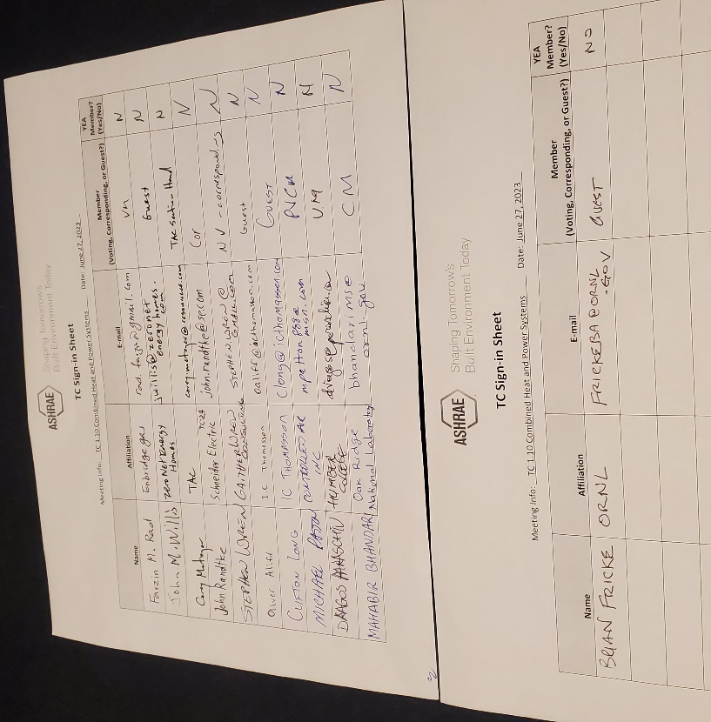

Virtual attendees:


