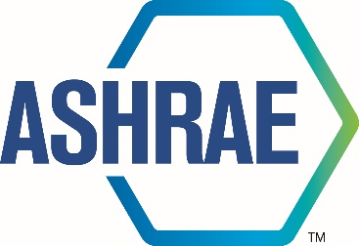

M I N U T E S

TECHNICAL COMMITTEE

2026 Winter Meeting

Feb 03, 2026



180 Technology Parkway NW, Peachtree Corners, GA 30092
404-636-8400

TC/TG/MTG/TRG MINUTES COVER SHEET

(Minutes of all Meetings are to be distributed to all persons listed below within 60 days following the meeting.)

TC/TG/MTG/TRG No. 8.4 DATE 02/03/2026

TC/TG/MTG/TRG TITLE Air-to-refrigerant heat transfer equipment

DATE OF MEETING Feb 03, 2026 LOCATION Las Vegas

MEMBERS PRESENT | YEAR APPTD | Attendance |  | YEA?
Christian Bach (Chair, VM) | 2024 | In-Person
Arindom Joardar (Vice Chair, VM) | 2024 | In-Person
Pedro Perez (Program & Standards Chair, VM starting 06/30/2025) | 2024 | In-Person
Kashif Nawaz (Handbook Chair, NV) | 2022 | No
Kishan Padakannaya (Research Chair, VM) | 2021 | In-Person
Pratik Deokar (Webmaster, VM, serving as acting secretary for this meeting) | 2022 | In-Person
Matthew Baker (VM) | 2022 | In-Person
Vikrant C Aute (MTG Liaison, VM) | 2022 | In-Person
Lokanath Mohanta (new Secretary) | 2024 | Virtual
Omar Abdelaziz (VM) | 2024 | In-Person
Jun Li (VM) | 2022 | Virtual
DISTRIBUTION: All Members of TC/TG/MTG/TRG plus the following:
TAC Section Head: |  |  | SH0804@ashrae.net
All Committee Liaisons as Shown On TC/TG/MTG/TRG Rosters (Research, Standards, ALI, etc.) |  |  | See ASHRAE email alias list for needed addresses.
Steve Hammerling,  Assistant Manager of Research & Technical Services |  |  | AMORTS@ashrae.net

- CALL TO ORDER

The Chair called the meeting to order at 3:45 local time. Voting member attendance listed on cover sheet and Quorum was established.

- Review of Scope

- SELF INTRODUCTIONS AND ATTENDENCE:

- The Chair requested everyone present in-person and online to introduce themselves with names and affiliations. Attendance sheet was available in the meeting room to sign for those physically present. (7 voting members present, 5 absent at the time of introduction and voting)

- APPROVAL OF 2025 Winter Orlando MEETING MINUTES:
Arindom motioned to approve the meeting minutes from 2025 Winter meeting in Orlando, Vikrant seconded. The meeting minutes were approved with 7-0-0 votes.
- APPROVAL OF 2025 Summer Phoenix MEETING MINUTES:
Pedro Perez made the motion for approval of meeting minutes from summer meeting in Phoenix, Min Che seconded. The meeting minutes were approved with 7-0-0 votes

- UPDATE FROM CHAIR’s BREAKFAST REPORT (Christian Bach)
Chair could not attend the detailed discussions of the chair’s breakfast. However, the topic was covered multiple times for most members in other meetings. Chair breakfast notes attached.

- RESEARCH BREAKFAST UPDATE

Carl Huber presented a brief update from research administrative committee, which was not clearly audible virtually. Attached is the detailed report presented by the committee.

- RESEARCH SUBCOMMITTEE REPORT (Kishan Padakannaya)

Kishan presented the summary of the research subcommittee report in the meeting. Following are the summary of the discussion presented during the committee meeting. Attached is the detailed research subcommittee report.
Current Research Activities
- Currently there is no active research project under TC 8.4 lead.
- RP-1785 Charge project – co-sponsored with TC 8.11.
  - Ray Rites (PMS Chair), Christian Bach (PI)
  - Complete and PMS approved, TC8.11 voted. To be published.
- Cosponsored RP-1683 Ammonia U-bend Project with TC 1.3
  - Ray Rite (PMS chair), Chad Bowers (PMS), Dr. Abbas (GIK Institute) is PI and Lorenzo Cremaschi is co-PI.
  - Project is complete and published in August 2025
Current RTARs in preparation are as follows:
- 2025-RTAR Investigation of the effect of Tube Material Thermal conductivity for Data Reduction of In-Tube Heat Transfer (Yirong/Kishan) was accepted with comments. Develop WS. TC 1.3 is co-sponsoring.
- RTAR Ready to submit: Pratik will prepare the RTAR for creation of unified database of refrigerant correlation and its access through GenAI chatbot (Pratik/Rohit). TC 1.3 and MTG GenAI are cosponsoring. Deadline to submit is March 15. Email ballot can be used for voting.

New Research:

Regarding the RTAR idea of validation of small diameter tube airside performances, Vikrant mentioned that co-sponsorship from external agency for market research on <=4mm diameter tube is available. This needs to be started soon otherwise there is a risk of losing funds. Kishan will set up another meeting by end of February to expedite the RTAR development. There is a need for write up from Omar for the RTAR on Advanced fin evaluation using CFD topology optimization.

New Ideas:
- Alfredo- Europe is looking into use of propane, CO2 or N2 (60-120 bar) for transportation refrigeration. Does this topic relate to ASHRAE? Is co-sponsorship possible by SAE or TC10.6? Needs to be discussed with TC 10.6.

- TAC SECTION HEAD REPORT (NA)

In the absence of section head (Kashif), Vikrant provided feedback on behalf of Kashif. Below are the TAC related comments as relayed:
- Activity forms were due on February 3rd, 2026.
- References for all Standards should be checked to ensure that they are current. Latest citations to be updated.
- The Title and scope of the TC should be re-affirmed by the committee once a year. Qualitative assessment of the TC health should be discussed with TAC.
- Conference and exposition committee (CEC) is looking for new tracks from TC’s. CEC are open to mini tracks (6-7 seminars on one topic). Research summit to be included at the winter conference and exploring to expand, short papers to be invited geared towards the industry.
- The TC roster update is due by March 6th, 2026. Vikrant will relay the feedback to TAC.

- HANDBOOK SUBCOMMITTEE REPORT (Kashif Nawaz)
No updates on Handbook committee

- PROGRAMS SUBCOMMITTEE REPORT (Pedro Perez)
Pedro presented the programs subcommittee report about sessions at ASHRAE 2026. There were 4 debates, 6 panel discussions, 36 paper sessions, 65 seminars and 4 workshops. With in the scope of TC8.4 Seminar titled Drycoolers for Data Center applications was scheduled for Feb 4th 11.00 AM to 12.30 PM (PST). There are 8 different tracks proposed for 2026 Annual conference in Austin. He also presented the important dates for Annual conference and further reported the upcoming locations and dates for future meetings.

- MEMBERSHIP REPORT (Ratnesh Tiwari-Absent)
The committee deliberated on the roster changes that are needed for the next cycle as the TC needs new chair, membership chair and four VMs who are rolling off on 06/30/2026.

Volunteers for VM were the following:
- Lokanath Mohanta (Carrier): Will conflict with Arindom’s appointment as Chair
- Scott Creamer (Rheem): Current status is ‘guest’ and may not be on the roster
- Pedro Perez (Danfoss)
- Patrick Birbarah (Daikin)
- James Tancabel (UMD)

Pratik Deokar (Rheem) volunteered for the Membership Subcommittee Chair position
Arindom Joardar (Carrier) volunteered for the Chair position
Christian Bach (OSU) volunteered for the Vice-Chair position

- STANDARDS SUBCOMMITTEE REPORT (Omar Abdelaziz)
The subcommittee was not present. No report

- MTG LIAISON REPORT (Vikrant Aute)
Vikrant provided an update to the Low GWP MTG which was established in 2012. Over the years the MTG has made significant contributions and the work is gradually winding down. The MTG has executed 8 to 9 research projects and currently one project – RP1806 related to post-ignition risk assessment is still in progress. The MTG is seeking from the TCs on following three fronts:
- Should the MTG continue?
- Any changes to the scope? (see below)
- Re-affirm the MTG representation from TC8.4?
The committee deliberated on the status of the MTG wherein two research projects are completed but still not published. It was felt that MTG’s involvement is necessary for the pending research projects to complete and published fully. It was also mentioned that if CEBD takes over the LCCP portions do we still need the MTG. Furthermore, it may be appropriate to re-formulate the MTG towards Ultra-low GWP refrigerant transition. Ray Rite mentioned that an ad-hoc committee has been formed to address the A3 refrigerants and how that will impact the current MTG? Finally, in the absence of more information the committee decided to vote on item (1) above only at this time.
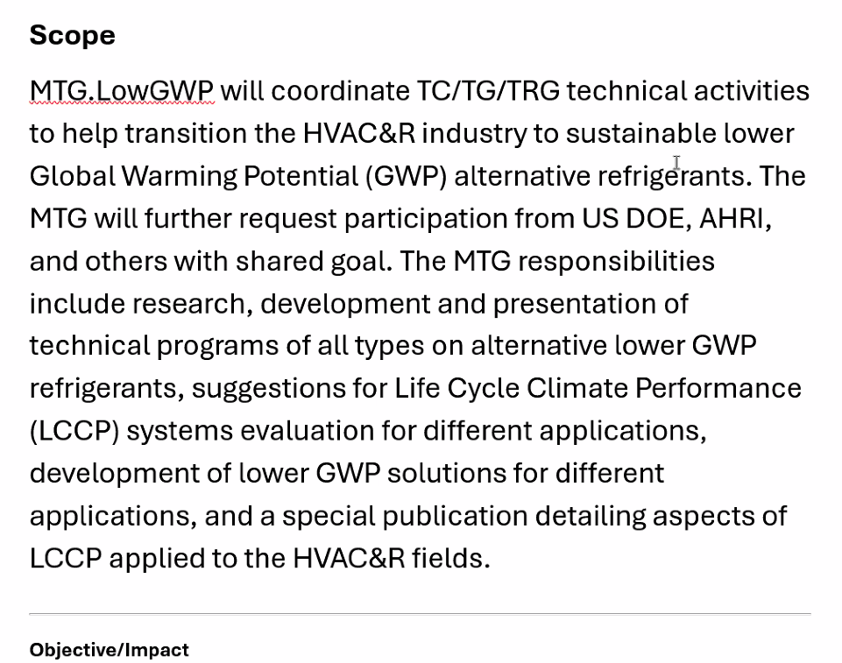

The Chair made the motion for the Low GWP MTG to continue in its current form and Arindom seconded. The motion was approved 6-0-1 with Min Che abstaining. Voting on remaining items can be conducted via email ballot on the discretion of the Chair later.

Vikrant to continue as the TC8.4 MTG liaison with Yirong as 1st alternate and Patrick Birbarah volunteered to the 2nd alternate.

- WEBMASTERS REPORT (Pratik Deokar)
Pratik Deokar relayed that the website was up to date.

- OLD BUSINESS
None.

- NEW BUSINESS
As mentioned before, the committee discussed whether to retain the title and scope of the TC8.4 in its current form. Vikrant made the motion to re-affirm TC8.4 scope and title, Min Che seconded and the motion was approved 7-0-0.

- ADJOURNMENT
Committee adjourned after completion of discussions. (Vikrant motions, Christian Bach seconds, all in favor)
Adjourned at 5:30 pm

- ATTENDANCE Sheets/Snapshots



