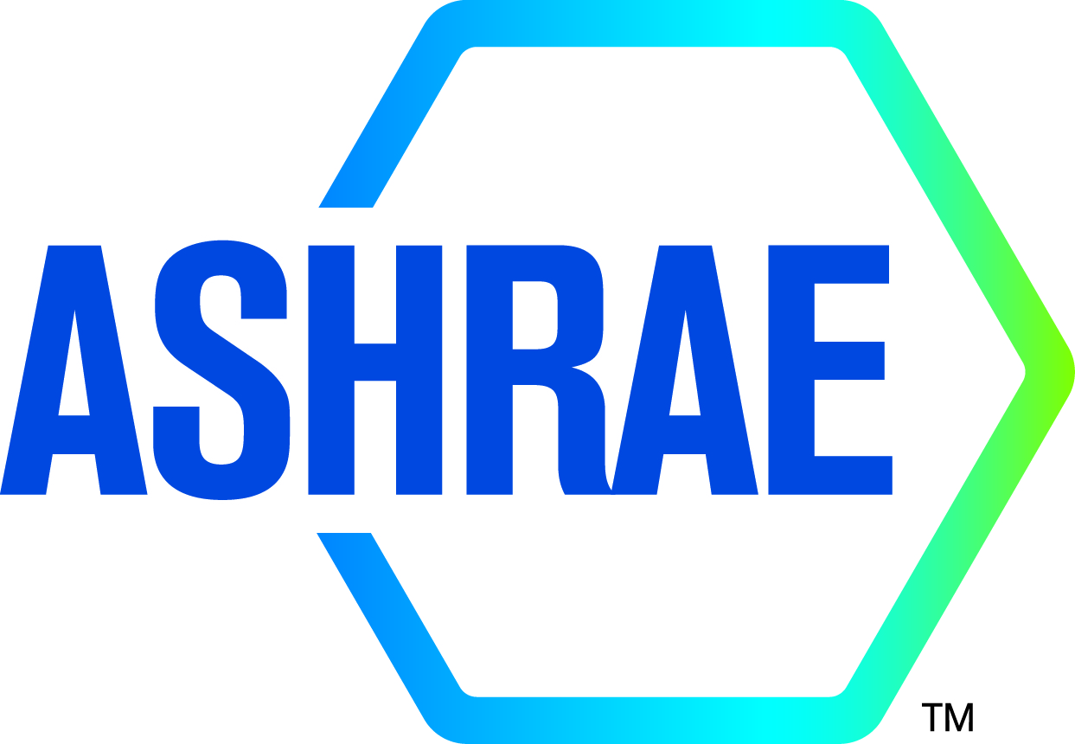

M I N U T E S

DRAFT

TC1.13 Optimization

2023 ASHRAE WINTER MEETING
Hybrid

Sunday February 5, 2023, 1:00 – 3:00 PM Eastern
Location: Omni CNN Center Atlanta, Cypress (M2-North)
Teams remote meeting

Note: These draft minutes have not been approved and are not the official, approved record until approved by the Technical Committee.
Minutes
1. Call to Order and welcome all members and visitors Kyle Gluesenkamp
Meeting was called to order at 1:03 pm (Eastern Time).

2. Roll Call / Introductions / Record Attendance Zhenning Li
Total Attendees: 14; 6 voting members; 3 corresponding members; 2 provisional member, 3 guests.
2 attendees are YEA members. 2 attendees are international members.11 attendees participate on-site; 3 attendees remotely participate.

Full Attendees List
Name | Category
Kyle Gluesenkamp | Voting, Chair
Farhad Omar | Voting, Vice Chair
Vikrant Aute | Handbook Subcommittee Chair
Omar Abdelaziz | Voting, Research Subcommittee Chair
Khaled Saleh | Voting Member
S.A. Sherif | Voting Member
Chris Laughman | Corresponding Member
Zheng O'Neill | Voting, Program Subcommittee Chair
David Yashar | Corresponding Member
Zhenning Li | Secretary, YEA
Rohit Dhumane | Provisional Member
Ivy Arkfeld | Guest
Yukiko Yoshida | Guest
Prem Anand Jayaprabha | Guest

3. ASHRAE Code of Ethics Commitment Kyle Gluesenkamp
In this and all other ASHRAE meetings, we will act with honesty, fairness, courtesy, competence, integrity and respect for others, and we shall avoid all real or perceived conflicts of interests. (See full Code of Ethics: https://www.ashrae.org/about-ashrae/ashrae-code-of-ethics.)
3. Introduction of ASHRAE Liaisons on Arrival Kyle Gluesenkamp

4. Establishment of Quorum Kyle Gluesenkamp
Voting Members for This Meeting (Need 4 for a Quorum)
VOTING MEMBERS FOR THIS MEETING
X | Kyle Gluesenkamp (6/30/2023) |  | X | S.A. Sherif (6/30/2025)
X | Farhad Omar (6/30/2025)
X | Zheng O'Neill (6/30/2026)
X | Omar Abdelaziz (6/30/2025)
X | Khaled Saleh (6/30/2023)
The TC presently has 6 voting members. A roll call of the voting members was taken, and a quorum was established with 6 of 6 Voting Members present.

5. TC 1.13 Purpose Statement Kyle Gluesenkamp
TC 1.13 is concerned with identifying, developing and disseminating optimization techniques that enhance the performance of HVAC&R components, systems and building systems that are not application or tool specific.

6. Approval of previous meeting minutes Zhenning Li
Action item:
- Email all members the Atlanta 2023 winter meeting minutes draft after the meeting and add to the website.
- Add to the agenda for next meeting to approve the meeting minute.

7. Chairman’s Overview and Report Kyle Gluesenkamp
Kyle emphasizes the balance requirement now applicable to TCs
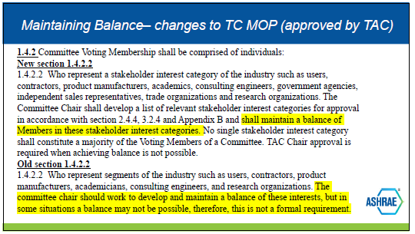
Current officers with categories:
 | officer role | category proposed
Kyle | Chair | G&R
Farhad | Vice chair | G&R
Zhenning | Secretary | G&R
Vikrant | Handbook | Academic
Omar | Research | Academic
Zheng | Program | Academic
Khaled |  | Manufacturer
Sherif |  | Academic

1:31 pm Kyle proposed to update the members and officers as below
- Farhad Omar is elected to be new chair
- Zhenning and Rohit are converted as VM (Rohit can maintain an industry category member position with Vikrant as fallback option)
- Khaled is selected as new handbook chair.
- Rohit is elected as new secretary
- Zhenning is elected as new vice chair
1:42 pm motion passes (6-0-0-0 CNV).

1:15 pm Kyle proposed to update TC 1.13 scope.
Attendees discuss the FG motions to TAC and seek for any reason to expand or change scope for TC 1.13. Attendees concluded to update the TC 1.13 purpose statement as below:
Old statement:
TC 1.13 is concerned with identifying, developing and disseminating optimization techniques that enhance the performance of HVAC&R components, systems and building systems that are not application or tool specific. The committee is focused on the fundamentals of optimization techniques (such as: mathematical formulation, constraints handling, multi-objective optimization, approximation techniques, robust optimization, etc.).
Proposed new statement:

TC 1.13 is concerned with identifying, developing, and disseminating optimization techniques that enhance the performance of HVAC&R components, systems, and building systems that are not application or tool specific. The committee is focused on the fundamentals of optimization techniques including mathematical formulation, constraints handling, multi-objective optimization, approximation techniques, and robust optimization. These fundamentals are the foundation of data-driven, machine learning (ML), and artificial intelligence (AI) methods.
1:29 pm motion passes (6-0-0-0 CNV).

Action item:
- Kyle sends Corey Metzger (section-1 head) to request for scope change after the meeting.

8. Subcommittee Reports Zheng O’Neill

a. Program

Three seminars are proposed for upcoming ASHRAE meetings, 1 seminar for 2023 Tampa summer meeting, 2 seminars for 2024 Chicago winter meeting.
- (Tampa, 2022 Summer) Optimization of TES controls for building decarbonization Chair: Kyle
  - Zhiyao
  - Zhenning
  - Omar
  - (Zheng to bring one more from 7.5, and/or from NREL)
- (Chicago, 2023 Winter) Khaled proposed: Optimization from components to HVAC systems, to building systems. Chair: Vikrant (needs his future confirm)
  - (speaker from Vikrant or) optimization of shape and topology of components (HX)
  - (speaker from David Yashar) chiller tube bundle
  - (Zheng, or speaker from Zheng, TC 7.5) HVAC system
  - (Zheng, or speaker from Zheng, TC 7.5) Building-to-grid, or community level integration
- (Chicago, 2023 Winter) Refrigerant blend optimization (refrigeration track), Chair: Vikrant.
  - Zhenning – Multi-objective optimization of low-GWP mixture composition and heat exchanger circuitry configuration for improved system performance and reduced refrigerant flammability.
  - NIST – new molecules, refrigerant blend
  - (Vikrant to identify) – optimization of blends for specific applications.
  - (Rohit to identify) – optimization of blends.

To submit new seminar, the six tracks Tampa 2023 summer meeting are:
1. HVAC&R Systems and Equipment (Track Chair: Ng Yong Kong | nyk@nyk.com.my)
2. Fundamentals and Applications (Track Chair: Brian Fronk | Brian.Fronk@psu.edu)
3. Research Summit (Track Chair: Davide Ziviani | dziviani@purdue.edu)
4. Pathways to Net Zero Energy and Decarbonization (Track Chair: Rafi Karim | rkarim@aeieng.com)
5. Future-proofing the Built Environment (Track Chair: Scott Peach | sp@sp.engineering)
6. Building Automation and Control Systems (Track Chair: Raul Simonetti | raul.simonetti@carel.com)
7. Professional Development and Education (Track Chair: Ahmed Abdel-Salam | ahaabdelsalam@gmail.com)

2:55 pm, Omar moves to submit new seminar for Optimization of TES controls for building’, Vikrant second, 6-0-0-0 (CNV)
Action item: Feb 27, 2023: Seminars proposals for Tampa due, Zhenning helps Kyle to confirm the presenters for seminar -‘Optimization of TES controls for building’.

b. Research Omar Abdelaziz
Omar proposed that, to date, members haven’t investigated RTARs in this TC. Challenge is how to define a research project on optimization.
Farhad proposed to consider a literature review on this topic.
David presumed that this TC is in a great position to support research by other TCs. Optimization that is agnostic of application is outside ASHRAE scope.

The members conducted a discussion on committee scope, regarding data-driven models, AI, ML, etc.
- TC 4.7 has subcommittee on data driven modeling
- TC 4.10 has a subcommittee regarding machine learning
- David suggested to talk with section head how to liaise with other TCs that are standing up subcommittees on ML, AI, DDM, etc.
c. Handbook Vikrant Aute
no updates

d. Standards Kyle Gluesenkamp
no updates
e. Membership Kyle Gluesenkamp
Farhad attended YEA meeting. Farhad reported that there are alot of interest in AI, ML, But optimization sounds like difficult mathematics and is scary.
f. TC Website Zhenning Li
Action item: Zhenning will follow up with Tara and Steve to get access to the website.

9. Old Business All

Approve 2023 Atlanta conference meeting minute.

Attendees review the TC 1.13 program activities in 2023 winter conferences. Seminar 11 (Optimizing Thermal Energy Storage Integrated with HVAC) chaired by Kyle was the second most attended seminars in ASHRAE winter conference.

10. New Business All
No updates

11. Next subcommittee and committee meetings Kyle Gluesenkamp
Not determined

12. Adjourn All
Omar moves to adjourn, seconded by Farhad.
3:06 pm motion passes 6-0-0-0 (CNV). Meeting is adjourned.

