Agenda
SSPC 154 Ventilation for Commercial Cooking Operations
In-Person Summer Meeting
Austin, TX
Monday, June 29th, 2026, 2:30 PM – 4:30 PM CT
JW Marriott, JW - 207 - L2
https://teams.microsoft.com/meet/218035952571555?p=A8AkZArq8FvhXDVzyv
- Call to Order
  - Commitment to the ASHRAE Code of Ethics – In this and all other ASHRAE meetings, we will act with honesty, fairness, courtesy, competence, integrity, and respect for others, and we shall avoid all real or perceived conflicts of interests. See full Code of Ethics and core values. https://www.ashrae.org/about-ashrae/ashrae-code-of-ethics. https://www.ashrae.org/about/ashrae-s-core-values.
  - ASHRAE Commitment to Care-The health and safety of all ASHRAE conference attendees is a top priority. Out of respect for our fellow attendees, monitor our health, seek medical attention if symptoms develop and adhere to all ASHRAE Commitment to Care protocols. We are committed to the well-being of one another.
  - Recording (Audio, Video, Screenshots) of ASHRAE meetings, including online meetings, is strictly prohibited.
  - Introduction of Members and Guests
PCVM Name |  | Affiliation |  |  | Classification |  |  | Present
Mr. Keith Page |  | Selkirk-Hart & Cooley |  |  | Chair, Producer (V) |  |  | X
Mr. Behrang Gilanpour |  | Mellifiq |  |  | Vice Chair, Producer(V)
Mr. Bryan Miller |  | Melink Corporation |  |  | Secretary, Producer (V)
Mr. Rich Swierczyna |  | Retired |  |  | General (V)
Mr. Randall Cooper |  | AHAM (Assoc Home Appliance Mfgrs) |  |  | General (V)
Mr. Jason Greenberg, PE |  | HFA |  |  | General (V)
Mr. Richard T Jones, PE |  | National Engineering |  |  | User (V)
Mr. Mark Skierkiewicz, PE |  | UL |  |  | General (V)
Mr. Terry McCabe |  | Greenheck & Accurex |  |  | Producer (V)
Mr. Russell Robison |  | Gaylord Industries |  |  | Producer (V)
Mr. Andre R Saldivar, I |  | SCE |  |  | General (V)
Mr. Fuoad Parvin, PE |  | Halton Company |  |  | Producer (V)
Abdel Darwich |  | Guttmann & Blaevoet Assoc |  |  | SPLS Liaison (NV)
Mr. Mark J Weber |  | ASHRAE |  |  | Staff Liaison (NV)
PCNVM & Guests | Affiliation |  | Present | PCNVM & Guests |  | Affiliation | Present
  - Quorum Determination.
  - Announcements

  - Liaison Report

- Roster Updates

Membership form: https://www.ashrae.org/technical-resources/standards-and-guidelines/apply-to-a-project-committee

- Approval of Winter 2026 Vegas meeting minutes.

- Continuous Maintenance Addenda/Proposals

  - Section 4.7 Hood Performance Test. Working group: DS (lead), RR, AS, RS, FK.
- To better address distinction in conducting the performance tests between type I and type II.
Update: No new text yet. Suggestion is to perhaps update the air flow rates for type II hoods instead of adding a capture/containment test that may not work. DS will also look into the overhangs. Proposal to be discussed in Chicago in 2024. To be added language/sub-section about updated hood performance testing/rebalancing if there is a modification in kitchen appliances.
Russ previously had mentioned 1778 flow rates ??
Discussed adding to the informative note after section 4.7.2 that Type II hoods may not fully capture/contain all heat. Also update 4.7.1. Russ to spearhead language.
Notes: No new updates; note that this is primarily for dishwasher capture and performance. Russ R. is planning to put additional thought into this as the existing flow rates are proven inadequate. Russ to take over as WG lead.
B. Section 7 System Controls. Controls and/or commissioning for DCKV systems – performance, building pressurization, air replacement, etc.
Working Group: Frank Kohout (lead), Rich Swierczyna, Russ Robison, Jason Greenberg.
1. COMMISSIONING PLAN
2. DESIGN REVIEW
3. PREFUNCTIONAL CHECK’s
4. FUNCTIONAL PERFORMANCE TESTING
5. POST OCCUPANCY TESTING (E,G. CKV SEASONAL TESTING)
6. MONITORING-BASED COMMISSIONING PLAN FOR CKV SYSTEMS
7. RETRO COMMISSIONING AND RECOMMISSIONING

Decision: Taking the checklist for commissioning from the Design Guide and adding it to an appendix. Changing the title of section 7 to include CKV and DCKV, wording by the working group (Std language style)
Frank noted that language is written up but needs to review with additional people.

Taking above checklist and adding it to the appendix, any edits from committee?
Additional language needed for each section. WG will meet and add language.
Decision to add in appendix or in section 7 (body)
Appendix is narrative approach.
If it goes in body section 7, will require rewrite
Frank noted that he believes this is ready to go, but needs approval from the rest of the WG. Propose to add another note in section 8 (8.1.3) that calls out that commissioning shall be done, then add notes to the Appendix (essentially copy from the Design Guide).
Proposed 8.1.3:
8.1.3 The system shall be commissioned to ensure compliance with all applicable codes, standard's and project requirements.
8.1.3.1 For additional guidance, on CKV systems see the Appendix Section XXX and "ASHRAE's Design Guide For Commercial Kitchen Ventilation".
8.1.3.2 For the requirements regarding the commissioning process refer to "Standard 202, - Commissioning Process for Buildings and Systems".
See attch’d DRAFT proposal from Frank

- Old Business
  - IFGC and Dampers: Amend 505.1.1, proposal to add “Exception 2” allowing dampers use in grease exhaust systems.
-Working Group: Derek Schrock and Keith Page. Pursue 2030 IFGC and will work thru ASHRAE Codes dept once we vote on it. Per Emily Toto, content for 2030 won’t likely be due until latter 2026.
Will monitor language.
505.1.1 Commercial cooking appliances vented by exhaust hoods. Where commercial cooking appliances are vented by means of the Type I or II kitchen exhaust hood system that serves such appliances, the exhaust system shall be fan powered and the appliances shall be interlocked with the exhaust hood system to prevent appliance operation when the exhaust hood system is not operating. The method of interlock between the exhaust hood system and the appliances equipped with standing pilot burner ignition systems shall not cause such pilots to be extinguished. Where a solenoid valve is installed in the gas piping as part of an interlock system, gas piping shall not be installed to bypass such valve. Dampers shall not be installed in the exhaust system.
Exception 1: An interlock between the cooking appliance(s) and the exhaust hood system shall not be required where heat sensors or other approved methods automatically activate the exhaust hood system when cooking operations occur
Exception 2: Dampers can be used where specifically listed for such use, or as part of a listed device or system. Dampers shall not restrict the venting of byproducts of combustion. Access shall be provided to both sides of the damper for the purposes of servicing and cleaning.

  - IMC M49-21 Passed IMC hearing allowing Unconditioned Makeup air through compensating hood.
Status: It’s in the 2024 IMC (see below). Pursue chg’n it for 2030 IMC via ASHRAE codes dept.
Target is to eliminate the Exception on 508.1.1. Determine what kind of substantiation will be required during public comment to get it pulled back out. Can we find what we had submitted previously the last time this was pulled out? Need to do some research to try and dig this up. Russ to reach out to Phil, Rich to reach out to Gregg Gress/Don Fisher.

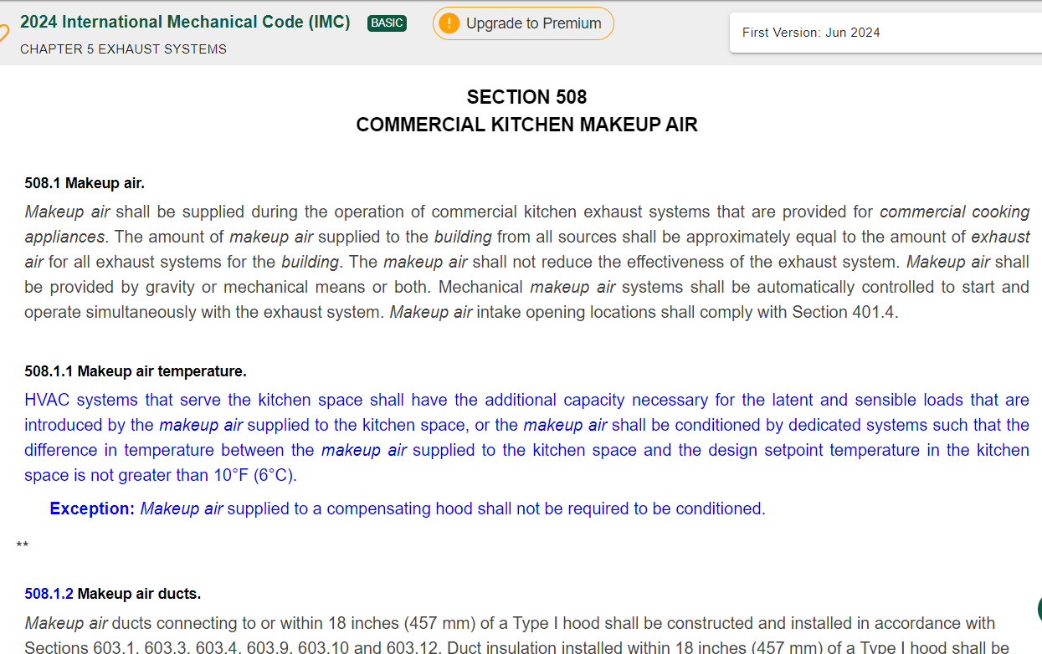
Frontier Energy thinks they still have the data backing this up. Suggestion from Russ to submit a letter from ASHRAE with the data attached as proof?
- Determine if there are any volunteers to monitor relevant codes (IMC, UMC, NFPA 96).

- New business
Look at clarifying Type II hood airflow rates to try and get IMC code updated (IMC currently way too low). Discussions on lightweight appliance airflows given in IMC 2024. Sources unknown?
India kitchen design/addenda inquiry (attached)

- Next Meeting: Winter Conference, Chicago, 2027
- Adjourn:

