TC 1.13 Optimization
Agenda for ASHRAE 2025 Annual Conference
Sunday, June 22, 2025
Phoenix, AZ, and hybrid-remote
http://tc0113.ashraetcs.org/

TC 1.13 meetings this meeting:

Main Committee Meeting (hybrid)
Sunday, June 22nd, 2025, 1:00 – 3:00 PM MST
Sheraton Phoenix Downtown
Room: Laveen A (Level 2)

1. Call to Order and welcome all members and visitors Zhenning Li
Zhenning Li called TC 1.13 to order 1:08 pm (MST)

2. Roll Call / Introductions / Record Attendance Zhenning Li

Record attendance, 14 attendances in total, 5 voting members, 6 Provisional members, 3 guests.

5 of 6 voting members presented. Quorum established at 1:09.

Voting members for this meeting (Orlando)
Position | Present | Voting member | Proposed interest category
Chair | ✓ | Zhenning Li | Gov & Res
Vice chair | ✓ | Rohit Dhumane | Industry
Voting Member | ✓ | S A Sherif | Academic
Program | ✓ | Zheng O’Neill | Academic
Research | ✓ | Omar Abdelaziz | Academic
Standards | x | Vikrant Aute | Academic

3. ASHRAE Code of Ethics Commitment Zhenning Li

ASHRAE Value Statement – In ASHRAE meetings, we will act with honesty, fairness, courtesy, competence, inclusiveness and respect for others, which exemplify our core values of excellence, commitment, integrity, collaboration, volunteerism and diversity, and shall avoid all real or perceived conflicts of interest. Our culture is one of inclusiveness, acknowledging the inherent value and dignity of each individual. We celebrate diverse and inclusive communities, understanding that doing so fuels better, more creative and more thoughtful ideas, solutions and strategies for the Society and the communities our Society serves. We respect and welcome all.
In this and all other ASHRAE meetings, we will act with honesty, fairness, courtesy, competence, integrity and respect for others, and we shall avoid all real or perceived conflicts of interests. (See full Code of Ethics: https://www.ashrae.org/about-ashrae/ashrae-code-of-ethics.)

4. Introduction of ASHRAE Liaisons on Arrival Zhenning Li
We will have a new section head in the upcoming TC meeting. Our previous Section Head, Jason Atkisson, will step down from this role since this meeting.

5. TC 1.13 Purpose Statement Zhenning Li
Purposes Statement
TC 1.13 is concerned with identifying, developing, and disseminating optimization techniques that enhance the performance of HVAC&R components, systems, and building systems that are not application or tool specific. The committee is focused on the fundamentals of optimization techniques including mathematical formulation, constraints handling, multi-objective optimization, approximation techniques, and robust optimization. These fundamentals are the foundation of data-driven, machine learning (ML), and artificial intelligence (AI) methods.

6. Approval of previous meeting minutes Zhenning Li
Rohit called the motion to pass previous meeting minutes. Rohit seconded. Approved by all attended VMs.
At 1:22 pm, the Orlando meeting minutes are approved.

7. Chairman’s Overview and Report Zhenning Li
Rohit provided details of updates to RTAR process. Committee may teach course for ASHRAE by co-sponsoring with ALI.

8. Subcommittee Reports

a. Program Zheng O’Neill
The following 3 seminars are accepted to present in the Pheonix annual conference.

Seminar 23: Systematic Approaches to Minimize Charge for Flammable Refrigerants in Refrigerators and Heat Pumps
Chair: Vikrant Aute, Ph.D.
8:00 - 9:30 AM MST
- A Survey of Numerical Studies on Refrigerant Charge Optimization
Presenting Author: Rohit Dhumane, Trane Technologies
- Working with Flammable Refrigerants: Tradeoff between Safety and Performance
Presenting Author: Omar Abdelaziz, The American University in Cairo
- Optimal Dynamic Charge Management of Heat Pumps
Presenting Author: Jie Cai, Purdue University

Seminar 32: Physics-Informed Machine Learning in HVAC
Applications
Chair: Rohit Dhumane
Mon, Jun 23 9:45-10:45 AM MST
- Review of Techniques and Applications of Using Machine Learning Models for Automatic Discovery of Physics from Data
Presenting Author: Rohit Dhumane, Trane Technologies
- Using Physics-Constrained Machine Learning for State Estimation of Vapor Compression Systems
Presenting Author: Vedang Deshpande, Mitsubishi Electric Research Laboratories
- Automated Discovery of HVAC and Thermo-Fluid Systems from Data Using Julia
Presenting Author: Ranjan Anantharaman, JuliaHub Inc
- LLM-Driven Data Extraction for Physics-Enhanced Building Equipment Modeling
Presenting Author: Hanlong Wan, Pacific Northwest National Laboratory

Seminar 38: Optimization Methods for Components, Systems, and Grid-Interactive Buildings
Chair: Cheng-Min Yang
Mon, Jun 23 11:20-11:40 AM MST
- Optimization of Chilled Water Systems, Including AHUs, Chillers, Pumps and Cooling Tower Operations for Reduced Utility Use and Increased Reliability Using Adaptive and Feed Forward Control Processes Using the Existing BMS
Presenting Author: Duane Warren, Engineering Director, Jones Lang LaSalle
- Demand Flexibility Optimizations for Building Energy Systems with an Ice Thermal Energy Storage Tank in a Commercial Building
Presenting Author: Zheng O'Neill, Texas A&M University

Brainstorm TC 1.13 Seminars for 2026 Las Vegas Winter Conference.

Rohit volunterred to form a seminar on AI application on fault FDD. The pending presenters include Rohit Dhumane, colleague from MERL, JuliaHub, Trane. Rohit will serve as the seminar chair and contacted each presenter respectively.

2026 Las Vegas tracks:
https://www.ashrae.org/conferences/2026-winter-conference/2026-winter-conference-technical-program

- Fundamentals and Applications (Track Chair: Kevin Brown, kevin@kbsquared.net)
- HVAC&R Systems and Equipment (Track Chair: Ng Yong Kong, nyk@nyk.com.my)
- Refrigeration & Refrigerants (Track Chair: Haotian Liu, sjtulht@hotmail.com)
- Research Summit (Track Chair: Li Song, lsong@ou.edu)
- Energy Storage and Grid Resiliency (Track Chair: Jon Cohen, jonjcohen1@gmail.com)
- Pathways to Building Decarbonization (Track Chair: Ehab Mamdouh, ehab.mamdouh@ipec-eg.net)
- Artificial Intelligence (Track Chair: Joshua Vasudevan, joshuavasudevan2011@gmail.com)
- Indoor Environmental Quality & Healthy Buildings (Track Chair: Joe Chow, joe.ashrae@gmail.com)
- Future-Proofing the Built Environment (Track Chair: Joe Chow, joe.ashrae@gmail.com)
Friday, August 1, 2025: Debate, Panel, Seminar, Forum, Workshop, and Debate proposals for Las Vegas are due.

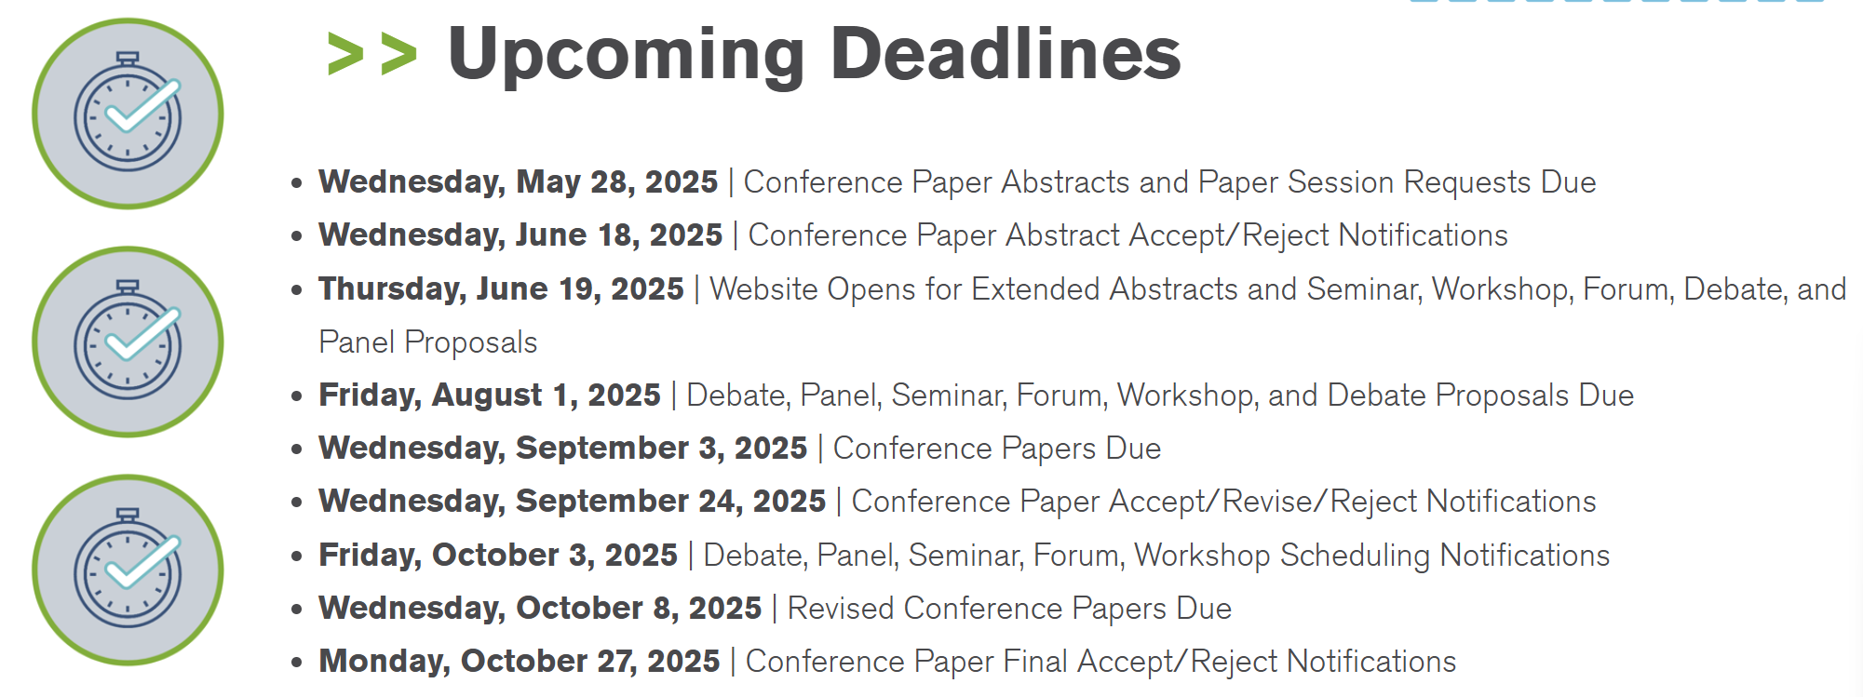

b. Research Omar Abdelaziz
Summary of notes that may serve as a useful starting point:
- To date we haven’t investigated RTARs in this TC.
- TC1.13 is in a great position to support research by other TCs.
- Optimization that is agnostic of application is outside ASHRAE scope.
- Other committees relevant to data-driven models, AI, ML, etc.,
    - TC 4.7 has subcommittee on data driven modeling, and
    - TC 4.10 has a subcommittee regarding machine learning.
- Co-sponsorship with other TCs
- Discussed RTAR with TC 4.7 data-driven modeling, but no active or proposed RTARs were identified for co-sponsorship. Potentially work with TC 1.4 and TC 7.5. RTAR 8.11 in unitary products.

c. Handbook Zhenning Li
Julia Ho volunteered to be the new handbook chair.

d. Standards Zhenning Li

e. Membership Zhenning Li
Zhenning promoted TC 1.13 in YEA event.

f. TC Website Zhenning Li
Zhenning manages TC website and updated the approved meeting minutes and draft agendas in all previous meetings.

10. Old Business All

11. New Business All

12. Next subcommittee and committee meetings Zhenning Li

13. Adjourn All
Omar called the motion to adjourn at 2:06, seconded by Zheng.

