Technical Committee Meeting Minutes
Technical Committee, TC 1.10 Combined Heat & Power Systems
Tuesday, January 23, 2024: 12:30 PM-2:00 PM CST

Location: Marriott Marquis Chicago, Room: Poetry (3)
Meeting Format: Hybrid

Chairs and Voting Members:

Position | Term | Name | Voting Status | Present
Chair | 06/30/2024 | Geoffrey Bares | VM | Yes
Vice Chair | 06/30/2024 | Michael Calabrese | VM | Yes
Secretary | 06/30/2025 | Praveen Cheekatamarla | Non-VM | Yes
Program Subcommittee Chair | 06/30/2024 | Gearoid Foley | VM | Yes
Handbook/Standards Subcommittee Chair | 06/30/2025 | Dragos Paraschiv | VM | Yes
Research Subcommittee Chair | 06/30/2025 | Farzin M Rad | VM | Yes
Member | 06/30/2027 | Zhiming Gao | VM | Yes
Member | 06/30/2026 | Vikas Patnaik | VM | No
Member | 06/30/2026 | William A Ryan | VM | Yes

Guest Attendees: Complete attendance list in Appendix A.

Position | Name | Present
TAC Section Head | Jason Atkisson | Yes
Member/DOE Liaison | Mahabir Bhandari | Yes
TC 8.3, Programs Chair | Bill Ryan | Yes

- The Chair (Geoff Bares) Called to Order at 12:30 pm

- The chair (Geoff Bares) discussed the Purpose Statement

Technical Committee (TC) 1.10 is concerned with combined heat and power (CHP) systems, their cycles and components including heat recovery, combustion turbine inlet cooling (CTIC), energy conversion and system integration. The systems provide both power (electric and/or mechanical) and cooling/heating thermal energy and are also known as cogeneration systems; trigeneration systems; and combined cooling, heating and power (CCHP) systems.

- ASHRAE Code of Ethics Commitment – Announced by TC Chair (Geoff Bares)

In this an all other ASHRAE meetings, we will act with honesty, fairness, courtesy, competence, integrity and respect for others, and we shall avoid all real or perceived conflicts of interest. (see full code of ethics: https://www.ashrae.org/about-ashrae/ashrae-code-of-ethics.)

- ASHRAE Diversity Equity and Inclusion Commitment – Announced by TC Chair (Geoff Bares)

ASHRAE is committed to providing a welcoming environment. Our culture is one of inclusiveness, acknowledging the inherent value and dignity of everyone. We proactively pursue and celebrate diverse and inclusive communities understanding that doing so fuels better, more creative, and more thoughtful ideas, solutions and strategies for the Society and the communities our Society serves. We respect and welcome all people regardless of age, gender, ethnicity, physical appearance, thought styles, religion, nationality, socioeconomic status, belief systems, sexual orientation or education.

- Introductions – TC Chair (Geoff Bares) hosted the virtual meeting and the in-person meeting.
  - Name, organization, and positions on committee. Roll call.
  - Quorum has been established with 7 voting members present.
  - Introduction to ASHRAE Liaison, Jason Atkisson (TAC Section 1 Chair)
    - Jason updated highlights from the Chairs meeting.
    - Manual of Procedures (MOP) for Functional Groups will be part of the Reference Procedure before the annual meeting
    - Roster updates will be completed by end of February 2024
    - 2025 Strategic Plan feedback can be provided at strategicfeedback.ashrae.org
    - Multidisciplinary Task Group for AI was discussed, is likely to be established soon.
    - Global program integration aspects were discussed
  - TC Chair (Geoff Bares) raised the idea of moving TC 1.10 from Section 1 to Section 6 to better align with like TCs. Jason thought this idea made sense and will discuss with Doug Reindl (Section 6 Chair) and send out the necessary form. A motion was made to recommend moving TC 1.10 to Section 6 by Michael Calabrese-TC Vice Chair, second by Dragos Paraschiv-VM. Motion passed 6-0-0-CNV.
  - Geoff Bares (TC Chair) mentioned that the ALI course on CHP will not be offered any more since the professional development committee is not interested. The last one occurred in 2020. Lucas Hyman, the course instructor, and Geoff Bares (TC Chair) are advocating to keep the course. The committee generally concurs and Geoff will continue working to re-establish.

- Meeting Minutes from the 2024 (Tampa) Winter Meeting
  - Copies of the draft minutes of the Tampa meeting were distributed to the members.
  - A motion to approve the meeting minutes of the 2024 Winter Meeting.
  - Motion by Michael Calabrese-VM, second by Dharam Punwani-VM, all Yea, no Nay. Motion passed unanimously , 6-0-0-CNV.

- Sub-Committee Reports:
  - Program: Gearoid Foley (Voting Member, Subcommittee Chair)
    - No Seminar in June 2024 meeting due to lukewarm response
    - Open to new meeting ideas with a focus on decarbonization rather than CHP
    - Program SC to emphasize and pursue CHP technologies at all venues
      - Collaborate with Mahabir Bhandari’s (Corresponding Member, DOE Liaison) group at Oak Ridge National Laboratory (ORNL) – presentations from this group will be considered
    - Alejandro Guada (Guest, GTI Energy) emphasized the significance of non-carbon fuels in the context of CHP
    - Seminar topics for Orlando (2025) conference discussed
      - Solar driven power generation
      - Gearoid Foley (VM, SC Chair) to reach out to Mahabir (ORNL) and Alejandro (GTI Energy) for topic discussion.
    - Bill Ryan (TC 8.3 Chair) suggested using efficiency numbers and other critical metrics to highlight the significance of CHP in decarbonization without electrification
    - Geoff Bares (TC Chair) to consult with TC 6.2, District Energy TC Chair for exploring future cosponsoring opportunities
    - Zhiming Gao (VM) discussed the Engenuity Power Systems’ reciprocating engine based micro-CHP technology benefits
    - Bill Ryan (TC 8.3 Chair) mentioned the Thermally Driven Heat Pump (TDHP) proposal for consideration towards TC 1.10 co-sponsorship in Indianapolis Conference. Title of the Seminar is “Decarbonization without waiting for electrification”.
      - Two talks titled – “Advancing heat driven heat pump equipment” and “Electrification possibilities and pitfalls – mitigation with TDHP) were mentioned by Bill Ryan (TC 8.3 Chair)
      - A motion to co-sponsor this seminar was made by Bill Ryan-VM, second by Michael Calabrese-Vice Chair, all Yea, no Nay. Motion passed unanimously, 6-0-0-CNV.
  - Research and Publications: Farzin Rad (Subcommittee Chair)
    - Farzin announced new Liaison (Mahabir Bhandari, DOE Liaison)
    - SC is willing to cosponsor the Fuel Cell seminar but not lead it
    - Discussed the Fuel Cell Cogeneration system Design Guide publication
      - “Fuel cells for Building Applications guide” document revision
      - Dragos Paraschiv (VM) to pursue RTAR funding to revise the design guide and Fuel Cell applications in buildings
      - Praveen Cheekatamarla (CM) to provide feedback and support this activity
    - New research idea proposed by John Willis (Corresponding Member)
      - Integration of Thermal Energy Storage, Solar Thermal technologies in buildings
      - Decision is pending
  - Handbook: Dragos Paraschiv (Subcommittee Chair)
    - No changes to Chapter 7.
    - Chapter 8 will be revised further, based on CTIC design guide.
      - Targeting ASHRAE publication this year
      - Dragos Paraschiv (Handbook SC Chair) to consult with Dharam Punwani (PCM) to submit the updated document in time
  - Standards: Dragos Paraschiv (Subcommittee Chair)
    - An effort is ongoing on updating C2.4 – Method of Testing for Micro-CHP and looking for volunteers to join and support
  - TC Website: Weblink to Department of Energy CHP eCatalog has been added by TC Chair (Geoff Bares) to the TC 1.10 website

- Announcements
  - Michael Calabrese to assume the role of TC Chair after the Indianapolis meeting (2024)
  - Alok Kumar (VM) is going to be the new Handbook Subcommittee Chair
  - Gearoid Foley to roll off from the Program Subcommittee Chair role and is willing to support the new Chair

- Old Business
  - TC Website has been updated by Geoff Bares (TC Chair)

- New Business
  - New committees have been announced
    - Global Technical Interaction Committee (GTIC)
    - Center of Excellence for Building Decarbonization (CEBD)
  - Technical briefings have been given to legislators

- Adjourn
  - Announcement by TC Chair (Geoff Bares) to close this session at 2:00 pm.
  - Motion by Michael Calabrese -Vice Chair, second by Dragos Paraschiv-VM, all Yea, no Nay. Motion passed 6-0-0-CNV.

Submitted by
Praveen Cheekatamarla, Ph.D.
Secretary, TC 1.10.

TC 1.10 COMBINED HEAT AND POWER SYSTEMS
2024 ASHRAE Winter Meeting (January 20-24, 2024); Chicago, IL

Subcommittee Meetings
Handbook, Program, Research, Membership Subcommittee
Tuesday, January 9, 2023: 1:30 PM-3:00 PM EST; Virtual
Click here to join the meeting
Meeting ID: 273 097 566 204
Passcode: H4MFb4
Download Teams | Join on the web
Or call in (audio only)
+1 872-256-4257, 599448513# United States, Chicago
Phone Conference ID: 599 448 513#

TC 1.10 Committee Meeting
Tuesday, June 23, 2023: 12:30 PM-2:00 PM CST; Marriott Marquis Chicago,
Room: Poetry (3)

TC 1.10 Sponsored Seminars
Seminar 24: Thermally Driven Heat Pumps for Cooling and Heating
Monday, January 22 8:00 AM – 9:30 AM CST

Marriott Marquis Chicago, 2nd Floor, Watershed B

AGENDA

1. Welcome Geoff Bares
2. Roll Call / Introductions Geoff Bares / All
3. Introduction of ASHRAE Liaisons on Arrival Geoff Bares
4. Establishment of Quorum Praveen Cheekatamarla
5. TC1.10 Purpose Statement Geoff Bares
6. Minutes of the 2023 Summer Meeting (Tampa) Geoff Bares
7. Subcommittee Reports
a. Program Gearoid Foley
b. Research Farzin Rad
c. Handbook Dragos Paraschiv
d. Standards Dragos Paraschiv
e. Membership Geoff Bares
f. TC Website Geoff Bares
g. Honors & Awards Geoff Bares
8. Chairman’s Overview and Report Geoff Bares
9. Old Business Geoff Bares
10. New Business All
11. Next Subcommittee and Committee Meetings Geoff Bares
12. Adjourn All

Attachment 1: Mission Statement:
“TC 1.10 is concerned with combined heat and power (CHP) systems, their cycles and components including heat recovery, combustion turbine inlet cooling (CTIC), energy conversion and system integration. The systems provide both power electrical/mechanical and cooling/heating thermal energy and are also known as cogeneration systems; trigeneration systems; and combined cooling heating and power systems.”

Appendix A: Attendees

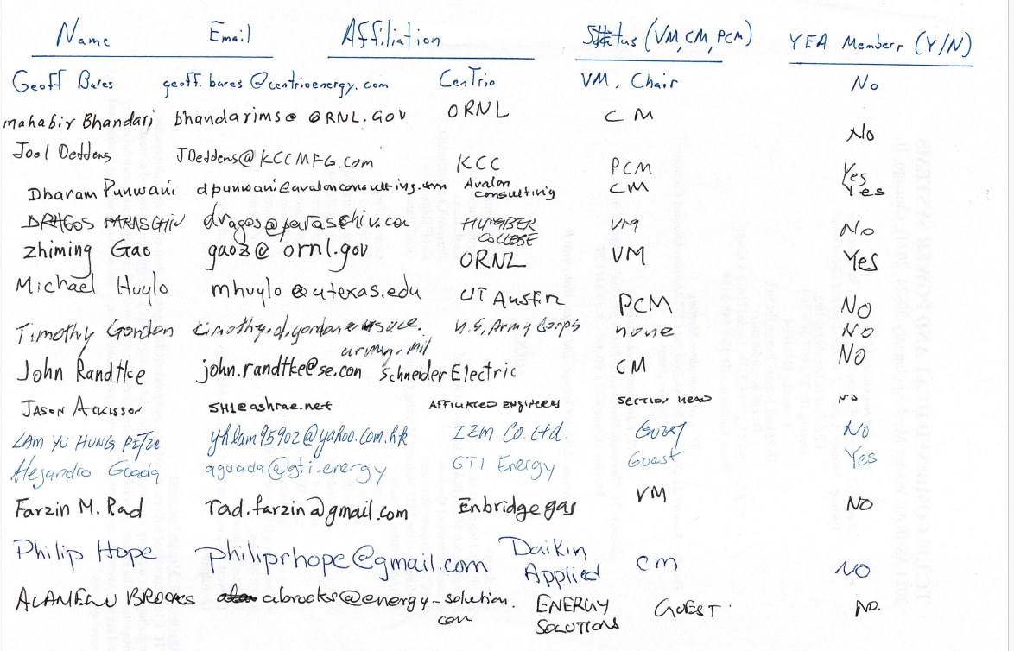
In-person attendees:

Virtual attendees:
- Michael Calabrese
- Bill Ryan
- Kahryn Hinkelman
- Praveen Cheekatamarla

