

1791 Tullie Circle, N.E./Atlanta, GA 30329
404-636-8400
DRAFT 1

TC/TG/MTG/TRG MINUTES COVER SHEET

(Minutes of all Meetings are to be distributed to all persons listed below within 60 days following the meeting.)

TC/TG/MTG/TRG No. TC 1.9 DATE 6/27/2025

TC/TG/MTG/TRG TITLE Electrical Systems

DATE OF MEETING 6/24/2025 LOCATION Phoenix, AZ (Hybrid)

 | MEMBERS PRESENT  (VM’s in bold, YEA) | YEAR APPTD | MEMBERS ABSENT  (VM’s in bold, YEA) |  | YEAR APPTD | EX-OFFICIO MEMBERS AND ADDITIONAL ATTENDANCE
 | Gerardo Alfonso | 2017 | Daryl Collerman |  | 2019 | Jason Atkisson (SH)
 | Luis Miguel Alvarado (PCM) | 2024 | Beatriz Salazar |  | 2021 | Rex Scare (HBL)
 | Steven Faulkner | 2006 | John Nix |  | 2007 | Stephen Duda
 | Jim Frey (PCM) | 2025 | Zach DeLuke |  | 2022 | Jim Early
 | Armin Hauer | 2011 | Dr Suren Babu |  | 2025
 | Randall Higa | 2016 | Panagiotis Kleomenis Bougas (PCM) |  | 2024
 | Larry Markel | 1997 | Eduardo Garcia Huertas (PCM) |  | 2025
 | Tom Pollard (PCM) | 2023 | Amina Abdul Ghafoor (PCM) |  | 2024
 | Frank Pucciano (PCM) | 2025 | Abrar Hussain (PCM) |  | 2023
 | Steve Rosenstock | 2005 | Mohamed Mostafa  Hassan Ibrahim (PCM) |  | 2024
 | Michael S. Todd | 2011 | Matthew Klok (PCM) |  | 2025
 |  |  | Dr. Fengqi Li (PCM) |  | 2024
 |  |  | Angel Lopez (PCM) |  | 2023
 |  |  | Amar Maniar (PCM) |  | 2025
 |  |  | Nisha A Nair (PCM) |  | 2024
 |  |  | Farhad Omar (PCM) |  | 2023
 |  |  | Michael Poplawski (PCM) |  | 2024
 |  |  | Subrata Saha (PCM) |  | 2024
 |  |  | Xinwei Zhuang (PCM) |  | 2024
 |  |  | Abiodun Olatokunbo  Abiola |  | 2021
 |  |  | Ricson Chude |  | 2017
 |  |  | Robert Crosby |  | 2004
 |  |  | Chad Dorgan |  | 2000
 |  |  | Robert Helt |  | 1994
 |  |  | Jamie Lian |  | 2023
 |  |  | Joseph Lunsford |  | 1995
 |  |  | Ken Luther |  | 1990
 |  |  | Ram Narayanamurthy |  | 2013
 |  |  | Timothy Patrick O'Leary |  | 2022
 |  |  | Glenn Remington |  | 2017
 |  |  | John Richardson Jr. |  | 2007
 |  |  | Pavithra Santhanam |  | 2018
 |  |  | Colleen Smith |  | 1994
 |  |  | Leo Stambaugh |  | 1994
 |  |  | John Stoops Sr. |  | 2003
 |  |  | Marvin Thedford Jr. |  | 1990
 |  |  | Gary Throckmorton |  | 2000
 |  |  | Russ Tiffany |  | 1998
 |  |  | Marija Todorovic |  | 2005
 |  |  | William Warren Jr. |  | 1983
DISTRIBUTION: All Members of TC/TG/MTG/TRG plus the following:
TAC Section Head: |  |  |  | SH1@ashrae.net
All Committee Liaisons as Shown On TC/TG/MTG/TRG Rosters (Research, Standards, ALI, etc.) |  |  |  | TACchair@ashrae.net  CTTC1@ashrae.net  RL1@ashrae.net  HBS3@ashrae.net  SL1@ashrae.net
Mike Vaughn,  Manager of Research & Technical Services |  |  |  | MORTS@ashrae.net

Note: These draft minutes have not been approved and are not the official, approved record until approved by the TC.
- CALL TO ORDER
Introduction of Members and Guests

Technical Committee 1.9 was called to order at 3:33 PM (EDT). Technical committee member introductions were made online. Absent members are identified on the cover sheet.

Gerardo Alfonso, Chair, reviewed the membership list and determined that a quorum was NOT initially present (4 of 8 VMs). Shortly later, more VMs arrived, and a quorum was in fact present (5 of 8 VMs). Gerardo reviewed with everyone the ASHRAE code of ethics, which is presented on the agenda.

- APPROVAL OF MINUTES AND REVIEW OF ACTION ITEMS
Motion: Steven Rosenstock/Randall Higa 5-0-0-3-CV (PASS) – Steven Rosenstock made a motion to approve the Orlando meeting minutes as distributed with a second from Randall Higa. There was no additional discussion, and the motion passed unanimously.

Motion: Steven Faulkner/Steven Rosenstock Higa 5-0-0-3-CV (PASS) – Steven Faulkner made a motion to approve the May 2025 interim meeting minutes as distributed with a second from Steven Rosenstock. There was no additional discussion, and the motion passed unanimously.

Report Action Items:

None.

- TC MEMBERSHIP AND COMMITTEE APPOINTMENTS
Since the last meeting in February, there were four provisional corresponding members (PCM) added to the roster.

- Eduardo Garcia Huertas
- Matthew Klok
- Amar Maniar
- Frank Pucciano

Welcome to our TC!

- CHAIR REPORTS: Gerardo Alfonso
Below is a list of highlights from the FG chairs breakfast meeting held on Sunday (reference Appendix I).
- See TAC liaison update below for highlights.

Up and coming meetings: Las Vegas, NV – January 31 to February 4, 2026

- SUBCOMMITTEE REPORTS
  - Standards: Steven Rosenstock
90.1 – might delay October PPR. Addendum BK is interesting next step. Addendum CA is for energy credits, which is currently at 50 points, wanted 100 points, maybe settling to 75 points. The 2028 – 2031 version of the standard may be split into two parts: part a on energy, part b on CO2 emissions. TPS changes dropped for 2025.
90.2 leadership residential; minor changes going out for PPR soon.
90.4 data centers; to maybe publish in August or September. 93 comments received and just responded to them, so not sure if publishing or not.
189.1 – to publish in 2026, carbon emission factors and residual factors.
240P and 242P (lifecycle carbon) for carbon emissions and calculations; 2nd ISC review.
Appliance DOE standards affecting almost everything by 2030. First time appliance standards have been overturned by congressional review act. Tax credits up in the air with the big-beautiful-bill. Tariffs causing refrigerants to increase 45% in cost; also affecting solar panels.
California tried to pass zero NOX requirements but was voted down and returned to the committee.
LEED version 5 just came out.
  - Research: Larry Markel
Gerardo stated that at the research chair’s breakfast, it was announced in March 2025 there were zero RTARs and only one in May. ASHRAE has money for research projects, but no one is asking.

  - Programs: John Nix & Frank Pucciano
Gerardo attended programs training today.
Armin Hauer asked the following: TC1.11 will submit a seminar proposal by August 1st for the Winter conference in Las Vegas (2026). Co-sponsorship was secured by YEA already. Would TC1.9 please co-sponsor this topic?
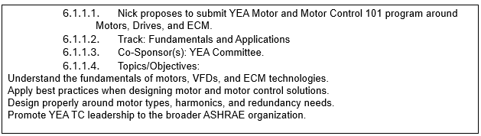
Motion: Steven Rosenstock/Randall Higa 5-0-0-3-CV (PASS) – Steven Rosenstock made a motion to co-sponsor the TC 1.11 seminar for the YEA Motor and Motor Control 101 as shown above with a second from Randall Higa. There was no additional discussion, and the motion passed unanimously.
Gerardo shared two tracks for Las Vegas that might work for our TC, which are Energy Storage and Grid Resiliency and Future-Proofing the Built Environment. Discussion ensued with Larry suggesting, can microgrids be used to help with managing outages/resources? He cited that recently, New Jersey would not allow these interconnections as an example. Larry suggested this as a potential forum/brainstorm session. Also, Larry volunteered to write a proposal and talk with TCs 7.5 and 6.9. The plan is for Larry to post on Basecamp. Here are the dates for Las Vegas programs.
- May 28 Conference Paper Abstracts Due
- June 18: Abstracts Accept / Reject Notifications
- August 1: Debate, Panel, Seminar, Forum, Workshop, and Debate Proposals Due
- September 3: Conference Papers Due
- September 24: Conference Paper Accept/Revise/Reject Notifications
- October 3: Debate, Panel, Seminar, Forum, Workshop Accept / Reject Notifications
Lastly, Frank offered to review the future tracks for Austin.

  - Handbook: Gerardo Alfonso
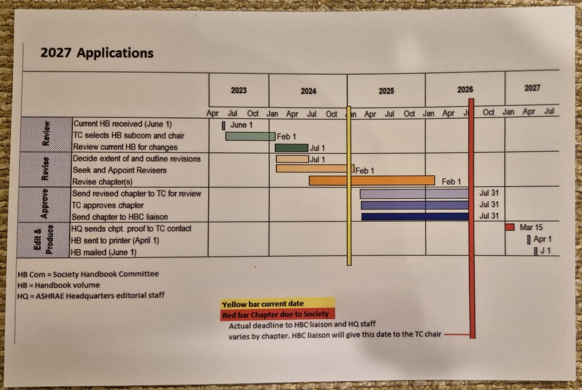
Gerardo posted updates to our Chapter 57. Larry replied with his comments via email and Marvin Thedford also made a recent comment via email. Frank suggested in the electric rates section to potentially present a comparison of regulated versus de-regulated electricity rates. Larry suggested it might be better to define the types of rates and provide information only, not analyze them. Larry suggested that Frank’s idea might make an excellent future forum. Steven Rosenstock suggested moving monitoring from the rates section to the efficiency section and to double check if there is another chapter already on monitoring. Gerardo will upload the document with Larry’s comments to the authoring portal to aid in revision. Gerardo laid out a rough schedule of folks to review in the following order: Steven Rosenstock, Stephen Duda, Jim Frey, Randall Higa, and again Larry Markel. FYI, the entire handbook is online as READ ONLY for ASHRAE members (ASHRAE Handbook Online). Lastly, Gerardo proposed a handbook working meeting in mid-November to finalize the chapter so a vote can be taken in Las Vegas.

  - Membership: Larry Markel
Total TC membership stands at 54 at this meeting. 8 VM, 0 MNQ, 22 PCM, 24 CM, 10 YEA.

  - Professional Development Committee (PDC Coordinator): John Nix
None.
g. WEBSITE: Steven Faulkner
Website is up to date.

- LIAISON REPORTS
Section Head (Jason Atkisson): New strategic plan for 2025 – 2028 is available on the ASHRAE website. TAC has asked for funding to help improve FGs, like to update the roster update tool and the activity form. The new society year starts on July 1. Our new section head will be Natascha Milesi-Ferretti. Jason is not leaving TAC and will hold a different position (training coordinator). YEA program shadow board members is being expanded to include the technical side, e.g. TAC chair shadowing. Please visit the government affairs webpage and sign up for bi-weekly newsletter/update. Jason will follow-up on fixing the TPS.

RAC: None.

TAC: None.

Handbook (Rex Scare): Chapter due 4/15/26 and needs to be voted out of our TC by then (suggest voting in Las Vegas). This is Gerardo’s plan. Please email Heather Kennedy to get access for everyone to the authoring portal.

Center of Excellence for Building Decarbonization [CEBD](Randall Higa): CEBD is now permanent. Strategic focus progressing which includes long term planning, strategic vision, and AI integration.

TC 7.5 Smart Building Systems (Jianming Lian): None.

- OLD BUSINESS
Website shows: 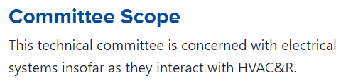

Agenda shows: "TC 1.9 is concerned with electrical systems insofar as they interact with the built environment."

Our TC voted in December 2023 to approve the expanded scope and was submitted to TAC for approval. TAC has provided the following feedback at this meeting: TAC believes that "the built environment" scope is too broad.

TAC approved our new TPS during their late meeting in Chicago!

Again, Gerardo announced that our scope has still not officially been changed.

- NEW BUSINESS
Jim Frey asked the TC some questions concerning power quality research. Is everything figured out and are there any issues/unknowns?
Randall explained that the cost to address PF and harmonics are spread across everyone and “no one really cares anymore.” Steven Rosenstock shared that there were concerns about 20+ years ago but most of the issues have been addressed. For example, there are IEEE standards addressing harmonics (e.g. IEEE 519-2022: IEEE Standard for Harmonic Control in Electric Power Systems).

- ANNOUNCEMENT OF NEXT MEETING
The next Winter meeting will be held in Las Vegas, NV on February 3, 2026, from 3:30 pm to 5:30 pm.

Gerardo will send out a Doodle poll for our next interim meeting likely in November.

Gerardo thanked everyone for attending the meeting.

- ADJOURNMENT
Steven Rosenstock motioned to adjourn the meeting with a second from Randall Higa. The meeting was adjourned at 5:26 PM (EDT).

Respectfully Submitted,

Michael S. Todd
Secretary

Note: These draft minutes have not been approved and not the official, approved record until approved by the TC.

Appendix I – TC Chair’s breakfast slides & handouts

