TC 1.13 Optimization
Meeting Minutes for ASHRAE 2025 Winter Conference
Sunday, February 9, 2025
Orlando, FL, and hybrid-remote
http://tc0113.ashraetcs.org/

TC 1.13 meetings this meeting:

Main Committee Meeting (hybrid)
Sunday, February 9th, 2025, 1:00 – 3:00 PM EST
Room: Clear Lake (lobby level)
MS Teams

1.13 program activities this meeting:

(none for this Orlando meeting)

Co-sponsoring:
(none for this Orlando meeting)

Agenda:

1. Call to Order and welcome all members and visitors Zhenning Li
Meeting was called to order 1:10 pm (EST)

2. Roll Call / Introductions / Record Attendance Zhenning Li

Record attendance

6 of 6 voting members presented. Quorum established at 1:39. Motion to pass previous meeting minutes proposed by Rohit. Approved by all. Meeting minutes approved.

3. ASHRAE Code of Ethics Commitment Zhenning Li
In this and all other ASHRAE meetings, we will act with honesty, fairness, courtesy, competence, integrity and respect for others, and we shall avoid all real or perceived conflicts of interests. (See full Code of Ethics: https://www.ashrae.org/about-ashrae/ashrae-code-of-ethics.)

3. Introduction of ASHRAE Liaisons on Arrival Zhenning Li
Our Section Head is Jason Atkisson; welcome, Jason.

4. Establishment of Quorum Zhenning Li

Roster: Voting members for this meeting (Orlando)
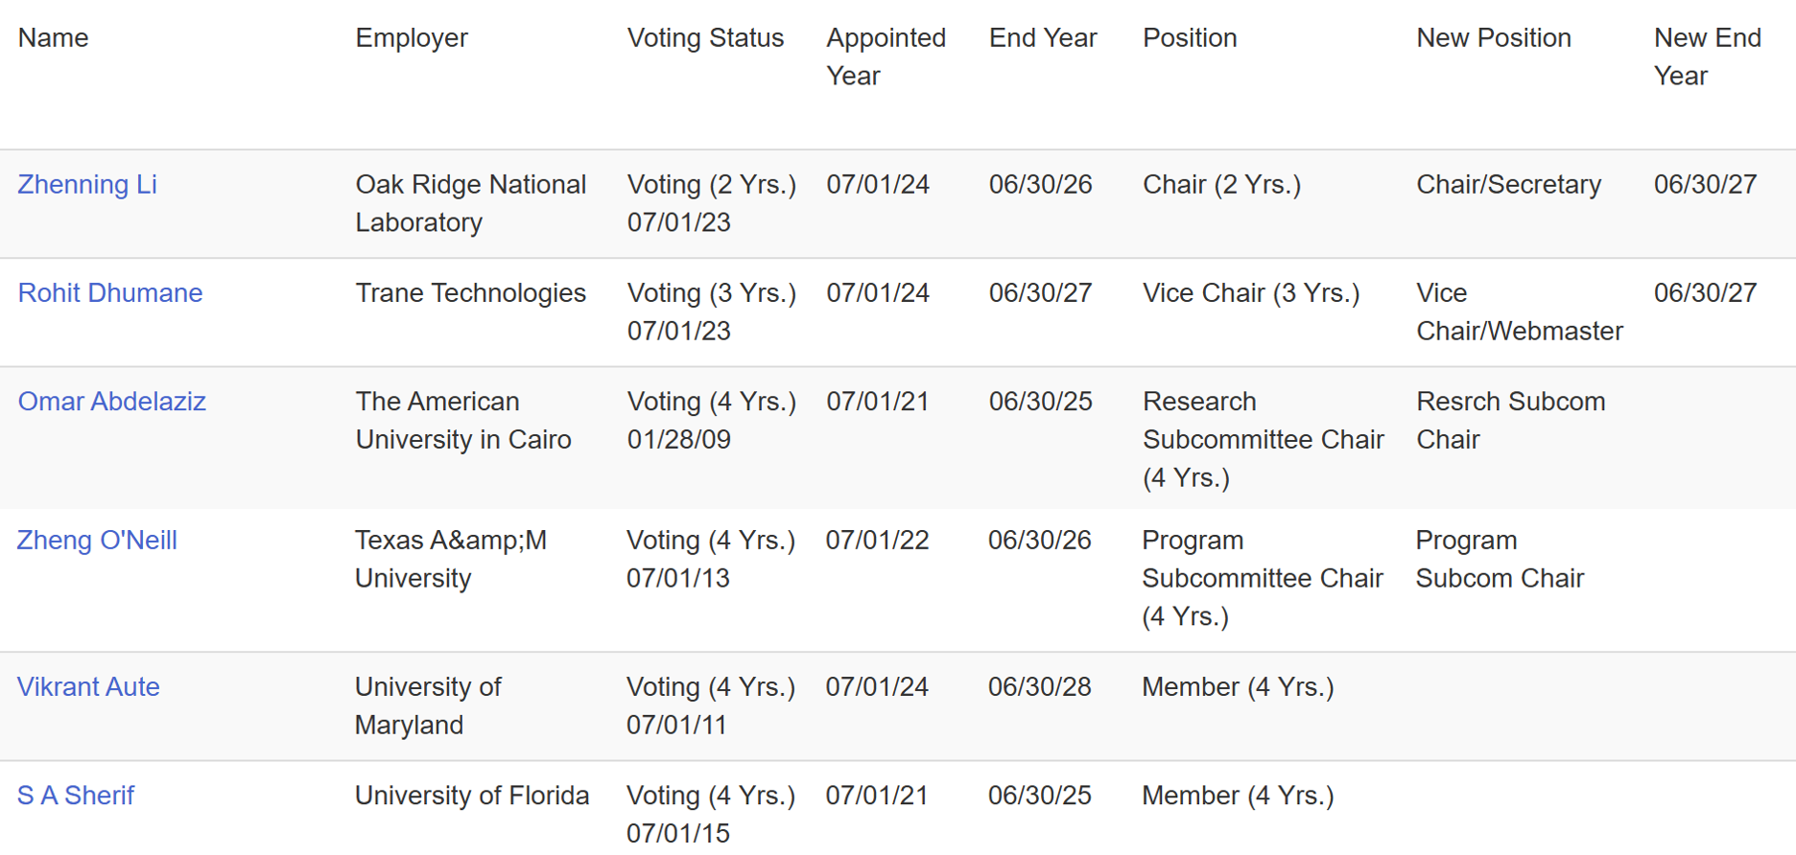
The TC presently has 6 voting members.
Recently, 2 new members requested to join the committee through TC’s website.

5. TC 1.13 Purpose Statement Zhenning Li
Purposes Statement
TC 1.13 is concerned with identifying, developing, and disseminating optimization techniques that enhance the performance of HVAC&R components, systems, and building systems that are not application or tool specific. The committee is focused on the fundamentals of optimization techniques including mathematical formulation, constraints handling, multi-objective optimization, approximation techniques, and robust optimization. These fundamentals are the foundation of data-driven, machine learning (ML), and artificial intelligence (AI) methods.

6. Approval of previous meeting minutes Zhenning Li
1:23 pm The Indianapolis meeting minutes are approved.

7. Chairman’s Overview and Report Zhenning Li
Rohit provided details of updates to RTAR process. Committee may teach course for ASHRAE by co-sponsoring with ALI. Vikrant provided information from his previous courses. Difficult to decide coursework to cater to audience.

8. Subcommittee Reports

a. Program Zheng O’Neill
The following seminars were proposed for the Pheonix annual conference.

Seminar 1: Systematic Approaches to Minimize Charge for Flammable Refrigerants in Refrigerators and Heat Pumps
Chair: Vikrant Aute, Ph.D.
- A Survey of Numerical Studies on Refrigerant Charge Optimization
Presenting Author: Rohit Dhumane, Trane Technologies
- Working with Flammable Refrigerants: Tradeoff between Safety and Performance
Presenting Author: Omar Abdelaziz, The American University in Cairo
- Optimal Dynamic Charge Management of Heat Pumps
Presenting Author: Jie Cai, Purdue University

Seminar 2: Physics-Informed Machine Learning in HVAC
Applications
Chair: Rohit Dhumane
- Review of Techniques and Applications of Using Machine Learning Models for Automatic Discovery of Physics from Data
Presenting Author: Rohit Dhumane, Trane Technologies
- Using Physics-Constrained Machine Learning for State Estimation of Vapor Compression Systems
Presenting Author: Vedang Deshpande, Mitsubishi Electric Research Laboratories
- Automated Discovery of HVAC and Thermo-Fluid Systems from Data Using Julia
Presenting Author: Ranjan Anantharaman, JuliaHub Inc
- LLM-Driven Data Extraction for Physics-Enhanced Building Equipment Modeling
Presenting Author: Hanlong Wan, Pacific Northwest National Laboratory

Seminar 3: Optimization Methods for Components, Systems, and Grid-Interactive Buildings
Chair: Cheng-Min Yang
- Optimization of Chilled Water Systems, Including AHUs, Chillers, Pumps and Cooling Tower Operations for Reduced Utility Use and Increased Reliability Using Adaptive and Feed Forward Control Processes Using the Existing BMS
Presenting Author: Duane Warren, Engineering Director, Jones Lang LaSalle
- Demand Flexibility Optimizations for Building Energy Systems with an Ice Thermal Energy Storage Tank in a Commercial Building
Presenting Author: Zheng O'Neill, Texas A&M University

2025 Phoenix tracks:
https://www.ashrae.org/conferences/2025-annual-conference-phoenix/2025-annual-conference-technical-program

Technical Program Chair: Som Shrestha (shresthass@ornal.gov)

      - Fundamentals and Applications (Track Chair: Erik Sanchez, esanchez@prmech.com)
      - HVAC&R Systems and Equipment (Track Chair: Li Song, lsong@ou.edu)
      - Refrigeration & Refrigerants (Track Chair: Jon Cohen, jonjcohen1@gmail.com)
      - Energy Storage and Grid Resiliency (Track Chair: Robin Bryant, RBryant@bandiflorida.com)
      - Pathways to Building Decarbonization (Track Chair: Joe Chow, joe.ashrae@gmail.com)
      - Artificial Intelligence (Track Chair: Suzanne LeViseur, sleviseur@haddadeng.com)
      - Industrialized Construction: Opportunities and Challenges (Track Chair: Stephanie Mages, s_mages@yahoo.com)
      - Ventilation and Indoor Environment Quality (Track Chair: Ehab Mamdouh, Joshua Vasudevan, joshuavasudevan2011@gmail.com)
      - Future-Proofing the Built Environment (Track Chair: Joshua Vasudevanm joshuavasudevan2011@gmail.com)

Wednesday, February 26, 2025: Debate, Panel, Seminar, Forum, Workshop, and Debate proposals for Orlando are due.

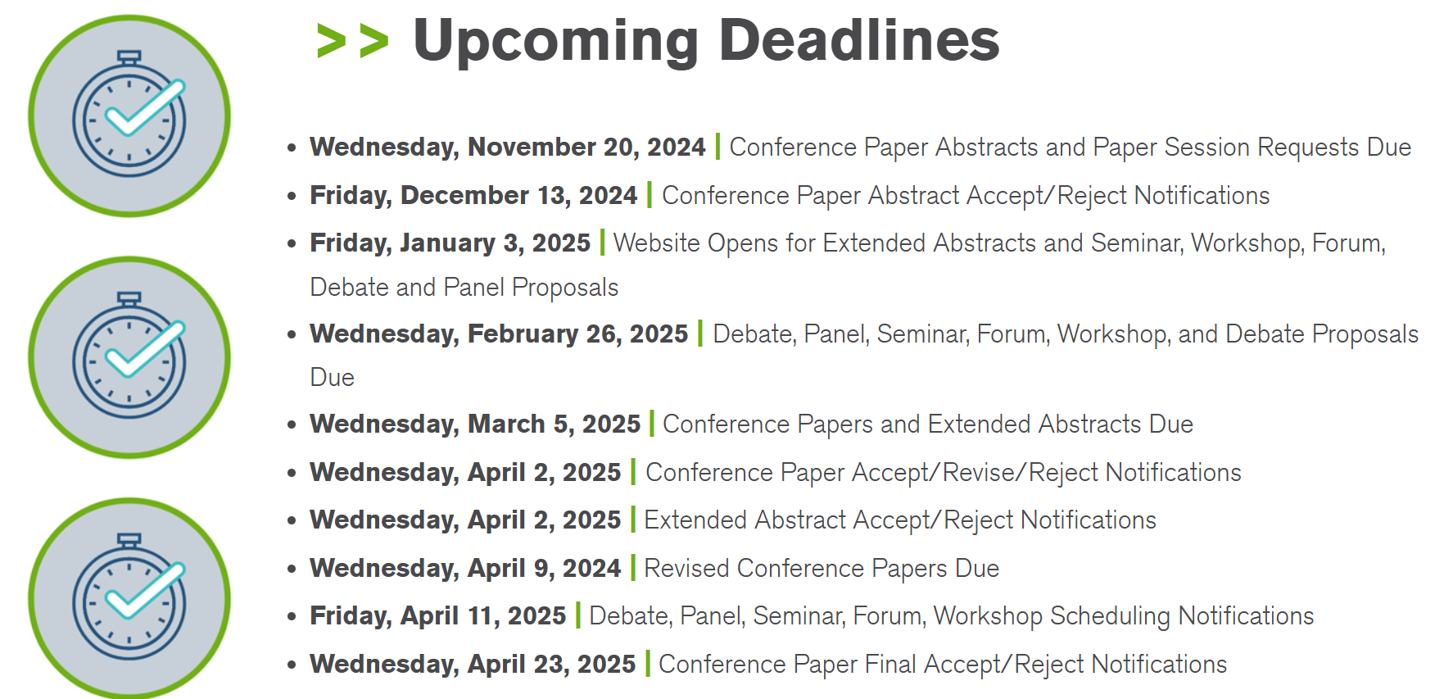

b. Research Omar Abdelaziz
Summary of notes that may serve as a useful starting point:
- To date we haven’t investigated RTARs in this TC.
- TC1.13 is in a great position to support research by other TCs.
- Optimization that is agnostic of application is outside ASHRAE scope.
- Other committees relevant to data-driven models, AI, ML, etc.,
    - TC 4.7 has subcommittee on data driven modeling, and
    - TC 4.10 has a subcommittee regarding machine learning.
- Co-sponsorship with other TCs
- Discussed RTAR with TC 4.7 data-driven modeling, but no active or proposed RTARs were identified for co-sponsorship. Potentially work with TC 1.4 and TC 7.5. RTAR 8.11 in unitary products.

c. Handbook Zhenning Li
Rohit suggested that we create a new subcommittee meeting.

d. Standards Zhenning Li

e. Membership Zhenning Li
Rohit promoted TC 1.13 in YEA.

f. TC Website Zhenning Li
Zhenning manages TC website.

9. Old Business All

10. New Business All

11. Next subcommittee and committee meetings Zhenning Li

12. Adjourn All
Rohit motion to adjourn at 1:58. Seconded by Vikrant.

