Agenda
SSPC 154 Ventilation for Commercial Cooking Operations
In-Person Summer Meeting
Indianapolis, IN
Sunday, June 23rd, 2024, 3:30 PM – 5:30 PM EDT
JW Marriott (105)
- Call to Order
  - Commitment to the ASHRAE Code of Ethics – In this and all other ASHRAE meetings, we will act with honesty, fairness, courtesy, competence, integrity, and respect for others, and we shall avoid all real or perceived conflicts of interests. See full Code of Ethics and core values. https://www.ashrae.org/about-ashrae/ashrae-code-of-ethics. https://www.ashrae.org/about/ashrae-s-core-values.
  - ASHRAE Commitment to Care-The health and safety of all ASHRAE conference attendees is a top priority. Out of respect for our fellow attendees, monitor our health, seek medical attention if symptoms develop and adhere to all ASHRAE Commitment to Care protocols. We are committed to the well-being of one another.
  - Recording (Audio, Video, Screenshots) of ASHRAE meetings, including online meetings, is strictly prohibited.
  - Introduction of Members and Guests
PCVM Name | Affiliation | Classification | Present
Mr. Keith Page | Selkirk-Hart & Cooley | Chair, Producer (V)
Mr. Behrang Gilanpour | Mellifiq | Vice Chair, Producer(V)
Mr. Bryan Miller | Melink Corporation | Secretary, Producer (V)
Mr. Rich Swierczyna | GTI | General (V)
Mr. Randall Cooper | AHAM (Assoc Home Appliance Mfgrs) | General (V)
Mr. Jason Greenberg, PE | HFA | General (V)
Mr. Richard T Jones, PE | National Engineering | User (V)
Mr. Francis J Kohout, PE | Cyclone Energy Group | User (V)
Mr. Mark Skierkiewicz, PE | UL | General (V)
Mr. Terry McCabe | Greenheck & Accurex | Producer (V)
Mr. David Hodson | Schneider Electric | User (V)
Mr. Russell Robison | Gaylord Industries | Producer (V)
Mr. Andre R Saldivar, I | SCE | General (V)
Mr. Fuoad Parvin, PE | Halton Company | Producer (V)
Dr. Margaret M. Mathison | Iowa State University | SPLS Liaison (NV)
Mr. Mark J Weber | ASHRAE | Staff Liaison (NV)

PCNVM & Guests | Affiliation | Present | PCNVM & Guests | Affiliation | Present
Mr. Derek Schrock | Halton |  | Mr. Steve Brown | Retired
Mrs. Jessica Weaver | Accurex |  | Jason Brown | Melink
Mr. Ermias Lamesgin | Greenheck |  | Jeff Parks | SMACNA
Mrs. Cherish L Samuels, PE | Amazon |  | Laura Degitz | Energy Solutions
Mr. Dan Mason | CleanAir Group |  | David Lunderberg | DOE/AAAS
Pradeep Prathibha | DOE/AAAS |  | Mina Agarabi | Agarabi Engineering
Terry McCabe | Accurex |  | Charlie Souhrada | NAFEM

  - Quorum Determination.
.
  - Announcements

- Roster Updates

Membership form: https://www.ashrae.org/technical-resources/standards-and-guidelines/apply-to-a-project-committee

- Approval of winter 2024 Chicago meeting minutes.

- Continuous Maintenance Addenda/Proposals

  - Section 6.2.1. It is permissible to supply replacement air to the kitchen space by using transfer air from areas other than the kitchen that meets air classification requirements per ASHRAE Standard 62.1.”
Working group: JW, RR, FP, JG (tabled in summer)

  - Section 5 EXHAUST SYSTEMS, propose to add subsection for duct clearance(s).
- Working group: KP (lead), MS
Decision: KP, RR and RJ will work on the language, will be revisited during the next meeting.
Decision: Asking internally to see where the 18” clearance comes from. Update to be presented during the next meeting. **K.Page: likely stems from 18” clearance for heating appliances from the 1960’s (NFPA 211 covering cooking appliances back then).
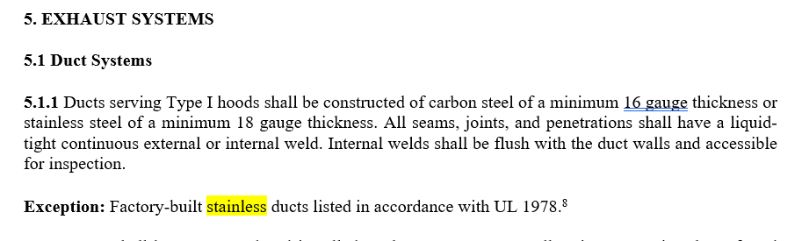
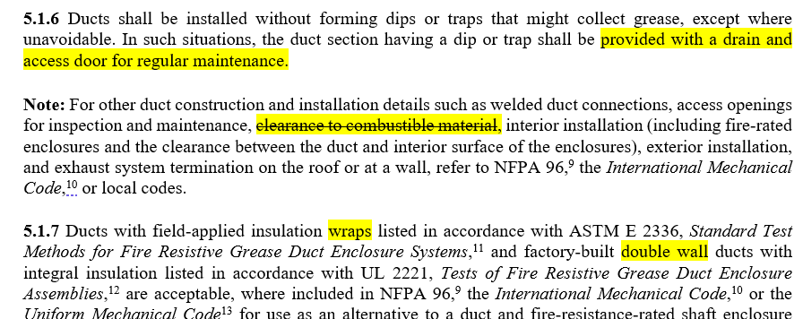
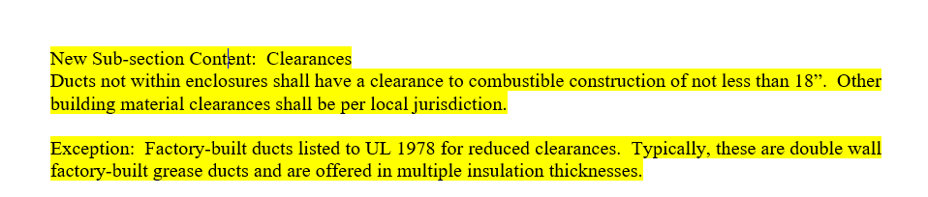
  - Grease Duct Sump. Address duct sump in the standard

Working group: KP (lead), DS, JG, KP, (RR colleague Bruce Lukens NFPA 96 committee member)
- Produce scripts encompassing NFPA 96 and IMC for duct sump and clarify installation and use. Grease Duct Sump needs to be defined in Section 3 Definitions.
Decision: Reservoirs/sumps language to be drafted for the standard. Changed lead from RR to KP.
IMC 2021, 506.3.7.1 Grease duct reservoirs. Grease duct reservoirs shall:
1. Be constructed as required for the grease duct they serve.
2. Be located on the bottom of the horizontal duct or the bottommost section of the duct riser.
3. Extend across the full width of the duct and have a length of not less than 12 inches (305 mm).
4. Have a depth of not less than 1 inch (25 mm).
5. Have a bottom that slopes to a drain.
6. Be provided with a cleanout opening constructed in accordance with Section 506.3.8 and installed to provide direct access to the reservoir. The cleanout opening shall be located on a side or on top of the duct so as to permit cleaning of the reservoir.
7. Be installed in accordance with the manufacturer’s instructions where manufactured devices are utilized.

  - Section 4.7 Hood Performance Test. Working group: DS(lead), RR, AS, RS, FK.
- To better address distinction in conducting the performance tests between type I and type II.
Update: No new text yet. Suggestion is to perhaps update the air flow rates for type II hoods instead of adding a capture/containment test that may not work. DS will also look into the overhangs. Proposal to be discussed in Chicago in 2024. To be added language/sub-section about updated hood performance testing/rebalancing if there is a modification in kitchen appliances.
Russ previously had mentioned 1778 flow rates ??

  - Section 6.2 Air Balance. Air Balancing for Commercial Kitchen Additions.
Working Group: BM (lead), RR, DH.
Decision: How can we couple the hood performance section with the air balancing section. The hoods need to be performing sufficiently if/when air flows change.
G. Section 7 System Controls. Controls and/or commissioning for DCKV systems – performance, building pressurization, air replacement, etc.
Working Group: Frank Kohout (lead), Rich Swierczyna, Russ Robison, Jason Greenberg.
1. COMMISSIONING PLAN
2. DESIGN REVIEW
3. PREFUNCTIONAL CHECK’s
4. FUNCTIONAL PERFORMANCE TESTING
5. POST OCCUPANCY TESTING (E,G. CKV SEASONAL TESTING)
6. MONITORING-BASED COMMISSIONING PLAN FOR CKV SYSTEMS
7. RETRO COMMISSIONING AND RECOMMISSIONING

Decision: Taking the checklist for commissioning from the Design Guide and adding it to an appendix. Changing the title of section 7 to include CKV and DCKV, wording by the working group (Std language style)
- TPS-Add residential. Propose to address Residential in the current publication and consider a future split: 154.1 for commercial and 154.2 for residential.
Working group for residential impacts. Rich Swierczyna (lead), Jason Greenberg, Derek Schrock, Mark Skierkiewicz, Russ Robison, Keith Page, Cherish Samuels, Behrang Gilanpour.
Title: Ventilation for Commercial Cooking Operations
SCOPE 2.1 This standard covers commercial and residential
Airflow, Sound, Capture Effic 62.2 (HVI 920) by 2025 (R. Cooper, liaison for 62.2)
Rich S. is planning to propose two potential paths (either split into two standards or augment existing). Randall Cooper talked about some of what 62.2 has been working on RE: range hoods. Airflow numbers are set. Planning on rating system for capture efficiency. Next will look at meeting sound requirements.
Rich and Randy to continue working on this.
- IECC kitchen exhaust limitations ~ maximum airflow ASHRAE 90.1. Rich Swierczyna to review for performance risks based on current research.

- SSPC 154 website, webmaster Keith Page.
https://tpc.ashrae.org/?cmtKey=ec57a86f-f70e-4ec0-b92d-7ad966a42d66

- Old Business
  - IFGC and Dampers: Amend 505.1.1, proposal to add “Exception 2” allowing dampers use in grease exhaust systems.
-Working Group: Derek Schrock and Keith Page. Pursue 2030 IFGC and will work thru ASHRAE Codes dept once we vote on it.
505.1.1 Commercial cooking appliances vented by exhaust hoods. Where commercial cooking appliances are vented by means of the Type I or II kitchen exhaust hood system that serves such appliances, the exhaust system shall be fan powered and the appliances shall be interlocked with the exhaust hood system to prevent appliance operation when the exhaust hood system is not operating. The method of interlock between the exhaust hood system and the appliances equipped with standing pilot burner ignition systems shall not cause such pilots to be extinguished. Where a solenoid valve is installed in the gas piping as part of an interlock system, gas piping shall not be installed to bypass such valve. Dampers shall not be installed in the exhaust system.
Exception 1: An interlock between the cooking appliance(s) and the exhaust hood system shall not be required where heat sensors or other approved methods automatically activate the exhaust hood system when cooking operations occur
Exception 2: Dampers can be used where specifically listed for such use, or as part of a listed device or system. Dampers shall not restrict the venting of byproducts of combustion. Access shall be provided to both sides of the damper for the purposes of servicing and cleaning.

  - IMC M49-21 Passed IMC hearing allowing Unconditioned Makeup air through compensating hood.
Working group: Keith Page and Mark Skierkiewicz-ASHRAE code interaction committee.
Status: It’s in the 2024 IMC (see below). Pursue chg’n it for 2030 IMC via ASHRAE codes dept.
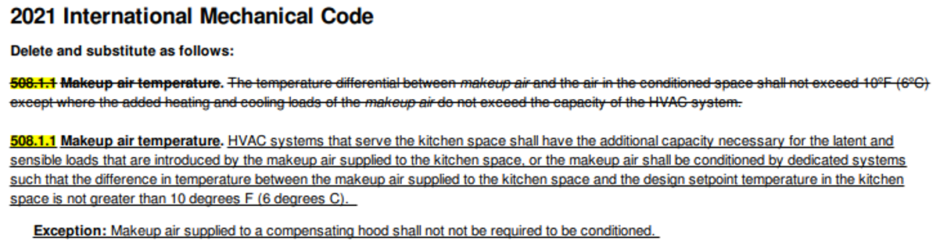
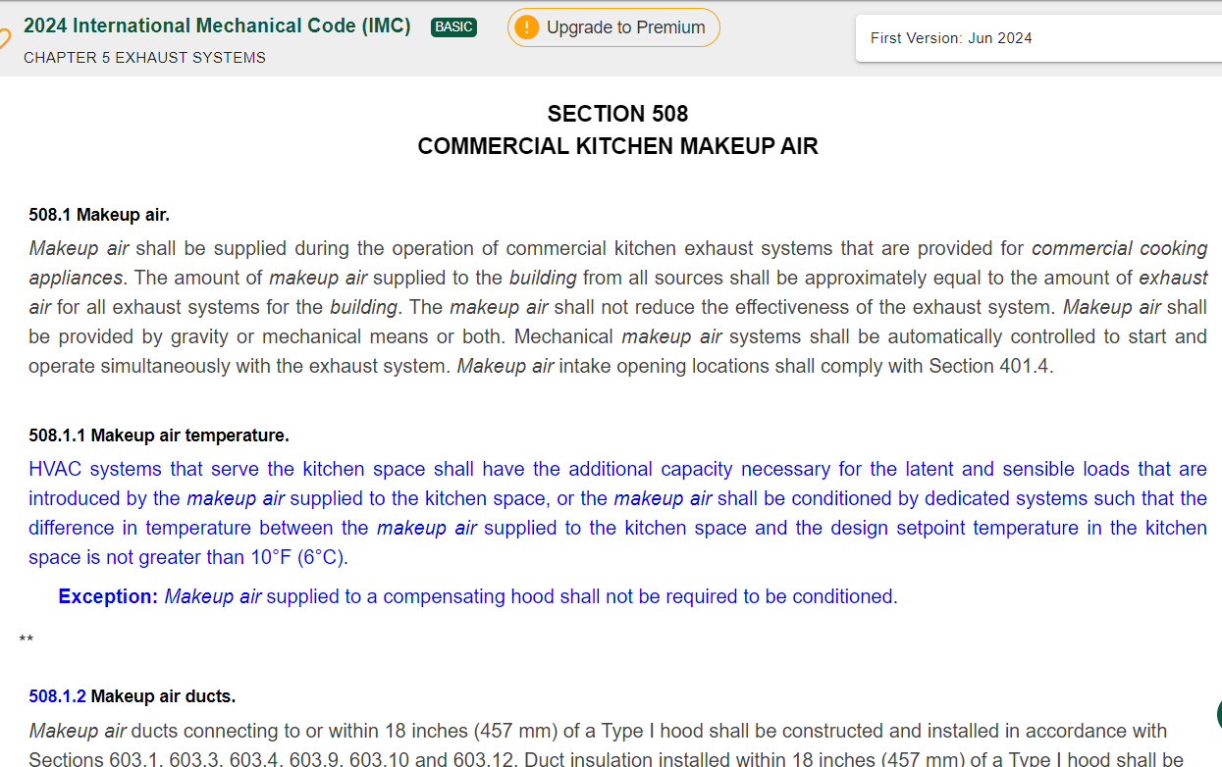

  - Determine if there are any volunteers to monitor relevant codes (IMC, UMC, NFPA 96).

- New business
- Next Meeting: Winter Conference, Orlando 2025.
- Adjourn

