

TC MINUTES COVER SHEET

(Minutes of all Meetings are to be distributed to all persons listed below within 60 days following the meeting.)

TC No. 2.2 DATE Monday, June 24, 2024

TC/TG/MTG/TRG TITLE Plant and Animal Environments

DATE OF MEETING June 24, 2024 LOCATION Indianapolis, Indiana

MEMBERS PRESENT | YEAR APPTD | MEMBERS ABSENT | YEAR APPTD | EX-OFFICIO MEMBERS AND ADDITIONAL ATTENDANCE
Danielle Monfet (Chair, VM) |  | Alekhya Kaianathbhatta (Programs, VM) |  | Bill Dean
Eric Sturm (Vice Chair, VM) |  | James Dyck (VM) |  | Joe Zulovich
Niss Feiner (VM) |  | Morgan Hayes (Webmaster/Handbook) |  | Kevin Muldoon
Craig Burg (MTG.CEA) |  | Henry Hays (MTG.ACR) |  | Anne Juran
 |  | Kyle Bowling (VM) |  | Darrell Sandlin
 |  |  |  | Pete Spinelli
 |  |  |  | Chen- Wei Liu
 |  |  |  | Tanner Whatley
 |  |  |  | Mindi Jimenez
 |  |  |  | Xinlei Wang
DISTRIBUTION: All Members of TC/TG/MTG/TRG plus the following:
TAC Section Head: Ms Lan Chi Nguyen Weekes, PE
Mike Vaughn,
Manager Of Research & Technical Services

Call to Order (Danielle Monfet)
- Meeting called to order by Chair Danielle Monfet at 2:30 p.m. EDT

Quorum not established.

Welcome and Introductions/Attendance (Monfet)

Review Scope

Code of Ethics (Monfet)
Code of Ethics Statement read by Chair Nadia Sabeh. “Commitment to the ASHRAE Code of Ethics – In this and all other ASHRAE meetings, we will act with honesty, fairness, courtesy, competence, integrity and respect for others, and we shall avoid all real or perceived conflicts of interest. (See full Code of Ethics: https://www.ashrae.org/about-ashrae/ashrae-code-of-ethics.)”

Accept Agenda (Monfet)
Motion to approve agenda moved and approved.
Skipped

Chair’s Report (Monfet)

Announcements and Highlights from TC Chair’s Breakfast (Monfet)
- Emphasis on decarbonization

Liaison reports
- TAC Section 2 head: Ms Lan Chi Nguyen Weekes, PE
  - Thank you for everything you do, and volunteering your time
  - Update roster by June 30
  - Succession should be in place for TCs
  - Activity form due Tuesday, Midnight, June 25
  - Please update your website
    - Scope approval is there
    - Latest agenda
    - Latest minutes
  - Strategy plan for society is not official and still being worked on
    - Align MBOs on existing requirements
    - Include decarbonization
  - Let me know about your difficulties
    - Love to hear of your accomplishments
    - Want to know what is happening, not just problems
    - Make sure you use your volunteers and get people involved
  - Question: functional group MOP – TAC chair can extend appointments through a written request to extend Niss’s voting status
  - Action: Eric to send Ms. Lan Chi Nguyen Weekes card to Danielle
- RAC
  - Not present
- MTG.ACR (Joe Zulovich, alternate)
  - Forum on Sunday morning discussing basics of air change rates
  - Group is still active
- MTG.CEA (Michael Gillespie)
  - Circulated a number of topics to be covered with agricultural section
  - Plan to review tomorrow to break up specialties and attack each piece
  - Establish state of the art, determine what needs to be augmented, then act
    - Handbook
    - New section
    - New guides
  - Identify TCs that want to say something on the spaces
  - Michael to become chair MTG.CEA
  - Kevin to become section head on TAC for MTGs
  - Michael to become TC 2.2 member as of July 1, 2024 and then will become MTG.CEA liaison
  - Kyle Bowling is listed as MTG.CEA alternate from TC 2.2 – will continue to serve in this position
    - Action: Danielle to contact Kyle and verify desire to continue serving as MTG.CEA alternate
    - Note: Hal Sindelair volunteered to serve as alternate if needed

Approval of minutes
- Postponed and will be done via email ballot

Membership roster
Starting July 1st: (All voting members and/or subcommittee chairs)
Name | Role | Voting
Danielle Monfet | Chair | Yes
Eric Sturm | Vice Chair | Yes
Alekhya Kaianathbhatta | Secretary | Yes
Nissun Feiner | Research Chair | Yes
K William Dean | Standards Chair
Morgan Hayes | Handbook Chair
Alekhya Kaianathbhatta | Program Chair | Yes
Morgan Hayes | Webmaster

- Roster was not updated for this year, but should be corrected as of July to stagger
- Action: Danielle to establish an email ballot to address membership (voting members, MTG.CEA members); additional voting member Xinlei Wang from University of Illinois
  - Discussion: TC chair can specify voting members and MOP allows this along with approval from TAC section head

Standards
- Bill Dean willing to continue service

Handbook Chair
- Morgan has not been around in a while
- Hal Sindelar has volunteered for handbook chair

Webmaster
- Anne Juran volunteered to serve as webmaster
- Action: Eric to add Anne Juran to Basecamp

Subcommittee reports
- Programs (Alekhya)
  - Michael reported on Seminar 8 and 16
  - Both seminars lightly attended but had decent questions
  - Request from TC 9.1 Large Building Air Conditioning Systems to co-sponsor a proposal for special challenges in pet relief areas and special challenges in growing facilities
    - Michael volunteered to speak on growing facilities
    - Niss stated his previous presentation might be applicable
  - Michael: micro-grow facility – would like to do a whitepaper “Case Studies in Decarbonizing Grow”
    - Could do a seminar instead (conference paper deadline missed?)
    - Comment: wrap-around heat pipe and liquid desiccants and decarb
    - Comment: debate three technologies to approach the same problem and discuss which would be best.
  - Action: Alekhya/Niss/Michael to coordinate a session before August 2 submission deadline
    - TC 9.10 research on desiccant wheel and contamination mentioned by Anne Juran
    - Anne to mention at the TC 9.10
    - Comment: suggested to reach out to TC 8.10?
  - Niss: Track from last summer had three topics through Indoor environmental quality track – “We’ve had one, yes, but what about second apocalypse?”
    - Speakers: Nadia, Niss, Joe Zulovich identified a veterinarian
    - Comment: did speak about co-sponsorship but hadn’t identified speakers in Tampa last year
    - Action: Michael to reach out to MTG.RAST to determine interest in “We’ve had one, yes, but what about second apocalypse?”
    - Action: Niss to reach out to Nadia to determine interest in “We’ve had one, yes, but what about second apocalypse?”
    - Action: Michael to inquire with MTG.CEA on interest for co-sponsorship of “We’ve had one, yes, but what about second apocalypse?”
  - https://www.ashrae.org/conferences/2025-winter-conference-orlando/2025-winter-conference-technical-program
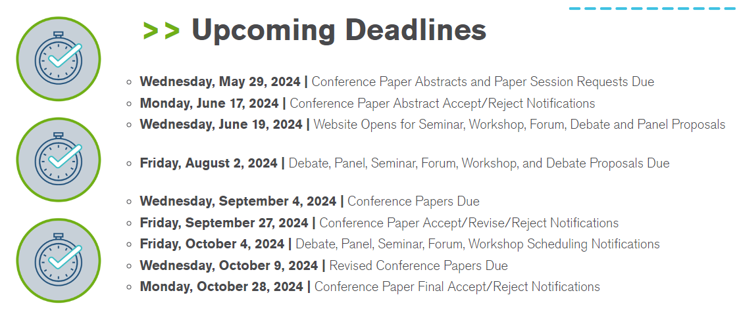

- Research (Niss)
  - RTAR-1887 Energy Use in Indoor Plant Environments
    - Will allow it fall aside
    - No work statement has been put together
    - Could be revisited later
    - Pete Spinelli and Bill Dean volunteered to participate in this RTAR
    - Action: Niss to determine status of RTAR-1887 and whether it needs to be restarted from scratch
    - Action: Niss to start a working group and begin work on RTAR-1887
  - RTAR-1901 Plant Transpiration Rates
    - Work statement written by Michael
    - Chris Gray, RAC liaison reviewed and send feedback for review
    - Michael: they wanted more information and specificity, and this would require a working group
    - First draft available on Basecamp
      - Michael: yesterday’s seminar discussed how the four methods we have don’t track well with actual transpiration rates
    - One comment was that funding request was insufficient
    - Co-funding
      - Comment: need to identify organizations and contacts and determine their willingness
      - Comment: NYSERDA, utilities, RII might have ideas on potential co-funders
      - Comment: equipment manufacturers
      - USDA has a grant program
      - Action: Niss to reach out to James Dyck around funding of research
    - Level of effort needs to be determined
    - Justification to the value of ASHRAE: should be tied back to strategic plan
      - Danielle volunteered to help with this
    - Action: Niss to reach out to Chris Gray and update with plan to move forward on RTAR-1901
    - Action: Niss to setup monthly meetings for research discussion
    - Action: everyone to use Basecamp site to volunteer for research group inclusion, contribute ideas to Basecamp for safekeeping
  - How to incorporate ASABE
    - The same people here in the room are involved with ASABE
    - Comment: they’re more focused on greenhouses
- Handbook (Hayes/Sabeh/Sindelar)
  - Rex Scare introduced himself as 2027 Handbook liaison
    - We have two chapters in the Applications handbook (chapters 25, 26)
    - 25: Indoor Plant and Animal Environments
    - 26: Drying and Storing
    - Revisions due April 2026
    - Rex: you’ll want to make sure that your changes were incorporated and report issues for mid-year change in online version
    - Chapter documents should be on the Authoring Portal by end of July
    - If you need access, reach out Heather Kennedy (hkennedy@ashrae.org)
    - Handbook chairs are invited to training meetings which is typically Sunday mornings around 9:00
    - Craig: Chapter 25 edits are available on Basecamp but we don’t see Chapter 26 edits online
- Standards (Dean)
  - No report, no standards activities at this time
- Website (Juran)

Old Business
- Design Guide for CEA (Niss)
  - Will keep as old business item

New Business
- None

Meeting adjourned at 4:05 p.m. EDT

