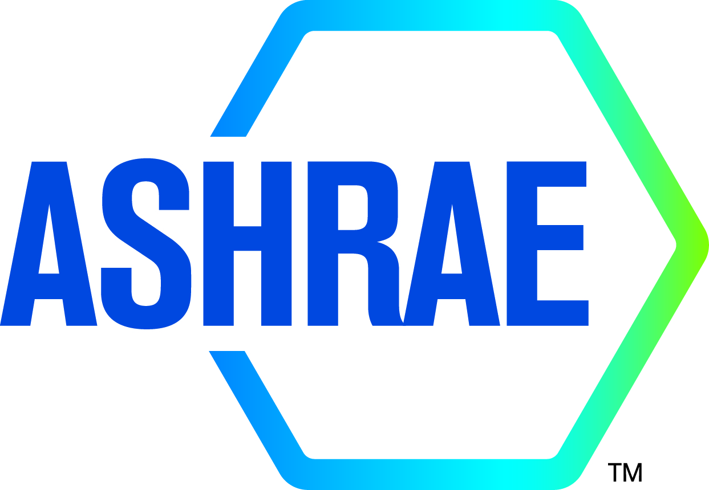

M I N U T E S

DRAFT

TC1.13 Optimization

2022 ASHRAE WINTER MEETING
Hybrid

Tuesday February 1, 2022, 1:00 – 3:00 PM Pacific
Location: Caesars Palace Octavius 7 (PS) meeting room
WebEx remote meeting

Note: These draft minutes have not been approved and are not the official, approved record until approved by the Technical Committee.
Minutes
1. Call to Order and welcome all members and visitors Kyle Gluesenkamp
Meeting was called to order at 1:05 pm (Pacific Time).

2. Roll Call / Introductions / Record Attendance Zhenning Li
Total Attendees: 11; 6 voting members; 4 corresponding members; 1 provisional member.
Two attendees are YEA members. 6 attendees participate on-site; 5 attendees remotely participate.

Full Attendees List
Name | Category
Kyle Gluesenkamp | Voting, Chair
Farhad Omar | Voting, Vice Chair
Vikrant Aute | Voting, Handbook Subcommittee Chair
Omar Abdelaziz | Voting, Research Subcommittee Chair
Khaled Saleh | Voting Member
S.A. Sherif | Voting Member
Chris Laughman | Corresponding Member
Zheng O'Neill | Program Subcommittee Chair
David Yashar | Corresponding Member
Zhenning Li | Secretary, YEA
Andrew Martin | Provisional Corresponding Member, YEA

3. ASHRAE Code of Ethics Commitment Kyle Gluesenkamp
In this and all other ASHRAE meetings, we will act with honesty, fairness, courtesy, competence, integrity and respect for others, and we shall avoid all real or perceived conflicts of interests. (See full Code of Ethics: https://www.ashrae.org/about-ashrae/ashrae-code-of-ethics.)
3. Introduction of ASHRAE Liaisons on Arrival Kyle Gluesenkamp

4. Establishment of Quorum Kyle Gluesenkamp
Voting Members for This Meeting (Need 4 for a Quorum)
VOTING MEMBERS FOR THIS MEETING
X | Kyle Gluesenkamp (6/30/2023) |  | X | S.A. Sherif (6/30/2025)
X | Farhad Omar (6/30/2025)
X | Vikrant Aute (6/30/2022)
X | Omar Abdelaziz (6/30/2025)
X | Khaled Saleh (6/30/2023)
The TC presently has 6 voting members. A roll call of the voting members was taken, and a quorum was established with 6 of 6 Voting Members present.

5. TC 1.13 Purpose Statement Kyle Gluesenkamp
TC 1.13 is concerned with identifying, developing and disseminating optimization techniques that enhance the performance of HVAC&R components, systems and building systems that are not application or tool specific.

6. Approval of previous meeting minutes Zhenning Li
Previous meeting minutes were reviewed by the attendees.
1:13 pm, Khaled move to approve the meeting minutes on 6/25/2021, Vikrant second with condition (recommend correcting typos and graphical errors). 5-0-0-1 (CNV)

7. Chairman’s Overview and Report Kyle Gluesenkamp
Kyle emphasizes the balance requirement now applicable to TCs
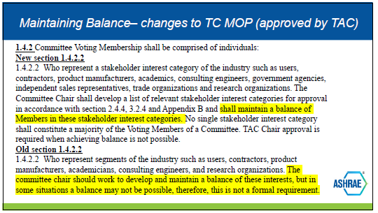
Current officers with categories:
 | officer role | category proposed
Kyle | Chair | G&R
Farhad | Vice chair | G&R
Zhenning | Secretary | G&R
Vikrant | Handbook | Academic
Omar | Research | Academic
Zheng | Program | Academic
Khaled |  | Manufacturer
Sherif |  | Academic

Action item: Kyle suggests voting member succession: in June 2022, Vikrant will roll off. If replaced by Zheng that would maintain category balance, Chris Laughman is also option.

Attendees discuss the FG motions to TAC and seek for any reason to expand or change scope for TC 1.13. Kyle reminds committee of the 3 available options for TC: continue TC 1.13 as an independent TC, merge with another TC, or dissolve the TC.
Omar notes that we have some low membership numbers. TC 1.5 (Computer application) is tangentially related. Omar notes that the committee has been struggling to complete handbook.
Farhad notes TC 1.4 (controls) is also close
Zheng notes other TCs, e.g., TC 7.5, section 8, use optimization.
Chris mentions that TC 1.13 is based on mathematical and fundamental methods. Other TCs are application-based.
Dave notes that 1.13 has a strength in programs. Not every TC has to be active in every area of TC activity (program, handbook, research, standards).
Omar says the handbook chapter will be an important contribution to ASHRAE for TC 1.13.
1:15 pm Vikrant moves to reaffirm as continuing as standalone committee Khaled seconds.
1:29 pm motion passes (5-0-0-1 CNV).

Kyle calls for recent awards to committee members.
- Zheng was elevated to ASHRAE Fellow.
Kyle calls for nominations of awards to committee members.
Vikrant volunteers to support a nomination
Kyle reviews list of available ASHRAE awards. Discussion of Fellow requirements:
- fellow needs to be a full grade member for 10 years
- 3 fellow candidates in TC 1.13: Dave, Vikrant, Omar
- It was noted that activities outside ASHRAE are the basis for Fellow awards.
- Fellow packages are due Dec 1 – includes couple letters of support, etc.
- ESA/DSA are due May

Kyle raises the discussion on whether to hold subcommittee meetings.
Vikrant proposes that we hold interim subcommittee meetings for handbook and suggests having someone take care of the handbook subcommittee meetings.
Action item: Khaled to schedule interim subcommittee meetings every other month. Interim meetings don’t require public advance notice. Subcommittee meetings at winter and summer (annual) do require notice.

Corey Metzger, section-1 head joined the meeting in-person. Corey reemphasizes
- the balance of member category.
- roster updates have new process online – due Feb 15
- goal is to not have a majority of any one category
- no requirement to have every category represented
- two forms (TC Activity Form and FG Evaluation Workbook) due

8. Subcommittee Reports Zheng O’Neill

a. Program

2022 June Toronto Annual Conference Tracks:
      - Fundamentals and Applications (Chair: Erik D Sanchez)
      - HVAC&R Systems and Equipment (Marites Calad)
      - Research Summit (Brian Fronk)
      - Connected Buildings, Connected Communities (Ahmed Abdel Salam)
      - Cold Climate Building System Design, Operation and Resilience (Davide Ziviani)
      - IAQ, Energy Use, Comfort and Health of Sustainable Buildings (Rafi Karim)
      - Professional Development and Education (Maggie Moninski)
      - Buildings in the Aftermath of COVID-19 (Scott Peach)
Feb 17, 2022: Seminars due, and extended abstracts for the Research Summit due
Khaled mentions that we can get more attendance by requesting our seminar be hybrid. We had ~45 in person attendees for the Seminar 26.

For June, the proposed seminars include
  - Bayesian optimization, Chair: Chris Laughman (re-submit what was sent for Las Vegas)
  - system level optimization – move up from components to systems
  - joint optimization
- Toronto tracks of interest:
  - track 2: HVAC&R Systems and Equipment
  - track 4: Connected Buildings, Connected Communities
  - track 6: IAQ, Energy Use, Comfort and Health of Sustainable Buildings

Action item: Seminar title: Machine Learning for Smart Building Optimization
  - connecting optimization with machine learning (Track 4)
  - chair: Dave Yashar
  - speakers:
    - Omar
    - Farhad’s colleague
    - Zheng or a student – current study using deep learning for optimization (compare rule-based control strategies)
  - possible cosponsors: TC 1.5, TC 7.5
  - alternate titles:
    - Machine Learning to Enable Smart and Connected Buildings
    - machine learning for optimizing buildings of the future
2:55 pm, Omar moves to submit new seminar for machine leaning for smart building optimization , Vikrant second, 5-0-0-1 (CNV)
2:57 pm, Omar moved the previous one from Orland meeting due to lack of presenters to be submitted, Khaled second, 5-0-0-1 (CNV)

b. Research Omar Abdelaziz
no updates

c. Handbook Vikrant Aute
no updates

d. Standards Kyle Gluesenkamp
no updates
e. Membership Kyle Gluesenkamp
Farhad agrees to serve as Membership Ambassador
Attendees discuss on membership outreach initiatives:
Dave notes that YEA outreach may help with membership.
Omar points out that chair or VC may be best positioned to do recruiting.
Dave notes that there is a 4 hour YEA meeting on the 1st day of winter conference Saturday mornings. This is more about coordinating YEA activities. And there are two YEA mixers.
Dave points out that having an ambassador drop in on other committees would help advertise to other committees. Omar suggests that we write an email to the TCs that would have interest and ask permission for a few minutes in the summer meeting and have them send someone to our meeting. Expand network and seek potential partners. Especially Section 7.

f. TC Website Zhenning Li
Zhenning agrees to take over webmaster role and update the roster and meeting minutes on webpage.
Chris sent Zhenning the log-in credentials.

9. Old Business All
Attendees review the TC 1.13 program activities in 2022 winter conferences.

Sponsoring (TC 1.13):
Seminar 26: Tuesday, February 1st, 8:00 AM to 9:30 AM Pacific
“Advanced Heat Exchanger Simulation and Optimization Tools for HVAC Applications”
Track: HVAC&R Systems and Equipment
Room: Neopolitan I/II.
Chair: Khaled Saleh
Speakers: Vikrant Aute, Piotr Domanski, Zhenning Li

Co-sponsoring (TC 8.5, 1.3, and 1.13):
Seminar 32: Tuesday, February 1st, 11:00 AM to 12:30 PM Pacific
“Novel Heat Exchangers Enabled by Shape Optimization and Additive Manufacturing”
Room: Neopolitan III/IV.
Chair: Zhenning Li
Speakers: Vikrant Aute, William King, Kentaro Yaji

10. New Business All
No updates

11. Next subcommittee and committee meetings Kyle Gluesenkamp
Not determined

12. Adjourn All
Omar moves to adjourn, seconded by Farhad.
3:16 pm motion passes 5-0-0-1 (CNV). Meeting is adjourned.

