NOTES
ASHRAE TC 2.5 | Global Climate Change
2026 ASHRAE Winter Meeting | Las Vegas

Full Committee
Monday, February 2, 2026
1:00-3:00 pm (local PST) / 4:00-6:00 pm (EST)

Caesars Palace, Pompeian II (P)
ASHRAE TC 2.5 Global Climate Change

Remote Participation
Link: Join Meeting Now
Meeting ID: 271 525 622 698 1
Passcode: jd7KY74h
Phone: Find a local number
Phone Conference ID: 632 864 916#

SUMMARY
::ACTION ITEMS::
  - Scope review
      - Carryover from Annual meeting
      - Matthew Clark and Joshua DeYoung volunteer to be part of the effort.
      - Dru Crawley suggested that we could streamline and shorten it.
      - Working group to be established at Chairs effort.
  - Notes on future meeting minutes
    - Be sure to include all attendees, including guests and online participants
NOTES
- Call to order Tomlinson
- Review Scope All
“TC 2.5 is concerned with the impact that activities of the HVAC&R industry may have on the global environment, including climate change and stratospheric ozone depletion. This TC enhances ASHRAE member awareness of these impacts and coordinates activities and planning for the Society to address these issues. This includes identifying factors within the scope of the HVAC&R industry, which may impact favorably and unfavorably, the global environment and the role that ASHRAE serves.”
- ASHRAE Value Statement Tomlinson
In ASHRAE meetings, we will act with honesty, fairness, courtesy, competence, inclusiveness and respect for others, which exemplify our core values of excellence, commitment, integrity, collaboration, volunteerism and diversity, and shall avoid all real or perceived conflicts of interest. Our culture is one of inclusiveness, acknowledging the inherent value and dignity of each individual. We celebrate diverse and inclusive communities, understanding that doing so fuels better, more creative and more thoughtful ideas, solutions and strategies for the Society and the communities our Society serves. We respect and welcome all.

Code of Ethics: https://www.ashrae.org/about/governance/code-of-ethics
Core Values: https://www.ashrae.org/about/ashrae-s-core-values
Diversity Statement: https://www.ashrae.org/about/diversity-equity-and-inclusion-dei
- Introductions All
- Around the room
  - Elizabeth Tomlinson (TC Chair, SSP240P Liaison, Stantec)
  - Elizabeth Jedrlinic (TC Vice Chair, Research Subc Ch, Trane)
  - Joshua DeYoung (TC Secretary, CM, KCC)
  - Gerardo Alfonso (VM, Webmaster, Ingeal)
  - Alamelu Brooks (VM, Energy Solutions)
  - Matthew Clark (VM, Carrier)
  - Janice Means (VM, Hndbk Subcom Chair, Retired)
  - Stephen Spletzer (VM, The Chemours Company)
  - Diana Fisler (TAC Section Head, CM, ADL Ventures)
  - Carrie Brown (CM, CEBD Liaison, Resource Refocus LLC)
  - Larry Burns (CM, MTG Liaison, Carrier Corporation)
  - Parag Cameron-Rastogi (CM, TC 4.2 Liaison, GRESB)
  - Drury Crawley (CM, Bentley Systems, Inc.)
  - Felix Flohr (CM, Daikin Chemical Europe GmbH)
  - Gursaran Mathur (CM, Ford Motor Company)
  - Eric Peterson (CM, Visiting Research Fellow-Univ. of LEEDS)
  - Aida Rezaei (CM, Program Subcom Chair, Honeywell)
  - Jean-Simon Venne (CM, BrainboxAI )
  - Mohammad Basha (Pro CM, Indoor Air Quality Solutions)
  - Muhammad Owais (Pro CM, University of Engineering & Technology Lahore)
  - Chrissie Walsh (Pro CM, GF)
  - Michael Akinawloyin (Guest)
  - Doug Cochrane (Guest)
  - Don Colliver (Guest)
  - Julia Ehlers (Guest)
  - Felix Flohr (Guest)
  - Joshua Gemmell (Guest)
  - Sam Loggia (Guest)
  - Peter Luttik (Guest)
  - Aidan McFall (Guest)
  - Paul O'Brien (Guest)
  - Siddharth Premkumar (Guest)
  - John Randtke (Guest)
  - David Ray (Guest)
  - Gilmer Rojas (Guest)
  - Oumou Sidibe (Guest)
  - Michael Swann (Guest)
  - Walt Vernon (Guest)
  - Don Wuebbles (Guest)
  - Yun Yang Ye (Guest)
  - Xinwei Zhuang (Guest)
- Online
  - Philip Jarrett (VM, ECCC)
  - Renee Clair (VM, Johnson Controls)
  - Donald Brundage (CM, Retired)
  - Jennifer Deskins (Pro CM, HED)
  - Eric Haley (CM, TC7.1 Liaison, Baskervill)
  - Jaclyn Kinson (Pro CM, CDM Smith)
  - Xin Qiu (CM, SLR Consulting (Canada) Ltd.)
  - Clayton Terry (Pro CM, Carrier Corporation)
  - Neetha Vasan (Pro CM, RWID)
  - Trevor Zeller (Pro CM, P2S Engineering)

- Determination of a quorum Tomlinson
  - Nine (9) of thirteen (13) voting members present – Quorum met
Name | Terms | Present | Voting
Beth Tomlinson, Chair | 6/2026 | X | X
Enrica Galasso | 6/2026 |  | X
Matthew Clark | 6/2026 | X | X
Alamelu Brooks | 6/2028 | X | X
Elizabeth Jedrlinic, VC | 6/2028 | X | X
Gerardo Alfonso | 6/2028 | X | X
Janice Means | 6/2028 | X | X
Philip Jarret | 6/2028 | X | X
Renee Clair | 6/2028 | X | X
Scott Sherwood | 6/2028 |  | X
Stephen Spletzer | 6/2028 | X | X
Vishnu Reddi | 6/2028 |  | X
Zhaoyun Zeng | 6/2028 |  | X
Need (8) or ½+1 for a Quorum

- Agenda additions All
  - Chair and VC to work out transition 2026/2027
    - Parag volunteering after 2027 to be a voting member
    - Matthew willing to continue as voting member
    - TC2.5 is looking to delay and stage the new voting members so that over the next few periods we will not have a large wave of members falling off all at once
  - Basecamp reset of accounts Members please check if you still have access and your email and your account type is correct. Thank you, Janice, for the hard work to clean it up.

- Approval of minutes from Phoenix 2025 Annual Meeting DeYoung
  - Meeting minutes sent out 1/26/26 for review, See: TC0205PhoenixAgenda20250623
  - Janice Means moved to approve, second by Alamelu Brooks
  - Minutes approved unanimously 8:0:1 (Chair Not Voting)
- Chair’s Report Tomlinson
  - Announcements and Highlights from TC Chairs Breakfast Meeting
    - RAC distributed a survey and is asking all ASHRAE members for participation.
    - TC 1.9 Chair Gerardo Alfonso mentioned the New DEI Committee as a standing committee.
- Membership/Roster Tomlinson
Review for June 30, 2026
Review Honor and Responsibility / Expectations
Name | Role | Voting |  | Name | Role | Voting
Beth Tomlinson | Chair | Yes |  | Geraldo Alfonso | Webmaster | Yes
Elizabeth Jedrlinic | Vice Chair | Yes |  | Alamelu Brooks | Member | Yes
Josh DeYoung | Secretary | Yes |  | Philip Jarrett | Member | Yes
Enrica Galasso | Standards Chair | Yes |  | Matthew Clark | Member | Yes
Aida Rezaei | Program Chair | No |  | Stephen Spletzer | Member | Yes
Janice Means | Handbook Chair | Yes |  | Vishnu Reddi | Member | Yes
Elizabeth Jedrlinic | Research Chair | Yes |  | Zhauyun Zeng | Member | Yes
Let us know if you’re interested in becoming a voting member
- Subcommittee Reports
  - Program Rezaei
  - Winter Conference Sessions Developed or Sponsored by TC2.5:

Seminar 38: Would your building perform satisfactorily during a heatwave or power-blackout?
Tuesday, February 3
8:00 AM – 9:30 AM EST
Caesars Palace Las Vegas, (P), Neopolitan III/IV

Seminar 39: Decarbonization for different applications such as waste heat harvesting and data center
Tuesday, February 3
9:45 AM – 10:45 AM EST
Caesars Palace Las Vegas, Milano V/VI
  - Subcommittee meeting update
  - Annual Meeting programs
    - For consideration the next Annual Meeting programs are going to be:
      - Fundamentals and Applications
      - HVC&R Systems and Equipment
      - Research Summit
      - Workforce Development
      - Ground Source Heat Pumps
      - Hot Climate Building System Design, Operation & Resilience
      - AI in Building Design and Construction
      - Building Decarbonization
    - Submissions for Annual meeting in Austin are due:
      - Wednesday, February 25, 2026 | Debate, Panel, Seminar, Forum, Workshop, and De-bate Proposals Due
      - Wednesday, February 25, 2026 | Conference Papers Due
  - Request for Program ideas as an open discussion Tomlinson
    - Reach out to chair with ideas for panel/debate
      - How do architects and engineers use climatic data
      - Where to find climatic data
    - Ideas around AI and Datacenter
    - Mohhamed asked about if these Decarb seminars if they also address building envelope.
    - Janice/Phillip – One item from handbook is that the national building code of Canada in 2025 edition, in it there is Future forecasting data of temperatures and wind loads. Design data with a minimum/maximum approach for designing the worst-case projection instead of looking at historic data. It’s a model code. Nominating Phillip to speak (maybe)
    - When coming up with ideas and programs be thoughtful of speakers and backup speakers, Just in-case.
    - A program to discuss the New handbook chapter and the position statement suggested by Janice
    - Idea to translate climatic data to include Humidity as a data point
      - Wet bulb is part of design conditions historically. Seminar 38 does address this specific issue.
  - Research Jedrlinic
  - RP-1947, Projected Climatic Data Research (Crawley)
    - Underway, First meeting was in December. Follow up meeting in March
    - Changing title to RP 1947 - Climate change driven extreme temperature effects map for efficiency and resilience map of heat pump technology
    - The contract has been re-established. First task is completed
    - PMS meetings are open just Email Dru Crawley for invite
  - New RTAR for Carbon Sequestration, (Akinawloyin/Means)
    - Joe Norris and Michael (online) have taken the lead on creating RTAR submission
    - The team is asking for any additional volunteers
  - As Elizabeth Jedrlinic is moving to be the next TC Chair we are asking for a New Research Chair volunteer
  - Standards Galasso
  - Subcommittee meeting update
  - Current Standards: None (Still)
  - Handbook, (Fundamentals) Chapter 36 Global Climate Change Means
  - Subcommittee meeting update
    - Due: 7/31/2028
    - From June of ’26 to ’27 we will be revising for next publication
  - ASHRAE Published handbook in Feb of 2025
  - We are asking for everyone to read the chapter and make/submit comments about updates or changes. Brainstorming new ideas. Feel free to email Jmeans@Ltech
    - A concern for the future is that many of the source data website from the US government are no longer available or sharing the same data.
    - Beth said that, although she is not a climatologist, she had any idea and where we did not have a sustainability section of the chapter previously with effort and help from the whole team we now do.
  - Handbook Training session – chapters are moving between different books. See Appendix A.
  - Let’s bring climate sciences info to our members even as it is being lost from other resources
  - Website Alfonso
  - Uploaded Chapter handbook and other information from Janice Means
- Liaison Reports
  - CEBD Brown/Rastogi
  - Meeting date moved, all info is on ASHRAE web site (decarb@ahsrae.org).
    - Workshops this year in Kenya and India
  - Research Jedrlinic
  - New research portal to submit topics through. Elizabeth will work with incoming chair.
  - Section Head Fisler
  - Looking for survey results for RAC survey that is coming out.
  - As section head she is always looking for suggestions of what is working and what could work better.
  - Position Document Brundage
  - Although the new statement is shorter, FAQ’s have been added and the committee believes members will be pleased.
  - The scope was limited because three other position statements have overlapping topics.
  - The new document is now more focused.
  - MTG Low GWP Burns/Karakash
  - Low GWP is now winding down as an MTG. 2025/2026
  - Focus shift to awareness
  - Discussions about the future of this MTG get re-defined to go from A2L to A3
  - TC2.8 Sustainability Means
  - Data centers are the elephant in the room
  - TC2.10 Resilience & Security Tomlinson
  - TC4.2 Climatic Data Brown/Rastogi
  - Taking comments on 1939 and 1999 RTAR
  - Kicked off the new guidelines for use of future weather data
    - How to use, what to use
  - TC7.1 Integrated Building Design Haley
  - TC9.9 Mission Critical Alfonso
  - Involving three standards due to energy and water consumption
  - New measures and controls due to the increase
  - Setting energy goals
  - Removing 2022 std
  - Std 127 set to write new code
  - SSPC90.1 Alfonso
  - Next addition 2028 will have Data Centers in it.
  - SSP240P Tomlinson
- Tying into emissions from 189 added option for acceptance of exclusion/inclusion of wastewater, also refrigerant emissions (will move to using GWP 100year values)
- Old Business
- MTG set to disband
  - Please speak with Beth Tomlinson if you have ideas about what the next version of the MTG could encompass.
- Proposed MTG – Utility Decarbonization Galasso
- ASHRAE Climate Science course
  - Previously approved by ASHRAE’s past president, Ginger Scogins.
  - Update on committee members, outline, etc.
  - Action item for Chair to get update, Chrissie Walsh would like to assist
- New Business
- GL49 Guideline for using Future Weather in Calculations Rastogi

- Walt Vernon raised the topic of the IFHE Bi-annual Cut the Carbs Awards Program. See Appendix B for all the details.
- How to get this done Tomlinson
  - Chair asks the committee to think about justifying the upfront cost to avoid risk reduction to climate risk. Like 240p and embodied carbon.
  - We have performed an analysis of centrifugal chiller embodied carbon for full life cycle. Resulting in a modifier to Life span. - Mike A.
  - From the insurance industry there is evidence that underwriting will change premiums based on the risk of location of equipment. -Josh G.
- Adjourn
Next Meeting: June 26 – July 1 2026 | Austin, TX

APPENDIX A: Moving Chapters Presentations
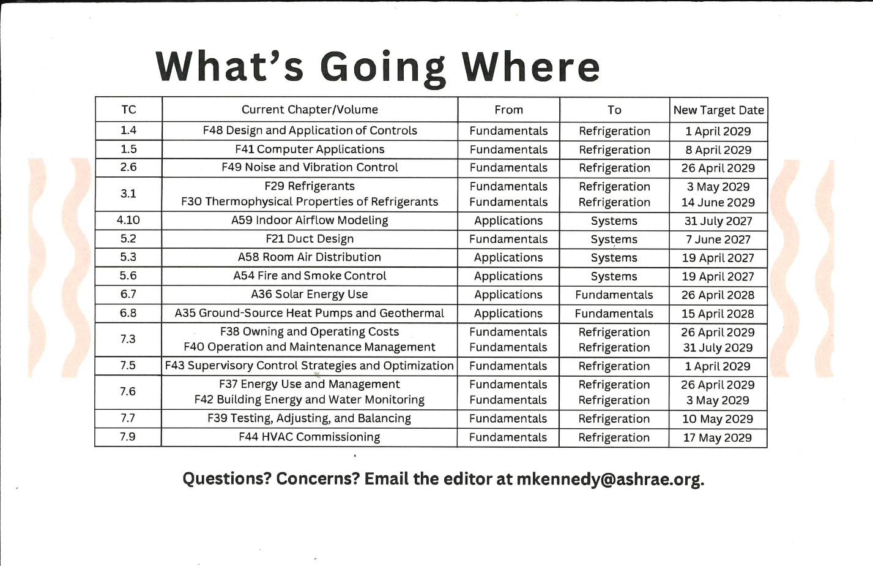

APPENDIX B: IFHE Bi-annual Cut the Carbs Awards Program
- The International Federation of Healthcare Engineering ( https://www.ifhe.info/) is soon going to announce its bi-annual Cut the Carbs Awards program. (https://www.ifhe.info/news/winners-of-the-inaugural-carbon-challenge) This program is for any healthcare building anywhere in the world. It recognizes any building that reduces its Carbon emissions by 5% or more. There is a best in country award and a best in world award. It runs off of the Energy Star platform. Please have your healthcare clients enter. We will announce Award Winners at the 2026 IFHE Congress, in New Orleans. (https://www.ifhe.info/news/ifhe-2026-in-new-orleans)
- IFHE has an MOU with ASHRAE. Some of our projects were with WHO, but, with the US Government removing funding from that organization, our projects have been cancelled. We have proposed several climate-related programs with ASHRAE, and, if there are ways we can collaborate with TC 2.5, we would love to discuss them. Our ASHRAE Liaison is Tim Wentz. Walt Vernon is the Liaison from IFHE.
- In accordance with the MOU, IFHE is promoting the work and the products of ASHRAE. Most notably, IFHE is having a webinar to promote the ASHRAE-UNEP Refrigerant Manual. Information here: https://www.linkedin.com/feed/update/urn:li:activity:7424576236439646208/
- The US National Academy of Medicine (https://nam.edu/product/nam-action-collaborative-on-decarbonizing-the-u-s-health-sector-executive-summary-and-reflections-from-phase-1-2021-2023/) is about to launch an effort to redefine healthcare quality to include low carbon healthcare. To advance this, they are going to encourage every health facility in the country to measure and report its building energy consumption. NAM is seeking volunteers who will help low resourced health faciliteis to do this. Please contact Walt Vernon, if you can help. walterv@mazzetti.com.

