ASHRAE TC 7.3
Operation, Maintenance, and Cost Management
Committee Meeting Agenda

Tuesday 06/30/2026, 3:30 – 5:30 PM CT
Hybrid + JW Marriott Austin, JW - 306 - L3
https://teams.microsoft.com/meet/23398352858512?p=0nk0bEww9sisByxOSH
- Call to Order

- ASHRAE Code of Ethics Commitment
In ASHRAE meetings, we will act with honesty, fairness, courtesy, competence, inclusiveness and respect for others, which exemplify our core values of excellence, commitment, integrity, collaboration, volunteerism and diversity, and shall avoid all real or perceived conflicts of interest. Our culture is one of inclusiveness, acknowledging the inherent value and dignity of each individual. We celebrate diverse and inclusive communities, understanding that doing so fuels better, more creative and more thoughtful ideas, solutions and strategies for the Society and the communities our Society serves. We respect and welcome all.
See full ASHRAE Code of Ethics: https://www.ashrae.org/about-ashrae/ashrae-code-of-ethics

- Confirm Quorum:

- Approve Minutes:
  - Winter 2026 in Las Vegas
- Work of the TC:
  - TC 7.3 has been asked to be the cognizant TC for Designing for Operational Excellence: Intentional Design for Effective Operation and Maintenance – published 2022, next review 2027
- Subcommittee reports:
  - Standards – Aaron Sorrell (Standard 180 & 221)
  - Guideline 4 - Colin Ross … Items have been posted on Basecamp.
  - Guideline 32 – Jeff Gatlin
  - Handbook – Josh Gemmell
  - Research – Josh Gemmell update on the SP1977 research project. Don Gariepy will be the new subcommittee Chair on July 1st.
  - Programs – Sonya Pouncy (Forum during this meeting time. Will have report when able to join.)
    - Seminar 3: Minding Your Business: Preparing for Tomorrow's Workforce Today
Sunday, June 28th at 8:00 am
    - Forum 2: The Inside Story: An ASHRAE “Open Mic” Competition of Entertaining Lessons Learned in Commissioning, Operating, or Maintaining Building Systems
Tuesday, June 30th at 3:15 pm

- Old Business:
  - PowerPoint slide deck explaining TC 7.3's purpose and activities that can be distributed to ASHRAE chapters to promote participation.
- New Business:
  - Review participant insight from “Bridging the Gap: Deferred Maintenance and Carbon Goals Meet Reality” Winter Conference Forum. Can TC 7.3 respond to the topics or recommendations from the Forum? Article reprinted on next pages.

- Reminders:
  - Future Full TC & Subcommittee interim meetings will be virtual and before the winter meeting in Chicago.

- Adjourn

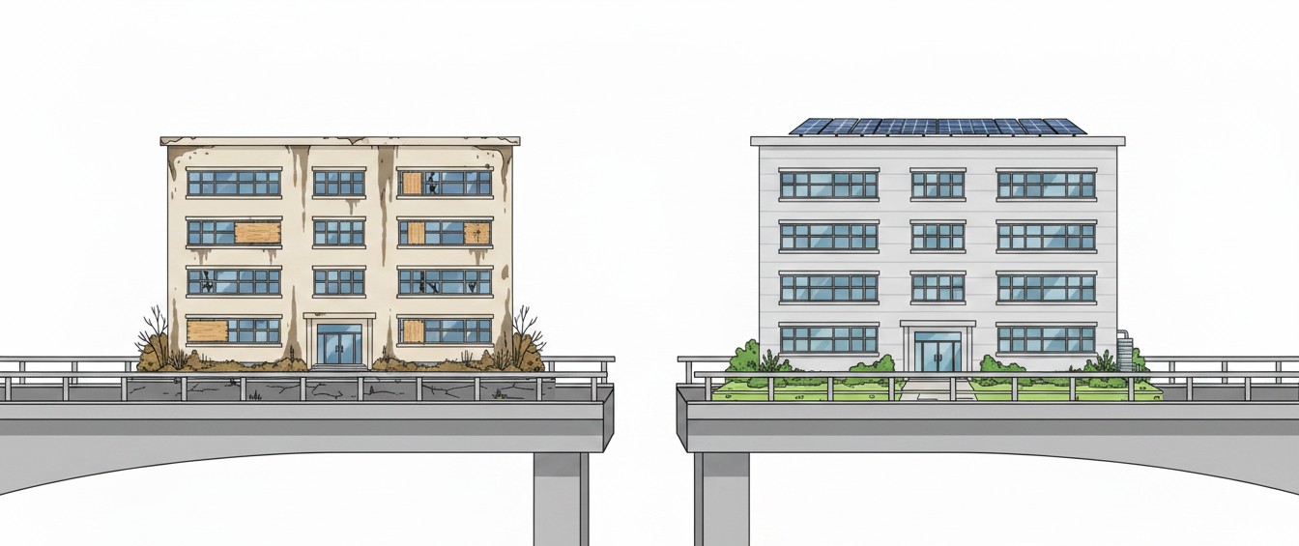
Image credit: AI-generated with OpenAI; concept and prompt by Catherine Tinkler.

Bridging the Gap: Deferred Maintenance and Carbon Goals Meet Reality
By Catherine Tinkler, EBCP, PMP, LEED AP O+M

Forum Highlights from "Renewal Meets Reality"
At the "Renewal Meets Reality: Bridging the Gap Between Deferred Maintenance and Carbon Goals" Forum, industry professionals convened to tackle one of the most pressing challenges in building management today: navigating the intersection of deferred maintenance, financial constraints, and ambitious sustainability goals. Hosted by ASHRAE TC 7.3’s Operation, Maintenance, and Cost Management committee and co-sponsored by Educational Facilities 9.7 and the College of Fellows, the forum brought together architects, consulting engineers, building owners, and planners to share their experiences and insights.
The discussion revealed a nuanced and multifaceted challenge: how can existing building portfolios with mounting deferred maintenance navigate financial pressures and technical hurdles to achieve resilience, decarbonization, and energy efficiency?
Key Themes Discussed
1. Defining Deferred Maintenance
A recurring conversation centered on the term "deferred maintenance" itself. As highlighted by the forum host, definitions vary across the industry, even among the major firms responsible for facility condition assessments. Some define deferred maintenance as the backlog of repairs; others use it synonymously with deferred renewal, where failing infrastructure should have been replaced long ago. This lack of clarity creates hurdles for building owners, planners, and design engineers and underscores the need for shared understanding of key terms when aligning portfolios with their energy efficiency goals.
Deferred maintenance presents significant risks—not only to building operations but to sustainability goals. Emergency repairs caused by deferred maintenance are often incompatible with decarbonization efforts or long-term energy strategies. Systematic renewal planning, informed by life cycle analysis, was seen as essential to enabling both operational continuity and progress toward carbon goals.

2. Financial Constraints and Cost Justification
Every participant acknowledged the tension between financial constraints and sustainability planning. Whether public institutions, private corporations, or nonprofit facilities, owners often prioritize immediate cost savings over long-term return on investment (ROI). The conversation called for a shift in perspective—prompting owners to consider the broader benefits of energy upgrades, such as improved indoor air quality, reduced utility bills, and increased property value.
Some participants advocated for life cycle cost analysis as a key tool to influence decision-making. Others pointed out the financial incentives tied to newer energy technologies, such as heat pumps or electrification of heating systems. For instance, one participant discussed a housing authority project in Colorado, where geothermal ground source technology combined with social cost of carbon calculations allowed for both financial and environmental benefits.
Education emerged as a critical strategy. Engineers and planners must help owners understand the marketing potential and long-term benefits of sustainable upgrades. Examples like LEED certification and energy-efficient designs were noted not only for their operational benefits but as effective branding tools—particularly for universities and other public-facing institutions eager to attract students or tenants.

3. Technical Hurdles to Carbon Goals
Transitioning aging facilities toward energy efficiency requires overcoming notable technical barriers. Many buildings, particularly in the Northeast or older cities, were not built to support low-carbon systems like heat pumps or advanced air distribution technologies. The limits of insulation, outdated HVAC systems, and envelope performance often prohibit the kinds of upgrades needed to meet modern energy codes.
Participants shared the challenges of adapting older systems or legacy infrastructure. Deferred maintenance in existing central plants, for example, can affect the feasibility of future new construction projects—linking past failures in maintenance to broader system-level concerns.
Additionally, the forum addressed the operational side of technical hurdles. With complex systems comes increased maintenance requirements. A consulting engineer pointed out examples of sophisticated systems in federal buildings that could not be maintained effectively by contracted maintenance teams. The result? Decreased energy efficiency and poor decision-making in operations.
Design professionals have an opportunity to address these gaps. Forum attendees called on engineers to consider not just design innovation but contextual appropriateness—choosing systems that can be reasonably maintained by existing operational teams.

4. Incorporating Energy Codes and Standards
The role of building codes and standards, including ASHRAE 90.1, became an important topic. While energy codes provide minimum performance standards for new construction and major renovations, compliance can sometimes feel prohibitive for owners with aging portfolios. Stricter standards have raised the bar, but they have also widened the gap for many existing buildings. Highly ambitious benchmarks might unintentionally discourage upgrades by increasing the financial burden of compliance.
Further discussion suggested creative approaches, including intermediate compliance levels tailored to older facilities. Participants asked whether standards could incorporate flexibility for historic or outdated structures while still encouraging carbon reduction through achievable, incremental progress.
Comparisons to international systems highlighted potential pathways. Australia’s National Australian Built Environment Rating System (NABERS) and the UK’s mandatory energy disclosure requirements for buildings have facilitated widespread improvements in energy efficiency. In Australia, energy consumption in buildings has been halved over two decades, thanks to incentives and regulations that mandate energy ratings during leasing, selling, or ownership changes. Participants questioned why the United States has not yet implemented similar mandatory disclosure requirements.

5. Leveraging Building Metrics to Drive Change
Comparing buildings’ energy performance was deemed critical in bridging the gap between deferred maintenance and carbon goals. Tools like Energy Star ratings, which benchmark building performance against national averages, enable owners to both track progress and compare their portfolios to industry standards. Some participants referred to Energy Star’s integration into federal leasing contracts—which has incentivized commercial building improvements for nearly two decades across the private sector.
Participants also discussed the importance of creating measurable building rating systems, akin to labels on household appliances or automobile miles-per-gallon ratings. By making energy performance ratings visible on leases, sales documents, or marketing materials, building owners can influence tenant decisions and create financial motivation for upgrades.

Moving Forward: Practical Recommendations
The discussion made clear that progress requires collaboration across disciplines. Below are key strategies suggested by participants to address the disconnect between deferred maintenance and carbon goals:
- Educate Owners: Help owners understand the ROI of energy-efficient upgrades and frame them within their organization’s mission—whether it’s marketing for universities, cost savings for commercial entities, or resilience for healthcare facilities.
- Incorporate Life Cycle Analysis: Shift focus from upfront capital costs to holistic life cycle cost assessments, accounting for long-term savings and social costs of carbon. Tailor solutions to align with both financial and sustainability goals.
- Advocate for Mandatory Energy Disclosure: A building energy rating system, paired with performance tracking, could incentivize both landlords and tenants to prioritize energy-efficient spaces, addressing gaps in the U.S. building market.
- Adopt Intermediate Standards: Flexibility in energy codes for older or historic buildings could encourage owners to transition toward compliance without the burden of complete reconstruction.
- Simplify Systems for Operations Teams: Design energy-efficient systems while accounting for the technical capacity of maintenance personnel. Complex systems are less likely to succeed without adequate planning for long-term operations.

Conclusion
The "Renewal Meets Reality" forum illustrated the magnitude of the challenges facing buildings with deferred maintenance amid growing pressure to decarbonize and improve energy efficiency. While addressing these issues is complex, collaboration among architects, engineers, planners, and owners can pave the way for meaningful progress. By leveraging standards, education, and measurable benchmarks, the industry can push forward on the path to balancing operational realities with ambitious sustainability goals. It may not be a simple journey, but as participants showed, small steps can move building portfolios toward the larger goal of carbon-conscious design.

