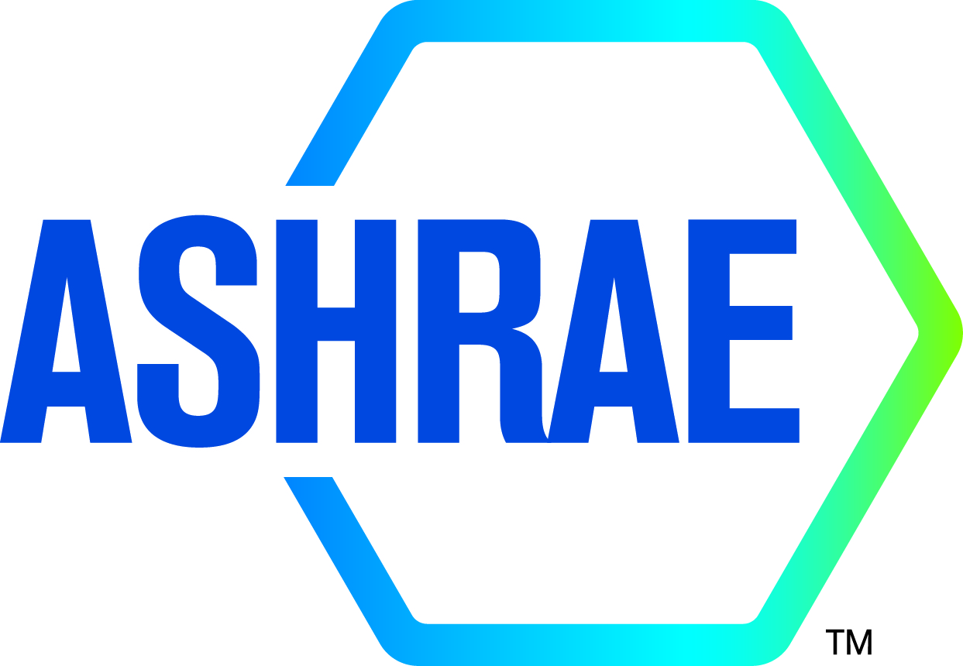

M I N U T E S

DRAFT

TC1.13 Optimization

2024 ASHRAE WINTER MEETING
Hybrid

Sunday January 21, 2024, 1:00 – 3:00 PM CST
Location: Marriott Marquis Chicago, Architecture (2)
Teams remote meeting

Note: These draft minutes have not been approved and are not the official, approved record until approved by the Technical Committee.
Minutes
1. Call to Order and welcome all members and visitors Farhad Omar
Meeting was called to order at 1:05 pm (Central Time).

2. Roll Call / Introductions / Record Attendance Farhad Omar
Total Attendees: 13; 6 voting members; 2 corresponding members; 2 provisional member, 3 guests.
2 attendees are YEA members. 1 attendee is international member.12 attendees participate on-site; 1 attendees remotely participate.

Full Attendees List
Name | Category
Farhad Omar | Voting, Chair
Walters Matt | Guest
ArkFeld Ivy | Provisional Member
Anand Jyothis | Provisional Member
Chris Laughman | Corresponding Member
Brian O’Malley | Guest
James Tancabel | Guest
Khaled Saleh | Corresponding Member
Yukiko Yoshida | Corresponding Member
Zhenning Li | Voting, Vice Chair
Rohit Dhumane | Voting, Secretary
Zheng O'Neill | Voting, Program Subcommittee Chair
S.A. Sherif | Voting Member

3. ASHRAE Code of Ethics Commitment Farhad Omar
In this and all other ASHRAE meetings, we will act with honesty, fairness, courtesy, competence, integrity and respect for others, and we shall avoid all real or perceived conflicts of interests. (See full Code of Ethics: https://www.ashrae.org/about-ashrae/ashrae-code-of-ethics.)
3. Introduction of ASHRAE Liaisons on Arrival Farhad Omar

4. Establishment of Quorum Farhad Omar
Voting Members for This Meeting (Need 4 for a Quorum)
VOTING MEMBERS FOR THIS MEETING
X | Zhenning Li (6/30/2023) |  | X | S.A. Sherif (6/30/2025)
X | Farhad Omar (6/30/2025)
X | Zheng O'Neill (6/30/2026)
X | Omar Abdelaziz (6/30/2025)
X | Rohit Dhumane (6/30/2023)
The TC presently has 6 voting members. A roll call of the voting members was taken, and a quorum was established with 6 of 6 Voting Members present.

5. TC 1.13 Purpose Statement Farhad Omar
TC 1.13 is concerned with identifying, developing, and disseminating optimization techniques that enhance the performance of HVAC&R components, systems, and building systems that are not application or tool specific. The committee is focused on the fundamentals of optimization techniques including mathematical formulation, constraints handling, multi-objective optimization, approximation techniques, and robust optimization. These fundamentals are the foundation of data-driven, machine learning (ML), and artificial intelligence (AI) methods.
6. Approval of previous meeting minutes Rohit Dhumane
Action item:
- Email all members the Chicago 2023 winter meeting minutes draft after the meeting and add to the website.
- Add to the agenda for next meeting to approve the meeting minute.

7. Chairman’s Overview and Report Farhad Omar
Quorum established – all 6 members present.

New section head present and provided updates. Reminder that roster update due by Feb 1 and new Roster to go into effect after summer Ashrae (1 July). No roster update at this time.

NTG on Gen AI created. Feedback expected until Jan 30 on strategic activities for it.

Webmaster issue still not resolved. Rohit unable to access database and upload.

8. Subcommittee Reports Zheng O’Neill

a. Program

Chris Laughman mentioned that his session with 3 speakers is approved for the ASHRAE Winter 2024 – Chicago. Vikrant’s session on refrigerant blend optimization was not approved. It will be resubmitted for ASHRAE Summer 2024 – Indianapolis.

Three seminars are proposed for upcoming ASHRAE meetings, 3 seminars for 2024 Indianapolis summer meeting, 0 seminars for 2025 Orlando winter meeting.
- (Chicago, 2023 Winter – resubmit for Indianapolis 2024) Component and System Optimization for Lower-GWP Refrigerants, Chair: Vikrant.
  - Zhenning – Multi-objective optimization of low-GWP mixture composition and heat exchanger circuitry configuration for improved system performance and reduced refrigerant flammability.
  - NIST – new molecules, refrigerant blend
  - (Vikrant to identify) – optimization of blends for specific applications.
  - (Rohit to identify – Michael Petersen) – optimization of blends.
- Indianapolis 2024: Accelerating Thermal System Simulation with AI, Chair: Rohit
  - Dr Zheng – Identify a post-doc.
  - (Zhenning to identify).
  - Rohit – Transport refrigeration related work.
- Indianapolis 2024: Optimal resource allocation, Chair: Ivy
  - Ivy – Optimal resource allocation for decarbonization. Ivy to organize. I
  - Dr Sherif - Optimal Allocation problem – need to find speakers. TC 10.2 might be someone who may collaborate. Optimal allocation of building energy. Decarbonization problem. What are you trying to optimize needs to be clarified. GWP.

Deadline to submit = Feb 26.
b. Research Omar Abdelaziz
No RTAR with us. Members discuss the option to co-sponsor with other sections. TC 7.5, research subcommittee Monday afternoon 5-15. One possibility is to provide feedback by the members if optimization is done correctly in cosponsoring RTARs. Members discuss which stage is ideal to join the RTARs. If they should join early on or just tag along for those much further in ideation. Dr Zheng to discuss with Omar for possibilities. Rohit/Farhad to meet with Data driven modeling sub-committee.

Members approve cosponsoring RTARs (6-0-0).

c. Handbook Khaled Saleh
no updates. Members discuss that subcommittee is necessary to get this moving. This way there is a dedicated slot with everyone’s commitment.

d. Standards Farhad Omar
no updates
e. Membership Farhad Omar
Promote in YEA
f. TC Website Zhenning Li
Action item: Zhenning will follow up with Tara and Steve to get access to the website.

9. Old Business All

Approve 2023 Atlanta conference meeting minute.

10. New Business All
No updates

11. Next subcommittee and committee meetings Farhad Omar
Not determined

12. Adjourn All
Farhad moves to adjourn, seconded by Rohit.
2:45 pm motion passes 6-0-0-0 (CNV). Meeting is adjourned.

