

1791 Tullie Circle, N.E./Atlanta, GA 30329
404-636-8400
DRAFT 1

TC/TG/MTG/TRG MINUTES COVER SHEET

(Minutes of all Meetings are to be distributed to all persons listed below within 60 days following the meeting.)

TC/TG/MTG/TRG No. TC 1.9 DATE 5/15/2025

TC/TG/MTG/TRG TITLE Electrical Systems

DATE OF MEETING 5/15/2025 LOCATION Teams

 | MEMBERS PRESENT  (VM’s in bold, YEA) | YEAR APPTD | MEMBERS ABSENT  (VM’s in bold, YEA) |  | YEAR APPTD | EX-OFFICIO MEMBERS AND ADDITIONAL ATTENDANCE
 | Gerardo Alfonso | 2017 | Daryl Collerman |  | 2019 | Scotty Hutto
 | Stephen Duda (PCM) | 2023 | Beatriz Salazar |  | 2021
 | Larry Markel | 1997 | John Nix |  | 2007
 | Tom Pollard (PCM) | 2023 | Steve Rosenstock |  | 2005
 | Michael S. Todd | 2011 | Steven Faulkner |  | 2006
 |  |  | Zach DeLuke |  | 2022
 |  |  | Randall Higa |  | 2016
 |  |  | Luis Miguel Alvarado (PCM) |  | 2024
 |  |  | Dr Suren Babu (PCM) |  | 2025
 |  |  | Panagiotis Kleomenis Bougas (PCM) |  | 2024
 |  |  | James Frey (PCM) |  | 2025
 |  |  | Eduardo Garcia Huertas (PCM) |  | 2025
 |  |  | Amina Abdul Ghafoor (PCM) |  | 2024
 |  |  | Abrar Hussain (PCM) |  | 2023
 |  |  | Mohamed Mostafa  Hassan Ibrahim (PCM) |  | 2024
 |  |  | Matthew Kiok (PCM) |  | 2025
 |  |  | Dr. Fengqi Li (PCM) |  | 2024
 |  |  | Angel Lopez (PCM) |  | 2023
 |  |  | Nisha A Nair (PCM) |  | 2024
 |  |  | Farhad Omar (PCM) |  | 2023
 |  |  | Michael Poplawski (PCM) |  | 2024
 |  |  | Frank Pucciano (PCM) |  | 2025
 |  |  | Subrata Saha (PCM) |  | 2024
 |  |  | Xinwei Zhuang (PCM) |  | 2024
 |  |  | Abiodun Olatokunbo  Abiola |  | 2021
 |  |  | Ricson Chude |  | 2017
 |  |  | Robert Crosby |  | 2004
 |  |  | Chad Dorgan |  | 2000
 |  |  | Armin Hauer |  | 2011
 |  |  | Robert Helt |  | 1994
 |  |  | Jamie Lian |  | 2023
 |  |  | Joseph Lunsford |  | 1995
 |  |  | Ken Luther |  | 1990
 |  |  | Ram Narayanamurthy |  | 2013
 |  |  | Timothy Patrick O'Leary |  | 2022
 |  |  | Glenn Remington |  | 2017
 |  |  | John Richardson Jr. |  | 2007
 |  |  | Pavithra Santhanam |  | 2018
 |  |  | Colleen Smith |  | 1994
 |  |  | Leo Stambaugh |  | 1994
 |  |  | John Stoops Sr. |  | 2003
 |  |  | Marvin Thedford Jr. |  | 1990
 |  |  | Gary Throckmorton |  | 2000
 |  |  | Russ Tiffany |  | 1998
 |  |  | Marija Todorovic |  | 2005
 |  |  | William Warren Jr. |  | 1983
DISTRIBUTION: All Members of TC/TG/MTG/TRG plus the following:
TAC Section Head: |  |  |  | SH1@ashrae.net
All Committee Liaisons as Shown On TC/TG/MTG/TRG Rosters (Research, Standards, ALI, etc.) |  |  |  | TACchair@ashrae.net  CTTC1@ashrae.net  RL1@ashrae.net  HBS3@ashrae.net  SL1@ashrae.net
Mike Vaughn,  Manager of Research & Technical Services |  |  |  | MORTS@ashrae.net

Note: These draft minutes have not been approved and are not the official, approved record until approved by the TC.

- CALL TO ORDER
Introduction of Members and Guests

Technical Committee 1.9 was called to order at 1:05 PM (EDT). Technical committee member introductions were made online. Absent members are identified on the cover sheet.

Gerardo Alfonso, Chair, reviewed the membership list and determined that a quorum was NOT present (2 of 8 VMs). Gerardo reviewed with everyone the ASHRAE code of ethics, which is presented on the agenda.

- APPROVAL OF MINUTES AND REVIEW OF ACTION ITEMS
Since a quorum was not present, a vote to approve the Orlando 2025 meeting minutes did not occur.

Report Action Items:

None.

- TC MEMBERSHIP AND COMMITTEE APPOINTMENTS
Since the last meeting in January, there were three provisional corresponding members (PCM) added to the roster.

- Eduardo Garcia Huertas
- Matthew Klok
- Frank Pucciano

Welcome to our TC!

- CHAIR REPORTS: Gerardo Alfonso
The focus of today’s meeting was to show the latest updates to our handbook chapter.

Up and coming meetings: Phoenix, AZ – June 21 to 25, 2025

- SUBCOMMITTEE REPORTS
  - Standards: Steven Rosenstock
None.
  - Research: Larry Markel
None.

  - Programs: John Nix & Frank Pucciano
Gerardo went over the upcoming tracks and deadlines for the next winter conference in Las Vegas, NV (Jan 31 - Feb 4, 2026).
Tracks:
- Energy Storage and Grid Resiliency
- Pathways to Building Decarbonization
- Artificial Intelligence
Deadlines/Dates:
- May 28 Conference Paper Abstracts Due
- June 18: Abstracts Accept / Reject Notifications
- August 1: Debate, Panel, Seminar, Forum, Workshop, and Debate Proposals Due
- September 3: Conference Papers Due
- September 24: Conference Paper Accept/Revise/Reject Notifications
- October 3: Debate, Panel, Seminar, Forum, Workshop Accept / Reject Notifications
Larry suggested a potential forum with the stated question of:
- What steps should ASHRAE take regarding carbon reduction within the current political climate (i.e ASHRAE strategy)?
  - Handbook: Gerardo Alfonso
Gerardo displayed and quickly went over his proposed handbook updates (file was recently uploaded to Basecamp).
Larry commented that he looks forward to reviewing these updates and that not everything added may not need to be added to our handbook but instead should be referenced to other documents/standards.

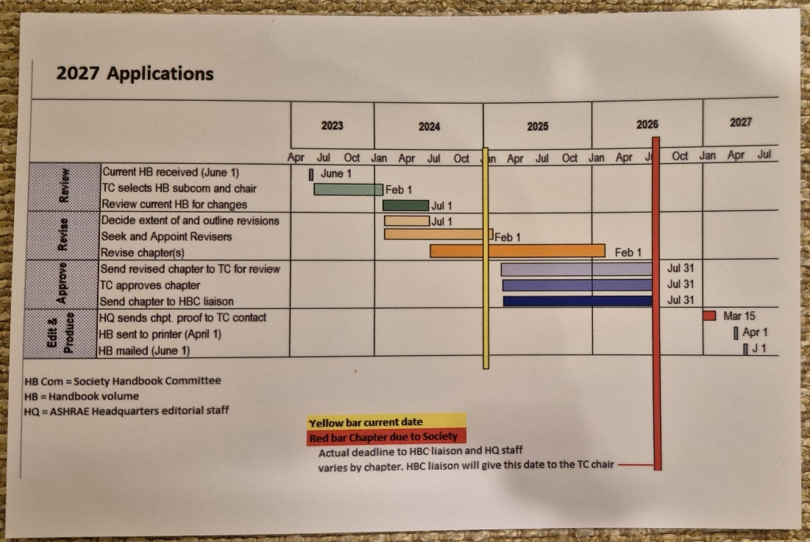

  - Membership: Larry Markel
Total TC membership stands at 53 at this meeting. 8 VM, 0 MNQ, 21 PCM, 24 CM, 12 YEA.
Stephen Duda requested to be moved from PCM to CM because he is scheduled to roll off on 6/1/25.
  - Professional Development Committee (PDC Coordinator): John Nix
None.
g. WEBSITE: Steven Faulkner
Website is up to date.

- LIAISON REPORTS
None.

- OLD BUSINESS
Website shows: 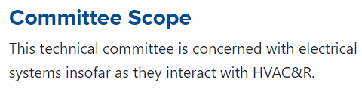

Agenda shows: "TC 1.9 is concerned with electrical systems insofar as they interact with the built environment."

Our TC voted in December 2023 to approve the expanded scope and was submitted to TAC for approval. TAC has provided the following feedback at this meeting: TAC believes that "the built environment" scope is too broad.

TAC approved our new TPS during their late meeting in Chicago!

Gerardo announced that our scope has still not officially been changed as of today’s meeting.

- NEW BUSINESS
None.
- ANNOUNCEMENT OF NEXT MEETING
The next Annual meeting will be held in Phoenix, AZ on June 24, 2025, from 3:30 pm to 5:30 pm.

Gerardo thanked everyone for attending the meeting.

- ADJOURNMENT
The meeting was adjourned at 1:29 PM (EDT).

Respectfully Submitted,

Michael S. Todd
Secretary

Note: These draft minutes have not been approved and not the official, approved record until approved by the TC.

