

1791 Tullie Circle, N.E./Atlanta, GA 30329
404-636-8400
DRAFT 1

TC/TG/MTG/TRG MINUTES COVER SHEET

(Minutes of all Meetings are to be distributed to all persons listed below within 60 days following the meeting.)

TC/TG/MTG/TRG No. TC 1.9 DATE 2/12/2025

TC/TG/MTG/TRG TITLE Electrical Systems

DATE OF MEETING 2/11/2025 LOCATION Orlando, FL (Hybrid)

 | MEMBERS PRESENT  (VM’s in bold, YEA) | YEAR APPTD | MEMBERS ABSENT  (VM’s in bold, YEA) |  | YEAR APPTD | EX-OFFICIO MEMBERS AND ADDITIONAL ATTENDANCE
 | Gerardo Alfonso | 2017 | Daryl Collerman |  | 2019 | Jason Atkisson (SH)
 | Luis Miguel Alvarado (PCM) | 2024 | Beatriz Salazar |  | 2021 | Jim Early
 | Steven Faulkner | 2006 | Zach DeLuke |  | 2022 | Eduardo Garcia
 | Jim Frey (PCM) | 2025 | Ala'a Mohammed Abu Shawish (PCM)  Shawish |  | 2023 | Matthew Nelson
 | Armin Hauer | 2011 | Dr Suren Babu |  | 2025 | Frank Pucciano
 | Randall Higa | 2016 | Panagiotis Kleomenis Bougas (PCM) |  | 2024 | Rex Scare (HL)
 | Larry Markel | 1997 | Stephen Duda (PCM) |  | 2023
 | John Nix | 2007 | Amina Abdul Ghafoor (PCM) |  | 2024
 | Tom Pollard (PCM) | 2023 | Abrar Hussain (PCM) |  | 2023
 | Steve Rosenstock | 2005 | Mohamed Mostafa  Hassan Ibrahim (PCM) |  | 2024
 | Michael S. Todd | 2011 | Dr. Fengqi Li (PCM) |  | 2024
 |  |  | Angel Lopez (PCM) |  | 2023
 |  |  | Kyle C Mullins (PCM) |  | 2023
 |  |  | Nisha A Nair (PCM) |  | 2024
 |  |  | Farhad Omar (PCM) |  | 2023
 |  |  | Michael Poplawski (PCM) |  | 2024
 |  |  | Subrata Saha (PCM) |  | 2024
 |  |  | Xinwei Zhuang (PCM) |  | 2024
 |  |  | Abiodun Olatokunbo  Abiola |  | 2021
 |  |  | Ricson Chude |  | 2017
 |  |  | Robert Crosby |  | 2004
 |  |  | Chad Dorgan |  | 2000
 |  |  | Robert Helt |  | 1994
 |  |  | Jamie Lian |  | 2023
 |  |  | Joseph Lunsford |  | 1995
 |  |  | Ken Luther |  | 1990
 |  |  | Ram Narayanamurthy |  | 2013
 |  |  | Timothy Patrick O'Leary |  | 2022
 |  |  | Glenn Remington |  | 2017
 |  |  | John Richardson Jr. |  | 2007
 |  |  | Pavithra Santhanam |  | 2018
 |  |  | Colleen Smith |  | 1994
 |  |  | Leo Stambaugh |  | 1994
 |  |  | John Stoops Sr. |  | 2003
 |  |  | Marvin Thedford Jr. |  | 1990
 |  |  | Gary Throckmorton |  | 2000
 |  |  | Russ Tiffany |  | 1998
 |  |  | Marija Todorovic |  | 2005
 |  |  | William Warren Jr. |  | 1983
DISTRIBUTION: All Members of TC/TG/MTG/TRG plus the following:
TAC Section Head: |  |  |  | SH1@ashrae.net
All Committee Liaisons as Shown On TC/TG/MTG/TRG Rosters (Research, Standards, ALI, etc.) |  |  |  | TACchair@ashrae.net  CTTC1@ashrae.net  RL1@ashrae.net  HBS3@ashrae.net  SL1@ashrae.net
Mike Vaughn,  Manager of Research & Technical Services |  |  |  | MORTS@ashrae.net

Note: These draft minutes have not been approved and are not the official, approved record until approved by the TC.

- CALL TO ORDER
Introduction of Members and Guests

Technical Committee 1.9 was called to order at 3:34 PM (EDT). Technical committee member introductions were made online. Absent members are identified on the cover sheet.

Gerardo Alfonso, Chair, reviewed the membership list and determined that a quorum was NOT initially present (3 of 8 VMs). Shortly later, more VMs arrived, and a quorum was in fact present (6 of 8 VMs). Gerardo reviewed with everyone the ASHRAE code of ethics, which is presented on the agenda.

- APPROVAL OF MINUTES AND REVIEW OF ACTION ITEMS
Motion: Steven Rosenstock/Gerardo 5-0-0-3-CV (PASS) – Steven Rosenstock made a motion to approve all three meeting minutes (Indianapolis, August virtual, November virtual) as distributed with a second from Larry Markel. There was no additional discussion, and the motion passed unanimously.

Report Action Items:

None.

- TC MEMBERSHIP AND COMMITTEE APPOINTMENTS
Since the last meeting in June, there were six provisional corresponding members (PCM) added to the roster.

- Dr Suren Babu
- Panagiotis Kleomenis Bougas
- James Frey
- Amina Abdul Ghafoor
- Mohamed Mostafa Hassan Ibrahim
- Nisha A Nair

Welcome to our TC and thank you Jim for joining our meeting today!

- CHAIR REPORTS: Gerardo Alfonso
Below is a list of highlights from the FG chairs breakfast meeting held on Sunday (reference Appendix I).
- Roster updates are due March 3 and won’t take effect until after the annual meeting in Phoenix.
- TC MOP change to FG Reference Manual and available on the ASHRAE website.
- Activity form was completed quickly on the fly during the meeting.

Up and coming meetings: Phoenix, AZ – June 21 to 25, 2025

- SUBCOMMITTEE REPORTS
  - Standards: Steven Rosenstock
90.1 – slated for next update in October 2025, showed only 0.3% savings, more addendums going out for PPR, also changes to TPS. Trying to combine addendums into a new addendum. Gas is firing back and threatening ASHRAE (potential lawsuits). Many folks abstained on latest vote so changes did not pass. Appendices are going back to sub-committees.
90.2 leadership residential; former chair passed away, vice-chair in the labs.
90.4 data centers; TPS now include emissions and water usage, lots of AI questions.
100 existing buildings; published last year, updating tables.
189.1, potentially updating TPS to include alterations and bird friendly windows, also lengthy discussions on turf grass and water metering requirements.
227 passive buildings going out for public review soon.
228 netzero buildings; trying to update it.
240P and 242P (lifecycle carbon) for carbon emissions and calculations. 400 comments to go through.
ICC 2024 published in August. States have two years to update residential codes but there is way to enforce.
Appliance DOE standards affecting almost everything by 2030. Some were withdrawn. DOE is being sued over many recent changes.
  - Research: Larry Markel
None, but some research ideas/topics popped up during the programs discussion below.

  - Programs: John Nix & Frank Pucciano
Phoenix seminar and forum proposals are due 2/26.
Gerardo suggested tracks 5, 6, and 7 for our TC in Phoenix.
TC 6.8 (Geothermal Heat Pump and Energy Recovery Applications) usually has something in the works. Frank suggested to contact them about any co-sponsorship opportunities. Frank will reach out. Their meeting is going on right now (same time as our TC).
For Las Vegas, Gerardo suggested another potential three tracks.
Steven Rosenstock and Gerardo to reach out to TC 9.9 (Mission Critical Facilities, Data Centers, Technology Spaces and Electronic Equipment, IT & Publications Workshops) about the potential topic of datacenter metering with and without AI for power requirements. Power requests are becoming crazy.

Can AI be used to help buildings save more energy (enhance energy management systems)? Can AI help us predict what might fail?

Randal proposed a forum based on the concern he sees with the increase rise of heat pump usage, what about emergency heat (strip heaters) use increase (especially all coming on at once)? California is expecting the peak of winter to soon match the peak of summer.
Can microgrids be used to help with managing outages/resources? Larry suggested this as a potential forum/brainstorm session. What about incentives/policies? Tie in with grid resiliency? Larry with Frank will lead this submittal.

  - Handbook: Gerardo Alfonso
Beatriz has not been responsive and not present at this meeting again. Gerardo made the executive decision to take over the next handbook revision. Chapter 57 is our chapter, and the initial draft is due Nov 2025.
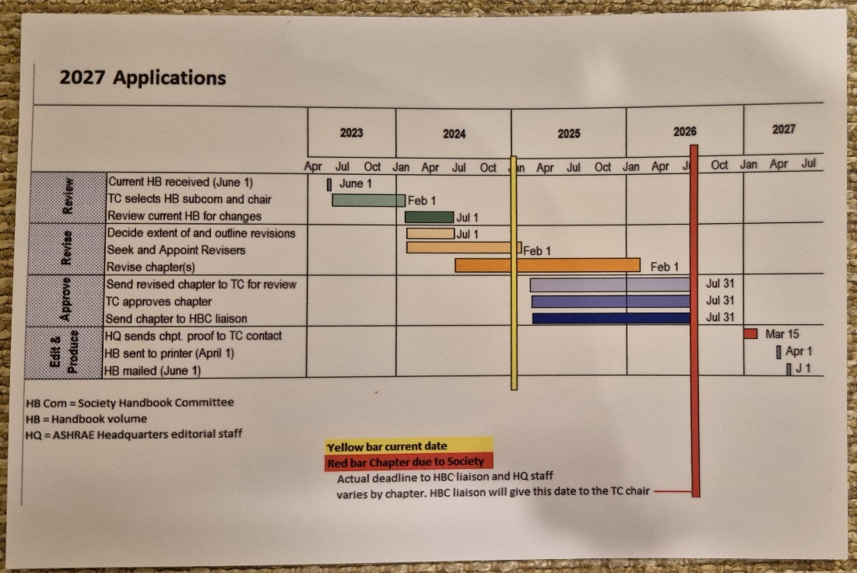

  - Membership: Larry Markel
Total TC membership stands at 50 at this meeting. 8 VM, 0 MNQ, 18 PCM, 24 CM, 13 YEA.

  - Professional Development Committee (PDC Coordinator): John Nix
PDC is going to have a thermal storage course online (added impact of thermal storage on renewable energy) on April 9. Randall proposed a future course idea on a building grid interaction course.
g. WEBSITE: Steven Faulkner
Website is mainly up to date. He needs some of the interim meeting minutes to post.

- LIAISON REPORTS
Section Head (Jason Atkisson): Jason is here to help. Roster update coming (links aren’t sent out yet), due March 3. High number of conference papers approved for Orlando, so lots of seminars were declined and all are encouraged to resubmit. New strategic plan for 2025 – 2028 was posted.
RAC: None.
TAC: None.
Handbook (Rex Scare): Chapter due 4/15/26, needs to be voted out of our TC by then. Gerardo’s plan is to work now to Phoenix and go to peer review by then. Our chapter is one of the earlier ones. The ASHRAE authoring portal has a digital version of the handbook schedule.

- OLD BUSINESS
Website shows: 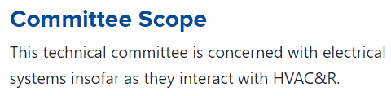

Agenda shows: "TC 1.9 is concerned with electrical systems insofar as they interact with the built environment."

Our TC voted in December 2023 to approve the expanded scope and was submitted to TAC for approval. TAC has provided the following feedback at this meeting: TAC believes that "the built environment" scope is too broad.

TAC approved our new TPS during their late meeting in Chicago!

Gerardo announced that our scope has still not officially been changed.

Randall announced that the MTG on decarbonization was disbanded and now transformed into the Center of Excellence for Building Decarbonization (CEBD) Update. Randall is no longer involved.

- NEW BUSINESS
Committee positions for the ASHRAE 2025/2026 year were discussed. A summary of the positions for the upcoming year are shown below.

Chair – Gerardo Alfonso (retain for a third year)
Vice Chair – Daryl Collerman (recommend to roll off VM to CM if intended to be next chair)
Secretary – Michael Todd (roll back on as VM)
Handbook Subcommittee – Gerardo Alfonso
Program Subcommittee – John Nix & Frank Pucciano
Research Subcommittee – Larry Markel
Standards Subcommittee – Steven Rosenstock
Webmaster – Steven Faulkner
Member Non-Quorum – Frank Pucciano
Jim Frey (new PCM) presented two ideas/topics for the TC to consider:
- Better metering in bldgs. (sub-15 minute at the branch circuit) proposed research to potentially use AI to run buildings more efficiently after the design/build phase and into the execution/maintenance phase
- DC power distribution within buildings.

- ANNOUNCEMENT OF NEXT MEETING
The next Winter meeting will be held in Phoenix, AZ on June 24, 2025, from 3:30 pm to 5:30 pm.

Gerardo will send out a Doodle poll for our next interim meeting likely in April.

Gerardo thanked everyone for attending the meeting.

- ADJOURNMENT
John Nix motioned to adjourn the meeting. The meeting was adjourned at 5:33 PM (EDT).

Respectfully Submitted,

Michael S. Todd
Secretary

Note: These draft minutes have not been approved and not the official, approved record until approved by the TC.

Appendix I – TC Chair’s breakfast slides

