

TC/TG/TRG No. TC 1.5_ DATE: February 10, 2025

TC/TG/TRG TITLE: Emerging Computing Applications

DATE OF MEETING: February 10, 2025, 7:00 pm ET LOCATION: Orlando, FL

ROSTER:
VOTING MEMBERS |  | NON-VOTING MEMBERS
1 | Anthony Fontanini (Chair) | TC 1.5 Non-Voting Leadership (CMs) |  | Provisional CMs:
2 | Mohammad Heidarinejad (Secretary) | 1 | Parastoo Delgoshaei (Vice Chair) | 1 | Joseph Adhemar Araoz, PhD
3 | Stephen B Roth | 2 | Todd Gottshall (Research Subc Chair) | 2 | Dr Jayson F Bursill
4 | Gerardo Alfonso (Webmaster,VNQ) | 3 | Bruce Billedeaux (Standards Subc Chair) | 3 | Mr SHOVAN CHOWDHURY
5 | Timothy C Dwyer (VNQ) | 4 | Mike Pouchak (Honors and Awards Subc Ch) | 4 | Mr Rubens de Andrade Neto, Eng
6 | Joshua New | 5 | Ben Bartling (Handbook Subc Chair) | 5 | Erin N Defrieze
7 | Mike Galler (Program Subc Ch) | 6 | Kartik Tiwari (Emerging Applications Subc Chair) | 6 | Kaoutar El Azzab
8 | Carol Lomonaco | Corresponding Members: |  | 7 | Mr Marcus Christensen Fich
 |  | 7 | Mr Mark Adams | 8 | Fawzan Firoz
 |  | 8 | Mr Norman Bourassa | 9 | Mr George Gartzounis
 |  | 9 | Mr Jonathan D Brinias | 10 | Mr Sang woo Ham
 |  | 10 | Mr John Crosby | 11 | Mr Matthew Houston
 |  | 11 | Dr Charles H Culp III, PE, FASHRAE, LEED-AP | 12 | Mr Cem Keskin PhD
 |  | 12 | Prof Bing Dong | 13 | Dr Fengqi Li
 |  | 13 | Mr Nikolaos Spiridonos Giannitsanos | 14 | Dr Fengqi Li
 |  | 14 | Dr Krishnan Gowri, PhD | 15 | Mr Hanumakumar Oleti
 |  | 15 | Prof Jeff S Haberl, PhD | 16 | Mr Bhavnesh Patel
 |  | 16 | Dr Jennifer Lather | 17 | Mr Lazlo Paul
 |  | 17 | Mr Mick CA Schwedler | 18 | Mr Praveen Kumar Ramachandran
 |  | 18 | Dr Pornsak Songkakul | 19 | Mr Vaibhav Sanjay Rathod
 |  | 19 | Mr Edward Ka Cheung Tsui | 20 | Prof Vishnu Reddi
 |  | 20 | Mr Justin Yurasek | 21 | Mr Rajnish B Setty
 |  | 21 | David Branson | 22 | Mr Mohammed Shamroukh
 |  | 22 | Dane Christensen | 23 | Dr Dennis Shelden
 |  | 23 | Steven Rosen | 24 | Jyoti Prakash Srivastava
 |  |  |  | 25 | Mr Edward Ka Cheung Tsui
 |  |  |  | 26 | Mr Chukwuma Emmanuel Ugorji
 |  |  |  | 27 | Mr Muhammad Usman, Eng
 |  |  |  | 28 | Mr Jean-Simon Venne
 |  |  |  | 29 | Nicolas Ventura
 |  |  |  | 30 | Miss Xinwei Zhuang
TAC CHAIR: Kevin Mercer
TAC SECTION HEAD: Jason Akisson
STAFF LIASON: Steven Hammerling
RESEARCH LIASON: Srinivas Katipamula
STANDARDS LIASON: Kenneth Monroe

Attendance:
First Name | Last Name | Affiliation | Membership | YEA Member | International Participation | Emerging Applications Subcommittee meeting 12-1 PM ET, Jan 17 | Program Subcommittee meeting 1-2 PM ET, June 17 | Research Subcommittee meeting 2-2:30 PM ET, June 17 | Handbook Subcommittee meeting 2:30-3 PM ET, June 17 | Main Committee Meeting: 7-9:30 PM ET, June 24
Anthony | Fontanini | NREL | VM | No | No | X | X | X | X | X
Parastoo | Delgoshaei | NIST | CM | No | No | X | X | X | X | X
Mohammad | Heidarinejad | IIT | VM | No | No | X | X | - | - | X
Stephen | Roth | Carmel Software | VM | No | No | X | X | X | X | X
Gerardo | Alfonso | Universidad de los Andes | VM | No | No | X |  | X | X | X
Joshua | New | ORNL | VM | No | No | - |  | X | X | -
Michael | Galler | NIST | VM | No | No | X |  | X | X | X
Carol | Lomonaco | Johnson Controls | VM | No | No | X |  | X | - | X
Todd | Gottshall | Western Allied Mechanical | CM | No | No | X |  | X | X | X
Bruce | Billedeaux | GreyMatter | CM | No | No | - | - | - | - | -
Mike | Pouchak | Honeywell | CM | No | No | X |  | X | X | X
Ben | Bartling | Intellimation | CM | No | No | X |  | - | - | -
Kartik | Tiwari | CloudKitchens | CM | No | No | X |  | X | X | -
Krishnan | Gowri |  | CM | No | No | - |  | - | - | X
Dennis | Shelden | RPI | CM | No | No | - |  | - | - | X
J. Patrick | Carpenter | FPE | PCM | No | No | - |  | - | - | X
Allora | Novak | Performance System Development | G | No | Yes | - |  | - | - | X
Baalaganapathy | Manohar | SSOE | G | Yes | No | - |  | - | - | X
Jonathan | Brinias |  |  | Yes | No | - |  | X | X | X
Alessandro | Agnello |  |  |  |  | X |  | - | - | -
Timothy | Dwyer |  | VM | No | Yes | X |  | - | - | -

VM: Voting Member
CM: Corresponding Member
PCM: Provisional Corresponding Member
G: Guest

Minutes, TC 1.5 Emerging Computing Applications (Hybrid)
7:00 PM – 9:30 PM ET, Monday, February 10, 2025
Orlando Meeting, February 8-12, 2025

Scope: TC 1.5 concerned with determination of computer applications to the design and optimization of refrigeration, heating, and air-conditioning systems, equipment and components thereof; and with programs for all such uses.

1. Call to order: 7:05 PM, Fontanini (Chair)

Chair called the meeting to order and reminded all the attendance about the ASHRAE code of ethics:

ASHRAE Code of Ethics: In ASHRAE meetings, we will act with honesty, fairness, courtesy, competence, inclusiveness and respect for others, which exemplify our core values of excellence, commitment, integrity, collaboration, volunteerism and diversity, and shall avoid all real or perceived conflicts of interest. Our culture is one of inclusiveness, acknowledging the inherent value and dignity of each individual. We celebrate diverse and inclusive communities, understanding that doing so fuels better, more creative and more thoughtful ideas, solutions and strategies for the Society and the communities our Society serves. We respect and welcome all.

2. Roll call: 7:05 PM, Heidarinejad (Secretary)

Present | Voting members
X | Anthony Fontanini (Chair)
X | Mohammad Heidarinejad (Secretary)
X | Stephen B Roth
X | Gerardo Alfonso (VNQ)
- | Timothy C Dwyer (VNQ)
X | Carol Lomonaco
X | Mike Galler (Program Subc Ch)
- | Joshua New

5 voting members were in person.

1 voting members were virtual.

Voting member not present: Timothy C Dwyer (VNQ) and Joshua New

6 of 7 voting members present. Quorum is acquired.

3. Introductions: 7:09 PM, Fontanini

4. Approval of Agenda for Orlando Meeting (February 2025): 7:11 PM, Fontanini (Chair)
- Moved: Mohammad Heidarinejad
- Seconded: Mike Galler
- Favor: 6
- Abstain: 0
- Against: 0
- Tally: 6-0-0 (Chair voting)

5 Approval of Minutes for Indianapolis Meeting (June 2024): 7:14 PM, Fontanini (Chair)
- Moved: Gerardo Alfonso
- Seconded: Mike Galler
- Favor: 6
- Abstain: 0
- Against: 0
- Tally: 6-0-0 (Chair voting)

6. Section Head Update, Research Liaison Update: 7:14 PM, Atkisson

The section head provided an update.

Roster will take effect in July. It is important to change the status of PCMs to CM as they will lose their status after two years. Roster updates take place two times per year. The last update of the roster went well.

Paying attention to the new system is also important. “D” is for delete from the roster, and “DV” is for delete as a VM.

It was always beneficial for subcommittee chairs to attend the training sessions (e.g., Handbook, Programs, Research).

0 RTAR was submitted this time. There is plenty of opportunity available for researchers.

The Programs deadline is February 26, 2025.

200 programs were submitted this time. There were a lot of papers this time, meaning less opportunity for forums and programs. Tracks are up for the Phoenix conference. The next summer will take place in Austin.

There was a focus on the center for excellence in the Chairs Breakfast. Also, a lot of updates were provided.

7. Research Liaison Update, Research Liaison Update: 7:30 PM, Katipamula
Was not present.

8. Report from the Chair/Announcements: 7:23 PM, Fontanini (Chair)

Jason covered most of the topics. Parastoo Delgoshaei and Mohammad Heidarinejad provided more updates. Such as the effort by ASHRAE to populate forms automatically. There is a new strategic plan. Also, there were discussions from the Government Affairs office.

9. Review of the Title, Scope: 7:32 PM, Fontanini (Chair)

- Title: Emerging Computing Applications
- Scope: TC 1.5 is concerned with determination of computer applications to the design and optimization of refrigeration, heating, and air-conditioning systems, equipment and components thereof; and with programs for all such uses.

There were no new discussions.

10. Website: 7:34 PM, Alfonso (Webmaster)

Gerrado Alfonso mentioned the website is updated. The most recent minutes, the agenda, and the minutes from the Indy and others are also included.

There were discussions on making sure we follow the Manual Procedure and Guides for the FG to post the minutes within the 60 days of the meeting. TC 1.5 members were reminded about:

- Agenda: At least 30 days in advance of any official meeting, prepare an agenda of the business to be conducted at the meeting and distribute a copy to those receiving a notice of the meeting

- Minutes: Ensure that draft minutes are distributed to all FG Members, guests, Section Head and MORTS no later than 60 days following any meeting. Minutes may be physical or electronic, and must be distributed whether there is a quorum or not and may be distributed by mail, email, electronic means or posting the minutes to the appropriate website or webpage and notifying all applicable parties.

- All draft minutes distributed shall include the following notice on the bottom of the cover page: “These draft minutes have not been approved and are not the official, approved record until approved by this committee.”

More details here: https://3.basecamp.com/3106353/buckets/4362382/uploads/8266031891

11. Membership Roster Activity: 7:50 PM, Fontanini (Chair)

- Steven L Rosen: Not a voting member, should be Corresponding Member
- Michael A Pouchak - Honors and Awards Subcommittee Chair starting 7/1/2024 (fixed)
- Ben Bartling: Handbook Subc Chair starting 7/1/2024. He is not on the roster.
- David Branson – Corresponding Member (to be re-added)
- Dane Christensen – Corresponding Member (to be re-added)

The terms for the VMs are:

Fontanini - 06/30/2025
Alfonso - 06/30/2025
Roth - 06/30/2025
Heidarinejad - 05/30/2027
Galler - 06/30/2027
Lomonaco - 06/30/2027
New - 06/30/2028

There was a discussion on the new officers and VMs:
- Parastoo Delgoshaei will the new Chair.
- Mohammad Heidarinejad will be the new Vice Chair.
- Anthony Fontanini, Gerrado Alfonso, and Stephen Roth will roll off in the next meting.
- Parastoo Delgoshaei will roll on as a VM. Mike Galler needs to roll off. This means two new VMs
- Jonathan Brinias is interested in being the new secretary and possibly a new VM.
- Mike Pouchak in interested in being a new VM.

Action Item: Tony and Parastoo to update the roster.

We need a new Handbook subcommittee chair. There was a discussion about who would be interested.

Action Item: Tony to look at the roster and find the right candidate.

Krishnan Gowri is the official liaison for the Handbook. He mentioned:
- Our chapter will be moved to the Refrigeration and Building Management Handbook Volume from the Applications Volume.

Krishnan Gowri also provided updates on the new vision for the incoming new ASHRAE President Elect:
- Gamification of HVAC systems.
- If you are interested in this topic, they are looking for an advisory board.
- Examples are exploring buildings by locating buildings on Google maps and doing energy audits of the building. Funding is available.
- There is new interest in Gen AI. There is a summer program for summer. If you are interested, please let Carol know.

Action Item: New section to be added to the Gen AI for the HVAC system in the Handbook chapter.

12. Review of this Activity Report: 7:50 PM, Delgoshaei

This Winter meeting Activity Report was reviewed and finalized during the meeting.

13. Cybersecurity: 8:04 PM, Galler

The subcommittee met earlier and ten people attended.

The need to update the handbook chapter.

The national Cybersecurity Excellence is forming a WG and they are soliciting feedback to get their viewpoint. The aim is to include all sectors. Each community can make their own profiles.

Carol Lomonaco talked to the editor for the March issue. They had enough articles. They are interested after June for the paper.

We are in the process of talking about the possibility of converting the MTG to a TC.

14. Subcommittee-Emerging Applications: 8:14 PM, Tiwari/ Fontanini (EA Subc Ch)

See Attachment 1 for details.

15. Subcommittee-Research: 8:15 PM, Gottshall (Research Subc Ch)

See Attachment 2 for details.

16. Subcommittee-Program: 8:40 PM, Galler

See Attachment 3 for details.

17. Subcommittee Handbook: 8:50 PM, Bartling/Tony

See Attachment 4 for details.

18. Honors and Awards: 8:57 PM, Pouchak

Several additional submissions:
- Submitted Dave Branson – ESA
- Submitted Stephen Roth (In 2023, but the new deadline is December, so now December 2024)
- Submitted Mohammad Heidarinejad– DSA

Several will be submitted or evaluated later this year:
- Carol Lomonaco - DSA (Also, working on the fellow which has a deadline of March 1)
- Gerrado Alfonso – ESA (Evaluate in summer)
- Mike Galler – ESA (Evaluate in summer)
- Parastoo Delgoshaei – DSA (Evaluate in summer)

Mike Pouchak provided several recommended steps:

Step 1: Update your Bio.
Step 2: Contact Mike Pouchak
Step 3: DSA/ESA Point Tally Form: https://3.basecamp.com/3106353/buckets/4362382/uploads/8200594974

Make sure to work with Mike Pouchak after the bio is ready and then copy him on the submission and the acceptance.

The deadline is December, and the award will be given in June.

19. Subcommittee-Standards Report: 9:05 PM, Billedeaux

No update. Anthony Fontanini to reach out to Bruce Billedeaux about the status of his engagement with the standard.

Action Item: Tony to follow up with Bruce

20. Old business: 9:06 PM
- Fontanini - to submit roster updates are due at the end of February (Will get done later
  - Action Item: Set up a meeting with Parastoo to submit the roster
- Fontanini - Work with the Section Head to make sure the Section 1 language matches the TC 1.5 website.
  - The email is out to Jason
  - He has acknowledged the problem (ASHRAE issue)
- Fontanini - Add acronyms as an appendix to the agenda.
- Fontanini - to add Mike Galler as the program subcommittee chair
- Fontanini - to make sure to show up on the schedule (for January not on the Martin Luther King)
- Fontanini - to add Kartik as the Emerging subcommittee chair
- Roth - fill out the form in July (from Standards) -for the gbXML standard. There will additional discussions if we want to have a standards subcommittee. It could take about six months.

Action Item: Roth to consult with the ASHRAE standards to seek if they are interested in supporting the ASHRAE/ANSI gbXML.

- Fontanini: Talk to the section head about the support for getting more YEA members.
  - Discussion on forming a LinkedIn page for the TC
- Fontanini: When a room is requested, we need to follow up to confirm the room is assigned.

Action Item: Fontanini to follow up to make sure when we submit programs the new TC name is listed. Follow up with Section Head

Action Item: Next Chair and the Handbook subcommittee to follow up to make sure when we submit the Chapter, the new TC name is listed.

21. New Business: 9:17 PM

Ensure to increase the membership.

Action Item: Parastoo to connect with Alessandro Agnello for the new membership activity on the LinkedIn and post TC work related activities.

22. Adjourn: 9:24 PM
- Moved: Mike P
- Seconded: Mike G

Next Meeting: June 23rd, 2025 – Phoenix, AZ

Appendix A: Useful Information
- ASHRAE Acronyms: https://www.ashrae.org/file%20library/about/marketing/final_ashrae-acronyms.pdf
- TC 1.5 Website: https://tpc.ashrae.org/?cmtKey=403bb090-6b4f-4dbf-b079-41de753022bb
- TC 1.5 Basecamp: https://3.basecamp.com/3106353/projects/4362382

Attachment 1:
Meeting Minutes
ASHRAE 2025 Winter Meeting
TC 1.5 Computer Applications Emerging Application Subcommittee

Monday, January 27th, Full Subcommittee Meeting 12:00 pm – 2:30 pm CT

Chair: Kartik Tiwari, kartik.tiwari@cloudkitchens.com, 206-483-5591

Editable agenda for minutes:
Call to Order – Jan 27 9:00 AM
Attendance: Alessandro Agnella, Carol Lomonaco, Parastoo Delgoshaei, Tim Dwyer, Michael Galler, Gerardo Alfonso, Mohammad Heidar, Mike Pouchak, Stephen Roth.
Name | Present? | Voting Status | Committee Position
Gerardo Alfonso | X | Voting | Webmaster
Bruce Billedeaux |  | Non-voting | Standards Subcommittee Chair
David Branson |  | Voting | Member
Patrick Carpenter |  | Voting | Member
Parastoo Delgoshaei | X | Non-voting | Vice Chair
Tim Dwyer | X | Voting (non quorum) | Member
Anthony Fontanini | X | Non-voting | Chair, Emerging Applications Subcommittee Chair
Michael Galler | X | Non-Voting | Program Subcommittee Chair
Todd Gottshall |  | Non-voting | Research Subcommittee Chair
Mohammad Heidarinejad | X | Voting | Secretary
Michael A Pouchak |  | Voting | Honor and Awards Subcommittee Chair
Stephen Roth | X | Voting | Member
Kartik Tiwari | X | Non-Voting | Subcommittee Chair

Other Attendees:
Chair’s Report
- Welcome old and new attendees and encourage participation.
Review of Action Items and Activities from previous meeting
- AI: Bring up WS 1811: Determining Occupancy Patterns in Clusters of Buildings with Data Drawn from Web Based Social Media and Mobile Positions in Research subcommittee meeting.
  - Reviewed in the Research subcommittee meeting.
- AI: Based on discussion in EA, bring up drones in the program subcommittee meeting.
  - Bruce to give a seminar. Bruce may not participate in future. Getting closer to retirement and more involved in industrial automation industry. May need an alternative for this topic.
  - Carol had a chat with some of the professors but they declined to participate.
- AI: Mohammad would like to bring an additive manufacturing/3D printing seminar to be brought up in program subcommittee meeting.
  - Mohammad volunteered to help with the seminar but will not be able to lead it.
- AI: Mohammad has interest in generative AI and creating user-defined-functions in CFD applications. Bring up in program subcommittee meeting.
  - Probably move it to the Programs Subcommittee
  - ASHRAE has strict rules on not using generative AI for any applications.
- AI Proposed project provide AR for wearable or phone and would peal away the ceiling with live data. Had technology in place. It was cost prohibitive. How do we move the technology along? Bring up in Research subcommittee meeting.

New Business (brainstorming)
Research project(s) –
- Social media technologies
- Drones
  - Drones with thermal cameras can be used to check for leakages throughout the building.
  - Drones with acoustics for determining air leakage in different parts of a facade. https://www.anl.gov/profile/ralph-t-muehleisen
  - Mike will bring it up during the Program subcommittee meeting
- Additive manufacturing / 3D printing
  - NIST have research and material on 3D printing for other industries, mostly on material and construction.
  - Some building managers are using 3D-printed replacement parts.
  - There is some research on using 3D-printed duct works for buildings.
  - Parastoo will reach out to her colleague at NIST to bring it up for a seminar for awareness.
  - Connect with people who might have industrial applications for the technology and collaborate on real applications.
- Mobile applications
  - More interest in using mobile applications in general for most of the users.
  - According to Alessandro 75% of the users access their software system via mobile application.
  - Could be a good seminar topic on how to integrated sensor data for building applications. Carol, Kartik, and Alessandro will work to get a seminar together for Las Vegas meeting.
- Web-services
- Big data modeling/mining
- Artificial intelligence /Machine Learning
  - Use of sensors and machine learning tools for fault diagnosis and preventative maintenance of HVAC equipment.
- LLM
  - Alessandro has worked on integrating LLM models with building data.
- Virtual and Augmented Reality
- Wearable technologies
- Digital Twin
  - Create a baseline for comparing different digital twin offerings in the market. There is a lot of ambiguity in the definition of digital twins. – Parastoo
  - Local application of digital twin on the premise
- Cyber security:
  - Cyber security for BMS systems. – Alessandro Agnello
- Kaggle Competitions
- Open Discussion
Application areas that are of interest to this subcommittee as they apply to the HVAC industry include but not limited to:
- Advanced Design Tools
- Contracting and Business
- Education and Training
- Engineering Design Productivity
- HVAC System, Equipment, and Component Optimization
- Predictive/real time fault analysis
- Operating Procedures and Diagnostics
Examples of current computer technologies that are of interest to this subcommittee include:
- Augmented Reality, GPS & GIS Application
- Building Information Modeling (BIM)
- Blockchain
- Cloud-based Computing
- Data Exchange and Interoperability
- Game Theory
- HVAC Applications for Smart Phones and Tablet Computers
- HVAC System Modeling Using Data Mining and Knowledge Discovery
- Optimal Control Using HVAC System Model based on Data Mining Approach
- Multi-disciplinary Design Optimization
- Multimedia
- Virtual Reality / Virtual BIM
Meeting Action Items

Next Meeting Time
June 21th-25th – Phoenix, USA
Adjourn – Jan 27 10:05 am

Attachment 2:

Meeting Agenda/Minutes
ASHRAE 2025 Winter Meeting – Remote
TC 1.5 Emerging Computing Applications Research Subcommittee

Monday, January 27, 2025, 2:00-2:30 EDT
Chair: Todd Gottshall tgottshall@westernallied.com 925-381-3049
- Call to Order: Joint Sub Committee Meeting
- Welcome – Introductions:
- Attendance
- Review of Agenda
  - ASHRAE Status
    - RAC (Research Administration Committee)
      - Steve Hammerling (MORTS)
        - Manager of Research and Technical Services
        - Mike Vaughn retired
      - Donna Daniel (AMR)
        - Assistant Manager of Research
    - RAC Purpose
      - Plan and coordinate research and technical studies in support of the ASHRAE Research Strategic Plan and provide for the dissemination of the results
      - Coordinate other activities to promote HVAC&R research
        - New Investigator Award
        - Homer Addams Award
        - Graduate Student Grant-in-Aid Program
        - Innovative Research Grant
        - Service to ASHRAE Research Award
      - Strategically and ethically administer the Research Fund for the benefit of all ASHRAE members
    - 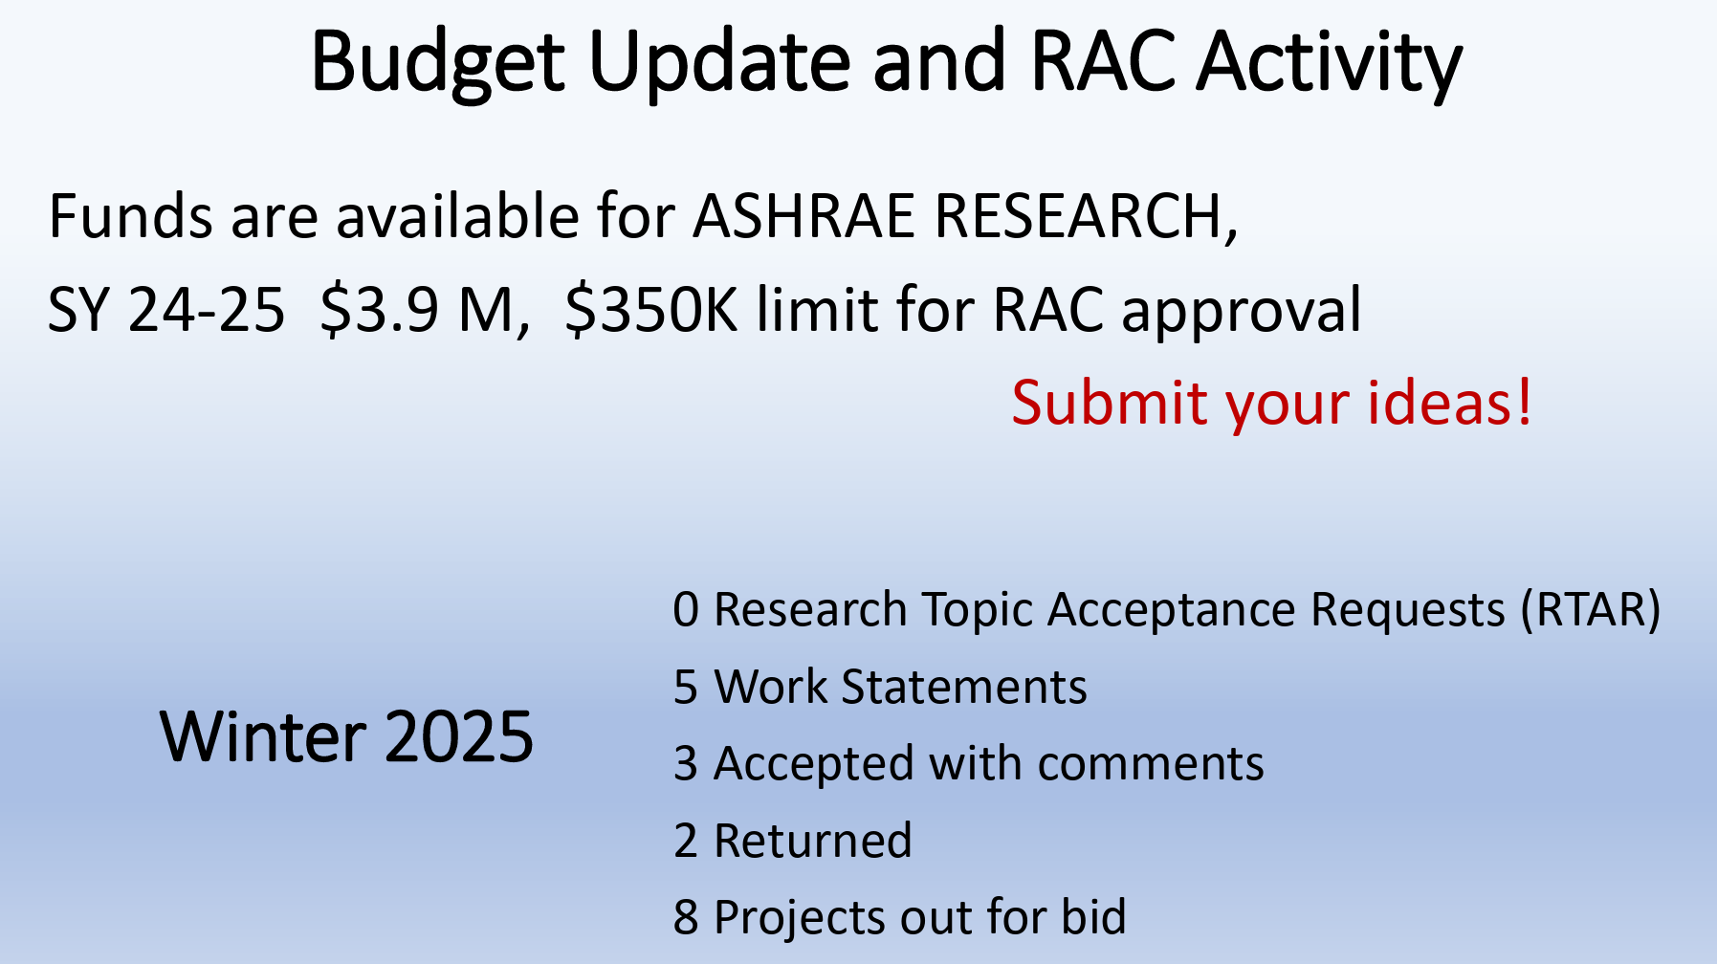
    - 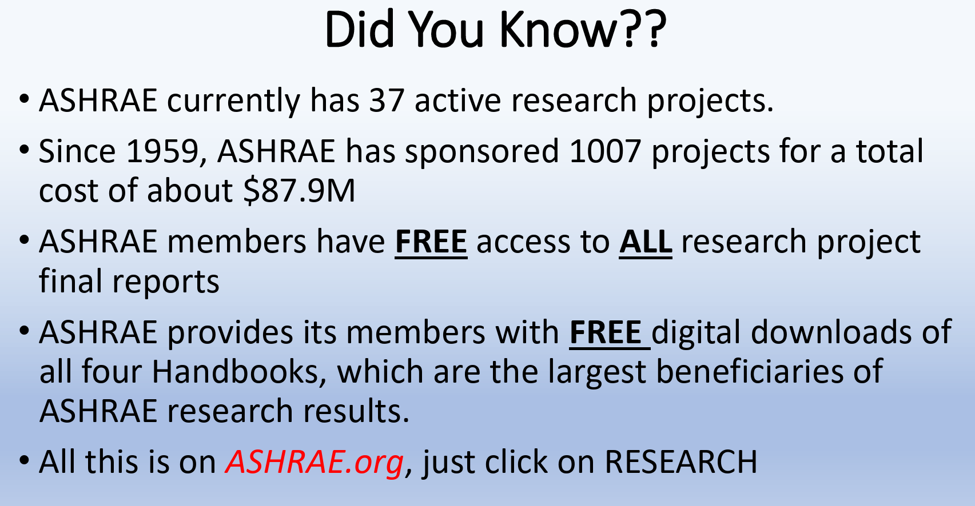
    - WS Budget Estimating Guidelines available
    - Raised $2.7 Million in 2024: RPs, Grants, Scholarships, Chapter Projects
    - Strategic Plan
      - ASHRAE Mission: Global Leader/Impact-Focused Engagement/Accessibility of Content
      - https://www.ashrae.org/file%20library/about/strategic%20plan/2025-28strategicplan.pdf
      - Healthy, Sustainable, and Resilient Communities
      - Empowered Workplaces
      - Organizational Agility
      - Emerging Technologies
      - Looking for members of Strategic Plan Committee for 2028-2030

    - Research Liaison : Srinivas Katipamula <Srinivas.katipamula@pnnl.gov>
  - RAC RTAR Web Tool
    - In Beta
    - Need volunteers
    - Mike P initiated
  - PMS Training
    - Required for prospective PMS members
    - See me for details
- Ongoing Business/Followup:
  - Research Project Status
    - 1815-RP, Integrating Occupant Behavior Data into Building Information Modeling for Performance Simulation
      - Author: Stephen Roth
      - Contractor: Stephen Roth
      - Completion Date: June 2024
      - PES/PMS
        - Rob Hitchcock, MTG OBB, Chair
        - Jeff Haberl, TC 4.7, TC 7.6
        - Jeetika Malik, MTG BIM
        - Todd Gottshall, TC 1.5
      - Update on Final Deliverables
        - Final report completed last summer
        - Disposition submitted
        - https://events.rdmobile.com/Lists/Details/2552354
        - Seminar 26: Overview of ASHRAE RP-1815: Integrating Occupant Behavior Data into Building Information Modeling for Performance Simulation
          - Monday, February 10
9:45 AM – 10:45 AM EST
    - New RTAR: 223P to IFC interoperability using SHACL rule sets
      - Will be reviewed in March
      - Author: Stephen Roth
      - TC 1.5 sole sponsor
      - The proposed research develops data modeling infrastructure to enable interoperability between the emerging ASHRAE 223P standard and emerging semantic standards developed by the IFC (Industry Foundation Classes) community. This effort enhances the value of 223P through bi-directional translation, validation, and querying capabilities which integrate with existing building information modeling standards.
    - WS-1811: Determining Occupancy Patterns in Clusters of Buildings with Data Drawn from Web Based Social Media and Mobile Positions
      - RAC conditional accepted the WS
      - Author: Bing Dong
      - Cosponsor with TC 7.10 Occupant Behavior in Building Design and Operation
      - PES
        - Todd Gottshall
        - Stephen Roth
        - Tianzhen Hong
        - 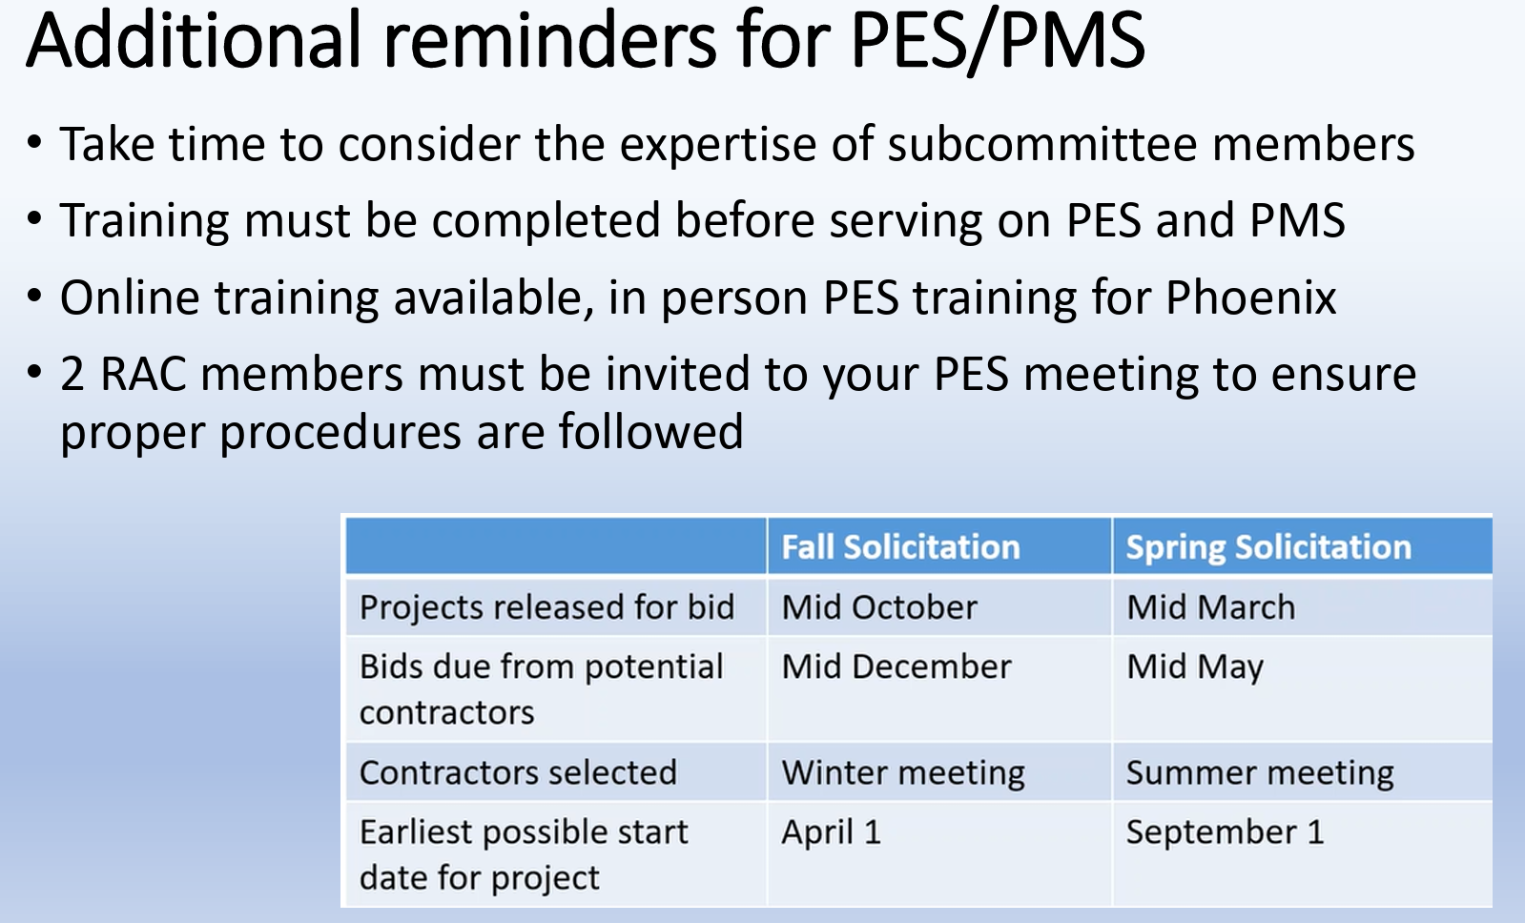
    - Potential RTARs
      - From Stephen, Todd will follow up
  - New RTAR Submission Deadlines
    - MMAD
    - March 15, 2025

- NEW RTAR / Workstatement Ideas
- AI Focus
  - Krishnan, AI MTG
    - Cosponsor with them
    - Todd will follow up
    - Brainstorm ideas to advance in Orlando main meeting
- Bruce Belledeaux
    - How do monetize ASHRAE knowledge base through APIs and Chatbots?
    - Mike P: Previous work on justification of Research to ASHRAE: Markel
- Anthony Fontanini
    - Follow on to Kaggle competition (Great Energy Predictor III)
      - Jeff H/Anthony F possibly to follow up
    - Co-Sponsor with 4.7 Data Driven Models (Main) and SSPC135 WG-SI
    - Extract Brick Codes from sensor data.
- Dave Branson
    - Follow on to RP 1468 DEVELOPMENT OF A REFERENCE BUILDING INFORMATION MODEL (BIM) FOR THERMAL MODEL COMPLIANCE TESTING
      - Remaining Items to be studied
      - Work relied on predetermined assumptions (core/perimeter zoning)
      - Jeff H student has some new models that might be further developed
    - Develop Reference BIM Model for Lighting Model Compliance Testing – Daylight
      - New modeling study: Daylighting, Radiance, Bim to Daylight to Thermal
      - Jeff H/Dave B to follow up
- Stephen Roth
    - Possible RP-1810 Follow on: GBXML Validator

- Anthony Fontanini
- Jeff H
    - Data Intervals: 1 Minute data sets
    - Example: 1 minute data on water heaters, can divine incoming water temperate and outlet temps.
    - Pecan Street: Submetering homes in Texas, 1 minute data
      - Other services: Nilm, 1 khz,
      - Sense
      - Mark Adams, Above 1 khz signal monitoring
      - Principal component analysis
    - Perhaps more appropriate in TC 4.7, in TC 1.5 can be more broad and not focused on building energy
- Decarbonization Track
    - Idea: Right size heating plants
    - Idea: Monitoring Renewable and Traditional Plants and making that data available to consumers for them to make educated decisions
    - NREL/AF: Long run rates to 2050
      - Long-Run Marginal Emission Rates: https://www.nrel.gov/analysis/cambium.html
      - Cambium
      - Cambium data sets contain hourly emission, cost, and operational data for modeled futures of the U.S. electric sector with metrics designed to be useful for long-term decision-making.
      - Database helps explore what the grid will do under different load scenarios
      - DOE
        - Also looking into emissions and using Cambium
    - Policies
      - Current Policies
      - Bay Area cities, Seattle, Boston, Cities in Canada
      - Potential Presentation/Program
        - Anthony F
          - Los Angeles 100
          - LA Muni
            - LA100: Getting LA to 100% Renewable Energy - https://www.nrel.gov/analysis/los-angeles-100-percent-renewable-study.html
            - LA100: The Los Angeles 100% Renewable Energy Study
            - NREL is providing rigorous, integrated engineering-economic analysis to the Los Angeles Department of Water and Power (LADWP) through the Los Angeles 100% Renewable Energy Study (LA100).
- Machine Learning Modeling
    - https://bit.ly/AutoBEM
- Next Meeting Time
- June, 2025 – Phoenix Hybrid
- Adjourn
- Attendance

Attachment 3:

Meeting Agenda/Minutes
ASHRAE 2025 Winter Meeting – Remote
TC 1.5 Program Subcommittee

Monday, January 27, 2025, 1:00-2:00 EDT
Chair: Mike Galler
Meeting link available at https://tc0105.ashraetcs.org/
- Call to Order: 1:00 PM.
- In Attendance: Galler, Lomonaco, Delgoshaei, Dwyer, Fontanini, Alfonso, Brinias, Kartik, Pouchak, Roth
- Review of Agenda
- 1 program proposals accepted:
Seminar 26: Overview of ASHRAE RP-1815: Integrating Occupant Behavior Data into Building Information Modeling for Performance Simulation, Monday, February 10, 9:45 AM – 10:45 AM EST, Chair: Stephen Roth, PE
- 2025 Phoenix Conference Tracks
- Fundamentals and Applications  - HVAC&R Systems and Equipment  - Research Summit  - Workforce Development | - Industrial Ventilation, Refrigeration, Air-Conditioning and Energy Utilization  - Heat Pumps, Refrigerants and Decarbonization  - Onsite Energy Storage
  - Deadlines
  - February 26 | Program (Seminar, Forum, Workshop, Debate and Panel) Proposals Due
  - March 5 | Conference Papers and Extended Abstracts Due
- Future Conferences:
Winter Conferences: | Annual Conferences:
Feb. 8-12, 2025 – Orlando, FL | June 21-25, 2025 – Phoenix, AZ
Jan. 31 – Feb 4, 2026 – Las Vegas, NV | June 27 – July 1, 2026 – Austin, TX
- Future Program ideas (and random notes):
- *Drones- Demo: Fly a drone during seminar: Title: Stick it up your duct
Lomonaco tried to organize a seminar for previous conference. Need approval from ASHRAE to fly drones in seminar. Contacts were reluctant to participate. Looking for someone to take over, or maybe try again in a year.
- Additive manufacturing, 3D printing- work at NIST of interest? Delgoshaei to reach out. How does this technology relate to HVAC? Possible seminar.
- Web apps/cell phone apps, HVAC related uses- Kartik- apps used for accessing building data,
Pouchak- goal is to get all building data accessible on smart phone, check alarms, all other methods of interfacing with building. Kartik- useful for monitoring, not control. Users check data and troubleshoot on their phones. There are companies demoing this at the expo, some of the more interesting ones could be contacted for possible seminar at AHR expo instead of at ASHRAE seminar. Schedule time for feedback at main TC meeting. Lomonaco could chair for Las Vegas or future.
- Digital twins, definitions, standards, etc. Delgoshaei will try to get speakers for Phoenix or LV. Roth- Raj Setty has digital twin software. Possible focus on business case/ROI for digital twins, where it’s appropriate. Intangible benefits, other uses (FDD, maintenance, …). Gerardo- data center digital twins, used for planning?
- Generative AI- Check with MTG.GenAI for updates? AI Track at Vegas.
- AI Machine Learning- Kartik- FDD and preventive maintenance using machine models, using T sensor for monitoring. Will look into organizing seminar. There are current applications in industry. Delgoshaei- Bartling is using ML for FDD.
- Computer Security Basics, cybersecurity- Galler contact Alessandro. Also Butler/Manufacturers Guide…
??? suggested seminar on cybersecurity stats, alert membership to extent of possible threats. Overlap of computer privacy and computer security, data is collected by good and bad actors.
- Database seminar. Time series vs relational.
- Big data user perspective
- Prototype buildings vs stock, panel/debate. Building energy modeling approaches, decarbonization policy, code development.
- Commissioning tools: Advances in current tools, new tools, new approaches.
- Cx agents- Grid interactive sequences of operation,
- Seminar on Research project 1815 OBXML for Orlando. (Seminar 26) Follow-up seminars?
- Tools to automate business processes- move data from email to spreadsheet or other documents.
- How can tech help make work orders faster. Current tech isn’t tailored towards knowledge and skillset of techs.
- Standards for UI and Ux.
- Panel on how ASHRAE members are using social media and application
- Mobile apps- how is ASHRAE embracing mobile app technology?
- Modelica/FMUs - RP 1661 (toolkit)
- Inverse model toolkit - possible future program item?
- CPU/GPU apocalypse - Joshua seminar on GPU/CPU Computing- can suggest speakers. New supercomputers have 98% of computing power in GPUs, modelling tools for HVAC use CPUs.
- Roth- Blockchain for refrigerant compliance, Solidity- blockchain language,
- RP-1801 Standardizing and Utilizing ASHRAE Online BIM Data Exchange Protocols presentation
- GPU Computing- Using GPUs for building energy simulations; Education component; Real-life from other domains- get data to support ASHRAE upgrade
- IOT sensors
- Digital Twinning and Blockchain
- Arduino for HVAC
- Big Data for HVAC
- "Optimize HVAC Energy consumption through data mining approach"
- “Capturing Design Intent in BIM”
- “Interoperability Software and Schema Technologies for Purposes of Building Energy Modeling”
- “Using gbXML To Run Loads and Build Your HVAC System BIM Schematics “
- “Put building geometry capture in your pipe and smoke it” MagicPlan?
- And You Thought You Owned Your Buildings Data In The Cloud!
- NetZero Analysis Strategies
- Free software tools: HVACR and looking at low-cost software tools like apps and open-source software
- More info on Phoenix tracks:
1. Fundamentals and Applications - Fundamentals are the foundation for understanding applications in engineering. Key components of ASHRAE fundamentals include thermodynamics, psychometrics, fluid flow, and heat and mass transfer. This track provides opportunities for papers and presentations of varying levels across a large topic base. Concepts, design elements and shared experiences for theoretical and applied concepts of HVAC&R design are included.
Track Chair: Atilla Biyikoglu | abiyik@gazi.edu.tr
2. HVAC&R Systems and Equipment - HVAC&R Systems and Equipment are constantly evolving to address the changing requirements of the built environment. Papers and programs in this track will focus on the development of new systems and equipment, improvements to existing systems and equipment and the proper application and operation of systems and equipment.
Track Chair: Ng Yong Kong | nyk@nyk.com.my
3. Research Summit - Active research, and the exchange of those research findings, are critical to the development of our HVAC&R industry and built environment. The 9th annual research summit invites researchers to share those results, including ASHRAE-sponsored research and research of interest to the ASHRAE community. Researchers are invited to present papers, extended abstracts, seminars, forums or participate in panel discussions. The Research Summit includes a partnership with ASHRAE's archival journal, Science and Technology for the Built Environment.
Track Chair: Haotian Liu | sjtulht@hotmail.com
4. Workforce Development - As members of a professional organization, we recognize that the single greatest strength of our organization is its membership. This track is designed to allow those professionals an opportunity to develop in the areas of presentation skills, leadership, team-building, understanding various business operations, interpersonal skills, etc. In short, the Workforce Development Track will cover all aspects of business and career development outside of engineering/technical applications and lends itself to interactive session types such as workshops and forums.
Track Chair: Anuj Gupta | anuj@design2occupancy.com
5. Industrial Ventilation, Refrigeration, Air-Conditioning and Energy Utilization - The industry sector accounts for roughly one third of the energy use in the US. Increasing efficiency demands are creating the impetus for new technology, targeted at industrial facilities. This track will explore these technologies and regulatory pressures facilitating them. This includes ventilation, refrigeration, and air conditioning for industrial facilities and strategies that can improve energy utilization such as, waste-heat recovery, high-temperature heat pumps, and ventilation techniques/strategies.
Track Chair: Vinod Venugopal | vinodpvgopal@gmail.com
6. Heat Pumps, Refrigerants and Decarbonization - Decarbonization is omnipresent and encapsulates many different elements. This track will focus on the development of heat pumps supporting decarbonization efforts. This includes improvements to legacy technologies, the refrigerant transition and component development. Additionally, this track will further explore more novel approaches that includes not in-kind technologies and less popular heat pump solutions such as ground-source heat pumps.
Track Chair: Money Khanna | khannamoney@gmail.com
7. Onesite Energy Storage - Thermal and electrical energy storage can alleviate the mismatch between renewable energy availability and peak building energy demands, enabling the incorporation of more renewable energy into the grid. Integration of onsite storage (either thermal or electrical) with residential and commercial building envelopes or HVAC systems would reduce buildings’ heating and cooling loads, level out peak energy demand, reduce HVAC size, increase energy savings, improve occupants’ thermal comfort and allow flexibility for shedding and shifting building loads. These benefits will improve grid resiliency, thereby enabling more cost-effective electrification of buildings. Papers and programs in this track focus on advances in cost-effective materials and systems, design, optimization and control as well as the integration of onsite storage in building envelopes or HVAC systems and grid resiliency.
Track Chair: Kevin Brown | kevin@kbsquared.net

Attachment 4:

Meeting Agenda
ASHRAE 2025 Winter Meeting
TC 1.5 Emerging Computer Applications - Handbook Subcommittee
Monday, January 27th, 2:30 pm – 3:00 pm ET
Chair: Ben Bartling
Attendees: Mike Pouchak (interim chair), Carol Lomonaco, Parastoo Delgoshaei, Anthony Fontanini, Michael A. Galler, Gerardo Alfonso, Jonathan Brinas, Kartik, Joshua New, Stephen Roth, Todd Gottshall.
Meeting link: TC 1.5 Handbook Subcommittee Meeting - ASHRAE TC 1.5
Called to Order at 2:30 PM ET by Mike Pouchak
- Tc 1.5 (Emerging Computing Applications) publishes one chapter in the ASHRAE Handbook. The most recent chapter published was Chapter 41 Computer Applications published in the 2023 ASHRAE Handbook HVAC Applications. It is 11 pages long. The next major publication is the 2027 ASHRAE Handbook HVAC Applications. The deadline for the final TC approved draft is June 2026.
- Follow up with Ben Bartling - switched industries.
- The following schedule was established:
- January 2024 Brainstorm and Identification of revision sections and contributors, identification of new sections and contributors. Work with TC chair and subcom chair minutes to identify new topics of interest. Distribute 2023 hvac app ch 41 computer app chapter; distribute 2019 hvac app computer app chapter, Distribute 2015 hvac app computer app chapter.
- June 2024 Outline Summary and identification of sections to be removed and new sections to be added and identification of contributors to those sections.
- June 2025 1st complete draft review
- June 2026 Final Deadline for 2027 HVAC applications: Computer Applications chapter approval.
How are computer used in the HVAC industry?
Action Item: Mike Pouchak to acquire the 2023 HVAC Application Chapter 41 Computer Applications chapter in word format and place on the basecamp HB subcom page. (completed Jan 25, 2025)
2023 HVAC App - Ch 41 Computer Applications Outline:
1. INTRODUCTION TO COMPUTING TECHNOLOGIES
Software Availability
Custom Programming
Programming Languages
2. BIG DATA
HVAC Applications
3. CLOUD COMPUTING
4. MOBILE COMPUTING
Mobile Applications in the HVAC Industry
5. CYBERSECURITY
Basic Cybersecurity Practices
6. SOFTWARE APPLICATIONS
Example Software Applications
BIM and Data Interoperability
7. BUILDING AUTOMATION AND CONTROL
Application and Purpose
Network Architecture and Components
Control Communication Protocols
BAS Security
ASHRAE Resources for BAS System Design

Potentially change name to emerging computing applications.

1. INTRODUCTION TO COMPUTING TECHNOLOGIES 41.1
Software Availability........................................................... 41.1
Bruce B. reflect on past pitfalls of HVAC software.
Custom Programming.......................................................... 41.2
Bruce B., no does not belong in the handbook.
Programming Languages..................................................... 41.2
Significant edit. If only 15 lines just delete.

2. BIG DATA........................................................................... 41.2
Obsolete term from 2010.
data science and analytics, maybe combined with AI? SR: get rid of it; data beyond of Peta btye; PD: whole field of data science ; tg: collecting trend log and analyzing;
now cloud and control & Bim; Meter data , utilities,; digital twin concepts. AI & ML related. data science: graph databases;
python libraries; used for analysis of data; statistical tools ; sql; fabric; power vi; we can't store data on a local machine. query and semantic modelling; K: lot of open source , prebuild libraries for data anlysis and ml like pyplots;
HVAC Applications............................................................. 41.3
PD:AFDD, commissioning, building to grid integration, predicitive maint.

3. CLOUD COMPUTING........................................................ 41.3
K:tied in data from bms, work ord mgmt sys; make them talk - more intelligent alerts.; build more complex learning model on cloud.l; better fault pre; PD: distributed agent and -
JB: increase speed of computing model using cloud; info from group of thermostats; smart thermostat companies use scripts to remotely download their builing data. ; ecobe -- 700 thermostat and look at data.; look at which units ; which occupants preferr hi vs lo temp; during buidling retrofit and why? amazon cloud vs google cloud - we could run energy models on one of those clouds and get results much ; AF: not everyone has their own computing cluster so ; We public data on OD (amazon data storage free serv) with querying tool to interact with it.
Include edge case computing

4. MOBILE COMPUTING....................................................... 41.3
Delete mobile computing
Phone app ; web apps; AlessA: 75% had iphone users
Mobile Applications in the HVAC Industry 41.4

5. CYBERSECURITY............................................................... 41.5
Absolutely very important to HVAC, BAS, GEB.
MTG.Cyb (MikeGaller chair) has agreed to review this section;
Basic Cybersecurity Practices.............................................. 41.5
6. SOFTWARE APPLICATIONS.............................................. 41.6
Example Software Applications............................................ 41.7
BIM and Data Interoperability............................................. 41.8
Reference a research project (Mohamed)
Keep it.

7. BUILDING AUTOMATION AND CONTROL 41.8
Application and Purpose...................................................... 41.8
Network Architecture and Components................................ 41.8
Keep it. Reference Guideline 13 for cybersecurity. ISA 62443.
Control Communication Protocols....................................... 41.9
BAS Security..................................................................... 41.10
ASHRAE Resources for BAS System Design 41.10
action: HB Chair to attend "Handbook Training for TCs Meeting in Orlando, Feb 9 9AM ET start.
Sunday, February 9, 2025 EST
9:00 AM – 10:00 AM EST
Handbook Training for TCs
Hilton Orlando, Lake Nona A (Lobby Level)
Tags:
Session Type: Standing Committee Meeting Format: Hybrid Location: Hilton Orlando, Lake Nona A (Lobby Level)

