ENERGY MANAGEMENT SUBCOMMITTEE
A Subcommittee of TC 7.6 Building Energy Performance

2022 Winter Conference (Hybrid)
Click to join the meeting: https://chime.aws/1580689526
Meeting ID: 1580 68 9526
Call in using your phone:
United States Toll-Free (1): +1 855-552-4463
Meeting ID: 1580 68 9526
One-click Mobile Dial-in (United States (1)): +1 206-462-5569,,,1580689526#
4:30 PM PST to 5:30 PST

Minutes

- Introductions
First Name | Last Name | Organization | Email | TC 7.6 Members/guest
Eric | Yang | Amazon Web sercies | ericyangcem@gmail.com | VM
Annie | Smith | Ross & Baruzzini | smithannelise314@gmail.com | VM
Bob | Silva | nVent Raychem | Robert.silva@nvent.com
Jim | Kelsey | kW Engineering | kelsey@kw-engineering.co. | VM-TC Chair
Harry | Bergmann | DOE | harry.bergmann@ee.doe.gov | CM
Barry | Abramson | Servidyne | barry.abramson@servidyne.com | CM
Dennis | Landsberg | L&S Energy Services, Inc. | DLandsberg@LS-Energy.com | CM
Amanda | Webb | University of Cincinnati | amanda.webb@uc.edu | VM
Terry | Sharp | Oak Ridge National Laboratory | sharptr@ornl.gov | CM
Linnea | Paton | ConEdison | patonl@coned.com; linneapaton@gmail.com | Guest
Mike | MacDonald | EPMI | mmacdonald@epminst.us | CM
Hyojin | Kim | New Jersey Institute of Technology | hyojin.kim@njit.edu | CM
Christine | Reinders | Iowa State University | christinereinders@gmail.com | CM
Dick | Person |  |  | CM

- Subcommittee Goal and Objective Review

The goal and objective of the proposed subcommittee group is reviewed with the group.

The updated plan of the Technical Committee (TC) 7.6 Energy Management Subcommittee is intended to align with ASRHAE Strategic Plan (2019-2024). One of three goals of ASHRAE strategic plan is to position ASHRAE as an Essential Knowledge Resource for a Sustainable, High-Performance Built Environment.

The Energy Management Subcommittee from TC 7.6 is directly connected with sustainable and high-performance built environment. Our goal as a professional group is to position this subcommittee as an essential knowledge source for energy and water management.

Previous programs cosponsored in the last conference:
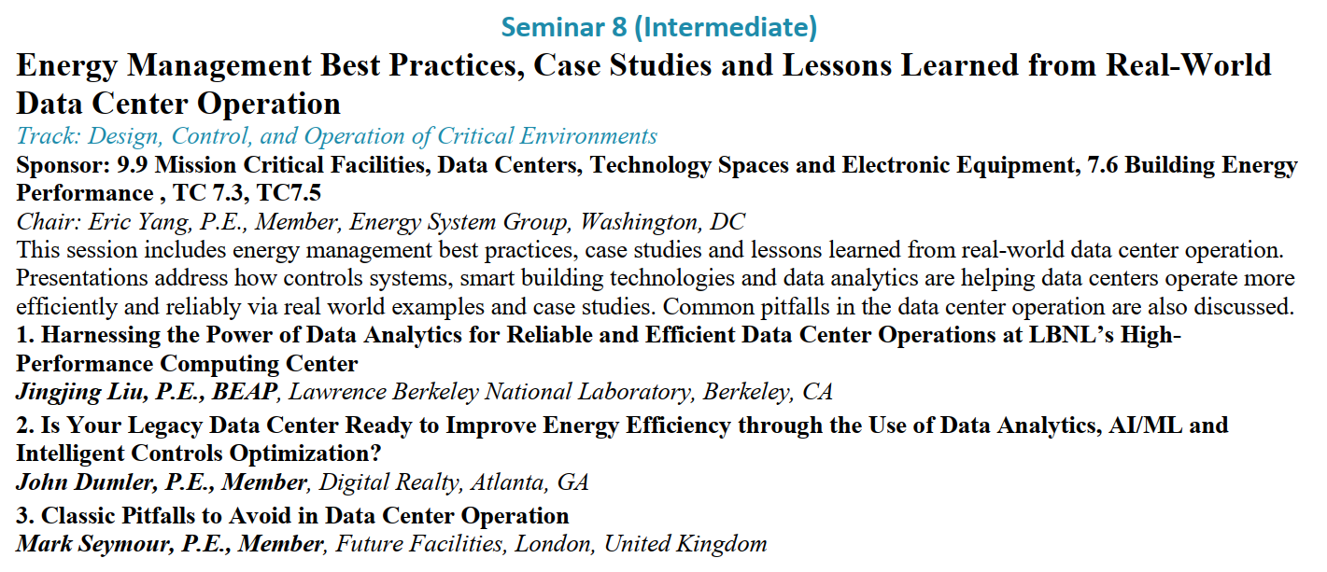

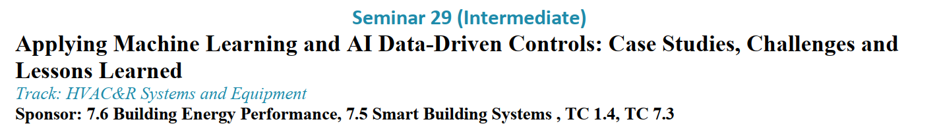
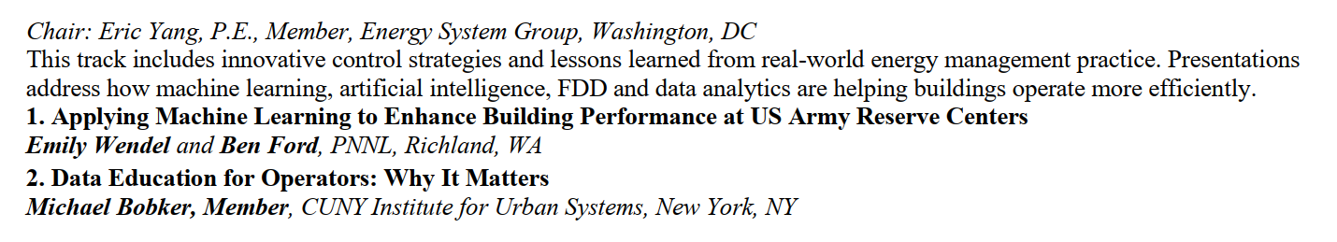
Program cosponsored this conference:
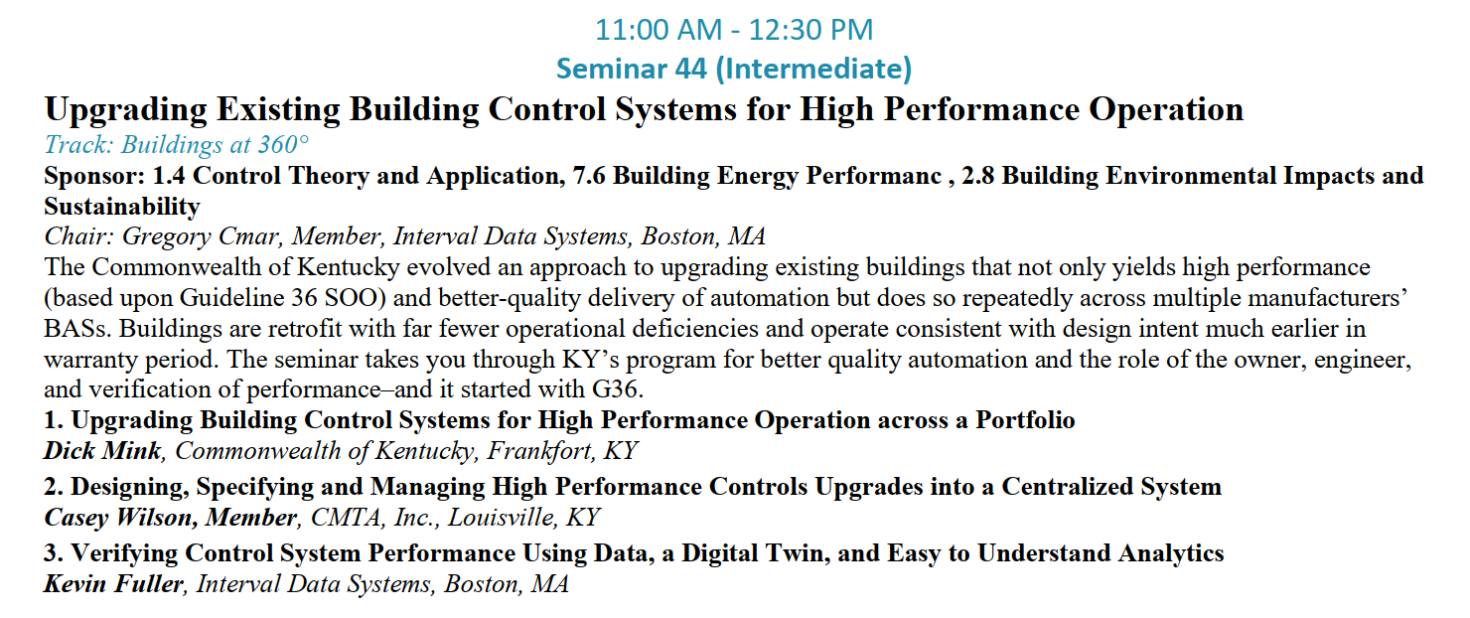

- Items to discuss

E. Yang: Energy Management ALI Course (3 hour) updates: scheduled in May 2022 online delivery.

E. Yang: a working group has been meeting monthly to make process on the course update and information sharing.

E. Yang: call for seminars on Energy & Water Management case study, ASHRAE g36, grid connected efficient buildings

J. Constantinide: Chapter 36 of the Applications Handbook (Energy and Water Use) seeks volunteers to help/edit. Chapter 37 of HVAC Handbook seeks volunteers to help/edit.

Research: any potential research project addressing water-energy nexus? Possibly collaborating with other TCs?

    - Programs
      - Propose Energy Management Case study program track

    - Research
      - Water-energy nexus: Eric will setup a call with Jeff Haberl (TAMU)
      - Trending process & sorting
      - Other new research ideas?
    - Handbook
      - none

- New Business
- TC2.8 –liaison -Steve Carlson
- TC7.3 – liaison Cristine Gibney
- ASHRAE 189 –Scott West
- ASHRAE Guideline 36 liaison - Greg Cmar

- Adjournment

- Any interested party who are interested in participating in Monthly call, please let Eric know.

