TC 9.08 Specialized Building Applications: Agenda
Monday, June 24, 2024 2:30-4:30
In Person Meeting: JW Marriott Indianapolis
(Establish Quorum: # of voting members present exceeds ½ of the # of total voting members of the committee (9 VM))
1) Call to Order
- Introduction of Members and Guests
- Quorum established? voting members present – No present.
- Voted on Meeting minutes from Tampa Annual Conference – Quorum not present.
- Quorum not present.
  - Andrew Dubel (Vice Chair)
  - Joy Altwies (TAC Liason)
  - Frank Mills (Sub Committee chair)
  - John Harrod (Corresponding Member)
  - Erich Binder (Guest)
  - Marcus Darcy (Guest)
  - Jim Liston (Programs Sub-committee chair)
  - Andy Manos (RP Sub-committee chair)
  - Frank Paradiso (Secretary)
  - Richard E. Vehlow (Voting Member)
  - Heather Schopplein Web (Non-voting)
  - Timothy Theriault (Pro-CM)
  - Keiron D. Nanan (Voting Member)
(See photo below of in-person sign in sheet)
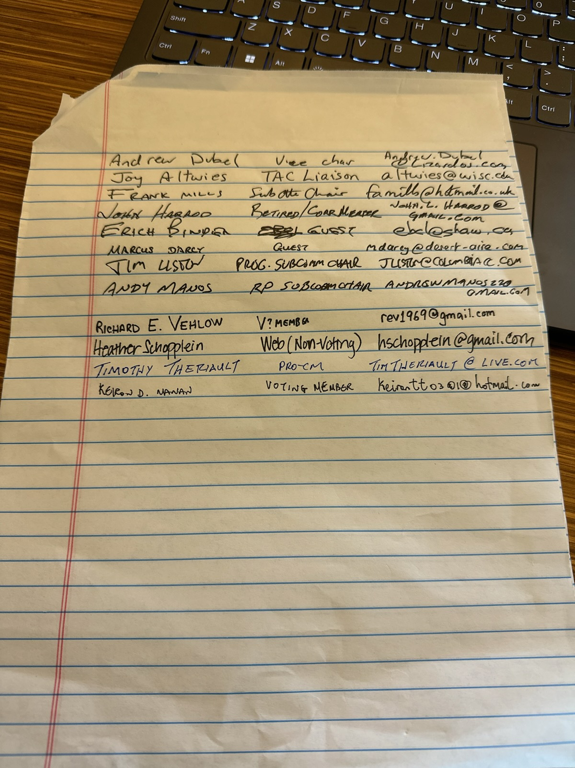
Joy Altwies (Incoming TAC Liason)
TAC update
- Replacing Brad Cochran
- New updated reference manuals for TC
- ASHRAE.org/TAC
- By Tuesday night
- Asking about feedback for roster updates
- Comments can be entered on the bottom of the activity form
- Changes in Spring take effect July 1
- February would be the meeting time.
- Couple of announcements at breakfast
- Government affairs office looking for updates
- Residential committee looking for updates

2) Handbook
a) Need new assignments and volunteers for next 2027 handbook updates to be further discussed in Annual Conference.
Notes from June 24th:
Handbook update Frank Mills
- Started cycle of revisions
- Helpful to put some names, solicit some help
- 10-11 chapters
- Retail
- Proposing 4 new chapters, have some names for those
- #2 Retail facilities, asking for volunteers
- Commercial and public buildings (needs work done on it)
- Places of assembly (Frank M and ralph worked on)
- Natatoriums (Assume that ralph is working on it)
- Hotels, Motels and Dormitories (Heather has some redlines on it and is looking for some international input) Change in title may have been Hospitality

- Justice - Doug Fitts
- Atriums (have a first draft on that)
- Fire stations (Doug fits has an outline, has he made more progress?) Ask about progress
- If new chapters are to be added get them in the queue now.
- Airport facilities (Anthony proposed this as a new chapter)
- Indoor growing facilities (MTG CEA, no documents yet.) pushing forward to get progress. They have a meeting tomorrow (Tuesday)
- By the early part of next year should be started to send drafts to the committee
- Retail - Kiernon Nanan offered to read through and
- Chapter 3 Commercial and public buildings (Andrew Manos volunteers)
- Places of Assembly needs someone to read
- Art Galleries (Andrew Dubel)
- By January 26th all of the chapters are to be voted on and approved.
- Any uploads should be on basecamp or emailed directly, not to be posted on any other shared cloud services.
CHAPTER NO | TITLE | Lead Author
2 | Retail Facilities
3 | Commercial and Public Buildings
5 | Places of Assembly
6 | Natatoriums
7 | Hotels, Motels, and Dormitories
10 | Justice
23/24 | Galleries, Archives and Library
 | Fire Stations
 | Airport Facilities
 | Indoor Growth Facilities
b) Handbook Assignments:
c) Reminder to attend handbook training for those who will be working on the handbook chapters.
- Start of 4 year period of updating (June)
- 2027 next applications handbook
- January 2026 chapters get voted on
d) Next updates shall consider the following and other current interests:
i) Covid
ii) Resilience
iii) Sustainability
iv) Climate change
v) Decarbonization
vi) Operation excellence
e) New Chapter Growing Facilities
i) The document from Chris Channing has been lost. Will follow up with MTG.CEA to see if they have anything they would like to include in a dedicated chapter.
f) ASHRAE would like to have 1 week advanced notice to put a meeting on the calendar and they will distribute a teams link.
g) Discussion of covid. Possible application of mitigation measure to be included in the next handbook revisions.
3) Subcommittee Reports
- TAC Update
- Programs (Jim Liston)
  - Next Winter meeting Feb 8-12 Orlando 2025
  - Following summer meeting Pheonix Summer
  - Following winter meeting Las Vegas 2026
  - 2026 summer meeting Austin TX
  - 2027 summer meeting New Orleans
Notes from June 24th:
Subcommittee reports: Jim Liston
See attached Programs report, not connected to BASECAMP, need to include copy of report as there was a lot of content and it was tough to record.
Programs
- Report for programs subcommittee 2024 Indy
- 8 tracks
- Research summit
- Electrification
- Building life cycle assessment
- 53 seminars / 64 chic
- 5 forums / 4 chic
- 3 debates / 2 chic
- Orlando Winter meeting
- Technical Program chair Sol
- Fundamentals HVAC
- Refrigeration and refrigerants
- Energy
- Pathway to building Decarb
- Artificial Intelligence
- Ventilation
- Futureproofing the build environment
- Passed 3 dates for
- August
- September
- October 4th
- October 9th revised conference papers are due
- ASHRAE upcoming Meeting schedules
- June 2025 Phoenix AZ
- Las Vegas Winter 2026
- Austin Texas Summer 2026
- Chicago Winter 2027
- June 2027 New Orleans
- 52700 net feet space (57000 ppl attended)
- Seminar 13 thermal energy storage
- Hydronic district energy systems
*Rick Hermins asked to be removed / no longer participated
- Membership Subcommittee (Kerion Nanan)
- Research
  - indoor grow room (Dessert Aire people interested)
  - Research on pool evaporation had been approved. Need finalize proposal
    - create a group of a few members to track updates
Notes from June 24th:
Research (Andy Manos)
RAAC Activities
- Donna Daniel – Basecamp
- 3 RTAR
- 7 work statements
- Awards Service to ASHRAE – Seat 1
- No one submitted awards
- Grant and aid to grad students
- 10,000 dollars awarded
- RAC increased $200k to 350k (increased due to post covid inflation)
- 14 RAC members can vote on, does not need board approval
- New Investigator Award – up to $125k
- PTAR - Publications, if you want to submit go through that
- RTAR web tool now in BETA testing
- New TC 9.13 Space X (New RTARS Solar angles and high radiation, load calcs for buildings on the moon) Artemis
- Talk of indoor grow room, talking about putting an RTAR for that
- Agricultural TC (2.2?) is also interested about getting into the mix
- 8.10 Natatoriums, RTAR, Ralph, calculations review the work (potentially going back 5 years, need to get it resolved)
- DSA Award
Image below
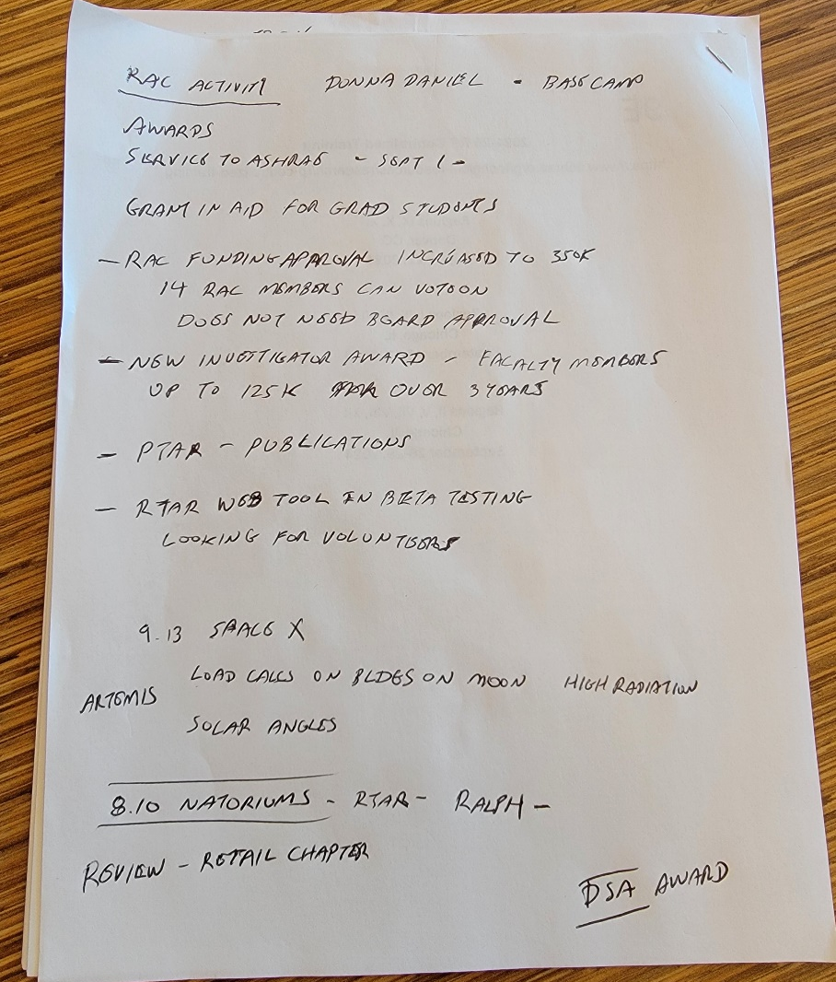

- Standards
  - Task Decarb
- ASHRAE Strategy (Bob Cox)
  - *(Potentially Bob Cox not being involved any longer)
- Webmaster (Heather Anderson)
- International Liaisons (Keiron Nanan,)
  - Looking at and reevaluation of standards for adoption
  - No unfinished business
- Justice facility subcommittee (Doug Fitts)
4) Unfinished Business
a) No additional unfinished business to follow up
5) New Business
- (Erich Binder- Guest)
- Design guide for Cold Weather buildings (Cold climates)
- Looking to put together a subcommittee
- 40-50 ppl interested
- Residential to Industrial (Calgary to Alaska)
- Try to do one every 3 years, take the data to update the manual
- “Snowflakes and Igloos”
- Address remote cold climates (Alaska, northern Canada)
- Heat pumps may not be the ideal solution for these areas
- The guide refers to the whole building (address the envelope)
- Major temperature swings throughout the seasons.
- North Country, daylight 24 hrs day how does that affect the building operations
- Or in the winter 5 minutes of daylight
- Severe temperature swings based on winds, severe indoor and outdoor temperature differences (100 deg swing)
- Need a subcommittee to manage the chapter
- Cold climate conference every 3 years
- Hot and humid is a similar cycle
- 15 chapters, looking to add 2 or 3 in the design guide
- Schools, Hospitals, museums in cold weather climates may fall under this as well.
- From TC 9.2 general industrial buildings
- Will stay in touch with TC 9.8
Any other new business?
Meeting unofficially adjourned 3:27 PM

Provide assistance, talk to Tony Giamitti (Chair of programs?)
He could bring it to staff and ask them what they would like to do
Basecamp updates, roster updates
Timothy Theriault volunteering to look at Justice commercial buildings chapter
6) Adjournment

Below are the current TC 9.8 Positions
Kasteny Knutson Chair Voting
Andrew Dubel Vice Chair Non-voting
Frank Paradiso Secretary Voting
Francis Mills Handbook Sub Chair Voting
Peter McDonnell Member Voting
Robert Cox Member Voting
Robert Roussel Member Voting
Keiron Nanan Membership Sub Chair Voting
James c Program Sub Chair Voting
E Fitts 9.4 Subc ch Non voting
Farhan Mehbob International Liaison Non voting
Roland Charneux Research Liaison Non voting
Andrew Manos Research Sub Chair Non-voting
Brad Cochran Section Head Non-voting
Steven Hammerling Staff Liaison Non-voting
Julie Majurin Standard Liaison Non-voting
James Bennett Tac Chairman Non-voting
Heather Schopplein Webmaster Non-voting

