TC 8.4 Research Sub-committee meeting – June 11, 2021 9:00 AM – 11:00 CDT

AGENDA and NOTES

- Introduction of members and guests – see list below

- Research Sub-committee Chair Meeting – None this Annual meeting?
Summary from Virtual Winter 2021 meeting held February 11, 2021
- Shortage of research funds typically $2.6M per year from donations, research promotions and AHR Expo contribution.
- RAC budget for SY 20-21 of $1.8M will cover current contract commitments only.
- Keep submitting the RTARs or Work Statements to be in queue.
- During the Winter meeting 4 RTARs and 6 WS were reviewed.
- Research Advisory Panel came up with seven initiatives based on survey of members
- PMS and PES training modules have been completed. However, PES training is suspended until project bid solicitation is resumed.
- Funded Publications – PTAR process is available
- https://www.ashrae.org/technical-resources/research

- Programs – Seminar 23 (On-demand): Additive Manufacturing of Heat Exchangers. Virtual presentations by Vikrant Aute (U of Maryland), Kashif Nawaz (ORNL) and Kevin Uvodich (UIUC).

- Current Research Projects
      - No active research as lead TC
      - Co-sponsor with TC 8.11 for RP1785 Charge Project
        - Ray Rite (PMS chair), Christian Bach (PI)
        - Update will be given during TC 8.11 research meeting (June 21)
      - Co-sponsor with TC 1.3 for RP1683 Ammonia U-Bend Project
        - Ray Rite (PMS Chair), Chad Bowers (PMS), Dr. Abbas (PI, GIK Institute), Lorenzo Cremaschi (Co PI)
        - Update will be given during TC 1.3 / 8.5 research meeting (June 14)

- Ideas for RTARS
      - Impact of oil return – Sankar started RTAR
      - Low superheat systems – speed of TXV and its interaction with transient response of heat exchanger – Sankar with support from Pedro and Christian (co-sponsor with TC 8.8?) - Sankar will have RTAR before RAC meeting in September – ID tube/fin coil and OD MCHX scope
      - Corrosion project follow-up?
      - Model for flow in distributors with focus on modulating flow / variable speed systems Kashif to share literature – Kishan to follow up with Kashif, Vikrant to help too. Kashif to share info.
      - Effect of coil damage (manufacturing/install/transport/during use) on performance – Bill Fox - follow up to fouling, recommendation to when coil replacement needed. Sankar – standard to quantify – Keep for future discussion
      - Unified testing methods for tubes (aka calorimeter testing) – drop from list
      - Update on market interest in < 4mm diameter tubes [Vikrant, Bill, Yirong] - keep for prototyping capability to catch up, various tube spacing main issue even with flat fin – Yirong assessment
      - Characterizing limits for condensate blow-off for ID/OD? coils – Yang - drop from list / consider next topic on coil coatings
      - Longevity of coil coatings – Yang - Yang to share Penn State U research – received, maybe proprietary information, Kashif to share some additional research.
      - In Orlando meeting Lorenzo suggested to identify gaps in TC 8.4’s handbook sections
        - Microchannel evaporators basics into handbook (look at Lorenzo’s research also) – Jun and Sankar to have offline discussion
      - Evaporative condensers - developing correlations – Emily Yin [TC 8.6 lead] - Information there in Condenser chapter 39

- New Ideas
    - Plate fin evaporator application in building HVAC industry [adopting] - Aerospace vs. Automotive – Kishan to look into further
    - Secondary loop systems fin-tube coil sizing study – A2L Refrigerant to Air OD coils > A2L to Glycol HX > Glycol to Air ID coil. Simulation followed by test validation - Tools already exist.
    - Evaporation in Microchannel coils – heat pump applications (do we need more data) – not much interest
    - Vote in main meeting on co-sponsoring RTAR from Christian.
    - Charge reduction with low GWP fluids – Christian’s idea (system or component level?)
    - Low GWP charge modeling for heat exchanger. Tube plate fin and microchannel. TC 1.3/8.5 can co-sponsor. Christian Bach volunteered.

- Adjourned at 10 AM
List of Attendees (Host – Kishan Padakannaya)
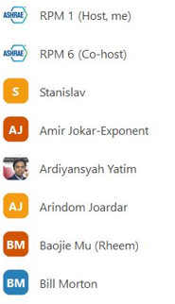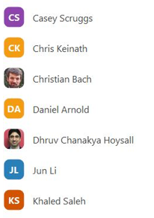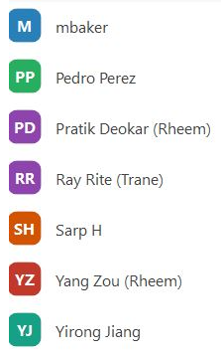
Vikrant Aute Cheng-xian (Charlie) Lin. Chris Seeton

