AMERICAN SOCIETY OF HEATING, REFRIGERATING AND AIR-CONDITIONING ENGINEERS, INC.

TC9.3 Agenda

February 7, 2022
Online Everywhere

Committee | Day | Date | Start | End | Room | Location
TC 9.3 Transportation Air Conditioning Main Committee | Monday | 2/7/2022 | 11:00 AM  Eastern | 13:00 PM  Eastern | Your own | online

TC 9.03 Main Committee

Link to join: https://events.rdmobile.com/Asset/Download/7656412
Meeting number:
2331 693 8899
Password:
TC9.3
Join by phone
18662994153 United States of America Toll Free
+14702385742 US Toll
Access code: 2331 693 8899

Agenda

11:00 Call to Order & Establishment of Quorum; Online
- Introductions
Voting Members:
Don Leblanc
Stephen Trent
Andreas Bezold
Richard Fox
Jim Bushnell
Quorum Reached
Non Voting:
G.D. Mathur
Paul Lebbin
Josh Kelton
Chris McDaniel
Judith Anderson
Rene Beaulieu
Thaddeus Rogowski
Ken Warren
Rahul Dixit
Catherine Thibauld
Ben Thiesse

Guests:
Florian Mayer
Carlos Eduardo Michels
Michelle Shi
- Roster Update
  - ID voting member roll-off after 2021 Summer Meeting
  - ID voting member additions
  - Review committee positions (new/continuing)

11:30 Old Business

Approval of Minutes from Summer Virtual Meeting
Vote is 5-0-0

11:40 New Business

- Research- Andreas Bezold

Meeting was joint with SSPC161. We have a new research Liaison (list name).
Andreas discussed other presentations. (See Research Committee Minutes)

- RP 1830 update and approval
PMS recommends approval. Byron Jones presented on results and answered some questions. Research committee recommends balloting for approval. Report is uploaded on T.C. 9.3 & SSPC 161 basecamps. No comments have been seen yet.

Rough Summary: Judith- Richard
Judith Anderson Comments: Page 4 & 125- Commented on Carbon Monoxide production temperature dependence- since temperatures were below 300°C would not expect CO. Judith relayed Byron stated that temperatures above 300°C would not be consistently expected in real engines either. Judith and Byron agreed that CO will not be a useful marker because it is not present in all conditions.
Richard Fox: Did not fully agree with position.
Judith: Refers to Crane et. al (1983) reference (306°C)
Richard: Sourcing for engine above 300°C. Typical ECS system limitations are roughly 600°F (approximately 300°C)
NRC Report (2002)-
A discussion was held on the above comments within the committee meeting.

Revised Language: Page 4:

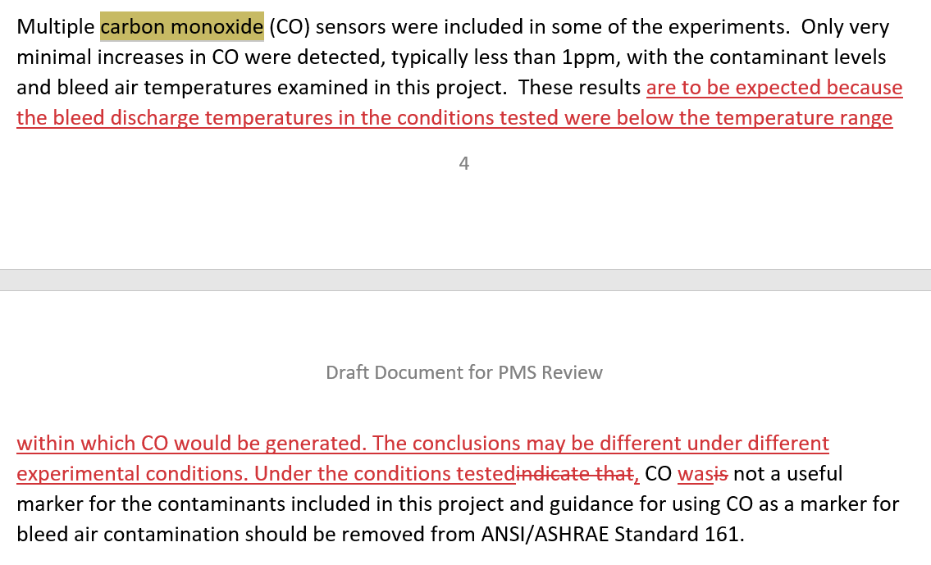

Page 125:

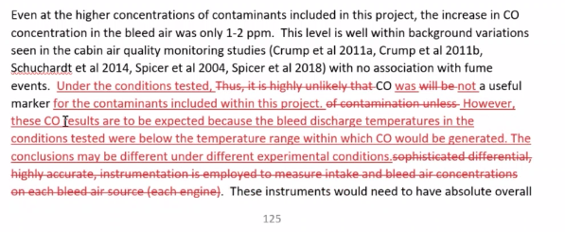
Motion for Approval (with comments): Richard Fox, Seconded by Andreas. Vote passes 5-0-0. Draft to be sent with these minutes.
- Ken Warren Proposed a potential research project on ground equipment and airport air connections. Study of air quality while at airport gates. Comparison of Air Quality (at gates) to that in flight, and SSPCs 62.1 & 161. Potential dialogue with SAE AGE-3 as well. Ken & Stephen to tag-up to draft proposal. See research committee minutes for full details.
- Mass Transit RTAR?
Rene presented on group final efforts for generating RTAR on
Subway Car Ventilation. Headed back to GPC23, upon approval will return to full committee. Another potential research, in collaboration with APTA and/or other potential stakeholders on air filtration and pathogens treatment was discussed. Doug Eaton (member of GPC 23) accepted to pursue discussions with APTA (Lisa Jerram) to evaluate their interest to such collaboration research project. See research committee minutes for full details.

- Subcommittee Reports and Handbook Chapter Approval Status
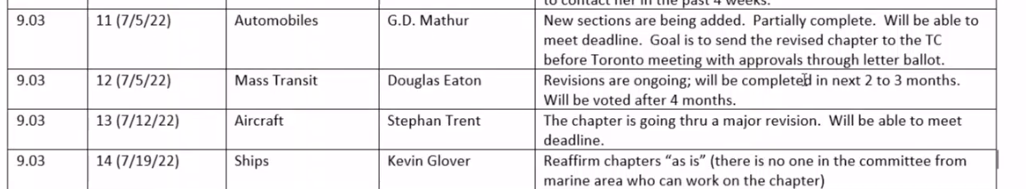

- Automobile & Chapter 11 -GD Mathur
See G.D’s Minutes.

- Mass Transit & Chapter 12-Rene Beaulieu
Pretty much completed, significant references to GPC 23, and language brought in alignment. Remaining work related to buses.

- Aviation & Chapter 13– Stephen Trent
Extensive revisions in process, largely on research projects, spread of disease, air exchange rates and general cleanup.

- Ship & Chapter 14-Kevin Glover

- Program Report- Lubos Forejt (15 min)
Lubos not present. Rene presented a summary on a potential program based on GPC 23. Thaddeus Rogowski (GPC 23 member) is poling the Rail/Mass Transit subcommittee members to elaborate a table of content for a potential seminar and to find interested participants and/or speakers.

- Standards Report

  - Aircraft-SSPC161- Catherine Thibaud/Judith Anderson
Guideline 28 Published
Edits on HEPA filter: Stephen Trent will tackle edits and send to committee
Task Group (Byron Jones, Judith Anderson, Andreas Bezold, Catherine Thibauld, Stephen Trent, Frank Brehany, Stephanie Licht, Richard Fox, Ben Thiesse) to work on language for CO in standard.

  - Mass Transit-GPC 23- Rene Beaulieu
GPC 23 approved an update of GPC23-2016R TPS (Title, Purpose, Scope) for Guideline 23. Approved TPS was submitted to ASHRAE Standard Committee for its approval.
GPC 23 also approved the updated GPC23-2016R Work Plan. The approved Work Plan was submitted to ASHRAE Standards Committee for its approval.
Process to release Guideline 23 (2nd revision)- Planned for release in July 2026. Small work groups are working on each section. Each working group is working on comments from a wide variety of commenters.
Following completion, will be brought back to full committee.
  - Ship-Standard 26- Kevin Glover

- Next Meeting Date and Location
  - Summer June 25 to 29, 2022, likely from home again or Toronto

Other new business?
- Jim Bushnell provided an update from Las Vegas. Awarded Epidemic Task Group. Included Don Leblanc as recognition for his efforts leading response for T.C. 9.3.
- Florian Mayer- CognitAir Project- Results in Publication in ASHRAE Journal (looking to write this year), and Present Results. To present results in IAQ 2020 (May 4-6, 2022 in Athens). Workshop at Indoor Air (ISIAQ- June 12-16 Kuopio, Finland) this year. Final Report submitted. Dates to be submitted.

Stephen & Don to discuss this afternoon on plans for Roster. We’ll send out a list of voting members and our plans for roster moving forward to keep a continuous list of voting members present on the committee.

13:00 Adjournment-
Stephen Motioned, Andreas Seconded. Meeting Adjourned.

