Technical Committee Meeting Minutes
Technical Committee, TC 1.10 Combined Heat & Power Systems
Tuesday, June 25, 2024: 2:30 PM - 4:00 PM EDT

Location: JW Marriott, Room: 304 (3)
Meeting Format: Hybrid

Chairs and Voting Members:

Position | Term | Name | Voting Status | Present
Chair | 06/30/2024 | Geoffrey Bares | VM | Yes
Vice Chair | 06/30/2024 | Michael Calabrese | VM | Yes
Secretary | 06/30/2025 | Praveen Cheekatamarla | Non-VM | Yes
Program Subcommittee Chair | 06/30/2024 | Gearoid Foley | VM | Yes
Handbook/Standards Subcommittee Chair | 06/30/2025 | Dragos Paraschiv | VM | Yes
Research Subcommittee Chair | 06/30/2025 | Farzin M Rad | VM | Yes
Member | 06/30/2027 | Zhiming Gao | VM | Yes
Member | 06/30/2026 | Vikas Patnaik | VM | Yes
Member | 06/30/2026 | William A Ryan | VM | Yes

Guest Attendees: Complete attendance list in Appendix A.

Position | Name | Present
TAC Section Head | Jason Atkisson | Yes
Member/DOE Liaison | Mahabir Bhandari | Yes
TC 8.3, Programs Chair | Bill Ryan | Yes

- The Chair (Geoff Bares) Called to Order at 2:30 pm

- The chair (Geoff Bares) discussed the Purpose Statement

Technical Committee (TC) 1.10 is concerned with combined heat and power (CHP) systems, their cycles and components including heat recovery, combustion turbine inlet cooling (CTIC), energy conversion and system integration. The systems provide both power (electric and/or mechanical) and cooling/heating thermal energy and are also known as cogeneration systems; trigeneration systems; and combined cooling, heating and power (CCHP) systems.

- ASHRAE Code of Ethics Commitment – Announced by TC Chair (Geoff Bares)

In this an all other ASHRAE meetings, we will act with honesty, fairness, courtesy, competence, integrity and respect for others, and we shall avoid all real or perceived conflicts of interest. (see full code of ethics: https://www.ashrae.org/about-ashrae/ashrae-code-of-ethics.)

- Introductions – TC Chair (Geoff Bares) hosted the virtual meeting and the in-person meeting.
  - Name, organization, and positions on committee. Roll call.
  - Quorum has been established with 8 voting members present.

- Meeting Minutes from the 2024 (Chicago) Winter Meeting
  - Copies of the draft minutes of the Chicago meeting were distributed to the members.
  - A motion to approve the meeting minutes of the 2024 Winter Meeting.
  - Motion by TC Chair (Geoff Bares)-VM, second by Michael Calabrese-VM, all Yea, no Nay. Motion passed unanimously, 8-0-0-CNV.

- The chair (Geoff Bares) discussed the Chair Breakfast meeting minutes
  - Presentations were provided by society groups, code interaction subcommittee
  - Government Affairs Committee (GAC) is looking for potential volunteers to participate in Adoption of Codes and Standards activities
  - Global Technical Interaction Committee (GTIC) promotes ASHRAE standards and participation at international stages. GTIC can be reached out directly for collaboration and participation
  - A new committee was announced - Residential Buildings Committee (RBC) is responsible for identifying major residential trends impacting the practice of HVAC&R. The committee will identify, recommend and coordinate relationships with societies and organizations that focus on residential buildings.
  - RTAR is moving online and is expected to be introduced in the Fall
  - ASHRAE has developed a policy on AI – ASHRAE prohibits the entry of content from any ASHRAE publication or related ASHRAE intellectual property (IP) into any AI tool, including but not limited to ChatGPT. Additionally, creating derivative works of ASHRAE IP using AI is also prohibited without express written permission from ASHRAE
  - Section Head for Section 1 has confirmed the move of TC 1.10 to Section 6
    - Motion by Dragos Paraschiv-VM, second by William Ryan-VM, all Yea, no Nay. Motion passed unanimously
    - Amend the motion to request 6.4 as the new TC designation. Motion by William Ryan-VM, second by Farzin Rad-VM, all Yea, no Nay. Motion passed unanimously.
    - TC Chair (Geoff Bares)-VM to inform Section Head for further processing
- Jason Atkisson (TAC Section 1 Chair) Jason updated highlights from the Chairs meeting
  - ASHRAE’s AI policy was reiterated
  - ASHRAE has 100 Functional Groups
  - Three new Groups/Committees have been formed
    - TC 9.13, TG9.Extraterrestrial and Deep Space Environmental Control Systems
    - MTG.BEQ will be responsible for the technical development, business development, planning, training, and marketing of programs for the Building EQ enterprise. Responsibilities include suggestions for research, development, and presentation of technical programs of all types on Building EQ and special publications detailing aspects of the Building EQ program.
    - MTG.AI will review the integration of Artificial Intelligence capabilities into the industry, the boundaries that need to be established around AI produced content and Intellectual Property of ASHRAE and its members.
  - Current Roster ends on June, 30th. New Roster will be updated and distributed
  - Jason Atkission (TAC Section 1 Chair) to move motion in TAC for moving TC 1.10 to Section 6. Expected to be completed and announced in the Winter Conference in Orlando

- Sub-Committee Reports:
  - Program: Gearoid Foley (Voting Member, Subcommittee Chair)
    - Winter Seminar Scope was discussed – proposed Energy Storage and Grid Resilience topics
    - Mahabir Bhandari (CM) proposed two topics – Thermal/Electric coupling, Flexible CHP
    - John Randtke (CM) announced that Jerry Kimmel (CM) is interested in presenting their work on Organic Rankine Cycle
    - Gearoid Foley (SC Chair) proposed CHPs role in electrification as another topic to consider
    - Farzin Rad-VM proposed another topic focused on Microgrid and Nanogrid – to discuss further with Gearoid Foley (SC Chair)
    - Motion to sponsor a submittal of TC 1.10 Seminar by Farzin Rad-VM, second by William Ryan-VM, all Yea, no Nay. Motion passed unanimously, 8-0-0-CNV
    - William Ryan (TC 8.3 Chair) is developing three presentations for the Winter Conference – utilization of alternative fuels and waste heat in absorption systems and tri-generation systems
      - Gearoid Foley-VM is interested in joining
      - Co-sponsorship of TC 8.3 Seminar by TC 1.10 was proposed by William Ryan-VM
        - Motion by Vikas Patnaik-VM, second by Dragos Paraschiv-VM, all Yea, no Nay. Motion passed unanimously, 8-0-0-CNV
  - Research and Publications: Farzin Rad (Subcommittee Chair)
    - Farzin Rad-VM updated the research SC highlights.
    - Research is being supported via $2.4M in total funding.
    - Two out of three RTARs were accepted along with four publications
    - 27 out of 67 student grant applications were accepted
    - RTAR funding has been increased to $350k
    - A new Strategic Research Plan Guide is being developed
    - RTAR web portal will be launched soon
    - Dragos Paraschiv (VM) to pursue PTAR funding to revise the Design Guide and Fuel Cell applications in buildings
      - Dragos found original research guide and will share with RSC and TC chairs - "Fuel cells for building applications, fundamentals, how cogeneration fits in commercial and residential buildings”
      - SPC Std 204 – TEST method for micro-CHP
      - PTAR to be submitted in the next meeting in Orlando
    - Another RTAR topic submitted by John Willis (CM) on stirling/solar thermal/PV system’s Lifecycle Analysis wasn’t accepted due to COI
    - New topic was proposed – integration of solar thermal energy storage in buildings – benefit of integration of nano-grid with CHP – A focused study on cycle efficiency, cost, and resiliency
      - Praveen Cheekatamarla (CM) expressed interest in participating and contributing
      - Farzin-VM to supply abstract for consideration to TC Chair before December 2024.
  - Handbook: Dragos Paraschiv (Subcommittee Chair)
    - No changes to Chapter 7 - to be implemented in 2028 cycle due to significant number of updates. Also, DOE-ASHRAE copyright issue prevented the effort from moving forward
    - Chapter 8 will be revised further, based on CTIC design guide. [Outdated note. Removed with approved minutes, Orlando Winter 2025 meeting.]
    - Starting July 1st 2024, Alok Kumar (VM) will be the new Handbook SC Chair
  - Standards: Dragos Paraschiv (Subcommittee Chair)
    - SPC 204 – members are on roster after Jan meeting (MOT for mCHP), TC 1.10 is responsible
    - Chair of committee – 7 members on the chapter
    - Updates to be provided in the Basecamp site
    - New meeting timeslot to Tuesday after TC1.10 meeting
- Announcements by Geoff Bares (TC Chair)
  - Geoff Bares to roll off as Chair on June 30, 2024. Michael Calabrese-VM and TC Vice Chair will be the new Chair starting July 1st, 2024
  - Praveen Cheekatamarla (CM) will assume the role of Vice Chair, starting July 1st, 2024
  - Kathryn Hinkelman (CM) will assume the role of Secretary, starting July 1st, 2024
  - 7 voting members in the TC, starting July 1st, 2024
  - Joel Deddens will be the new Webmaster, starting July 1st, 2024

- Old Business
  - TC Website has been updated by Geoff Bares (TC Chair)
  - Approved meeting minutes from Chicago will be posted by Geoff Bares (TC Chair)
  - New information related to completed research, papers, etc. can be posted on the website
- New Business
  - IDEA Liaison report - John Andrepont sent the minutes to Geoff Bares (TC Chair)
    - IDEA is an industry association with 3000 members from district energy/utilities/facilities/ manufacturers/suppliers from around the world. They have a quarterly magazine and conduct two conferences each year. Next meeting is going to be in Feb. 2025 in Boston
- Adjourn
  - Announcement by TC Chair (Geoff Bares) to close this session at 4:00 pm.
  - Motion by Farzin Rad -VM, second by William Ryan-VM, all Yea, no Nay. Motion passed unanimously.

Submitted by
Praveen Cheekatamarla, Ph.D.
Secretary, TC 1.10.

TC 1.10 COMBINED HEAT AND POWER SYSTEMS
2024 ASHRAE Annual Meeting (June 22-26, 2024); Indianapolis, IN

Subcommittee Meetings
Handbook, Program, Research, Membership Subcommittee
Tuesday, June 4, 2024: 1:30 PM-3:00 PM EDT; Virtual
Click here to join the meeting
Meeting ID: 269 455 245 024
Passcode: gLfb8i
Download Teams | Join on the web
Or call in (audio only)
+1 872-256-4257,,43395480# United States, Chicago
Phone Conference ID: 433 954 80#

TC 1.10 Committee Meeting
Tuesday, June 25, 2024: 2:30 PM-4:00 PM EDT; JW Marriott, Room: 304 (3)

TC 1.10 Sponsored Seminars
Seminar 33: LIVESTREAM: Mitigating Electrification Pitfalls with Thermally Driven Heat Pumps
Tuesday, June 25 8:00 AM – 9:30 AM EDT
JW Marriott – Indianapolis, 3, Grand Ballroom 4

AGENDA

1. Welcome Geoff Bares
2. Roll Call / Introductions Geoff Bares / All
3. Introduction of ASHRAE Liaisons on Arrival Geoff Bares
4. Establishment of Quorum Praveen Cheekatamarla
5. TC1.10 Purpose Statement Geoff Bares
6. Minutes of the 2023 Summer Meeting (Tampa) Geoff Bares
7. Subcommittee Reports
a. Program Gearoid Foley
b. Research Farzin Rad
c. Handbook Dragos Paraschiv
d. Standards Dragos Paraschiv
e. Membership Geoff Bares
f. TC Website Geoff Bares
g. Honors & Awards Geoff Bares
8. Chairman’s Overview and Report Geoff Bares
9. Old Business Geoff Bares
10. New Business All
11. Next Subcommittee and Committee Meetings Geoff Bares
12. Adjourn All

Attachment 1: Mission Statement:
“TC 1.10 is concerned with combined heat and power (CHP) systems, their cycles and components including heat recovery, combustion turbine inlet cooling (CTIC), energy conversion and system integration. The systems provide both electrical/mechanical power and cooling/heating thermal energy and are also known as cogeneration systems; trigeneration systems; and combined cooling heating and power systems.”

Appendix A: Attendees

In-person attendees:
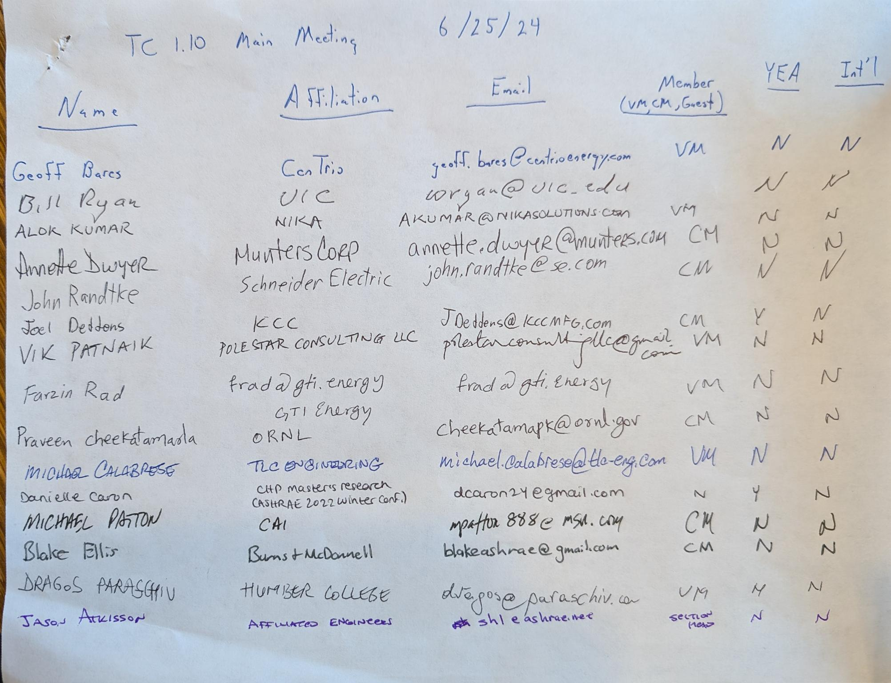

Virtual attendees:


