Minutes
TC 7.6 Monitoring and Energy Performance Subcommittee
Chicago, IL — Monday, January 26, 2015
Dennis R. Landsberg, Chair

The meeting was attended by 5 members of the TC, 10 corresponding members and 10 guests.

- Introductions and Introductory Comments
- Update On Standards and Guidelines Related to Energy Performance
  - ASHRAE Standard 100 – Chair Gordon Holness - second publication vote by Standards Committee- going into continuous maintenance.
  - Standard 211 Commercial Building Energy Audits - Anticipate advisory draft by March
  - Standard 90.4 Energy Standard for Data Centers and Telecommunications Buildings.
  - ASHRAE Guideline 14 –published
  - Standard 34P - ASHRAE Energy Guideline for Historic Buildings
  - Standard 214 – Methods for Measuring and Expressing Building Energy Performance in a Rating Program – Wayne Stoppelmoor Chair
  - New Global Protocol for Community-Scale Greenhouse Gas Emission Inventories at ghgprotocol.org/files/ghgp/GHGP_GPC.pdf
  - Anyone have experience with ASHRAE 62.2?
  - BPI STD 1105 (MF energy audits) still be in revision based on comments received
  - Is the increased attention to "performance-based" paths in 90.1 and 189.1 simply ignoring the inevitable switch to performance-based standards?
  - CA stringent EE standards have not made CA any better than a B+ grade in empirically-based grading system? Is the overall approach working? (http://epminst.us/states/st09ecgrade.htm - next version of grades will be after 2014 SEDS data released in Fall 2016)

US State Buildings Energy Conservation Grades 2009
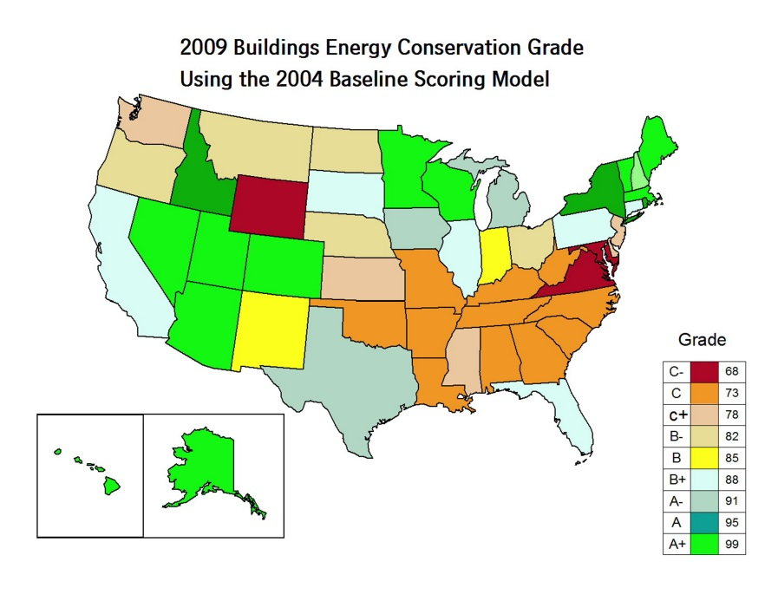

- Building Rating Disclosure and Benchmarking
  - Updates on building disclosure laws and regulations. Is required energy benchmarking having an impact on state-wide or city-wide energy use? How is the transition to required energy audits proceeding?
    - New York City – 12,000 buildings > 50,000 sf – proposed virtual audit for buildings 25-50,000 sf www.nyc.gov/BuiltToLast
    - Chicago – 2014 384 non-residential buildings > 250,000 sf – 2015 buildings > 50,000 sf http://www.cityofchicago.org/content/dam/city/progs/env/EnergyBenchmark/2014_Benchmarking_Report_Final.pdf
    - Seattle
    - Orlando – government buildings > 10,000 sf 1,200 commercial buildings > 40,000 sf by 2018– www.cityoforlando.net/greenworks
    - www.BuildingRating.org
    - The City Energy Project under Institute for Market Transformation and the National Resources Defense Council – www.TheCityEnergyProject.org
  - bEQ – Proposal to support research project – Energy Modeling of Typical Commercial Buildings in Support of the ASHRAE Building Energy Quotient Rating Program

- US Initiatives
  - The New York State Public Service Commission Reforming the Energy Vision (REV) – plans from NYSERDA and the IOUs due first quarter 2015, with program implementation in the 2016-2018 period. Focus to include demand reduction and emissions. IOUs will be able to offer programs specific to load pockets. It is envisioned that a Distributed System Platform Provider (utility?) integrate Distributed Energy Resources (DER) as the primary means of meeting system needs. Where DER consists of Energy Efficiency, Demand Response and Distributed Generation.
http://www3.dps.ny.gov/W/PSCWeb.nsf/All/26BE8A93967E604785257CC40066B91A?OpenDocument
  - What are the potential conflicts between increased zero-energy and smart grid?
  - DOE net zero definition for public comment - https://www.federalregister.gov/articles/2015/01/06/2014-30927/request-for-information-rfi-for-definition-for-zero-energy-buildings
  - Shaheen Portman Energy Bill – stalled in congress. http://www.shaheen.senate.gov/news/press/release/?id=52fbb7ba-d513-4482-a7a2-1aa57f40a76f
  - Termination of rebate programs - Indiana, Ohio, Arizona

- World Energy Initiatives
  - The Buildings Performance Institute Europe (BPIE) released a report that addresses fuel poverty in the European Union. The report explains why considering fuel poverty is necessary in order to achieve sustainable and inclusive growth. The report defines funding solutions and examples that include Energy Efficiency benefits to fuel poverty and vulnerable consumers. http://bit.ly/1lr68OB
  - India: India implementing a code for energy savings through green buildings by 2017. It will be mandatory for all state governments to implement the minimum requirements for energy efficient design and construction. To do this, the Bureau for Energy Efficiency (BEE) will implement the Energy Conservation Building Code (ECBC), to cross-check for building designs and specifications. http://bit.ly/1xOo89P Energy growth for buildings in India is expected to be the highest in the world over the next decades. . Expansion of nuclear plants for China and India are major considerations now.
  - South Korea is mostly nuclear and is expected to stay nuclear Projections on renewables growth are tricky to do and challenging to consider and interpret. Will EPA rules on coal cause more nuclear plants to be considered in US?
  - Paper by Mike MacDonald on Global Buildings Sector Energy Use – energy use in Europe appears high. http://epminst.us/states/worldtrend1.htm
  - Recent NBI study on potential of zero-energy DC has some interesting results, e.g., not really possible to make large commercial offices zero energy, so community-based accounting needed to play the game (http://newbuildings.org/sites/default/files/ZNECostComparisonBuildingsDC.pdf )
  - Europe – Energy Efficiency Performance Directive – continuous 15 minute energy monitoring of all buildings, mandatory disclosure of poor performing buildings – www.ISERVCMB.info
  - International Partnership for Energy Efficiency Cooperation – Energy Efficiency Action Plan - www.IPCC.ch
  - Abu Dhabi – Summer peak caused primarily but air conditioning – desalinization also significant There is an end-use metering effort –mostly residential Government forming an ESCO.

- Energy Monitoring and Energy Audits
  - Lawrence Berkeley National Laboratory, QUEST, and the DOE’s Building Technologies Office are developing testing procedures that can be applied by energy efficiency project and program administrators to assess the performance of automated M&V methods.
- Energy Performance Databases
  - DASH – Bruce Hunn
  - BEDES has been implemented http://energy.gov/eere/buildings/building-energy-data-exchange-specification-bedes
- EUI Task Group
  - Workshop on Wednesday
  - We need other expressions of EUI and better methods of building benchmarking

ASHRAE Sessions of Interest
Sunday, 9:45 AM-11:45 AM Seminar 6
Online Optimal Scheduling for Demand Response under Real-Time Price

Sunday, 11:00 AM-12:30 PM Seminar 13
Variable System Field Results and Why Load Based Testing Is Needed for Residential Equipment Applications

Monday, 11:00 AM-12:00 PM Technical Paper Session 7
IEA Annex 61: Deep Energy Retrofits, Part 1

Monday, 4:00 PM-5:00 PM Workshop 4
Energy Rating and Auditing Your Commercial Building Using the ASHRAE bEQ Program (Building Energy
Quotient): How to Do It, and Why You Should

Tuesday, 8:00 AM-9:30 AM Conference Paper Session 7
A Paradigm Shift for HVAC Design

Tuesday, 8:00 AM-9:30 AM Technical Paper Session 8
Control and Monitoring for Improved Building Energy Efficiency

Tuesday, 9:45 AM-10:45 AM Technical Paper Session 9
IEA Annex 61: Deep Energy Retrofits, Part 2

Tuesday, 11:00 AM-12:30 PM Conference Paper Session 9
Evaluating Building Efficiency Using Case Studies

Wednesday, 8:00 AM-9:30 AM Seminar 55
Simulation Calibration
Wednesday, 11:00 AM-12:30 PM Workshop 8
Lies, Damn Lies, and…EUIs?

Tenth International Conference on Climate Change (ICCC-10) will take place Thursday, June 11 and Friday, June 12, 2015 at the Washington Court Hotel in Washington, DC (http://heartland.org/events/iccc-10 )

