ASHRAE TC 5.4
INDUSTRIAL PROCESS AIR CLEANING (AIR POLLUTION CONTROL)

Meeting Minutes
2:30 - 4:15 P.M. – Monday, June 27th
(Hybrid meeting)
These draft minutes must be approved by this committee to be the official approved record.

Note: For votes concerning standards actions all members must be given an opportunity to vote. In the event all members are not present at the meeting a letter ballot will be sent to the absent members to vote, that will include all negative votes at the meeting and a Chair’s response. In the event negative votes are received during the continuation ballot a recirculation ballot will be conducted.

Negative voters with comment on publication public review votes will be given an opportunity to appeal once the Board of Directors has approved the document for publication. Negative voters who do not comment will not be offered a right to appeal.

Attendees (include voting members and guests) [see attendance below]
Name | Affiliation | Name | Affiliation
Alex Wells (VM) | Camfil | Kevin Marple (VM) | TAC Section 5
Brian Mathews (VM) | Scientific Dust Collectors | Bob Burkhead (VM) | Blue Heaven Tech.
Geoff Crosby (VM) | Independent Consultant | Bruce McDonald (VM) | Retired (mostly)
George Gruetzmacher |  | Jack Clements | Independent Consultant
Daniel Vangilder | Camfil | Bill Lampkin | Greenheck Fan
Adam Bumann (VM) | Pleatco Filtration | Eileen Jensen
KJ Choi (VM) | C&S | Randi Huckaby | Camfil
Ihab |  | Tim Rosiek | Parker Hannifin
Blake Mead | Camfil | Tim Hudson | Pleatco Filtration
*Highlighted attended in-person

- Call To Order
  - Meeting called to order at 1:38PM EST by Alex Wells, Chair

- Review of code of ethics
  - Self Introduction of Members and Guests: Chairman (2:30) - code of ethics: https://www.ashrae.org/about/governance/code-of-ethics

- Membership Roster
  - Voting Members Present (6 of 9, quorum): Alex Wells, Brian Mathews, Bob Burkhead, Adam Bumann, KJ Choi, Kevin Marple
    - Voting members not present: Monroe Britt, Evan Reese ,Chris Fischer
  - Officers:
    - Chair: Alex Wells
    - Vice Chair: Brian Mathews
    - Secretary: Chris Fischer
    - Subcommittee chairs
      - Research: Evan Reese
      - Standards: Chris Fischer
      - Program: KJ Choi
      - Handbook: Bob Burkhead
      - Webmaster: Bob Burkhead
  - Membership Updates
    - Alex to check: Geoff should be rolling on as VM, KJ shows rolling off this year (may be incorrect)
    - Hybrid meetings may be here to stay, might help to retain/increase attendance by others not typically drawn to ASHRAE meetings
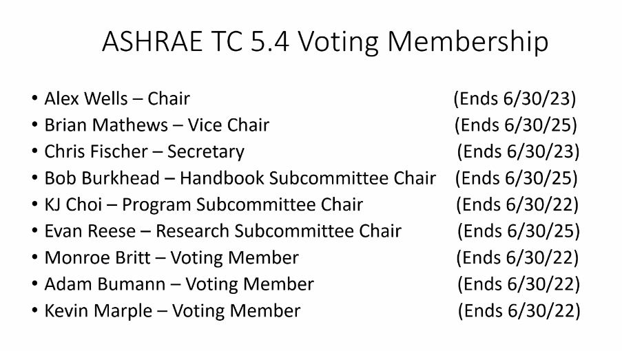

- Approval of Minutes
  - Bob Burkhead found item in January 31, 2022 minutes that needs correction:
    - Chapter 30: HVAC Systems & Equipment
      - Original: 2021 edition (current)
      - Revised: 2020 edition (current)

- Liason Reports: New Section Head - Kevin Marple
  - Activity Form Due by June 28, 2022
  - TC Mock has been revised
    - Review TAC Website
  - Ventilation 2022: 13th International Industrial Ventilation Conference in Tortonto, Canada from June 22-24, 2022
    - Good review.

- Sub-Committee Reports
  - Research: Evan Reese (not present) – Alex Wells presented
    - RTAR 1623: Oil Mist
      - Review ISO/TC 142 N 886 “Cleaning Equipment for Air & Other Gases” Document by voting members
  - Standards: Chris Fischer (not present) – Alex Wells presented
    - January 2022 meeting voted to officially create revision committee. The following members have been a regular part of the monthly meetings:
    - Chris Fischer, Alex Wells, Brian Mathews, Bob Burkhead, Jack Clements, Adam Bumann, & Bruce McDonald
    - Revised draft is nearly complete.
    - Need to finalize recomendations for dust dispersion system.
  - Handbook: Bob Burkhead
    - Chapter 30 Equipment Handbook
      - Publication coming up in 2024
      - Send unsolicited copy to entire committee attendants for review.
    - Need to add ASHRAE 199 information to document
      - Alex Wells, Brian Mathews & Jack Clements volunteer to assist.
  - Program: KJ Choi
    - Forum, Workshop, Debate and Panel Proposals Due Tuesday August 9, 2022 for Atlanta Conference held February 4-8, 2023.
    - Workshop – Industrial Air Quality – Randi Huckaby will submit for Atlanta
    - Seminar – Media Selection - Adam Bumann will submit for Atlanta
    - Workshop - Decarbonization – Bob Burkhead will start preparing a title and bullet points for Tampa, June 24-28, 2023. Review at next meeting.

- Chairman’s Report: Alex Wells
    - Website (http://tc0504.ashraetcs.org/): has been updated
    - For any NEW attendees, please visit site and under “MEMBERSHIP” Tab click “Join TC 5.4”

- Old Business
    - How to make Standard 199 better
      - Possible to shorten the test?
      - Abbreviate versions of test
      - Single Filter Setup
      - Supplemental “how to read” or “how to use” the test report

    - Commericail / Industrial Filter Test Standard (static)

- New Business
    - Standard 199 Improvement Committee created:
      - Alex Wells organizing a group to meet and review improvements:
        - Jack, Bob, Alex, Tim, Randi, Adam, Daniel, Brian
    - Commericail / Industrial Filter Test Standard (static)
        - Alex created a summary of ISO 29461-1 and send to voting members. Review and add to Handbook.
    - RTAR Ideas
    - Programs
    - Additional reports/guielines TC 5.4 can publish
    - Experts needed for WG 7 – Cleanable Filter Media used in Industrial Applications
    - 3D Printer Emissions
- Next Meeting
  - TBD

- Adjourn
  - Meeting adjourned at 4:20PM EST
Attendance (Zoom screen-capture)


