Chapter XX

Moisture Management in Buildings

Effects of Humidity & Dampness
Elements of moisture management
Envelope and HVAC interactions
The vapor balance

Understanding the balance

Hygric buffering
vapor release related to building use

Residential buildings

Natatoriums
Indoor-outdoor vapor pressure difference analysis

Residential buildings

Natatoriums
Student residences and schools
Avoiding Moisture Accumulation

Whole building fabric

Building envelope

Mold

Surface condensation

Interstitial condensation

HVAC systems

Ground pipes
Climate-Specific Moisture Management Issues

Temperate and mixed climates

Hot and humid climates

Cold climates
handbook information to assist moisture management
Excessive indoor moisture and humidity interferes with the use and enjoyment of buildings, and may shorten their service life over the long term. Problems affecting owners and occupants include reduced comfort, poor indoor air quality, negative health effects, damage to the building’s materials and structural fasteners, and wasted energy in HVAC operation. Consequently, moisture management demands attention from the architect, the builder, the mechanical system designer, and from those charged with the budgeting, management and maintenance of the building and its mechanical systems.
All buildings occasionally experience peaks in relative humidity and moisture. Short-term episodes of these extremes can generally be accommodated by storage within the building materials, but when moisture and humidity accumulate for extended periods in vulnerable materials, major problems can and often do occur. Moisture problems are unfortunately quite common in buildings. It is the responsibility of those in a position of authority to minimize the risks associated with excessive moisture accumulation. Successful management of moisture and humidity requires an understanding of the complex and dynamic relationship between the building’s enclosure and the mechanical systems over the entire service life of the building. This dynamic interaction holds the potential for either an excellent result over decades, or for frequently repeated disruptive and expensive problems. Experience suggests that maladjusted human behavior can overcome virtually any building technology, so educating owners and occupants is important in a successful design and usage of a building.
Effects of humidity and dampness
The preferred range of relative humidity for human health and comfort is between 40% and 60%, although that interval is often broadened from 30% to 70%. High relative humidity degrades thermal comfort once the operative temperature exceeds 25-27°C, making the environment feel oppressive. High humidity also facilitates VOC release, especially formaldehyde, which degrades indoor air quality and triggers olfactory dissatisfaction. High relative humidity in microscopic environments such as beds activates dust-mite reproduction and related allergy risks for atopic people, while high humidity at surfaces can activate mold germination and growth (Annex 14, 1990; ASHRAE, 2012). Very low relative humidity in turn induces electrostatic discharge. It also causes dryness of mucous membranes (i.e., nose, lips, and throat) and eye dryness complaints, especially by people wearing contact lenses. On the other hand, some respiratory ailments can be relieved by dry environments. Finally, too low and too high relative humidity both create conditions favorable to bacterial and viral infections, allergic rhinitis and asthma. Chapter F9 in this handbook gives a more in-depth analysis of the impact of humidity on thermal comfort. Chapter F10 discusses the effects of relative humidity on indoor environmental quality, chapter F11 looks at mold. and chapter F12 discusses the relationship between humidity and olfactory perception. Reference is also made to the applications report of the IEA-EXCO EBC, Annex 41 (Holm at al, 2008).
Prolonged and excessive relative humidity and wetness can degrade materials physically, chemically and biologically. Examples of physical degradation are frost damage and salt attack. Chemical degradation includes lime/gypsum reaction, carbonization of concrete, alkali/granulate reaction in concrete and corrosion of ferrous and non-ferrous metals, where moisture determines whether damage will occur in the presence of corrosive agents (e.g., sulfides, acetic acid). Wood rot by fungi and bacteria is a clear example of biological degradation. Also, very dry conditions can damage wood, causing cracking or warping. Fluctuations between extremes of high and low relative humidity can induce cracking in hygroscopic materials.
The fact that relative humidity can impact comfort, indoor air quality and health, and that excessive wetness can shorten the service life of materials and assemblies, proves that moisture tolerance of materials and assemblies and appropriate indoor relative humidity levels should be considered to be requirements for a sustainable built environment.

Elements of Moisture Management
The term “moisture” captures the gaseous, liquid and solid state of water with the last two containing dissolved contaminants. Precipitating rain, wind-driven rain, construction moisture, rising damp, and water from incidental pipe dripping are examples of liquid-state phenomena. Precipitation wets pitched roofs, low-slope roofs and inclined facades, whereas wind-driven rain wets the enclosure as a whole. Buildings (including the envelope) start their service life containing significant quantities of construction moisture. This is particularly true for concrete, aerated concrete, mortar and plaster (and wood framing, if the building is not protected from rain during construction). Groundwater and discharge from downspouts may lead to rising damp, while pipe leakage reflects failing fixtures or pipe corrosion (Trechsel et al, 1994) (Munovic et al, 2009) (Hens, 2010). Water from wind-driven rain within building envelopes with insufficient drainage, leaks from the roof or gutters, and leaks from internal plumbing are the single largest contributors of moisture. These liquid-water sources must be addressed and resolved for the building envelope to succeed.
The gaseous state of water, known as vapor, comes from outside humidity and from interior vapor release. Vapor in the air, expressed as relative humidity, governs hygroscopic loading of materials. High relative-humidity values at surfaces favor mold growth and, once reaching 100%, give rise to surface condensation. When vapor pressure and temperature gradients in and across assemblies go in the same direction, so-called interstitial condensation is possible. Once liquid water is addressed, vapor pressure and relative humidity are the factors to consider. Two forces are responsible for vapor movement within buildings and across the envelope:air-pressure differences (induced by termperature, wind, and fans) that drive humid air, andvapor-pressure differences that activate vapor diffusion. Air-pressure differentials typically overwhelm diffusion in terms of the total vapor flux displaced. However, in hot humid climates or in buildings showing high indoor-outdoor vapor pressure differences, pure diffusion may nevertheless cause problems.
Chapter F13 in this handbook gives information on intra-zone airflow, multi-zone network airflow and contaminant transport, included vapor. Chapter F15 on fenestration discusses surface condensation on windows. Chapter F16 on infiltration and ventilation mentions interstitial condensation due to air leakage, while together with chapter F20 it contains information on air movement in buildings. Chapter F24 discusses air flow around buildings. Chapter F25, F26 and F27 on heat, air, moisture control in building assemblies finally contain an in depth analysis of all moisture loads impacting the envelope. In addition, ANSI/ASHRAE Standard 160-2009 provides criteria to evaluate the transient hygrothermal performance of envelopes. Such transient analysis is often used to evaluate moisture tolerance in cases where, besides vapor, liquid water is a factor of importance.

Envelope and HVAC interactions
Designing for correct moisture and humidity management includes the choice of building materials and the layers in the exterior envelope, as well as the design and component selection of the HVAC system.
As suggested by Figure 1, heat, air and moisture move continuously throughout a building, driven by differences in temperature, vapor pressure and air pressure between the indoor and outdoor environment and by similar differences between adjacent indoor zones. Construction moisture contributes to the initial wetness of the whole building fabric, including the envelope. Over time, envelope assemblies exposed to rain and snow may become moist by seeping rain and melting snow or by extracting dampness from the moist earth, which wets walls just above grade. Leaking and dripping interior pipes can also be responsible for excessive wetness.
Fig. 1 Dynamic interaction between air, moisture and materials in both HVAC systems and the building envelope
The opaque and transparent portions of the building envelope must be designed so that their thermal transmittance approaches the energy-related economic optimum. Together with the overall building fabric, the envelope should allow passive solar control, while all assemblies proposed must prevent rain from wetting layers that must stay dry. The building details should withhold run-off and prevent rainwater runoff from wetting basements and floors on grade. Correct protective measures must prevent rising damp and promote effective construction-moisture drying, whereas water vapor moving across the envelope assemblies should not result in unacceptable interstitial moisture accumulation. Detailing and workmanship must minimize air leakage across the envelope as well as wind washing, indoor air washing and air looping within the envelope assemblies. Correct design, workmanship and maintenance should prevent plumbing leakages or sweating of pipes running in or across walls and floors.
The HVAC system must provide a thermally comfortable and healthy indoor environment. Ventilation is commonly accepted as being a necessity for delivering fresh air to the building’s occupants. Generally at the set-point temperature, when heat losses by transmission, infiltration and ventilation exceed the solar gains through the transparent and opaque envelope parts and the internal gains by lighting, appliances and occupancy, heating is required. If instead the gains exceed the losses, cooling is needed. The temperature difference with outdoors in both cases creates a thermal stack effect, which together with wind and fanoperation, maintains air-pressure differentials with the exterior.
In heating mode, the indoor vapor concentration is typically left free-floating, fluctuating with the vapor in the ventilation and infiltration air, and the vapor released indoors. The net vapor concentration and the air temperature maintained by the HVAC system determine the relative humidity. Only when the ventilation and infiltrating air is too dry or too humid, when the vapor release indoors is very high or when the building’s function requires relative humidity control, must the HVAC system intervene actively to control humidity by removing vapor from or adding vapor to the indoor air, a process called dehumidification or humidification. The energy required for that process is called the latent heat load. In cooling mode, the latent load arises based on the supply-air temperature required for cooling and the dew-point temperature of the outside air. Condensation on the coil removes some portion of the humidity in the incoming ventilation air.

The water Vapor balance
HVAC design, or a durability assessment of an envelope and a whole building during design, requires knowledge of the expected indoor humidity conditions. This is essential for taking the right decisions to prevent mold, surface condensation, problematic interstitial condensation and reduced drying.
The function of a building and the conditions outdoors dictate whether the indoor relative humidity needs control or not. Basic for evaluating ‘what to do?’ is the vapor balance, which considers the various mechanisms involved in vapor release, vapor removal and vapor storage. One of the unknowns in this balance is the vapor release related to building use. A first method consists of quantifying these releases directly. A second method to get information starts from extended indoor-outdoor climate measurements in large sets of buildings to deduce a statistically relevant indoor-to-outdoor time-averaged difference in vapor pressure or vapor concentration in relation to the outdoor air temperature. Both methods are discussed in the two paragraphs that follow.

Understanding the balance
The air humidity indoors is assumed to be free-floating. Five vapor fluxes contribute, then, to maintaining the equilibrium in a room:
- Vapor carried and supplied by infiltrating outside air and by ventilation;
- Vapor removed by exfiltrating inside air and by the exhaust ai;r
- Vapor released by the occupants and their activities, by plants, water surfaces and drying fabric parts;
- Vapor adsorbed and desorbed by all hygroscopic surfaces present; and
- Vapor condensing on inside surfaces that are colder than the dew-point temperature indoors, or evaporating from inside surfaces wetted by surface condensation.
These five fluxes load and unload the room air with vapor. There is even a sixth flux: vapor inflow and outflow by diffusion through the envelope. Its magnitude, however, is insignificant compared to the five fluxes mentioned, so ignoring it does not introduce any noticeable error.
Assuming fully mixed air within a room, the moisture balance looks like:
(1)
Where:
- G_{a,in} are all air flows entering the room in kg/s. THis includes infiltration from outside, ventilation supply air and infiltration from adjacent rooms.
- x_{v,in} is the water vapor ratio in the entering air, expressed in kg vapor per kg dry air (kg/kg)
- G_{a,out} are all air flows leaving the room. in kg/s. This includes exfiltration to the outside, the exhaust air and exfiltration to adjacent rooms
- x_{v,i} is the water-vapor ratio in the room, expressed in kg vapor per kg dry air (kg/kg)
- β_{j} is the surface film coefficient for diffusion at each hygroscopic surface. in s/m
- A_{j} is the area of each hygroscopic surface in the room. in m²
- p_{i} is the water-vapor pressure in the room in Pa
- p_{sat,Aj} is vapor-saturation pressure at the different hygroscopic surfaces in the room. in Pa (fabric, furniture and furnishings)
- φ_{sat,Aj} is the relative humidity at the different hygroscopic surfaces in the room on a scale from 0 to 1 (fabric, furniture and furnishings)
- β_{k} is the surface film coefficient for diffusion at all surfaces in the room whereupon vapor condenses or evaporates. in s/m
- A_{j} is the area of all surfaces in the room suffering from surface condensation or showing surface condensate drying. in m²
- p_{sat,Aj} is the vapor-saturation pressure for the different condensing and evaporating surfaces in the room, in Pa
- G_{v,P} is the vapor release in the room, in kg/s
- V is the air volume of the room, in m³
- t is the time, in s
Solving the equation requires knowledge of all positive and negative air flows between the room and adjacent rooms; all positive and negative air flows between the room and outdoors; the ventilation supply airflow; the exhaust airflow; the water vapor transported for these four air flows ; the surface temperatures and vapor balances at all hygroscopic surfaces; the surface temperatures at all condensing and evaporating surfaces; and the surface film coefficients for diffusion at each of these surfaces (see Hens, 2012). Calculating requires numerical methods, preferably embedded in dedicated software to account for the transient nature of the variables involved (Woloszyn et al, 2008).
In reality, due to stack effects, supply air jets and convective plumes around people, the air in a room is never fully mixed. Consequently, vapor-pressure gradients exist inside every room. Wetter and warmer air is also lighter and creates a positive temperature and humidity gradient along a room’s height, even in so-called stagnant conditions. Despite these internal gradients, whose quantification requires CFD calculations, further discussion remains based on the fully-mixed assumption.
When considering longer-term average conditions, where the room maintains an average humidity, which is consistent with the steady-state condition, then sorption/desorption to and from hygroscopic surfaces no longer interferes and the humidity balance simplifies to:
(2)
If the only incoming airflow is from outdoors (e.g., infiltration, natural ventilation or airside economizer applications), equality between supply and exhaust then yields as mean relative humidity indoors:
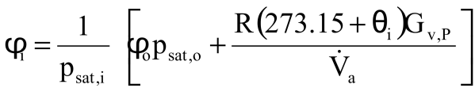 (3) (3)
Where:
- φ_{i} is the relative humidity indoors on a scale from 0 to 1
- p_{sat,i} is the vapor saturation pressure for the temperature indoors, in Pa
- φ_{o} is the relative humidity outdoors on a scale from 0 to 1
- p_{sat,o} is the vapor-saturation pressure for the temperature outdoors, in Pa
- R is the gas constant for water vapor, equal to 462 Pa.m³/(kg.K)
- θ_{i} is the indoor temperature, in degrees Celsius
- G_{v,P} is the average vapor release indoors, in kg/h
- is the outdoorair ventilation or/and infiltration rate, in m³/h
Relative humidity over longer periods of time consequently depends on the mean outdoor temperature through p_{sat,e,} the mean relative humidity outdoors, the mean air temperature indoors through p_{sat,i}, the mean vapor release indoors and the mean outdoor-air ventilation and/or infiltration rates.
In cold and temperate climates, the outdoor-air ventilation required by the building standards easily dilutes the vapor released in residences, offices and schools. Heating in temperate climates tends to give relative humidity levels below the upper acceptability threshold. In really cold climates, ambient temperature and relative humidity outdoors may be such that normal ventilation rates cannot raise the indoor relative humidity above 15-20% at room temperature. Humidification may then become necessary. In hot, humid climates, outdoor temperature and relative humidity can be so high that the combined action of ventilation, cooling and vapor release raises indoor relative humidity above the upper acceptability threshold. Air dehumidification then is required.
In the case where air from outside infiltrates into the room, while at the same time the ventilation system delivers supply air at a fixed condition, the mean relative humidity indoors changes into:
(4)
Where:
- φ_{o} is the relative humidity outdoors on a scale from 0 to 1
- p_{sat,o} is the vapor-saturation pressure for the temperature outdoors, in Pa
- φ_{s} is the relative humidity of the supply air on a scale from 0 to 1
- p_{sat,s} is the vapor-saturation pressure for the temperature of the supply air, in Pa
- is the volumetric flow rate of outside air infiltrating, in m³/h
- is the volumetric flow rate of supply air, in m³/h

Hygric buffering
Hygric buffering it the phenomenon by which vapor from the air is adsorbed into hygroscopic materials when the relative humidity rises, and released back into the air when the relative humidity lowers. When considering shorter time scales, buffering by various elemens (including the indoor air, the building fabric including the envelope, furniture and furnishings) dampens and shifts fluctuations in relative humidity and consequently in vapor pressure indoors, compared to the fluctuations of the exterior vapor pressure and the internal vapor release.
Figure 2 compares measured indoor vapor pressures (colored) in an office building with the exterior vapor pressure (black) over the course of a winter month when the exterior conditions changed from cold and dry to warmer and more humid (Hens, 2009). Indoor vapor pressure remains higher than the outdoors during the cold and dry spell, but drops lower than outdoors during the consecutive warmer and more humid spells.
Figure 3 shows the calculated buffering effect on the daily indoor vapor pressure in a well-ventilated two-person bedroom during winter (Hens, 2012). The effects of hygric buffering, in keeping the daily changes in vapor pressure much lower than if only the air acted as buffering volume, are obvious.
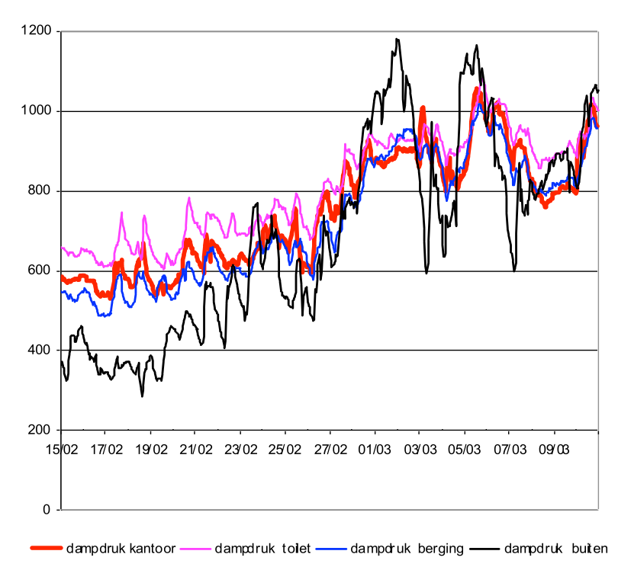

Figure 2 Office building, measured water vapor pressure outdoor (black) and indoors (colored)
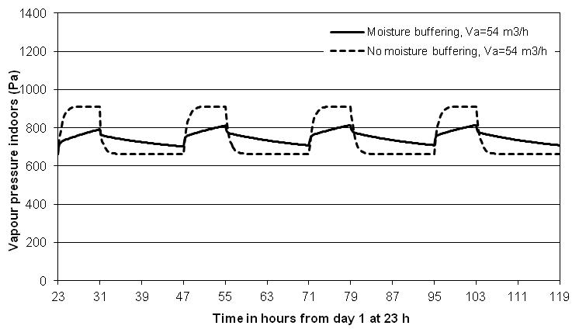
Figure 3 Daily vapor pressure course in a two persons bedroom, 16 m² large with an air volume of 40 m³ and walls and ceiling finished with a papered gypsum plaster without (dashed line, only air buffering) and with its moisture buffering effects taken into account (full line)
Antretter et al, 2012, performed a series of buffering experiments in a test room, simulating summer and winter conditions. A four- to six-day period was considered. For the summer simulation, the temperature, relative humidity and air-change rate were kept constant at 20°C, 90% and 1 ach respectively for one to three days, then followed by an air change rate of zero and a temperature change from 20 to 35 °C in 2 hours. These conditions were held constant for 10 hours, after which the temperature was turned back to 20°C in 2 hours and held so the next three days. For the winter simulation, the temperature, relative humidity and air-change rate were kept constant at 23°C, 50% and 1 ach for one to three days, followed by three days with two vapor-release peaks, accompanied by reduction in the air-change rate from 1 to 0.5 ach. The reference experiment was initially done without moisture buffering, then subsequently repeated with large sorptive tiles in the room. Figure 4 illustrates how the relative humidity changed the day after the initializing period. Buffering is evident.

Figure 4 Comparison of relative humidity during the day after the initializing one to three days for the summer and winter case. The buffered case is the red line, the non-buffered case the blue line (Antretter et al, 2012)
In buildings with massive construction, hygroscopic buffering can even induce dampening and phase-shifting on an annual basis. This is illustrated by the calculation results of Figure 5 for the bedroom as represented in Figure 3 and shown in Figure 5 (Hens, 2012). For the same vapor release indoors and constant ventilation rate, the monthly mean indoor vapor pressures form an inclined ellipse with highest value in winter, lowest value in summer and lower values in springtime than in the fall.
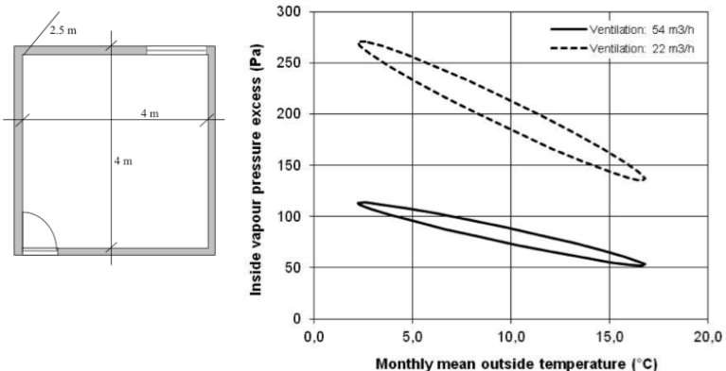
Figure 5 Annual monthly averaged vapor pressure in the sleeping room of Figure 3 (solid line for a mean ventilation flow of 54 m³/h, dashed line for a mean ventilation flow of 22 m³/h

vapor release related to building use
Water-vapor release indoors combines several sources: building occupants and their activities (such as cleaning, cooking, showering and bathing); pets; plants; water surfaces; drying of wet fabrics;,, and so on. A distinction must be made between two types of releases: those more or less independent of the indoor temperature and relative humidity, and those heavily influenced by it (Ten Wolde et al, 2007). The first include human presence, human activities and plants. The second concern evaporation from free water surfaces and drying of wet fabrics. Accounting for these two types of sources, equation (3) expands into:
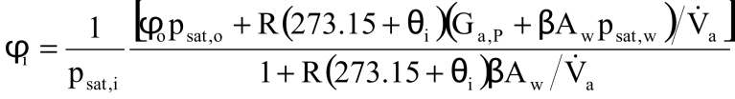 (5) (4)
Where
- A_{w} is the free water surface, in m²
Solving this equation and equation (3) presumes knowledge of the magnitudes of the water-vapor sources. As measured data are scarce, those that follow are taken from literature.

Residential buildings
An estimate of the moisture loads requires knowledge of the occupancy patterns and the release rates per individual, per activity, plant and water surfaces present. In most cases, the real occupancy is unknown and the data per source is even more difficult to quantify. Some activities within the same classification will differ in the amount of vapor released: take cooking, for example, which varies with the type of meals prepared. Literature sources only give global average numbers, and should therefore be used with care and understanding of the implicit assumptions, see the tables 1 to 5 (IEA-ECBCS, 1990) (Ten Wolde et al, 2001) (Kumaran et al, 2008) (Sanders, 1996).
Table 1 Vapor released by humans, human activities and plants
Source |  | Units | Release
Humans | light activity | g/h | 30-60
 | Medium activity | g/h | 120-200
 | Hard work | g/h | 200-300
Bathroom | Bath (15 minutes) | g | 60
 | Shower (15 minutes) | g | 660
Breakfast preparation for 4 people |  | g | 160 to 270
Lunch preparation for 4 people |  | g | 250 to 320
Dinner preparation for 4 people |  | g | 550 to 720
Breakfast dish washing for 4 people |  | g | 100
Lunch dish washing for 4 people |  | g | 70
Dinner dish washing for 4 people |  | g | 310
Simmering pot (diameter 15 cm, 10 minutes) |  | g | 60
Boiling pot (diameter 15 cm, 10 minutes) |  | g | 260
Potted flowers |  | g/(h.pot) | 5-10
Potted plants |  | g/(h.pot) | 7-15
Drying laundry | Already spin-dried, until dry | g/h | 20-200
 | Dripping wet, until dry | g/h | 100-500
 | Non-vented drier, until dry | g/h | 2130 to 2900
Table 2 Daily vapor release by humans, human activities and plants, data from three countries
Source, units | Release
Source, units | UK | Denmark | USA
Humans, kg/(person.day) | 1.2 | 0.9 | 1.25
Cooking for 4 people with electricity, kg/day | 2 | 0.9 | 1.2
Cooking for 4 people with gas, kg/day | 3 |  | 2.5
Dishwashing, kg/day | 0.4 | 0.4 | 0.5
Bathing/washing, kg/(person.day) | 0.2 | 0.4 | 0.25
Washing clothes, kg/day | 0.5
Drying clothes (kg/day) | 1.5 | 1.8 | 2.2
Cleaning floors with water, kg/day |  | 0.2
Plants, kg/(plant.day) |  | 0.02 | 0.05
Refrigerator defrost, kg/day |  |  | 0.5
Table 3 Vapor released by fuel burning
Fuel | Vapor released (kg/kWh)
Natural gas | 0.15
Manufactured gas | 0.10
Paraffin | 0.10
Coke | 0.03
Coal | 0.01
Table 4 Vapor release for a family of two, both working, weekday schedule
Time  h | Persons present | Vapor released, g/hour |  |  |  | Sum  g
Time  h | Persons present | Persons | Cooking | Hygiene | Washing | Sum  g
1-5 | 2 | 120 |  |  |  | 600
6 | 2 | 120 | 240 | 720 |  | 1080
7 | 2 | 120 | 240 |  |  | 360
8-17 | 0 |  |  |  |  | 0
18 | 2 | 120 |  |  |  | 120
19-10 | 2 | 120 | 480 |  |  | 1200
21-22 | 2 | 120 |  |  |  | 240
23 | 2 | 120 |  | 480 |  | 600
24 | 2 | 120 |  |  |  | 120
Sum/day |  | 1680 | 1440 | 1200 |  | 4320

Table 5 Vapor release for a family of four, mother and one child at home, weekday schedule
Time  h | Persons present | Vapor released, g/hour |  |  |  | Sum  g
Time  h | Persons present | Persons | Cooking | Hygiene | Washing | Sum  g
1-5 | 4 | 240 |  |  |  | 240
6-7 | 4 | 240 | 480 | 720 |  | 2880
8 | 2 | 120 |  |  | 120 | 240
9 | 1 | 120 |  |  | 180 | 300
10 | 1 | 120 | 720 |  | 180 | 1020
11-12 | 2 | 120 | 1200 | 120 |  | 2880
13-14 | 2 | 120 | 480 | 120 |  | 1440
15 | 2 | 120 |  |  | 120 | 240
16-17 | 2 | 180 |  |  | 120 | 600
18 | 4 | 240 |  |  |  | 240
19 | 4 | 240 | 480 |  |  | 720
20 | 4 | 240 | 480 | 240 |  | 960
21-22 | 4 | 240 |  |  |  | 480
23 | 4 | 240 |  | 240 |  | 480
24 | 4 | 240 |  |  |  | 240
Sum/day |  | 4680 | 6000 | 2400 | 840 | 13920
Table 6 Daily vapor release in relation to the number of family members (several sources)
Family members | 2  (no children) | 3  (1 child) | 4  (2 children) | >4  (>2 children
Vapor release (kg/d)  According to several sources | 8 | 12 | 14 | >14+1 kg/(day.child)
Vapor release (kg/d)  According to several sources |  | 10
Vapor release (kg/d)  According to several sources | 7 | 20
Vapor release (kg/d)  According to several sources |  |  | 14.6
Vapor release (kg/d)  According to several sources | 13.2 | 19.9 | 23.1
Vapor release (kg/d)  According to several sources |  | 11.5
Vapor release (kg/d)  According to several sources |  | 5-12
Vapor release (kg/d)  According to several sources |  | 6-10.5
Vapor release (kg/d)  According to several sources | 4.3 |  | 13.7
Vapor release (kg/d)  According to several sources | 8.2 | 12.1 | 14.1 | 14.4
Mean | 8.14 | 11.9 | 15.9 | -
The mean values in Table 6 yield as a least-square regression:
(kg/day) (6)
Where:
- G_{v.P} is the daily vapor release, in kg/day
- n is the number of family members present.
The individual data, however, produce a different relationship with considerably more scatter:
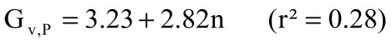 (kg/day) (7)
In formulas (6) and (7), each person is considered being at home 24 hours a day. Equation (7) indicates that such each person adds 2.82 kg of water vapor to the environment. Measurements in some German apartments, however, suggested that this release rate is too high. For a family of three, the release rates documented ranged from 5.6 to 7.8 kg per day (Hartmann et al, 2001), giving a value between 0.8 and 2.48 kg per person per day. Data from Estonia suggest a person present 24 hours a day adds, on average, 1 kg to the vapor released.
To bring the equation (7) closer to reality, the number of family members present is best weighted by the ratio between the hours each is at home and 24 hours a day. For example, if four persons occupy the home for 16 hours daily, n would be:
Table 7 provides some country-related statistical information about the vapor release expected in different types of residential buildings.
Table 7 Vapor release rates by percentile
Country | Group | Vapor release rate (kg/day)
Country | Group | 10% | 50% | 90%
Canada | Detached houses | 3.0 | 8.7 | 21.0
Denmark | Flats/mechanical ventilation  Detached houses/mechanical ventilation  Detached houses/natural ventilation | 2.5  3.5  3.0 | 5.8  8.0  6.5 | 10.0  13.5  13.0
Sweden | Detached houses  Multi-family dwelling units | 4.6  2.4 | 8.7  5.6 | 15.7  11.0

Natatoriums
Evaporation from the pool surface, from the wet swimmers and the wet floor around the pool are the main sources of water vapor here. The evaporation rate is calculated based on the pool surface and related surface film coefficient, multiplied by a correction factor to account for the average number of pool users and the wet floor around the pool using equation (8):
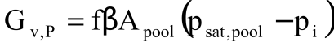
(8)
Where
- G_{v,P} is the evaporation flow rate, in kg/s
- β is the surface film coefficient for diffusion at the water surface in the pool, in s/m
- f is a multiplicand that accounts for the average number of pool users and the wet floor
- A_{pool} is the water surface area, in m²
- p_{sat,pool} is the vapor-saturation pressure at the pool’s water temperature, in Pa
In cases where the airflow comes from outside, equation (8) can be combined with equation (3) to yield the mean vapor pressure in a natatorium:
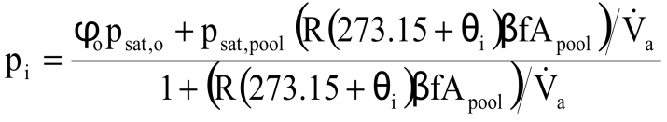
(9)
Measurement of the pool surface, the water temperature, the air temperature, the relative humidity, the ventilation supply flow and the number of users in a university and a recreation natatorium allowed an estimation of the surface film coefficient for diffusion β, which for the last six university data includes the multiplicand f, and related evaporation rate in g/(m².h), see Table 8 (Hens, 2009).
Table 8 Measured surface film coefficients for diffusion, related to the pool surface
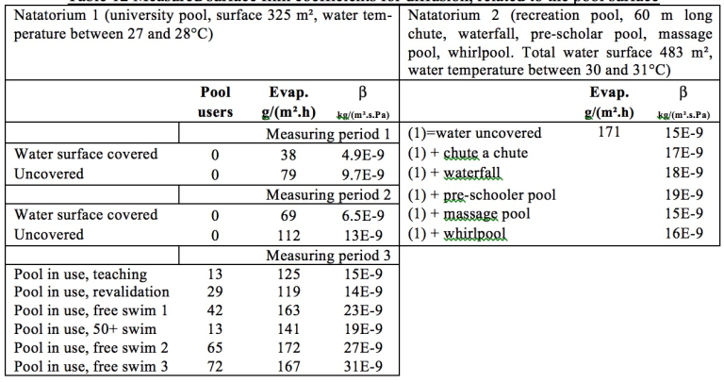
Using the university data, the multiplicand f could be derived as a function of the number of pool users:
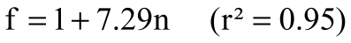
(10)
Where:
- n is the number of users per m² of pool surface
For zero users, f equals 1. The least-square line is depicted in Figure 6. As an example, for a water surface area of 50x20 m², a water temperature of 28°C, an air temperature of 30°C, an indoor relative humidity of 60% and 100 pool users, evaporation amounts to an impressive 80 kg/h.
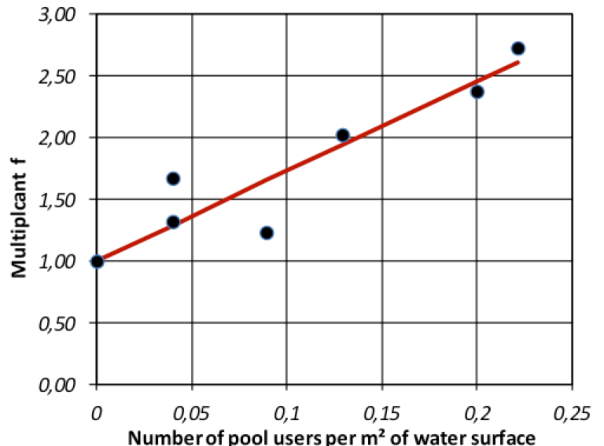
Figure 6 Multiplicand f as a function of the pool user density, expressed as the number of users per m² of pool water surface

Indoor-outdoor vapor pressure difference analysis
As stated previously, measuring vapor release rates directly is a difficult and time-consuming task. The typical alternative is to monitor the indoor temperature and relative humidity and compare the related indoor vapor pressure to the value outdoors. Therefore, most experiments looking to quantify air humidity in buildings use a quantity called the average indoor-outdoor vapor-pressure difference (Δp_{io}) or vapor-concentration difference (Δρ_{io}), which represents the second term in equation (3): i.e., the ratio between the average water-vapor release and the average infiltration and ventilation flow:
(Pa) or (g/m³) (11)
The average difference over a given period of time is then typically linked to the average outdoor air temperature over the same period of time.

Residential buildings
In North America and Europe, there have been many monitoring programs in residential buildings that gathered data on the indoor-outdoor vapor-pressure and vapor-concentration difference. The least-square linear relationships found between these data, averaged over a given period of time, and the outdoor air temperature averaged over the same period of time, typically show a decreasing trend at higher temperatures. Figure 7 exemplifies such a relationship for passively ventilated homes with massive construction (Hens, 2012). There are two reasons for the decrease: firstly, windows are more frequently set ajar in warmer weather, resulting in more outside air ventilation and thus lower indoor-outdoor vapor pressures and concentration differences at higher outdoor air temperatures; secondly the massive building fabric that absorbs and releases significant amounts of vapor and consequently dampen and shift the indoor vapor pressure compared to the outdoors even on an seasonal basis.
Figure 7 Daytime rooms in dwellings: weekly mean indoor/outdoor vapor pressure difference as a function of the weekly mean outside temperature, measured values and least-square straight line
In the UK, long-term measurements were performed in 1065 living rooms and 916 bedrooms ((Ridley et al, 2008). The least-square regressions, based on half-hour averages, are shown in Figures 8 and 9.
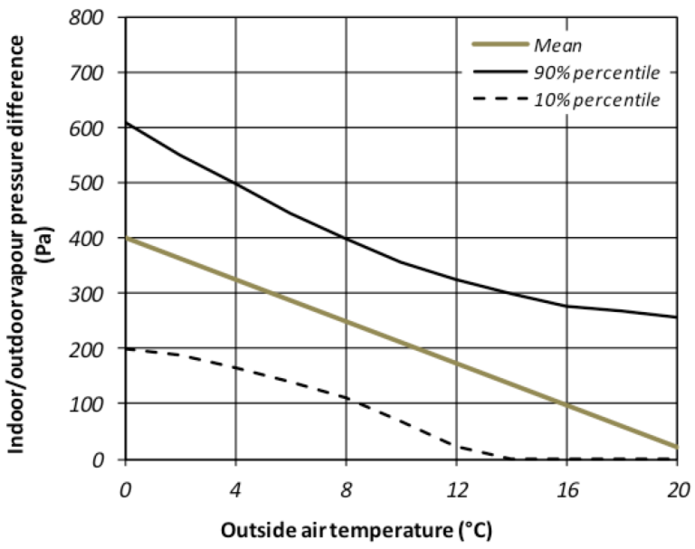
Figure 8 1065 living rooms in UK homes: indoor-outdoor vapor-pressure difference: 10% percentile, 90% percentile and average line in relation to the outside air temperature
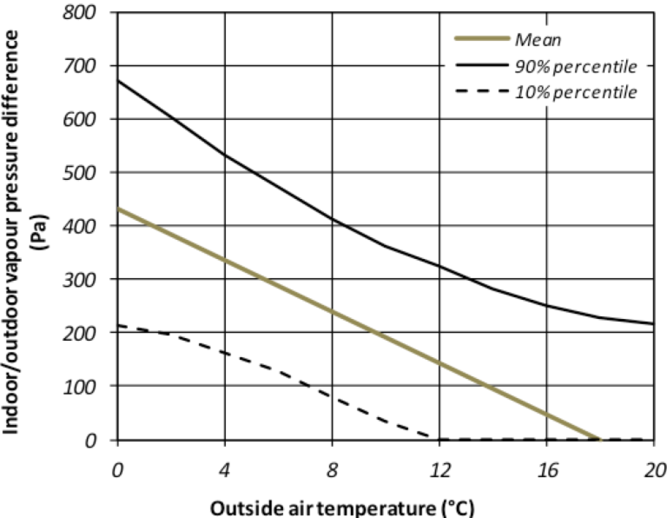
Figure 9 916 bedrooms in UK homes: indoor-outdoor vapor-pressure difference: 10% percentile, 90% percentile and average line in relation to the outside air temperature
The mean lines (Pa) are given by:
Living rooms: 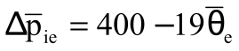 (12) (13)(

Bedrooms 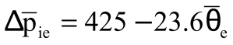 (13)
Figure 10 and Table 9 are based on measurements in 101 dwellings in Finland and Estonia (Kalamees et al, 2006), The data gained were approximated by three distinct linear segments with the weekly running average indoor-outdoor vapor-pressure differences constant below 5°C and above 15°C outdoors and varying linearly in between. A distinction was also made between high, average and low vapor load.
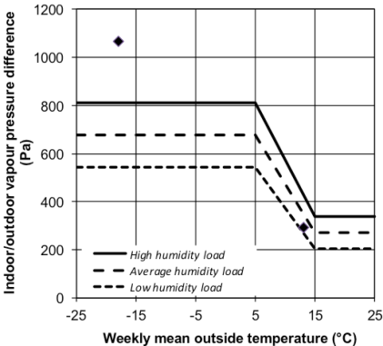
Figure 10 Water vapor pressure excess in relation to the running weekly mean temperature for northern Europe. The two dots represent data for northern Canada

Table 8 Finland and Estonia, indoor climate, boundaries (weekly means)
Humidity load | Indoor/outdoor vapor pressure difference, Pa
Humidity load | 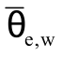<5°C | 5°C15°C | >15°C
Low | 540 |  | 200
Average | 680 |  | 270
High | 810 |  | 340
The two data points for northern Canada give an average indoor-outdoor vapor-pressure difference collected during a 4-day period. The value of the data point at an average outside temperature of -18°C lays substantially higher than the Finish and Estonian high humidity results. Although the dwellings were reported to have higher than normal air leakage rates for the type and age of construction, the high vapor release rates were explained by the fact that a ‘boil water’ advisory (to ensure acceptable water quality) was in effect in the community when the measurements were taken. The other data point, representing measurements at 13°C outdoors, is close to the Finish and Estonian low-humidity curve, even though the number of household members was higher than the typical occupancies in southern Canada. The dwellings monitored had air-change rates of up to 12 at 75 Pa.
The mean, maximum and minimum least-square regression for measurements in the living room of ten German homes are shown in Figure 11.
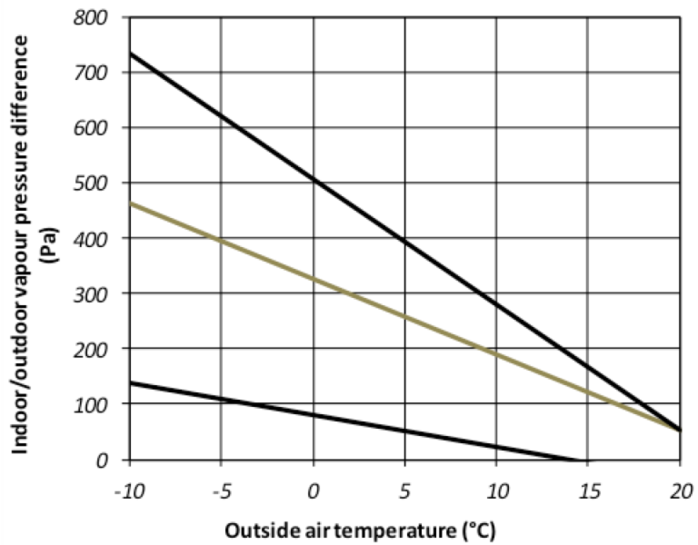
Figure 11 Ten German homes, living room: lowest, highest, and mean indoor-outdoor vapor-pressure difference line
The range between driest and most humid is considerable. The main variable seems to be the number of household members and their living habits, including window operation (Antretter, 2010). A comparison of these German means in Figure 11 with the UK means shown in Figures 8 and 9 gives lower differences at lower (and higher differences at higher) outdoor temperatures:
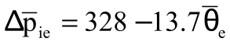 (14) (15)
Also the extreme curves differ, but show the same general trends.
Temperature and relative humidity data collected in 60 homes, equally spread over 3 climate zones in the United States (Pacific northwest, a cold location in the northeast, and a hot and humid location in the southeast) gave an average relation between the moving monthly mean outside temperature and the moving monthly mean indoor-outdoor vapor pressure difference, as shown in Figure 12 (Arena et al, 2010). The figure clearly shows the dehumidying effect of air conditioning. The least-square regression line for a running monthly mean outside temperature below 19.5°C equals:
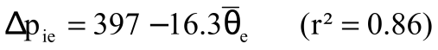 (15) (16)
Above 19.5°C, the line turns into:
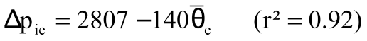 (16) (17)
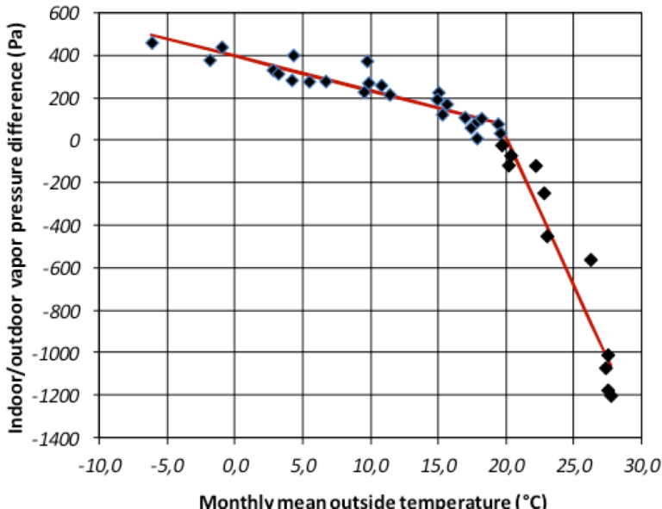
Figure 12 Monthly mean indoor-outdoor vapor-pressure difference in relation to the monthly mean outside air temperature in three climate zones in the US
Measurements in 10 homes in Madison, WI, and 10 homes in Knoxville, TN, over a one-year period gave a monthly mean difference in indoor-outdoor vapor concentration shown in Figure 13 (Antretter et al, 2010).
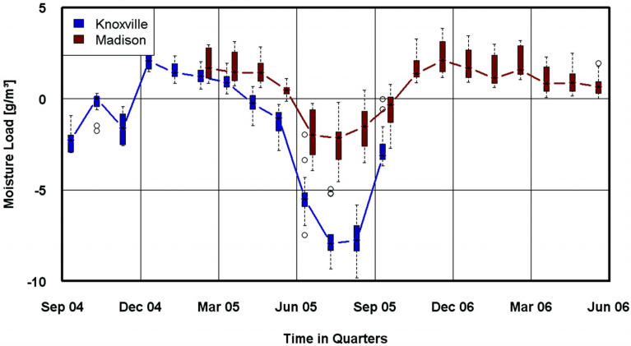
Figure 13 Measured monthly mean indoor-outdoor vapor concentration difference in 10 homes in Madison, WI, and 10 homes in Knoxville, TN (Antretter et al, 2010)
The data are consistent with what Figure 12 underlined: vapor-pressure deficits only occur during the summer months in the Madison, WI, climate (cold winter but warm summer), and between April and November in the warmer and more humid Knoxville, TN, climate. Both situations are the results of dehumidification by air-conditioning.
Measurements taken in 71 homes on Rhode Island are shown in Figure 14 as the distribution of the logged indoor/outdoor vapor pressure difference at 0°C outdoors (Francisco et al, 2010).
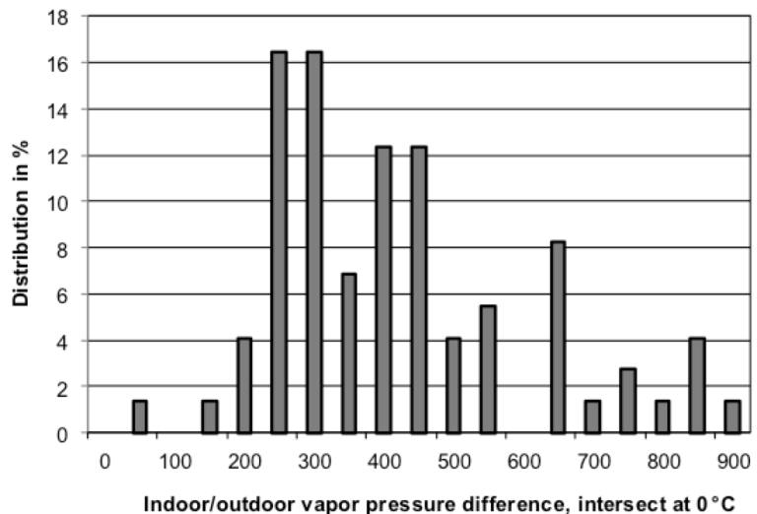
Figure 14 71 homes in RI, indoor-outdoor vapor pressure difference at the intersect with 0°C
The mean is 396 Pa, close to what equation (14) suggests, whereas the 95th percentile value equaled 772 Pa. This is higher than the data measured in the temperate climate of Northwestern Europe, where for larger homes the 95th percentile on a weekly basis was (Hens, 2010):
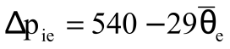 (17) (18)
while for small homes the relation became:
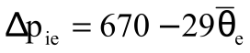 (18) (19)
To minimize risk, the 95th percentile is often used for design purposes.
The above results are based primarily on homes using natural ventilation. Many building codes in the United States now require homes to add mechanical ventilation to compensate for tighter envelopes. That is a significant modification and must be considered in evaluation of residences.
Measurements in 30 homes by Francesco et al, 2009 concluded that unvented gas fireplaces added, on average, about 100 Pa to the indoor-outdoor vapor pressure difference.

Natatoriums
Vapor-pressure difference measurements in natatoriums are rare. However some studies have been conducted in a few countries. Figure 15 gives weekly mean indoor-outdoor vapor pressure differences in relation to the weekly mean outdoor air temperature, measured in 20 natatoriums in a temperate climate region (Hens, 2012). There is a considerable amount of scatter. Least-square regressions for the mean and 95th percentile are given below. The r² values are quite low:
Mean
(19) (20)
95th percentile
(20) (21)
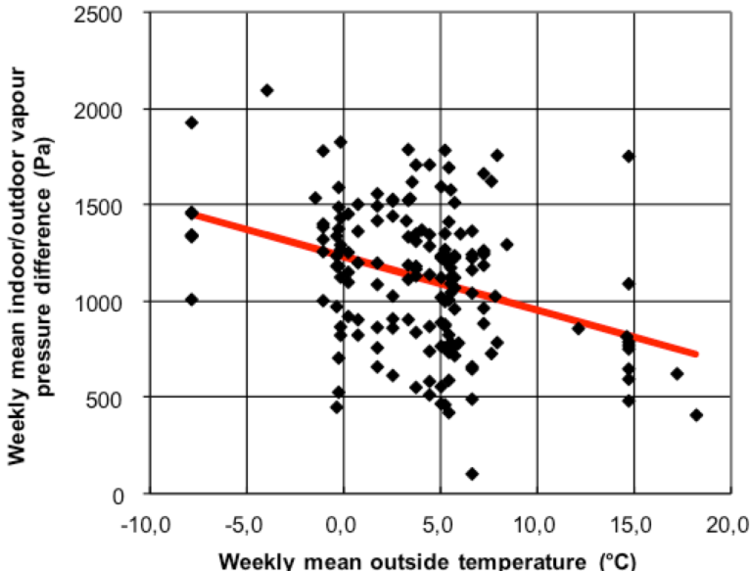
Figure 15 20 natatoriums. Weekly mean indoor/outdoor vapor pressure differences, measured data, measured data and least-square straight line
The data clearly show that, while not highly correlated with the outdoor temperature, vapor-pressure differences in natatoriums are consistently high. These buildings therefore require specific measures to prevent accumulation of moisture within the envelope leading to severe degradation (see Figure 16).
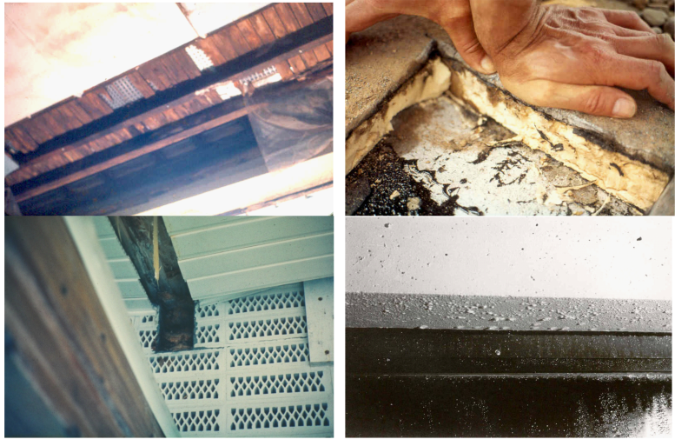
Figure 16 Natatoriums: top left low-sloped roof, damaged by convection-induced interstitial condensation; top right interstitial condensation in low-sloped roof polyurethane foam insulation; bottom left a timber beam collapse; bottom right abundant surface condensation on a window and the lintel above

Student residences and schools
The few measuring campaigns undertaken in student residences and schools in a region with temperate climate gave a very diffuse picture with a large spread in weekly mean indoor-outdoor vapor-pressure differences, see Figure 17 (Hens, 2005) and table 14 (Hens et al, 2007).
The lowest full line in the figure indicates the design reference for well-ventilated buildings with very limited vapor release, while the lowest of the two upper solid lines gives the design reference for large dwellings, and the highest line is the design reference for small homes in that region.
Figure 17 Weekly mean indoor-outdoor vapor-pressure differences in four student residences, measured data
Table 14 Indoor air temperature and indoor-outdoor vapor-pressure difference: means and extremes measured in five schools in a temperate climate
School | Temperature, °C |  |  | Indoor-outdoor vapor pressure difference, Pa
School | Mean | Min | Max | Mean | Min | Max
1 | 17.7 | 14.7 | 23.2 | 197 | -138 | 722
2 | 15.0 | 12.0 | 26.8 | 215 | -155 | 800
3 | 20.3 | 14.2 | 25.2 | 198 | -266 | 1059
4 | 17.5 | 10.3 | 23.1 | 151 | -169 | 609
5 | 17.9 | 14.1 | 23.4 | 35.9 | -403.8 | 495.6

Avoiding moisture problems

Whole building
Construction moisture must have the opportunity to dry within an acceptable period of time without inducing such high relative humidity indoors that mold growth becomes a risk. If necessary. a temporarily higher ventilation rate helps.
If there is no watertight layer or capillary break inserted above grade, stone buildings may suffer from rising damp and salt transport. Building components wetted by rising damp act as permanent moisture sources affecting indoor vapor release and the indoor-outdoor vapor-pressure difference.

Building envelope

Even when rain-tightness is guaranteed, excessive vapor pressures indoors can still induce condensation and mold on interior surfaces, while large temperature and vapor-pressure differences between indoors and outdoors may cause interstitial condensation in assemblies.

Mold growth
Mold growth on interior opaque surfaces starts at temperatures between 5°C and 25°C when the relative humidity passes the so-called mold threshold during a long enough period of time. If, for example, a material has absorbed an amount of water from a leak, drying may temporarily sustain a surface relative humidity level high enough to be conducive to mold. The IEA Annex 14 reports (IEA-EBC, 1990) contain two design formulas for estimating mold risk. One formula calculates the four-week relative humidity threshold, above which the likelihood that mold will develop is 100%, while the other evaluates the surface relative humidity needed for mold development at shorter time intervals. Combining the two yields:
(21)
Where:
- Φ is the relative humidity at the surface on a scale from 0 to 1
- θ_{si} is the inside surface temperature in °C (5°Cθ_{si}25°C)
- T is the period considered in days
The threshold for a one-day period is approximately 99%.
Since the completion of Annex 14, two more comprehensive models have been published, see Sedlbauer, 2001, and Vitanen et al, 2007. Recent work, however, points out that predictions with any model give varying results for growth probability and mold density (Vereecken et al, 2012).

Surface condensation
Each time the inside surface temperature somewhere on the envelope drops below the dew-point of the indoor air, condensate forms. Glazed surfaces are especially prone to surface condensation. Hygroscopic materials (e.g. wood, masonry, gypsum and some plasters) may buffer the local surface wetness, preventing visible condensate but increasing the moisture content within the material. As long as short periods of condensation or high humidity alternate with periods of drying, there tends to be no negative consequences. Long-lasting surface condensation or long periods of high humidity, however, will degrade timber and other materials, while condensate deposited on aluminum frames may wet the window reveals. Thermal bridges in particular can experience prolonged periods of condensation that cause damage to the inside finish (for example the wall paper glue slowly losing adhesion).

Interstitial condensation
Whenever water vapor condenses within envelope components, as a consequence of temperature and vapor-pressure gradients that point in the same direction, the term ‘interstitial condensation’ applies. The driving forces are diffusion linked to vapor-pressure differences, and moist air leakage linked to air-pressure differences (in- or exfiltration). Absorption of wind-driven rain followed by solar-driven vapor flow may be a cause of interstitial condensation in layers close to the interior space. In wood and wood-based materials, interstitial condensation may raise the surface relative humidity above the mold threshold and, even worse, raise the moisture content above the rot threshold. When the relative humidity adjacent to non-porous, non-adsorbing or capillary wet layers in an assembly becomes 100%, condensation with droplet formation occurs, followed by run-off, sometimes dripping, which is especially annoying for the occupants.
How to prevent condensation?
Avoiding mold, surface condensation and interstitial condensation in cold and temperate climates requires the following measures:
- Insulate building envelopes to such a level to eliminate the risk of surface mold and surface condensation at room temperature and typical levels of relative humidity . Insulation requirements imposed by the current building codes for energy efficiency are typically much higher than those needed to address that level of risk
- Avoid structural thermal bridges. No point on the inside surface of an opaque portion of the envelope should be colder than the interior surface of the glazed portion
- Minimize infiltration and exfiltration by making the envelope as air-tight as possible and, if the outside finish guarantees air-tightness, avoid leaks in the inner part that connect with air layers in front of the insulation. Indoor air washing along the outer face of the thermal insulation can increase the risk of interstitial condensation
- For light-weight construction, it may be necessary to install a continuous vapor-retarding layer inboard of the insulation.
- Take measures to avoid problems with solar-driven vapor flow when applying vapor retarders at the inside of envelopes that have a rain buffering outer finish such as a brick veneer (see 1235-RP)
- Never sandwich layers that contain construction moisture between vapor-tight materials
In hot and humid climates, it is important to:
- Insulate according to the requirements imposed by the current building codes for energy efficiency and eliminate structural thermal bridges
- Make the envelope as airtight as possible and avoid, if the inside finish provides the air-tightness, air gaps in the outer finish that allow hot humid outside air to infiltrate into the envelope and the coupled partition walls, leading to interstitial condensation behind the colder inner finish
- For light-weight construction, it may be necessary to install a vapor-control layer on the exterior or warm side of the insulation
- Take measures to avoid problems with solar-driven vapor flow when applying vapor retarders at the inside of envelopes that have a rain-buffering cladding (see 1235-RP)
- Never sandwich layers that contain construction moisture between vapor-tight materials
HVAC systems
HVAC systems provide space heating and cooling, ventilation and, when needed, humidification and dehumidification. The system can affect air-pressure differences among building zones and between building zones and the exterior. HVAC operation also alters the indoor relative humidity, while related ventilation, humidification and dehumidification helps to shape the indoor-outdoor vapor-pressure difference. To minimize the humidity concern, the following measures should be taken:
- Insulate chilled-water pipes and cool-air ducts to minimize heat gain. The insulation should have a vapor-control layer on the outside surface and be thick enough to prevent surface condensation. Warm-water pipes and warm-air ducts only require insulation to minimize heat losses. For more details, see Chapter F23 in this handbook.
- Natural or mechanical ventilation in temperate climates should aim to keep the indoor relative humidity within the preferred 30 to 70% range
- HVAC systems in hot and humid climates should ventilate the building, while cooling and dehumidifying the ventilation air. The building should also be pressurized. Instead, HVACs systems in really cold climates should ventilate and warm the building while humidifying the air and putting the building under negative pressure
Ground pipes
In temperate climates, ground pipes (ventilation air ducts buried in the soil near the building) are sometimes used to moderate the condition of the incoming ventilation air. Rain and groundwater must be prevented from entering these pipes. In fact, water penetration turns them into air humidifiers with very negative consequences for indoor air quality. In dry pipes, relative humidity during the warm season should not exceed the mold threshold. This can load the supply air with mold spores that then germinate in the supply filter. The risk for both to happen was found to be high enough to not recommend ground pipes as a safe choice (Hens, 2012).

Climate-Specific Moisture Management

Temperate and mixed climates
Ventilation addresses the human need for a healthy indoor environment. The flow rates, which are based upon the number of occupants and their activities, must be sufficient to maintain low CO₂-concentrations, eliminate unwanted odors and dilute material emissions of harmful compounds, such as formaldehyde, to below the acceptable concentration limits. However, neither humidification nor dehumidification is explicitly required except when necessary for functional reasons, for example in museums and operating rooms.
In temperate and mixed climate zones, some depressurization during winter is advisable to minimize interstitial condensation risk, for example by using demand-controlled exhaust ventilation or balanced ventilation with heat recovery and a correctly chosen pressure balance between supply and exhaust. The envelope must be so air-tight that depressurization will not result in flows beyond the ventilation needed for health reasons. High air permeance (low air-tightness) has additional drawbacks; sound insulation degrades, drafts can occur, heat loss increases and inside surface temperatures might lower to a point where mold develops or even surface condensate appears. Ground floors above crawlspaces must be airtight enough that soil moisture, crawlspace odors and radon are prevented from infiltrating into the conditioned space.
How to avoid mold problems during winter? Assume that the insulating glass used excludes surface condensation on the panes. If only outside air enters a room, whether by infiltration and/or ventilation, the average airflow needed to avoid mold on the coldest spot of the opaque envelope’s inside surface during the coldest one- to four-week period is estimated using the following set of equations:
(22)
If single glazing is used and its surface stays wet due to surface condensation during the whole period considered, then the third equation expands to:
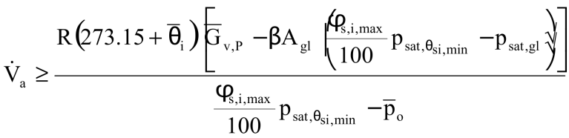 (23)
In the set of equations (22) and the equation (23):
- 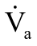 is the required average outside air ventilation or infiltration flow needed during the period considered, in m³/h
- 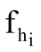 is the temperature ratio at that coldest spot
- 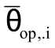is the mean operative temperature indoors during the period considered, in °C
- 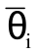 is the mean dry bulb temperature indoors during the period considered, in °C
- 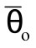 is the mean dry bulb temperature outdoors during the period considered, in °C
- 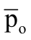 is the mean vapor pressure outdoors during the period considered, in Pa
- 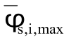 is the maximum mean relative humidity indoors allowed during the period considered, in %
- 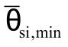is the mean inside surface temperature on the coldest spot during the period considered (above the glass temperature), in °C
- 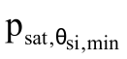 is the vapor-saturation pressure at that inside surface temperature, in Pa
- R is the gas constant of water vapor, in Pa.m³/(kg.K)
- 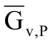 is the mean rate of vapor release indoors during the period considered, in (kg/h)
- 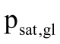 is the mean vapor saturation pressure at the glass surface during the period considered, in Pa
    - β is the surface film coefficient for diffusion at the glass surface, in s/m
- A_{gl} is the glazed surface, in m²
- T is the period considered in days

The mean ventilation flow needed depends on multiple parameters, among them the value of that lowest temperature ratio, fixing the lowest inside surface temperature and related lowest vapor-saturation pressure. Other parameters intervening are the mean dry bulb temperature outdoors, the mean operative temperature indoors (which involves the insulation quality of the whole room enclosure), the temperatures in the adjacent rooms, the mean air temperature and vapor pressure outdoors and the average amount of vapor released indoors minus the vapor removed by surface condensation on the glazing. The lowest temperature ratio is most often found on structural thermal bridges. Acceptable envelope performance now requires that the inside surface temperature ratio there must be high enough to prevent mold to occur at the expected average vapor release indoors, the environmental conditions outdoors, the desired thermal comfort settings and the mean ventilation rate required for good IAQ and human health.
Why is this approach, based on averages, limited to a one-week period and longer? Because shorter periods see hygric inertia affecting the vapor pressure in the room, which makes steady-state calculations unreliable.
Ventilation is also used to avoid surface condensation, which occurs each time the indoor dew-point temperature exceeds the lowest inside surface temperature, with the glazed surfaces as usual location. Assuming only outside air enters a space, whether by infiltration or ventilation, estimating the average airflow needed to avoid day-long surface condensation on glass is estimated by solving:
(24)
Where:
- is the average inside surface temperature of the glass, in °C
- U_{gl} is the thermal transmittance of the glass in W/(m²,K)
- h_{i} is the thermal surface film coefficient at the inside surface of the glass in W/(m².K)
- is the vapor-saturation pressure at the glass surface, in Pa
The ventilation flow required depends on the same parameters as for mold, except using the design temperature outdoors for heating. For surface condensation on thermal bridges and other surfaces than glass, the equations for mold apply with surface relative humidity at 100%.
Well-insulated double- and triple-glazed gas-filled low-e glass windows used in new construction and retrofits can have water condensing on the outside surface during cold clear-sky nights instead on the inside surface. That this blurs the view to the outdoors is bothersome but inevitable.

Hot and humid climates
In hot and humid climates, ventilation rates remain based upon the number of occupants and their activities. To avoid mold growth and surface condensation, dehumidification should maintain the inside relative humidity below 60%, although brief periods of elevated relative humidity do not necessarily result in mold germination. Maintaining the building under positive air pressure is required to minimize interstitial condensation in wall cavities.
Dehumidification
Air-handling units that mix outdoor air with return air to provide constant air flow rates at variable supply temperatures will not provide continuous dehumidification. At higher supply-air temperatures, the cooling coil no longer removes moisture from the ventilation air. The result is temporarily elevated indoor relative humidity levels and a high potential for microbial growth. This becomes even more pronounced in energy-efficient buildings where sensible cooling loads are reduced and the cooling coil has long off-times. In this case, moisture removal becomes really ineffective (Rudd et al, 2005) (Rudd, 2010). For variable supply temperature systems, the ventilation air portion can be pre-conditioned using a Dedicated Outdoor Air System (DOAS). Such systems restrict dehumidifying to the ventilation air, while cooling loads are handled by a separate air-handling unit. A DOAS is a good choice for providing continuously dehumidified ventilation air. If heat recovery is economically feasible without compromising pressurization, a DOAS with heat recovery is an energy-efficient choice, provided that the supply and return fans maintain correct pressurization and the relative humidity of the air passing through the supply filters remains low enough to avoid mold growth there. Since schools, office buildings, hospitals and dwellings require continuous ventilation based on the number of occupants present, demand-controlled DOAS-based outside ventilation air dehumidification can be achieved at a constant cooling-coil temperature. Reheat of the ventilation air may be required anyway, to avoid overcooled supply air if the ventilation demands are high. The result is more stable dehumidification and improved relative humidity control.
Alternatives for residential construction include local stand-alone dehumidifiers, continuous exhaust-supply indoor air dehumidification using a central HVAC system with sub-cooling followed by reheat, continuous exhaust-supply indoor air dehumidification using ducted dehumidifiers, a stand-alone dehumidifier with central system mixing or, ducted DX condenser-regenerated desiccant dehumidifiers (Rudd, 2013) (Harriman III et al, 2009).
Pressurization
Dehumidification reduces the indoor vapor pressure lower than the outdoor vapor pressure. Cooling does the same for temperature. As a result, the pressure and temperature gradients cause moisture migration by diffusion towards the interior. If the envelope is not air-tight, building depressurization and related infiltration increase this moisture flow through the exterior wall cavities. This may raise the relative humidity at surfaces within these cavities to levels that allow mold or interstitial condensation. Pressurization reverses the air flow, allowing dehumidified indoor air to exfiltrate, neutralizing inward vapor diffusion. In any case, the envelope should be constructed airtight, so that pressurization should not require a supply ventilation higher than needed.

Cold climates
In cold climates, ventilation rates are based upon the number of occupants and their activities. The techniques for avoiding mold and surface condensation are the same as in temperate and mixed climates. During the cold portion of the year, the indoor relative humidity can drop well below 30%. Maintaining healthy levels of relative humidity then requires humidification, which results in an increased vapor-pressure difference for a temperature gradient to the outdoors, promoting vapor diffusion towards the exterior.
Humidification
At part-load, the same problem occurs as with dehumidification. On/off air-handling units that heat and humidify a mixture of outdoor and return air, may operate so intermittently that during the off periods indoor relative humidity levels drop substantially. Moisture buffering by the building fabric, furniture and furnishings can reduce that variation in relative humidity (Simonson et al, 2004a,b). A better choice in larger buildings, however, is a DOAS that restricts humidification to the ventilation air, while heating loads are handled by a separate system. Since the ventilation required mainly depends on the number of occupants, humidification can be achieved by using steam injection modulated according to demand or by preheating the ventilation air, followed by adiabatic humidification and reheat to the set-point indoor temperature. The result is more stable humidification and better relative humidity control. Alternatives in homes are stand-alone humidifiers, a continuous supply air humidification at constant dew-point by the central HVAC-system and so on.
Pressurization/depressurization
Pressurizing buildings in cold climates leads to air exfiltration, which provides an extra vehicle for vapor egress. Together with diffusion, this could lead to really severe interstitial condensation in envelope assemblies, especially when the inside vapor retarder is ineffective and the air barrier not continuous. Depressurizing buildings, which leads to infiltration, therefore acts as effective way to avoid interstitial condensation problems, with the proviso that the envelope is sufficiently air-tight such that depressurization does not require ventilation rates beyond what the occupancy demands. Otherwise, not only will large exhaust rates be required but all drawbacks mentioned in the section on temperate climates will surface, but in a more detrimental way.

Handbook Information to assist Moisture Management
Tables 15 to 18 summarize information about moisture and humidity as discussed in several chapters of the ASHRAE Handbooks.
Table 15 2013 ASHRAE Handbook—Fundamentals
Chapter 1 Psychrometrics | Ideal gas relations and thermodynamic properties to analyze conditions and processes involving moist air.
Chapter 4 Heat transfer | Heat transfer processes that impact temperature and moisture transport in buildings
Chapter 9 Thermal comfort | Effects of relative humidity, temperature and vapor pressure on thermal comfort
Chapter 10 Indoor environmental health | Effects of relative humidity on IEQ, mould and humidifier fever
Chapter 11 Air contaminants | Controlling mould requires control of relative humidity at material surfaces
Chapter 12 Odors | Temperature and relative humidity may affect olfactory perception and perceived indoor air quality
Chapter 13 Indoor environmental modeling | Intra- and inter zone air flows, included pollutant transfer with water vapor as one of them
Chapter 14 Climatic design information | Contains data on outdoor dry and wet bulb temperatures for design purposes
Chapter 15 Fenestration | Looks to the relation between relative humidity and condensation potential on glazing
Chapter 16 Ventilation and infiltration | Air leakage across the envelope can lead to interstitial condensation, while air infiltration across the envelope may pose moisture control problems
Chapter 17 Residential cooling and heating load calculations | Air humidification required in many climates to maintain comfortable relative humidity values indoors. The chapter gives formulas to calculate the latent load
Chapter 18 Nonresidential cooling and heating load calculations | Looks to the latent heat gain from moisture diffusion, mentions different moisture sources, among them the ones in natatoriums
Chapter 19 Energy estimating and modeling methods | Considers cooling and dehumidification coils, gives some information on cooling towers
Chapter 23 Insulation for mechanical systems | Discusses condensation control for below-ambient temperature HVAC components
Chapters 25, 26, 27 Heat, air and moisture control in building assemblies | Detailed information on the heat, air and moisture response of building envelope assemblies. Includes the fundamentals of combined heat, air and moisture movement, relevant material properties and examples. The fundamentals consider moisture content, moisture buffering and moisture flow. Material properties include sorption isotherms and vapor permeability
Table 16 2012 ASHRAE Handbook—Systems and Equipment
Chapter 4 Air handling and distribution | Discusses humidity control and air handling unit psychrometric processes
Chapter 11 Steam systems | Discusses condensate removal from temperature-regulated systems and steam traps
Chapter 12 District heating and cooling | Describes condensate drainage and return in district systems
Chapter 22 Humidifiers | Looks to the optimum humidity range for human comfort and health, discusses surface and interstitial condensation, contains a few data on vapor release indoors (family of 4: 320 g/h, unvented heating devices 1 kg of vapor for each kg of fuel burned, single-color offset printing presses 200 g of vapor per hour)
Chapter 23 Air cooling and dehumidifying coils | Discusses dehumidification coils
Chapter 24 Desiccant dehumidification and pressure-drying equipment | Defines dehumidification and discusses methods of dehumidification with primary emphasis on sorption dehumidification
Chapter 25 Mechanical dehumidifiers and related components | Discusses mechanical dehumidification
Chapter 26 Air to air energy recovery equipment | Discusses air-to-air energy recovery processes from the basic thermodynamics, to types and applications of air-to-air heat exchangers and technical considerations. Includes condensation and freeze-up in air-to-air heat exchangers and gives an energy and moisture recovery procedure
Chapter 40 Cooling towers | Discusses among others evaporation based cooling towers
Chapter 41 Evaporative air-cooling equipment | Discusses evaporative humidification and dehumidification

Table 17 2015 ASHRAE Handbook—Applications
Chapter 1 Residences | Discusses residential humidification and dehumidification
Chapter 2 Retail facilities | Discusses humidity control in stores
Chapter 3 Commercial and public buildings | Discusses thermal comfort design criteria and load characteristics in commercial and public buildings
Chapter 4 Tall buildings | Discusses the stack effect and practical considerations for minimizing stack effects.
Chapter 5 Places of assembly | Mentions latent load in arenas, mentions humidity problems in ice rinks, considers vapor release in natatoriums with some consequences for envelope design
Chapter 6 Hotels, motels and dormitories | Mentions dehumidification as a load characteristic, considers moisture control using DOAS
Chapter 7 Educational facilities | Mentions humidity control in classrooms, libraries, gymnasiums, showers and natatoriums
Chapter 8 Health-care facilities | Looks to the importance of relative humidity for different kind of patients
Chapter 9 Justice facilities | Provides dry bulb and wet bulb design criteria for the various general and specialized spaces in courthouses, detention and correction facilities.
Chapter 16 Laboratories | Underlines the importance of relative humidity control
Chapter 18 Clean spaces | Underlines the importance of relative humidity control
Chapter 19 Data Centers and telecommunication facilities | Gives the drawbacks of high (anodic failure) and low relative humidity (electrostatic discharge), talks on envelope considerations and humidity control
Chapter 20 Printing plants | Stresses paper moisture content control and the importance of controlling relative humidity in pressrooms for various printing processes.
Chapter 21 Textile processing plants | Mentions the role of relative humidity
Chapter 22 Photographic material facilities | Mentions the role of relative humidity
Chapter 23 Museums, galleries, archives and libraries | Discusses the importance and impact of relative humidity mean values and fluctuations.
Chapter 24 Environmental control for animals and plants | Mentions the role of relative humidity
Chapter 25 Drying and storing selected farm crops | Mentions the role of relative humidity
Chapter 26 Air conditioning of wood and paper product facilities | All about moisture control in the process
Chapter 30 Industrial drying | Looks to drying as a process
Chapter 31 Ventilation of the industrial environment | Discusses the use of ventilation to reduce relative humidity in cold and moderate climates
Chapter 33 Kitchen ventilation | Discusses the use of ventilation to reduce relative humidity in cold and moderate climates
Chapter 44 Building envelopes | Looks to all aspects of liquid water and vapor control in building envelopes
Chapter 47 Design and application of controls | Discusses humidity control
Chapter 52 Evaporative cooling | Considers humidification and dehumidification
Chapter 62 Moisture management in buildings | Couples practice to this Fundamentals chapter on Moisture Management in Buildings
Table 18 2014 ASHRAE Handbook—Refrigeration
Chapter 7 Control of moisture and other contaminants in refrigerant systems | Contains a thorough discussion of the role of moisture as a contaminant in refrigeration systems
Chapter 10 Insulation systems for refrigerant piping | Discusses how moisture diffusion through low water vapor permeance insulation and water permeable claddings can produce damaging condensation and moisture accumulation.
Chapter 23 Refrigerated-facility design | Considers the moisture aspects of refrigerated-facility envelope design
Chapter 24 Refrigerated-facility loads | Discusses sensible and latent heat loads
Chapter 44 Ice Rinks | Considers the specific ceiling moisture problems as a consequence of long wave radiation between ice surface and ceiling
To summarize: moisture loads and material wetness that can reduce the durability of buildings together with the negative effects of insufficient or excessive levels of indoor relative humidity are recapitulated; data not included elsewhere in the Handbooks on indoor vapor releases and measured indoor-outdoor vapor-pressure or vapor-concentration differences are the core of this chapter on moisture and humidity control.

References
Antretter F, Mitterer C., Young S-M, 2012, Use of moisture-buffering tiles for indoor climate stability under different climatic requirements, HVAC&R Research, 18(1–2):275–282
Florian Antretter F., Andreas Holm A, Karagiozis A., Glass S. 2010, Interior Temperature and Relative Humidity Distributions in Mixed-Humid and Cold Climates as Building Simulation Boundary Conditions, Proceedings of the Buildings XI Conference, Clearwater Beach (CD-ROM)
Arena L., Karagiosis A, Mantha P, 2010, Monitoring of Internal Moisture Loads in Residential Buildings-Research Findings in Three Different Climate Zones, Proceedings of the Buildings XI Conference, Clearwater Beach (CD-ROM)
ASHRAE, 2017, Handbook of Fundamentals, Atlanta
ASHRAE, 2016, Handbook of HVAC Systems and Equipment, Atlanta
ASHRAE, 2015, Handbook of HVAC Applications, Atlanta
ASHRAE, 2014, Handbook of Refrigeration, Atlanta
ASHRAE, 2009, ANSI/ASHRAE Standard 160-2009, Criteria for Moisture-Control Design Analysis in Buildings, Atlanta.
ASHRAE, 2012, Position Document on Limiting Indoor Mold and Dampness in Buildings, Atlanta
BRE, 2010, BREEAM International Bespoke 2010
Francisco P., Gordon J., Rose W., 2009, Indoor Moisture in 30 Homes Using Unvented Gas Fireplaces, ASHRAE Transactions, Vol 115, part 2
Francisco P., Rose W., 2010, Temperature and Humidity Measurements in 71 Homes, Proceedings of the Buildings XI Conference, Clearwater Beach (CD-ROM)
IEA-ECBCS, Annex 14 on Condensation and Energy, 1990, Sourcebook, ACCO, Leuven,
IEA-ECBCS, Annex 14 on Condensation and Energy, 1990, Guidelines and Practice, ACCO, Leuven, 55 p
Hartmann T., Reichel, D. und Richter, W.: Feuchteabgabe in Wohnungen – alles gesagt? Gesundheits-Ingenieur 122 (2001), H. 4, S. 189-195 (in German)
Harriman III L., Brundrett G., Kittler R., 2001, Humidity Control Design Guide for Commercial and Institutional Buildings, ASHRAE, Atlanta, 491 p
Harriman III L., Lstiburek J. W., 2009, The ASHRAE Guide for Buildings in Hot & Humid Climates, ASHRAE, Atlanta, 319 p
Hens H., 2005, Energy consumption in student residences, impact of building performance, usage patterns and indoor climate, Proceedings Clima 2005, Lausanne
Hens H., De Meulenaer V., 2007, Schools, all problem buildings?, Proceedings Clima 2007. Helsinki
Hens H., 2009, IEA-ECBCS Annex 41 Whole Building Heat, Air and Moisture Response, ASHRAE Transactions, Vol. 115, Part 2
Hens H., 2009, Indoor Climate and Building Envelope Performance in Indoor Swimming Pools, ‘Energy Efficiency and New Approaches’, edited by Bayazit N., Manioglu G., Oral G., Yilmaz Z., Istanbul Technical University, pp 543-552
Hens H., 2016, Applied Building Physics, Boundary Conditions, Building Performance and Material Properties, 2^{d} edition, Ernst & Sohn (a Wiley Company), Berlin, ISBN 978-3-433-02962-6
Hens H., 2012, Passive houses: what may happen when energy efficiency becomes the only paradigm, ASHRAE Transactions 118, part 1
Hens H., 2012, Building Physics, Heat, Air and Moisture. Fundamentals and Engineering Methods with Examples and Exercises, 2^{d} edition, Ernst & Sohn (a Wiley Company), Berlin, ISBN 978-3-433-03027-1
Holm A., 2008, Whole Building Heat, Air, Moisture Response: Applications (Indoor Environment, Energy, Durability), Final Report IEA ECBCS Annex 41, ACCO, Leuven
Kalamees T., Vinha J., Kurnitski J., 2006, Indoor Humidity Loads in Light-weight Timber-framed Detached Houses, Journal of Building Physics 29(3), 219-246
Kumaran K., Sanders C., 2008, Whole Building Heat, Air, Moisture Response: Boundary Conditions and Whole Building HAM Analysis, Final Report IEA ECBCS Annex 41, ACCO, Leuven
Künzel H.M., 2010, Indoor Relative Humidity in Residential Buildings – A Necessary Boundary Condition to Assess the Moisture Performance of Building Envelope Systems
Künzel H.M., Zirkelbach D., Sedlbauer K., Predicting Indoor Temperature and Humidity Conditions Including Hygrothermal Interactions with the Building Envelope,
Mumovic D., Santamouris M editors, 2009, The handbook on sustainable building design and engineering, Earthscan, London
Ridley I, Davies M., Hong S. H., Oreszcyn T., 2008, Vapour pressure excess in living rooms and bedrooms of English dwellings: analysis of the warm front dataset, Appendix III of the IEA-ECBCS Annex 41 report on ‘Boundary Conditions and Whole Building HAM Analysis, ACCO Leuven, p 187-205
Rudd A. F., Lstiburek J.W., Ueno K., 2005, Residential Dehumidification Systems Research for Hot-Humid Climates, September 1, 2001—December 30, 2003, NREL/SR-550-36643
Rudd A.F., 2010, Enhanced Dehumidification, Building America Report 1008
Rudd A.F., 2013, Supplemental Dehumidification in Warm-Humid Climates, Building America Report 1310
Sanders C., 1996, Environmental Conditions, Final report IEA-ECBCS Annex 24, Volume 2, 96 p.
Sedlbauer K., 2001, Vorhersage von Schimmelpilzbildung auf und in Bauteilen (Prediction of mould development on and in building assemblies), PhD-thesis TU-Stuttgart (in German)
Simonson C., Salonvaara M., Ojanen T., 2004, Heat and Mass Transfer Between Indoor Air and a Permeable and Hygroscopic Building Envelope: Part 1 – Field Measurements, Journal of Thermal Envelope and Building Science, Vol 28 (1) pp 63-101
Simonson C., Salonvaara M., Ojanen T., 2004, Heat and Mass Transfer Between Indoor Air and a Permeable and Hygroscopic Building Envelope: Part 2 – Verification and Numerical Studies, Journal of Thermal Envelope and Building Science, Vol 28 (2) pp 161-185
Ten Wolde A., Walker I, 2001, Interior Moisture Design Loads for Residences, Proceedings of the Buildings VIII Conference, Clearwater Beach (CD-ROM)
Ten Wolde A., Pilon C, 2007, The effect of Indoor Humidity on Water Vapor Release in Homes, Proceedings of the Buildings X Conference, Clearwater Beach (CD-ROM)
Trechsel H., editor, 1994, Moisture control in buildings, ASTM Manual Series MNL 18
USGBC, LEED 2009 for New Construction and Major Renovation, Washington DC
Vereecken E., Roels S., 2012, Review of mould prediction models and their influence on mould risk evaluation, Buildings and Environment, Vol. 52, p 296-310
Viitanen J, Ojanen T, 2007, Improved Model to Predict Mold Growth in Building Materials, Proceedings of the Buildings X Conference, Clearwater Beach (CD-ROM)
Woloszyn M., Rode C., 2008, Whole Building Heat, Air, Moisture Response: Modeling Principles and Common Exercises, Final Report IEA ECBCS Annex 41, ACCO, Leuven

