MINUTES
ASHRAE TC 4.2 | Climatic Information
2025 ASHRAE Annual Meeting | Phoenix AZ
Tues, June 24 2025 | 1:00 – 3:00pm MST
https://tc0402.ashraetcs.org/meetings.php
Remote Participation Link: https://us06web.zoom.us/j/81353194671?pwd=alyszXilev0zUJPUFDEbabDUrca8Bh.1
Meeting ID: 813 5319 4671 Passcode: 592904
SUMMARY
::ACTION ITEMS::
  - Program
    - Las Vegas proposals due 1st August 2025
  - Research
    - Deadline for Fall RAC meeting is 8/15. Share any new WS or RTARs with TC 4.2, co-sponsoring TCs, and RL by 7/15 to allow time to review, revise, and vote.
    - See updates below for remaining project-level action items.

These minutes drafted Saturday 28th June 2025 by outgoing Secretary, Eric Peterson (University of Leeds)
- Call to order 1-1:02 pm Brown
- Review Scope Brown
“TC 4.2 identifies, researches, analyzes, and disseminates climatic data for design of sustainable built environments.”
- ASHRAE Value Statement Brown
In ASHRAE meetings, we will act with honesty, fairness, courtesy, competence, inclusiveness and respect for others, which exemplify our core values of excellence, commitment, integrity, collaboration, volunteerism and diversity, and shall avoid all real or perceived conflicts of interest. Our culture is one of inclusiveness, acknowledging the inherent value and dignity of each individual. We celebrate diverse and inclusive communities, understanding that doing so fuels better, more creative and more thoughtful ideas, solutions and strategies for the Society and the communities our Society serves. We respect and welcome all.

Code of Ethics: https://www.ashrae.org/about/governance/code-of-ethics
Core Values: https://www.ashrae.org/about/ashrae-s-core-values
Diversity Statement: https://www.ashrae.org/about/diversity-equity-and-inclusion-dei
- Introductions All
  - Determination of a quorum (attendance by 6 voting Members & 2 voting Members Non-Quorum)
Present in the room: Brown, Jarrett, Qui, Baltazar, and Barnaby.
Meanwhile active on-line attendance: Peterson, Erell (VNQ), and Assaf (VNQ)
Name | Ending |  | Name | Ending
Riad Assaf (NQ) | 2026-06-30 |  | Evyatar Erell (NQ) | 2025-06-30
Juan-Carlos Baltazar | 2025-06-30 |  | Philip Jarrett | 2029-06-30
Carlo Bianchi | 2026-06-30 |  | Eric Peterson | 2027-06-30
Chip Barnaby | 2029-06-30 |  | Parag Cameron-Rastogi | 2029-06-30
Carrie Brown | 2029-06-30 |  | Xin Qui | 2027-06-30
Need (4) or ½+1 for a Quorum

Attending in-person:
Chair - Carrie Brown (Resource Refocus, Oakland, California)

Voting Members
Philip Jarrett (Environment Canada Met Service),
Xin Qiu (SLR Consulting, Ontario),
Juan-Carlos Baltazar (Texas A&M University),
‘Chip’ Charles Barnaby (Consultant)

Corresponding Members
‘Joe’ Yu Huang (Whitebox Technology),
James Pegues (Carrier),
Joshua New (ORNL),
Wes Davis (Air Conditioning Contractors of America)

Incoming Secretary - Sagar Rao (Co-founder of NeuMod Labs, Madison, Wisconsin)

Provisional CMs
Kevin McFadden (2050 Partners), Juliana Velez (measurabl.com), Mehdi Jalayerian (Stantec), Joshua DeYoung (KCCmfg.com), Hassan Ali Younes (GRFN.global, Dubai)

Guests: Christie Walsh, Pengxiang Jiang, Zach Londo, Martin Eseverri, Julia Ho, Neal Kruis, Randall Higa (Southern California Edison)

TAC Section Head - Kyle Gluesenkamp (ORNL)

Attending on-line:

Research Subcom Chair - Michael Roth (Klimaat Consulting & Innovation, Guelph, Ontario)

Handbook Subcom Chair - Didier Thevenard (Recurrent Energy, Waterloo, Ontario)

Secretary - Eric Peterson (University of Leeds, UK)

Voting Members Non-Quorum
Evyatar Erell (Ben-Gurion University of the Negev)
Riad Assaf (Lebanon Green Building Council and Con Edison NY)

Corresponding Members
Raj Gupta (Malaviya National Institute of Technology, India)
‘Neal’ Jack Lott (ret. NOAA NCEI)
Robert Morris (Green Quill Climate Services, Ontario)

Provisional CMs
Guanzhou Ji (Carnegie Mellon University),
Paul Stackhouse (NASA Langley Research Center),
Amanda Fraga Krelling (LBL)

Guests: Rowen Schmidt (Radbridge Inc), Zhaoyun Zeng (Argonne NL)

Apologies
Vice Chair - Parag Cameron-Rastogi (GRESB, Attending London Climate Action Week)

Program Subcom Chair - Carlo Bianco (NREL, planning to attend on-line but prevented by fire alarm)

Standards Subcomm Chair – Dru Crawley (Bentley Software – Attending London Climate Action Week)

- Agenda additions All

No agenda additions offered.
- Approval of minutes from Indianapolis Brown
Basecamp > ASHRAE TC 4.2 > Docs & Files > Main Meeting > 2025.02.11 Orlando Winter Meeting
  - See: TC0402OrlandoNotes20250211_v2.docx
Chip Barnaby moves to approve. The motion was seconded by Juan-Carlos Baltazar.
No abstentions, CNV. Minutes approved by seven votes to none. (7-0-0)

- Chair’s Report 1:11 PM Brown
  - Announcements and Highlights from TC Chairs Breakfast Meeting
TC4.2 submitted the only RTAR received since the winter meeting in Orlando. See updates from Kyle below.
- Liaison reports
  - Center of Excellence for Building Decarbonization (CEBD) 1:12 PM Brown
  - 8 guides now available: https://www.ashrae.org/about/cebd-technical-resources
  - Continuing work on research projects. 2 RFPs open until 7/18/25
- 1977-SP, Expand and update the ASHRAE Service Life Table in the HVAC Applications Handbook: Sponsoring Committee: TC 2.8 Building Environmental Impacts and Sustainability; Co-sponsored by: TC 7.3 Operation, Maintenance and Cost Management.
- 1988-SP, Whole-Life Carbon Gap Analysis: Sponsoring Committee: Center of Excellence for Building Decarbonization; Co-sponsored by: TC 2.08, Building Environmental Impacts and Sustainability; TC 4.04, Building Materials and Building Envelope Performance; TC 4.07, Energy Calculations; TC 6.07, Solar and Other Renewable Energies & TC 7.06, Building Energy Performance
- For 25-26SY, Brown serving as Vice Chair and Cameron-Rastogi is a voting member.
  - BIM 1:13 PM
No one in the meeting had any news regarding the MTG.BIM (Multidisciplinary Task Group on BIM)
  - Resilience Brown
    - Scope: MTG.RES will coordinate TC/TG/TRC activities related to resilience including promoting the ASHRAE definition of “resilience”, finalizing a roadmap for ASHRAE to follow, prioritizing activities, and providing guidance to functional groups regarding developing their resilience plans. The MTG will develop documents as necessary to formalize resilience concepts and procedures.
    - Roadmap to Resilience shared with TC 2.10
    - Awaiting results of vote on whether MTG will disband.
  - Research 1:14 PM Landsberg
  - Dennis Landsberg attended our Research Sub-committee meeting, but did not attend this meeting.
  - Incoming Section 4 RAC liaison is Davide Ziviani.
  - Section Head Glusenkamp
    - See 2025-2028 Strategic Plan & Initiatives. New research should align with this.
    - Check for materials from training on Tuesday for Program sub-committee Chairs.
  - Climate Change (TC 2.5 Global Climatic Change and Ozone Depletion) 1:14 PM Jarrett
- Leading the update of ASHRAE’s Global Climate Change Position Document. Brown and DeYoung both working on this. Recommended not combining this with the Decarbonization PD.
- 1947-RP Climate change driven extreme temperature effects for efficiency and resilience map of heat pump technology. Restarting contracting process because PI moved to different university.
- Membership/Roster 1:16 PM Brown
To June 30, 2025
Name | Role | Voting |  | Name | Role | Voting
Carrie Brown | Chair | Yes |  | Chip Barnaby | Member | Yes
Parag Cameron-Rastogi | Vice Chair | Yes |  | Juan-Carlos Baltazar | Member | Yes
Eric Peterson | Secretary | Yes |  | Philip Jarrett | Member | Yes
Drury Crawley | Standards Chair | No |  | Xin Qui | Member | Yes
Carlo Bianchi | Program Chair | Yes |  | Riad Assaf | Member NQ | Yes
Didier Thevenard | Handbook Chair | No |  | Evyatar Erell | Member NQ | Yes
Michael Roth | Research Chair  Webmaster | No
Red font indicates changes for Society Year (SY) 25-26 (SY runs 01 July – 30 June). 4-year limits are being enforced, but voting members can return after 1 year. Roth will replace as Handbook Chair Thevenard for SY 26-27. DeYoung interested in helping.
From July 1st, 2026
Name | Role | Voting |  | Name | Role | Voting
Parag Cameron-Rastogi | Chair | Yes |  | Chip Barnaby | Member | Yes
Eric Peterson | Vice Chair | Yes |  | Carrie Brown | Research Chair | Yes
Sagar Rao | Secretary | Yes |  | Juan-Carlos Baltazar | Member | No
Drury Crawley | Standards Chair | Yes |  | Philip Jarrett | Member | Yes
Carlo Bianchi | Program Chair | Yes |  | Xin Qui | Member | Yes
Didier Thevenard | Handbook Chair | No |  | Riad Assaf | Member NQ | Yes
Michael Roth | Webmaster | No |  | Evyatar Erell | Member NQ | No
- Subcommittee Reports
  - Program
  - Carlo Bianchi was unable to report on-line due to last minute work requirements.
  - Will follow up with proposals discussed during the Program subcommittee.
  - Las Vegas program proposals are due August 1, 2022. But any proposal’s co-sponsorships and learning objectives need to developed prior.
  - Research Roth/Brown
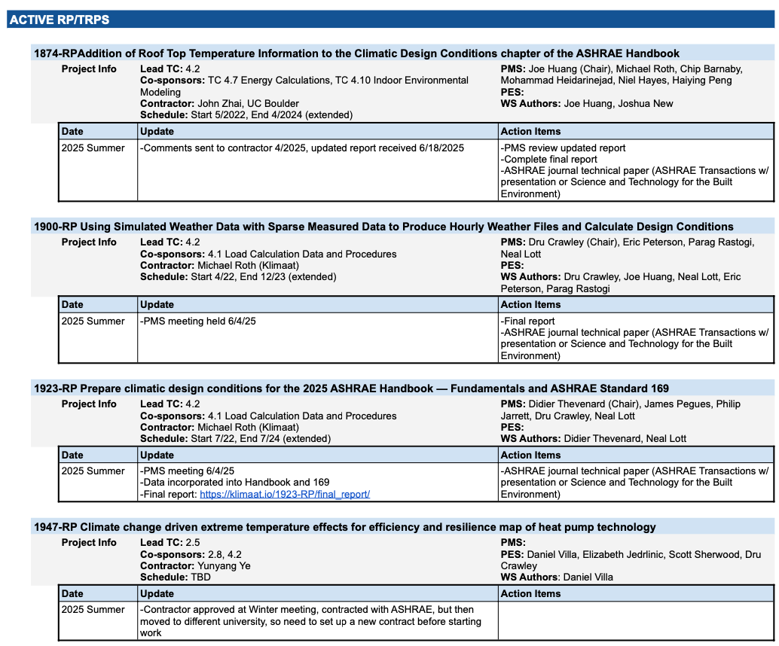
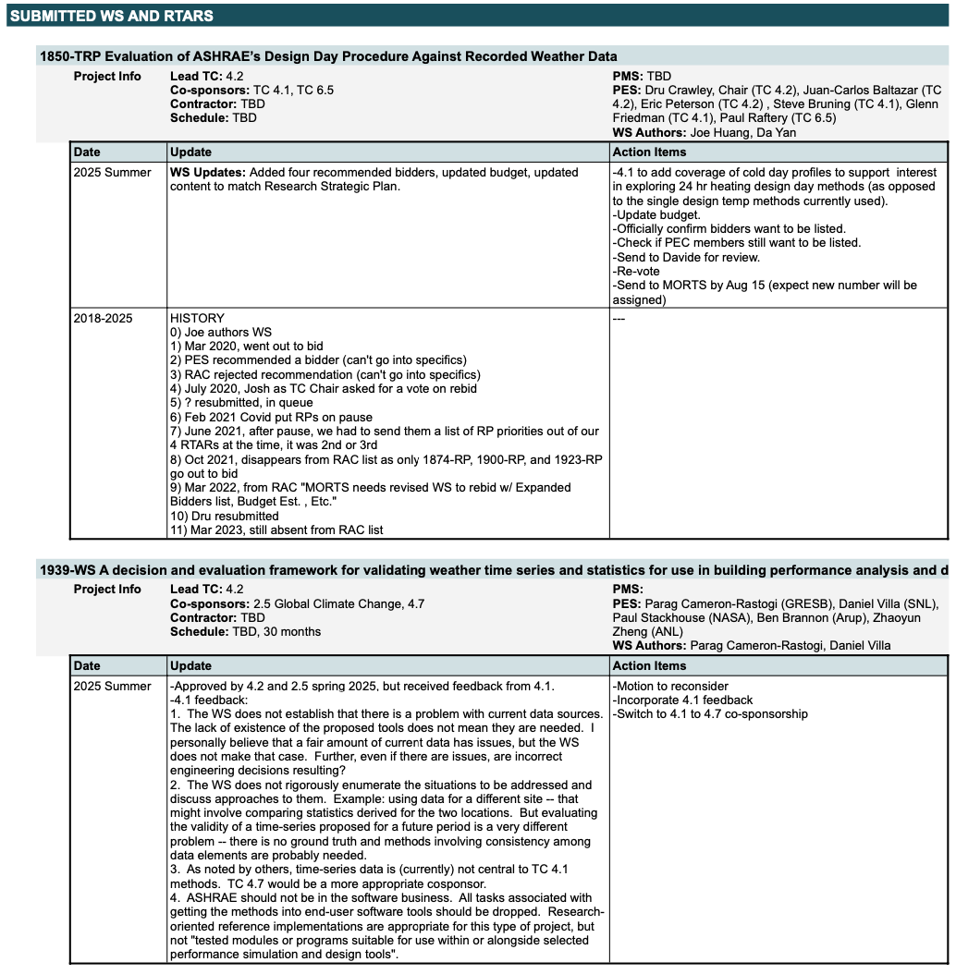
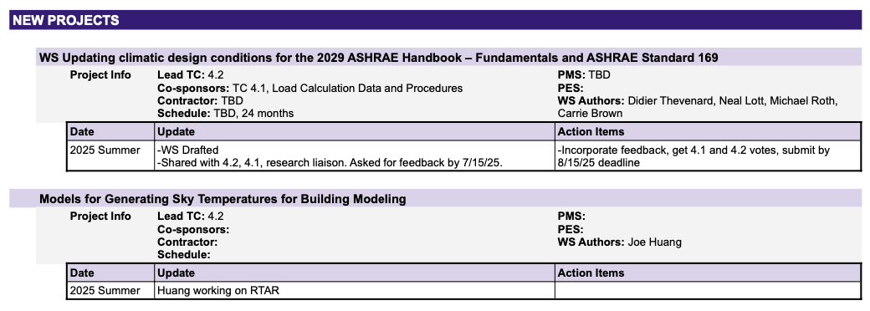
- TC 6.5/TC 4.2 Snowmelt RTAR: Zach Londo (TC 6.5 Radiant Heating and Cooling) interested in work on snow melt design tables published in the 1990s based on 1980s data. He will work with their research chair, Carlos, to flesh out the RTAR. It would be great to get feedback from 4.2 members as well, especially from someone involved with the original RP-926.
  - Bob Morris: Worked (in Environment Canada) to support development of those design tables to melt snow at building entrance steps. At the time there was a desire for hourly snowfall rates, but such were unavailable, so meteorologists had to interpret and estimate from periodic “present weather” (such as “light” or “moderate”) and 24-hour accumulation totals. Thinks reanalysis of more recent observation data could access some hourly rates in Canada.
  - Neal Lott: 3-hourly “present weather” are the highest resolution, but not consistently, and only within US and Canada. “Mixed bag” sometimes/places with 6- or 12-hourly liquid equivalent rates. Also some snow depth observations up to 6 hourly at best. Supported expert meteorologist estimations of pseudo rates such as Bob’s team previously delivered. Only NOAA NCEI has any hourly snow data, but it is a patchwork with respect to spatial and temporal consistency.
  - Although ASCE has published a guide to rooftop snow loads, this was based on daily accumulation rates, so some estimation model of hourly intensity would be needed for design of the pavement snow melt systems.
  - Paul Stackhouse added that reanalysis of precipitable moisture and snow depth with NASA Power is potentially limited to “research” unless it were compared with hourly surface observations if they were somehow available.
  - Standards New
- Incorporated new data from 1923. 169 voted to release addenda for public review. Last time no comments were received.
  - Handbook Thevenard
  - 2025 Handbook-Fundamentals Chapter 14 updates are complete.
  - See above for update on new WS for 2029 update.
  - Roth will take over as Handbook Chair and coordinate with new contractor (including server transition)
  - Website Roth
- Old Business Brown
- Proposed new Guideline: Integration of Future Weather Data into Built Environment Analysis
  - TPS approved by PPIS and TAC during Phoenix meeting. Cameron-Rastogi and Brown will work with RL on next steps.
  - Kruis provided input on QA/QC needs (e.g., 9999 entries). Plan to incorporate input from Roth’s 1900/1923 work and NASA POWER.
- New Business
- Climate zone classification for 0B Younes
  - Hassan Younes (GRFN.global, Dubai) spoke about the need for ASHRAE to act globally. Hassan outlined his problem with the rainfall definition of ASHRAE Standard 90.4’s hot climate zones 0A and 0B. Hassan prefers revision to consider wet bulb differences between hot-dry and hot-humid places in his region of professional practice (Arabian/Persian Gulf).
  - Joshua New responded as chair of Standard 169 that practitioners from Brazil and India have also be asking similar questions, but that repeated votes of the 169 Committee have opposed redefinition – only to move the locations of ASHRAE Climate Zones with respect to climate change. (Secretarial comment - perhaps 169 Committee’s position is that the definition of goal posts must not be changed while we come to grips with the changing annual heating and cooling degree days?)
  - Joshua points out that there is no reason local groups can subdivide their prescriptive energy codes with more granular recognition of climate details. Joshua made that suggestion in response to Hassan’s persistence that we tackle the issue to be better design for anticipated 2080 climate conditions. Joshua pointed out that a quarter of the page count of the standard is already overflowing with tables of location-specific information.
  - Chip pointed out that standard 169 is meant to be strictly based on data. Meanwhile Bob Morris entered into the chat- “It’s hard to imagine two locations with 600+ elevation difference in the same climate zone”.
  - Raj Gupta added – “I have worked on climate classification of India and faced the same comments for the boundary locations. I am a lot interested to be a part of the ASHRAE 169 meetings.”
  - Paul Stackhouse chat- “It's useful to trace the migration of the climate zones in time. We've created some graphics to show those. I think Michael included such climate zone change in his reports.”

- AHRI Standard 1600 test procedure for rating central air conditioners and heat pumps McFadden
  - Appendix M lives on the DOE docket for the CAC/HP test procedure rulemaking
  - See slides and spreadsheet.
  - Comments
    - Joshua: A number of urban locations have changed climate zone over time, and that quarter-degree spatial resolution of climate zone classifications can be made available throughout Canada.
    - Raj Gupta expresses support for recognizing humidity in defining climate zones.
    - Joshua: Mentioned a paper by Kyle Gluesenkamp (ORNL) investigating heat pumps in climate zones 5-8. In Los Angeles county, there are a number of climate zones, which required a population-weighted analysis that was then applied over all the US to select the best representative climate zone assignment for each county.
- Show-and-Tell 2:49 PM
  - PRUVE website. If slides are available, these will be posted to Basecamp for all. Stackhouse
  - See a couple of example screenshots below.

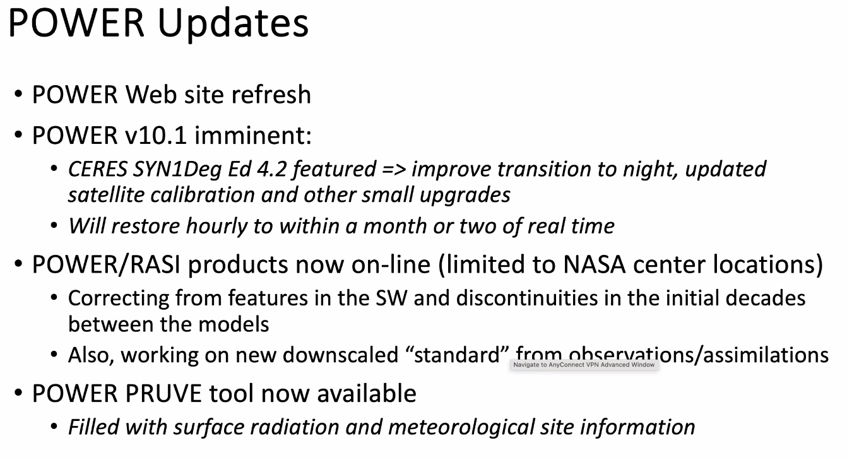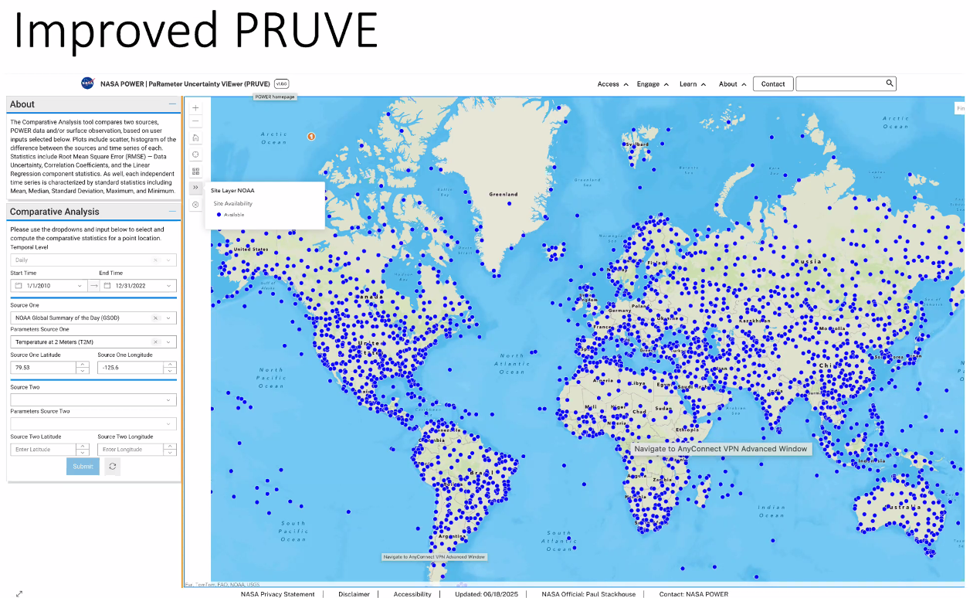

- Adjourn 3:55 PM
Next Meeting: Jan 31 – Feb 4, 2026 | Las Vegas, NV

