Minutes
TC 7.6 Monitoring and Energy Performance Subcommittee
St.Lousi, MO — Monday, June 27, 2016
Dennis R. Landsberg, Chair

The meeting was attended by 5 members of the TC, 9 corresponding members and 11 guests.

- Introductions and Introductory Comments
- Update On Standards and Guidelines Related to Energy Performance
  - ASHRAE Standard 100 –in continuous maintenance.
    - Major modifications proposed to deal with CHP and district heating and cooling
  - Standard 211P Commercial Building Energy Audits - Vote for public review soon
  - Standard 90.4 Energy Standard for Data Centers and Telecommunications Buildings.
  - Standard 214P – Methods for Measuring and Expressing Building Energy Performance in a Rating Program
  - ASHRAE Design Guide for Tall, Supertall and Megatall Building Systems
- Energy Performance Databases
  - BEDES has been implemented http://energy.gov/eere/buildings/building-energy-data-exchange-specification-bedes
  - CBECS 2012 summary report on initial results is out, Release date: March 18, 2016:
http://www.eia.gov/consumption/commercial/reports/2012/energyusage/
      - It compares 2012 to previous years in several ways – Eg. Electricity is now 61% of site (delivered) end-use energy
      - Energy use has decreased by 23.3% in the median and 25.8% in the mean, although energy use for some building sectors has increased – recreation, social/meeting, assembly, and self storage.
      - From Mike MacDonald:
In the published tables, EIA lumps all “solar” buildings together at about 40,000 in the country, but there is a variable on presence of PV. PV Buildings in CBECS 2012
Buildings with PV electricity generation total 101 out of 6,720 in total data set (1.5%) Numbers of Buildings with PV
Principal building activity # bldgs in sample # bldgs, weighted
Office 28 9,799
Laboratory 1 203
Nonrefrigerated warehouse 13 4,501
Food sales 1 227
Public order and safety 4 2,207
Outpatient health care 2 30
Religious worship 2 1,572
Public assembly 8 3,463
Education 21 6,391
Inpatient health care 10 70
Lodging 2 1,389
Strip shopping mall 1 738
Retail other than mall 6 3,408
Service 1 356
Other 1 191
All 101 34,545

Total PV electric generation as a What-If exercise, if average PV fraction of 10% is applied to all 101 observations, electricity generated is maybe 2,000 GWh/yr from PV in the commercial sector in 2012 (out of 1.2 Million GWh total):

Principal building activity # bldgs weighted GWh/yr from PV, weighted
Office 9,799 777
Laboratory 203 101
Nonrefrigerated warehouse 4,501 94
Food sales 227 30
Public order and safety 2,207 39
Outpatient health care 30 21
Religious worship 1,572 18
Public assembly 3,463 172
Education 6,391 436
Inpatient health care 70 127
Lodging 1,389 10
Strip shopping mall 738 26
Retail other than mall 3,408 299
Service 356 24
Other 191 6
All 34,545 2,178

  - EPMI report on US residential sector 2012 energy performance, extracted from the longer book, grades states residential energy performance: http://epminst.us/states/stres12grade.htm
  - ANSI EE roadmap progress report released in April, https://www.ansi.org/standards_activities/standards_boards_panels/eescc/EESCC-Progress-Report-2016.pdf
  - NEEP looking at standardizing an online platform for technical reference manuals.
  - IPMVP 2016 Core Concepts released
  - ISO 50001 – usage mainly by very large corporations
  - ASTM E2797, Standard Practice for Building Energy Performance Assessment for a Building Involved in a Real Estate Transaction
- Energy Audits, Benchmarking and Disclosure
  - Public building benchmarking in Minnesota
    - 12,000+ public buildings in the program
    - 98% of public buildings are benchmarked and have energy model basis comparisons to provide savings potential, as well as EnergyStar ratings, which are available for approximately 20% of public buildings.
    - Focus of the program is on identifying potential savings to target retrofit and retrocomissioning projects
    - $41 million in potential savings identified, with 80% of that in just 20% of the buildings
    - Requirement is all public buildings must provide one year of utility bill information. Approximately ¼ of all buildings are providing ongoing information. mn.b3benchmarking.com
  - Public building benchmarking in Iowa
    - Just rolling out an optional program
    - 2,000+ buildings already enrolled. ia.b3benchmarking.com
  - bEQ
    - Train ASHRAE student chapters

  - Commercial New Construction utility incentive programs in the Midwest (Minnesota, Iowa, Wisconsin, and Illinois)
    - Generally we are seeing Midwestern programs moving to more modeling based programs for small new construction (down to 5,000 sf) in response to more stringent codes instead of line-item rebates
    - Alliant Energy in Iowa is piloting a modeling based existing building program that is claiming savings compared to the existing conditions
  - Merging building-level energy benchmarking with city-level and state-level: when should it start?
    - Wide variety of benchmarking laws and regs for buildings in cities
    - City-level energy-use modeling has been started, e.g., Boston Community Energy Study (http://www.bostonredevelopmentauthority.org/planning/planning-initiatives/boston-community-energy-study#report )
    - State-level data available from EIA on residential and commercial sector energy use by fuel type
    - EPMI benchmarking of state buildings sectors and residential sectors has been completed and is updated every 5 years (http://epminst.us/states/states.htm )
    - When should more attention be paid to energy performance benchmarking of cities and states? Should ASHRAE start including such info in the Handbook? Are requirements for results reporting needed so that building-level, city-level, and state-level data can be compared? Merged?
    - What methods can be developed to make data mergers at these different geographic levels more readily attainable?
    - Using simulation tools is probably the wrong approach - a way to make the CBECS methods (or population statistics methods) applied more broadly might be more appropriate

- US Initiatives
  - DOE Building Performance database – 700,000 buildings
  - EIA web site with worldwide energy production and use.
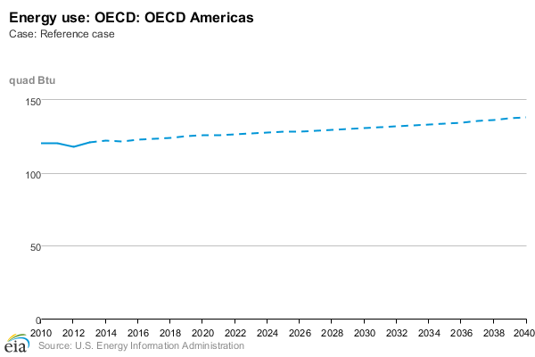
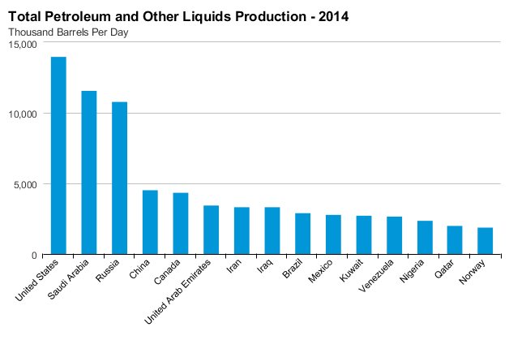
http://www.eia.gov/beta/international/data/browser
EIA has fixed its world data browser, so 2013 world energy use still went up. Apparently China caused a glitch when their bureau of mines increased estimates of coal use over several years, and EIA had to figure out how to revise all their numbers for Asia, which caused energy production and use for Asia to be way low for a while.
  - New EPMI article on Energy and GDP challenges the validity of using economic energy intensity as a country-level energy performance indicator: http://epminst.us/states/Energy_and_GDP.htm
  - New EPMI look at EU energy suggests they could claim they have already met their 2020 energy goals in 2014 by subtracting renewables energy from total energy: http://epminst.us/panorama/EU-edata-16.htm
  - Navigant Research indicates market for EPSC may reach $11.5 Billion/yr in the US and $14.7 Billion worldwide by the year 2024. Not a large market - Current market in US may be $8-9B. https://www.navigantresearch.com/research/energy-service-company-market-overview

- International Initiatives
  - EU Joint Research Centre report on energy audits and energy management related to Article 8 of the Energy Efficiency Directive has been released: https://ec.europa.eu/jrc/en/publication/eur-scientific-and-technical-research-reports/survey-energy-audits-and-energy-management-systems-member-states

  - European Union Energy Data
The energy target for 2020 of 1483 Mtoe has already essentially been surpassed if renewables energy is subtracted from "Gross" energy in the year 2014.The effects of economic slowdowns on energy use can be interesting. The Eurostat data can be located at: http://ec.europa.eu/eurostat/web/energy/data/energy-balances

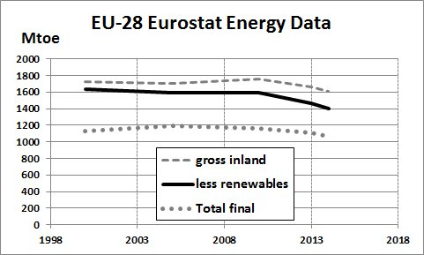

  - Global Buildings Performance Network – The Global Buildings Performance Network (GBPN) is a globally organised and regionally focused organisation whose mission is to provide policy expertise and technical assistance to advance building energy performance and realise sustainable built environments for all.
Report on “Robust Building Data: A Driver for Policy Development”, at
http://www.gbpn.org/reports/robust-building-data-driver-policy-development
It is estimated that by 2050, if we follow current policy trends the energy use from the building sector will increase by around a half of 2005 levels. However, if current best practices were to become standard practice, it is possible to reduce global building final energy use by one third of 2005 levels.
BPIE’s open data hub, is the first knowledge repository for statistics and policy information on Europe’s building stock. This hub introduces powerful tools such as a data search engine that allows for cross-country comparisons, generation of customised country profiles and cost-free downloads. Users can access a comprehensive glossary and join the discussion on the Buildings Data Community. This user-friendly site is a central resource for data that feeds into EU policy making, research and various stakeholders' decisions. http://www.buildingsdata.eu/
- EUI Task Group

  - Has become Working Group 5 under SSPC 100 – meeting Sunday 12PM-2:00PM
  - Two charges – stacked approaches for multi-use buildings and alternate expressions of EUI
  - Issue - Should we change the TPS of Standard 100 from energy efficiency to energy performance? Is Energy/sf the best metric?
  - What about standard reporting? Carbon reduction goals exclusive of energy goals obscure what is happening, so some type of requirement on energy reporting is needed to assure that energy reduction goals or requirements are always specified in energy units, and carbon goals cannot imply energy reductions are needed unless specific energy goals are included with any carbon goals
ASHRAE Sessions of Interest
Sunday, June 26, 8:00 AM-9:00 AM SEMINAR (ADVANCED)
Results of RP-1651 Development of Maximum Technically Achievable Energy Targets for UltraLow
Energy Use Commercial Buildings
Sunday, June 26, 8:00 AM-9:00 AM WORKSHOP (INTERMEDIATE)
Developing the Business Case for Submetering: Leveraging GSA’s Portfolio to Demonstrate
Submeter Functionalities, Range of Benefits and Cost Savings
Sunday, June 26, 9:45 AM-10:45 AM WORKSHOP (INTERMEDIATE)
DDC for Smart Buildings and Smart Grid
Sunday, June 26, 11:00 AM-12:30 PM CONFERENCE PAPER SESSION (INTERMEDIATE)
Examples of Smart Controls
Sunday, June 26, 11:00 AM-12:30 PM SEMINAR (INTERMEDIATE)
Comfort Challenges in Commercial Kitchens
Sunday, June 26, 11:00 AM-12:30 PM SEMINAR (INTERMEDIATE)
Performance Monitoring and Systems Testing Per ASHRAE Standards 184, 30, and the 41 Series
Sunday, June 26, 11:00 AM-12:30 PM SEMINAR (INTERMEDIATE)
Smart Grid in the Heartland: See What Happens Next
Sunday, June 26, 1:30 PM-3:00 PM CONFERENCE PAPER SESSION (ADVANCED)
System Design, Diagnostics and Operation
Sunday, June 26, 1:30 PM-3:00 PM SEMINAR (INTERMEDIATE)
Energy Guideline for Historical Buildings
Sunday, June 26, 3:15 PM-4:45 PM SEMINAR (INTERMEDIATE)
Energy Management for Multi-Building Portfolios from the Owner-Operator and the Consultant Perspectives

Monday, June 27, 8:00 AM-9:30 AM SEMINAR (INTERMEDIATE)
Using ASHRAE Performance Measurement Protocols for Measuring and Benchmarking

Monday, June 27, 9:45 AM-10:45 AM TECHNICAL PAPER SESSION (INTERMEDIATE)
Energy and Cost Savings from Improved VFD Control
Monday, June 27, 9:45 AM-10:45 AM SEMINAR (INTERMEDIATE)
Energy Savings via ASHRAE Level III Auditing, Retrofit and Recommissioning: A Case Study at
Hameetman Science Center, Occidental College I
Monday, June 27, 11:00 AM-12:00 PM CONFERENCE PAPER SESSION (INTERMEDIATE)
Airflow Measurements

Monday, June 27, 11:00 AM-12:00 PM WORKSHOP (BASIC)
Answering the Call: How ASHRAE Standards Can Meet State and Local Demand for High Performance Green Building

Tuesday, June 28, 8:00 AM-9:30 AM SEMINAR (INTERMEDIATE)
HVAC Controls for Smart Grid Applications

Wednesday, June 29, 8:00 AM-9:30 AM CONFERENCE PAPER SESSION (INTERMEDIATE)
Field Data and Ensuing Recommendations
Wednesday, June 29, 8:00 AM-9:30 AM SEMINAR (INTERMEDIATE)
Standard 100-2015 Overview and the Potential of Its High-Performance Existing Building Metrics
Wednesday, June 29, 8:00 AM-9:30 AM SEMINAR (INTERMEDIATE)
Smart Equipment: the Intelligent Buildings Revolution Is Happening in the Edge
Wednesday, June 29, 9:45 AM-10:45 AM
SEMINAR (INTERMEDIATE)
Energy Savings via ASHRAE Level III Auditing, Retrofit and Recommissioning: A Case Study at
Hameetman Science Center, Occidental College II

