TC 7.5 Handbook Subcommittee Meeting Agenda
June 2 (Tuesday) 2:15 PM to 3:00 CDT
Virtual Meeting

Web meeting info:
Join Zoom Meeting
One tap mobile: | US: +13462487799,,92582752938# or +16694449171,,92582752938#
Meeting URL: | https://tamu.zoom.us/j/92582752938?pwd=NPHIlbWXwSKJKoUBmb96Gqsa75Wash.1&from=addon
Meeting ID: | 925 8275 2938
Passcode: | 729508

- Called to order / Introductions
- Reported from TC 7.5 handbook Chair (Li Song)
  - Chapter 43 is requested by the Handbook committee to move to the “Refrigeration” handbook which will be renamed. Discussion of several different point views was carried out. Zheng will send an email to Handbook committee to provide feedback. Zheng will share the draft with Mike, Joe, Li and Bernard first to collect input.
  - Schedule for the next version is reviewed as follows
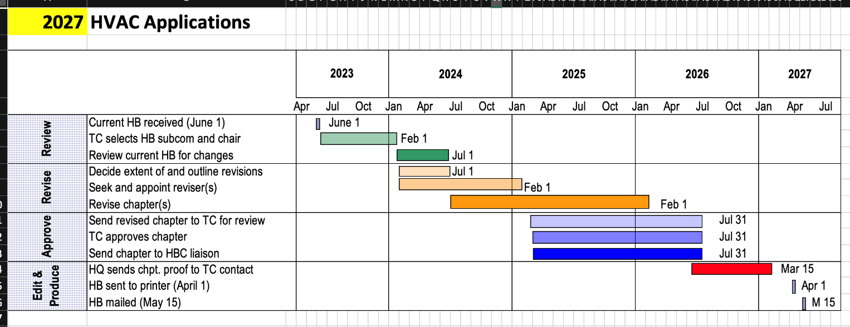
- Ch 43 – revisions were made and the revised draft was approved and submitted to Society staff 3/31/2026. Revision is completed for this cycle.
    - Ch 63 – An initial draft of the overhaul revision has been completed and is currently under review by volunteers.
      - Approvals due to Society staff no later than 7/31/2026.
  - Handbook Online
    - We finally have the access to the editor portal.
    - Updates to handbooks online can be brought forward at any time. Follows a similar process to normal cycle. TC must approve changes via vote.
    - ASHRAE publication timeline may vary depending on workload from normal cycle.

- Review Of Chapter 43 (~15 min)
    - Chapter overview
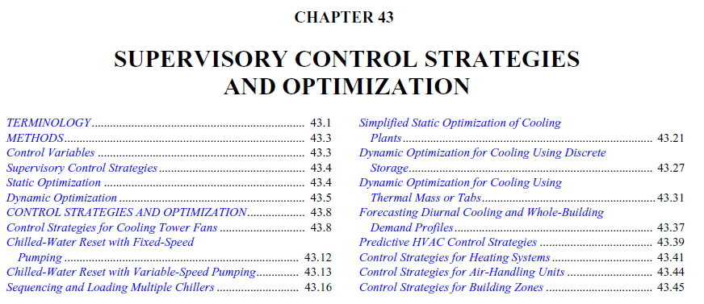
    - Updates since the Winter 2025 conference
- Review and Edits
  - Revisions are based on the draft provided by Zheng.
- Section Assignments
- Section 1 – Terminology: Led by Li Song
- Section 2 – Methods: Led by Peter Armstrong, with support from Guowen Li
- Section 3 – Control Strategies and Optimization: Led by Zufen Wang, with support from Mingyue Guo, Yongsik Choi. Below are updates from Zufen

- Review Of Chapter 63 (~15 min)
    - Chapter overview
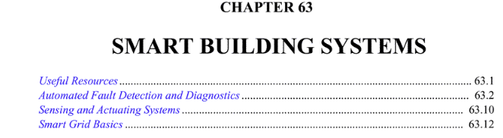
    - Updates since the Winter 2025 conference
- Review and Edits
  - Revisions are based on the draft provided by Greg.
- Meeting History
  - Five meetings have been conducted.
- The chapter revisions is completed with an overhaul on its structure and scope.
- Proposed the new structure by Joe Zhou and supported by Andrew Kevwe
- Smart Building System Overview (completed by Andrew with Joe’s note)
- Smart Building Control Platform (Andrew is working on it by converting Joe’s note)
- Smart algorithms (Andrew is working on it by converting Joe’s note)
- Energy Management Information System (Andrew is working on it by converting Joe’s note)
- Sensors and Actuators
  - Carol leads with the support of Matin
- Smart Grid Basics
  - Updated received from David Holmberg on April 15, 2025 with the coordination of Natascha
- Carol has invited reviewers for the review of Sensors and Actuators Section and also conducted a training session for the new reviewers. Carol will follow up with her contact in Siemens for the review of Sensor and Actuator session
- Mike Brambley has requested access to Chapter 63
- Bernard was informed that the Section of Sensors and Actuators is ready for his review.
- Next handbook subcommittee meeting (2 min)
Bi-monthly meetings are held virtually. Please contact Li Song if you would like to attend.
- Adjourn

