NOTES
ASHRAE TC 4.2 | Climatic Information
2025 ASHRAE Winter Meeting | Orlando
Tues, February 11 2025
1:00 – 3:00pm Eastern
https://tc0402.ashraetcs.org/meetings.php

Clear Lake Room, Hilton Orlando, 6001 Destination Pkwy, Orlando, FL 32819, USA
Remote Participation
Link: https://us06web.zoom.us/j/81353194671?pwd=alyszXilev0zUJPUFDEbabDUrca8Bh.1
Meeting ID: 813 5319 4671
Passcode: 592904

SUMMARY
::ACTION ITEMS::
  - Program
    - Phoenix proposals due 2/28/25
    - Duncan Philips seeks volunteers from TC 4.2 for TC 9.12 Tall Buildings seminar
      - At a TC4.7 SC, discussion of a seminar proposal to look at alternative TMYs for buildings with 100% OA to be coordinated with TC 4.2. Joe agreed to help and suggested that it be combined with Duncan Philip's proposed seminar. Joe will coordinate with Pat Carpenter and Duncan.
    - Peterson notes we missed an action item: Suggest forum/panel with TC9.9 to address methodology to establish more extreme joint dry-bulb/wet-bulb conditions for data centers, etc.
  - Research
    - Invite Dennis Landsberg to PMS meetings moving forward.
    - 1850-TRP “Evaluation of ASHRAE’s Design Day Procedure Against Recorded Weather Data”
      - Needs to be updated for committee review/approval before resubmitting.
    - 1939-WS “A decision and evaluation framework for validating weather time series and statistics for use in building performance analysis and design”
      - Parag will update this for committee review/approval before resubmitting.
    - “Abbreviated Weather Year Files for Faster Simulation Time” (Huang)
      - See: rtar-abbreviated-weather-v05.docx
      - Committee to review draft and vote soon.

NOTES
- Call to order Brown
- Review Scope All
“TC 4.2 identifies, researches, analyzes, and disseminates climatic data for design of sustainable built environments.”
- ASHRAE Value Statement Brown
In ASHRAE meetings, we will act with honesty, fairness, courtesy, competence, inclusiveness and respect for others, which exemplify our core values of excellence, commitment, integrity, collaboration, volunteerism and diversity, and shall avoid all real or perceived conflicts of interest. Our culture is one of inclusiveness, acknowledging the inherent value and dignity of each individual. We celebrate diverse and inclusive communities, understanding that doing so fuels better, more creative and more thoughtful ideas, solutions and strategies for the Society and the communities our Society serves. We respect and welcome all.

Code of Ethics: https://www.ashrae.org/about/governance/code-of-ethics
Core Values: https://www.ashrae.org/about/ashrae-s-core-values
Diversity Statement: https://www.ashrae.org/about/diversity-equity-and-inclusion-dei
- Introductions All
- Around the room
  - Philip Jarrett (VM, ECCC)
  - Amanda Krelling (guest, LBNL)
  - Carrie Brown (TC Chair, Resource Refocus)
  - Charles Barnaby (VM, Chip Barnaby)
  - Don Colliver (guest, UKY)
  - Dru Crawley (CM, Bentley)
  - Elizabeth Tomlinson (CM, Stantec)
  - Eric Peterson (TC Secretary, University of Leeds)
  - James Pegues (CM, Carrier)
  - Jeff Newel (guest, Hillpheonix)
  - Juan-Carlos Baltazar (VM, Texas A&M University)
  - Juliana Velez (guest, golden gate chapter)
  - Kevin McFadden (guest, 2050 Partners)
  - Krishnan Gowri (guest, Energy Solutions)
  - Kyle Gluesenkamp (section head, ORNL)
  - Mark Malkin (guest, University of Wisconsin-Madison)
  - Mehdi Jalayerian (CM, Stantec)
  - Mohamed Osman (guest, SSG)
  - Neal Kruis (guest, Big Ladder)
  - Parag Cameron-Rastogi (TC Vice Chair, Gresb)
  - Randall Higa (guest, Southern California Edison)
  - Sagar Rao (guest, NML)
  - Sam Loggia (guest, CSA Group)
  - Veronique Delisle (PCM, Nat Res Canada)
  - Wesley Davis (CM, ACCA)
  - Xin Qiu (VM, SLR Consulting)
- Online
  - Joe Huang (CM, Whitebox Technology)
  - Carlo Bianchi (Program Chair, NREL)
  - Evyatar Erell (VNQ, Ben Gurion University)
  - Matt Menne (guest, NOAA NCIA)
  - Michael Roth (CM, Klimaat, TC webmaster, TC Research Chair)
  - Nada Tarkhan (guest, MIT)
  - Neal Lott (CM,NOAA-ret)
  - Paul Stackhouse (CM, NASA)
  - Raj Gupta (CM, Research Scholar)
  - Riad Assaf (VNQ, Con Edison, TC1.1 Handbook)
  - Robert Morris (CM, Environment and Climate Change Canada)
  - Jacky Kinson (guest)
  - Russel Vose (CM, NOAA NCIA)
- Determination of a quorum Cameron-Rastogi
  - All voting members present
Name | Ending |  | Name | Ending
Riad Assaf (NQ) (online) | 2026-06-30 |  | Evyatar Erell (NQ) (online) | 2025-06-30
Juan-Carlos Baltazar | 2025-06-30 |  | Philip Jarrett | 2029-06-30
Carlo Bianchi (online) | 2026-06-30 |  | Eric Peterson | 2027-06-30
Chip Barnaby | 2029-06-30 |  | Parag Cameron-Rastogi | 2029-06-30
Carrie Brown | 2027-06-30 |  | Xin Qui | 2027-06-30
Need (4) or ½+1 for a Quorum

- Agenda additions All
  - No additions
- Approval of minutes from Indianapolis Brown
  - See: TC0402 Indy Annual Meeting Draft Minutes 20240625v0.docx
  - Minutes approved unanimously 9:0:1 (Chair Not Voting)
- Chair’s Report Brown
  - Announcements and Highlights from TC Chairs Breakfast Meeting
    - Brown and Cameron-Rastogi were able to attend the first half.
    - ASHRAE is developing a Research Mentors program
    - 37 Projects with funding are currently in progress, funding available for new project proposals.
- Liaison reports
  - Center of Excellence for Building Decarbonization Brown
    - 6 guides published, 2 will be released soon
    - 12 Training developed, 2 more soon
    - 10 active projects
    - See https://ashrae.org/decarb for more info
  - BIM Cameron-Rastogi
    - Inactive. ASHRAE’s MTG BIM report isn’t due for another year, refer developing standards SPC 205 & 224.
  - Resilience Brown
    - Didn’t meet this time, but working on updates to the Position Document.
  - Research Landsberg
  - Section Head Glusenkamp
  - Climate Change (TC 2.5) Jarrett
    - Elizabeth Tomlinson (TC 2.5 Chair) / Phil Jarrett noted that promoting adaptation and mitigation in response to climate change is still an ASHRAE priority as we are an international society.
    - Climate Change Position Document committee actively working on updates.
- Membership/Roster Brown
- Upcoming changes noted in red.
  - Secretary still TBD.
  - Michael would be happy to hand off webmaster.
- Folks interested in becoming voting members can reach out to Parag and Carrie.
  - No need to attend meetings physically.
  - ASHRAE supports voting non-quorum (VNC) international members.
From July 1st, 2026
Name | Role | Voting |  | Name | Role | Voting
Carrie Brown | Research Chair | Yes |  | Chip Barnaby | Member | Yes
Parag Cameron-Rastogi | Chair | Yes |  | Juan-Carlos Baltazar | Member | No
Eric Peterson | Vice Chair | Yes |  | Philip Jarrett | Member | Yes
Drury Crawley | Standards Chair | Yes |  | Xin Qui | Member | Yes
Carlo Bianchi | Program Chair | Yes |  | Riad Assaf | Member NQ | Yes
Didier Thevenard | Handbook Chair | No |  | Evyatar Erell | Member NQ | No
Michael Roth | Webmaster | No |  | TBD | Secretary
- Subcommittee Reports
  - Program Bianchi
  - Hybrid meeting held Sunday Feb 9th. See appendix for notes.
    - Peterson notes we missed an action item to suggest a Program item to TC9.9 Data Centers before developing proposals for relevant Research:
      - ::ACTION ITEM:: Suggest forum/panel with TC9.9 to address methodology to establish more extreme joint dry-bulb/wet-bulb conditions for data centers, etc.
  - Potential presentations
    - ::ACTION ITEM:: Phoenix proposals due 2/28/25
    - ::ACTION ITEM:: Duncan Philips seeks volunteers from TC 4.2 for TC 9.12 Tall Buildings seminar
      - Joe Huang: At a TC4.7 SC, discussion of a seminar proposal to look at alternative TMYs for buildings with 100% OA to be coordinated with TC 4.2. Joe agreed to help and suggested that it be combined with Duncan Philip's proposed seminar. Joe will coordinate with Pat Carpenter and Duncan.
    - Should also start thinking about next Winter Las Vegas conference
  - Recent presentations
    - TC4.2 sponsored Seminar 33. Monday Feb 10th Seminar “What future weather do you need for future-proofing?” presented by Daniel Villa and Parag Cameron-Rastogi.
      - Well attended.
      - There is scope for additional seminars and forums to expand upon the developing application of future weather datasets.
    - Weather presentation at 2025 ASHRAE Decarbonization Conference: Elizabeth Tomlinson noted video didn’t work. Carrie can share slides.
  - Research Roth
  - Hybrid meeting held Sunday Feb 9th. See appendix for notes.
  - Active Research Projects/TRPs
    - Three active projects nearly complete. Held virtual meetings earlier.
    - 1847-RP "Addition of roof top temperature information to the climatic design conditions chapter of the ASHRAE Handbook"
    - 1900-RP "Using Simulated Weather Data with Sparse Measured Data to Produce Hourly Weather Files and Calculate Design Conditions"
    - 1923-RP "Prepare climatic design conditions for the 2025 ASHRAE Handbook—Fundamentals and ASHRAE Standard 169"
      - New live on Weather Data Viewer https://weather.ashrae.org/
    - 1947-TRP “Climate change energy and resilience map for heat pumps”
      - 6 out of 7 bidders were responsive.
      - TC 2.5 voted to approved contractor based on cost per score.
  - Work Statements Submitted or Waiting to Bid
    - 1850-TRP “Evaluation of ASHRAE’s Design Day Procedure Against Recorded Weather Data”
      - ::ACTION ITEM:: Needs to be updated for committee review/approval before resubmitting.
    - 1939-WS “A decision and evaluation framework for validating weather time series and statistics for use in building performance analysis and design”
      - ::ACTION ITEM:: Parag will update this for committee review/approval before resubmitting.
      - Will coordinate with 169 when ready
  - New Research Topics
    - Develop Abbreviated Weather Year Files for Faster Simulation Time Huang
      - See: rtar-abbreviated-weather-v05.docx
      - ::ACTION ITEM:: Committee to review draft and vote soon.
    - Models for Generating Sky Temperatures for Building Modeling Barnaby
  - Standards Crawley
    - Standard 169 update will incorporate data from Michael Roth’s final report from 1923-RP “Prepare climatic design conditions for the 2025 Handbook and Standard 169.”
    - 169 will coordinate with 1939 when ready
  - Handbook Thevenard
    - Virtual subcommittee meeting held 1/29/25.
    - Updated Handbook of Fundamentals Ch 14 previously approved.
  - Website Roth
- Old Business
- Review previous action items
  - Beth Tomlinson developing a spreadsheet of references on where ASHRAE climate data is used within and without ASHRAE. Choices are often left to the “Engineer of Record”. Investigating societies outside ASHRAE, such as AIA – which are using future weather data – and that they use postal zip codes rather than counties to select design criteria among ASHRAE’s established climate zones.
- ASHRAE Guideline for using Future Weather in Calculations Cameron-Rastogi/Brown
  - Draft materials: Guideline: Future Weather Integration in Calculations for the Built Environment
  - TC will vote on Application to Create a Guideline (including Title Purpose and Scope) soon.
  - Interested attendees: Crawley, Stackhouse, Barnaby, Tomlinson, Rao, Baltazar, Jarrett, Tarkhan
- US EPA Energy Star Portfolio Manager, Adoption of 15-Year-Average Weather Data Tomlinson
  - See: Basecamp post and ENERGY STAR website
  - HoF uses the most recent 20 years when available, but sometimes as few as 8.

  - Kevin McFadden (guest from 2050 Partners) has been working with TMY files to extract histogram for weighting HVAC equipment testing, resulting in informative appendices that US DOE references. This was called for because AHRI 1600 had referenced weather data from 1950s and 1960s. So, Kevin sought out one hourly files at each of 57 cities to better represent post-2000 operational weather, to assess heat pump water heater seasonal performance.
    - Riad Assaf: Climate Normals have used up to 50 years of observations for special uses. But there is no uniform number of years among methods and standards. There is no internationally recognized obligation to use any one method of defining climate normals.
- New Business
- NCEI update on GHCN-Hourly Menne/Lott
  - Slides: Menne 2025 The Global Historical Climatology Network hourly (GHCNh) dataset.pdf
  - See appendix for chat log.

- Representing Climate Extremes: An Event-Driven Approach to Urban Building Performance Assessments Nada Tarkhan
  - Slides:
  - See appendix for chat log.
- Show-and-Tell All
  - NASA POWER update Stackhouse
    - Slides: POWER_ASHRAE_Meeting_20250211_final.pdf
    - See appendix for chat log.
- Adjourn
Next Meeting: June 21-25, 2025 | Phoenix, AZ

APPENDIX: Presentations and chat log

13:55:49 Neal Lott introduces Matt Menne (NCEI) regarding newly available GHCNh datasets.
1:56 PM NCEI update on GHCN-Hourly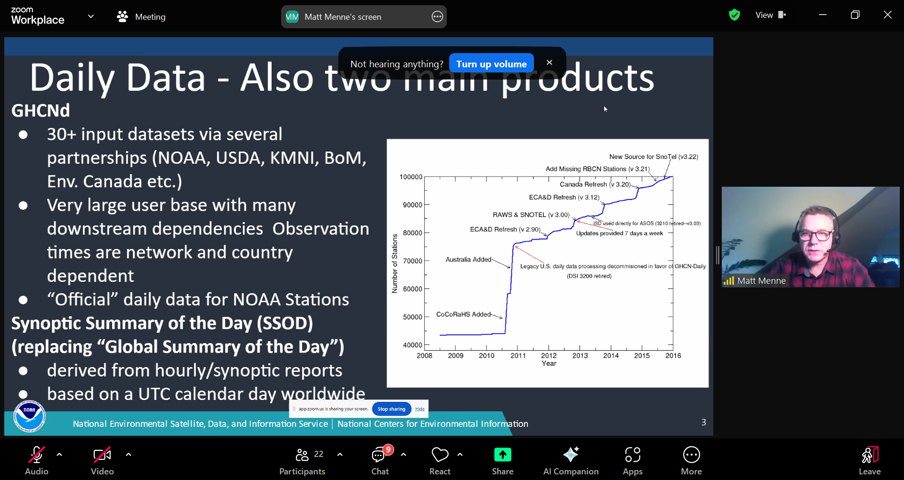

Matt Menne (NOAA) – example screen share
NCI GHCNh sub-daily, Global historical climatology network – hourly
Robert Dunn Met/Hadley, Maynooth University (Ireland), GHCNm v4
Neal Lott is father of hourly 14th Weather Squadron
Sharing agreements and data rescue
CHAT 13:58:29 From Neal Lott to Everyone:
Sorry folks...my internet went down but back up now.
2:01 PM Issues 7th release now sub-hourly precipitation
Bi-partisan infrastructure, Data rescue Neal Lott 3850
2:03 PM Location mapping is not trivial. Coastal problems worse.
2:04 PM APIs to download where available. 140 data sources. Overarching goal ERA6.
Early 20th and 19th century. WMO going to web-based sharing may help update.
Version 1.0.1 n=34,000. 38 variables, metadata, QC codes --- pipe delimited files (PSV)
2:09 PM Summary: HadleyISD, HPDv2 precipitation checks
2:10 PM Weekly updates internally. Pushing to make public, but overwhelmed by scope of data.
NOAA SWO process – (US stations)
2:11 PM Summary GHCNh is now reprogrammed H.O.M.R.
2:12 PM LCDv2 local climatologies
2:14 PM Inadvertent station merges. Munich
2:15 PM On deck additions. Australian Bureau of Meteorology. US DoD forts
2:17 PM Work annually to integrate new datasets. Move API updates.
2:18 PM NOAA long view NCEI
2:19 PM Neal Lott: change point detection (M. Roth’s suggestions please?) Unique Coordinate pairs.
Joe Huang: Questions Document API access. Matt Menne responds there will be email shortly.
2:21 PM Take off-line. When ISD goes offline?? Neal Lott will email. Key date June 30th
CHAT 14:22:32 From Neal Lott to Everyone: “I'll email the GHCN-H access URL to the tc 4.2 group.”
CHAT 14:23:10 From Joe Huang to Everyone: “Neal. How much longer will the ISD be online ?”
CHAT 14:26:31 From Matt Menne to Everyone: “It will remain online for the foreseeable future at this point, but updates will cease sometime this year. A potential date for updates to stop is June 30 based on IT migrations.”
CHAT 14:27:57 From Dru Crawley to Everyone:
https://www.ncei.noaa.gov/products/global-historical-climatology-network-hourly/
CHAT 14:49:05 From Michael Roth | Klimaat to Everyone: “FYI. I pushed Matt Menne's ppt to Basecamp.” Riad Assaf:👍
CHAT 14:53:11 From Raj Gupta to Everyone: “ How can I join basecamp...”
CHAT 14:53:44 From Carrie Brown (she/her) to Everyone:
you can email me at carrie@resourcerefocus.com and I’ll add you
CHAT 14:55:55 From Raj Gupta to Everyone: “ Ok thanks”

2:22 – 2:37 PM Representing Climate Extremes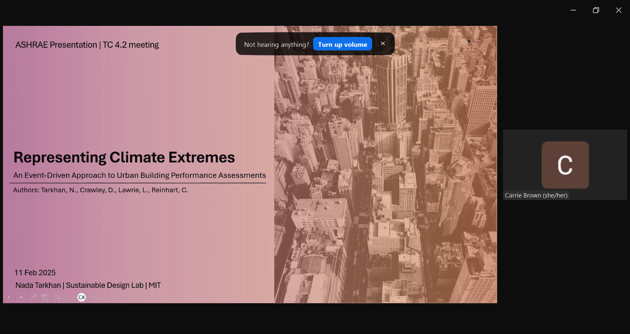

Nada Tarkan (MIT PhD student) – sharing screen
2:38 PM – 2:39 PM Avatar: extreme value theory
2:42 conclusion of Nada’s presentation
2:43 PM Kyle – Section 4 Roster update … succession pipeline support.
Carrie proposals basecamp and website

2:45 PM Show-and-Tell 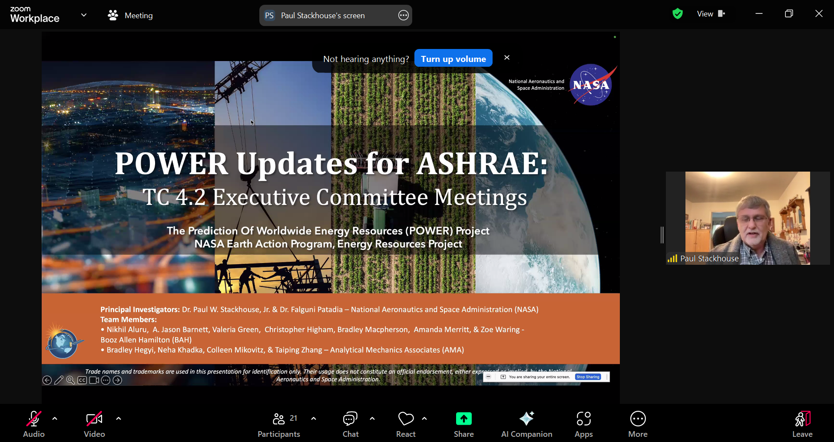Paul Stackhouse (NASA POWER) – screen share
2:47 PM New search dictionary
PRUVE tool beta testing. Hourly ends July 2024. MERRA 21C. EPW hourly.
2:56 PM Paul Stackhouse concludes

APPENDIX: TC4.2 Research subcommittee 3 PM Sunday February 9th 2025 in Orlando (Clarmont Room)
Chaired by Michael Roth (TC 4.2 Research Chair, Klimaat) remotely with on-line participation by
- Carlo Bianchi (TC 4.2 Program Chair, NREL)
- Evyatar Erell (TC 4.2 VNQ, Ben Gurion University)
- Riad Assaf (TC4.2 VNQ, Con Edison, TC1.1 Handbook)
- Robert Morris (CM, Environment and Climate Change Canada)
- Joe Huang (CM, Whitebox Technology, and Chair of 1847-PMS)
- Didier Thevenard (TC 4.2 Handbook Chair, and Chair of 1923-PMS)
- Neal Lott (CM, ret NOAA)
Attendance in the room noted by TC 4.2 Secretary:
- Gabriel Flechas (guest, mines.edu)
- Quin Guy (guest, mines.edu)
- Parag Cameron-Rastogi (TC4.2 VC)
- Phillip Jarrett (VM, EC)
- Beth Tomlinson (CM, Stantec)
- Eric Peterson (TC4.2 Secretary, Leeds.ac.uk)
- Dru Crawley (TC4.2 Standards, and Chair of 1900-PMS)
- Joshua De Young (guest, KCCMFG.com)
- Carrie Brown (TC4.2 Chair)
- Randall Higa (guest, SCE.com)
- Zhaoyun Zeng (guest)
- Dennis Landsberg (ASHRAE Research Rep)
- Dennis Shelden (guest, RPI.edu)
- Paulo Rabares (guest, mines.edu)
Dennis Landsberg highlighted that TC4.2 Climatic Information currently is managing three active research projects.

Dennis asked to be invited to all PMS meetings. Dennis pointed out that ASHRAE recently has raised “a lot of money” for new research projects, but that he has not seen any RTARs this past round. TC4.2 Research subcommittee chair Michael responded that there is a developing RTAR for the 2029 revision of the Handbook of Fundamentals, “plus a couple more in the works”. Michael commented that as contractor completing two of the ongoing research projects, that he has not been paid in a year. Dennis “don’t hand it in on the day due”. At this point Didier commented as PMS chair of Research Project 1923 that the summary of work updating the 2025 edition of the Handbook is finished except for the final report from the contractor. Dru pointed out that there is no need to file an application for another no-cost-extension. Carrie Brown, Neal Lott, Didier Thevenard, and Michael Roth will soon complete their review of a developing work statement to update the Handbook of Fundamentals again for the 2029 edition. Michael pointed out that ASHRAE’s on-line “Weather Data Viewer” already is presenting the 2025 edition of data. He has long shared a log-in link for members of the 1900-RP and 1923-RP PMS subcommittees to review the 2025 edition of data via the “Weather Data Viewer”, which is now available by subscription.

Joe Huang spoke on finalising 1974-PR development of rooftop temperatures for the Handbook of Fundamentals, contracted to University of Colorado. Last June’s draft “final” report was reviewed by the PMS and followed up by on-line meeting with the contractor, which raised “serious concerns” that the PMS submitted to the contractor later last summer. Follow up has been delayed by the lead faculty member’s sabbatical, and associated PhD student’s other pressing deadlines. So, at this juncture Joe will chase up and arrange another PMS meeting with the contractor.

1900-PMS chair Dru was please to yield to the contractor Michael Roth to update progress. Python code will ultimately be shared on GitHub repository, and the final report will be shared wit the PMS “very very shortly” by June 2025. Dru responded that Michael must make sure ASHRAE Standards and Research Project Data Repository (data.ashrae.org) know about the GitHub repository.

Carrie moved discussion to the recent bids of 1947-TRP (sponsored by TC4.2 with co-sponsorship by 2.8 and 4.2), from which the PMS chair will also be Dru. Carrie pointed out that Daniel Villa (the lead author or the work statement initiating 1947) is not attending any committee meetings. At this point Dru added that Daniel will not know which contractor is awarded the contract until after the contract is awarded by ASHRAE. Dru was able to state that 1947-TRP evaluation committee met to consider 7 bids, and made recommendations after finding six of the proposals were “very very good” which scored highly within 5 points. So, it was likely that further deliberation would award the successful contractor based on a calculation of value-for-money. Michael commented that seven bids is a remarkable response, to which Dru responded that it was “tough” to choose among them, and that any of the better six could have been successful to the full satisfaction of ASHRAE’s requirements.

1850-TRP, “Evaluation of ASHRAE’s Design Day Procedure Against Recorded Weather Data” had been out to bid prior to the pandemic, but could not be awarded. So, Michael suggested it should be tweaked prior to readvertising by ASHRAE.

The author of 1850, Joe Huang then conveyed a concern on behalf of Chip Barnaby (who could not attend this meeting) that the scope could now be increased to support dynamic simulation of passive heating performance. Michael ponders if such an increase in scope would be appropriate, while Dru responds it would make more sense to revise now.

Discussion moved into Michael’s ideas of developing future weather weeks from historical observations. He explained his approach would be to “grab weeks” in assembling TMYs rather than the current practice of forcing a marriage of 12 months from past years of observations. His idea is to design for extreme heat waves and cold snap events that rarely persist more than a week. Michael elaborates his idea is speculative, and should not be forced into a revision of 1850-TRP. Joe responds that 1850 should remain focused on using historical records – “future is too far a reach”. Michael concurs and rephrases that the revised scope would “only add heating”. Joe emphasises that 1850 is an application of recent/current climate data. Ardeshir Moftakhari (TC4.1 Load Calculations) added that heat pump dynamic extreme low temperature issues could be addressed by the extended design day scope. Carrie aims to review the draft that Dru and Michael are collaborating on, with March 2025 deadline for resubmitting 1850-TRP.

Dennis Shelden mentioned Open Data.

Paulo Tabarus (CS Mines) was interested in 20 year forecasting for district heating schemes.
Parag reflected that his 1939-WS proposal for research into decision framework was rejected a couple of years ago as “too broad” but that a new chair would need to take over from Joshua New.

At this point Michael noted that new projects no longer depend on an RTAR, such as Jason Glazier (TC4.7) and Joe Huang’s idea of developing “abbreviated weather files”. Juan Carlos and others from Texas A&M are interested in this proposal. Joe explains that there was paper published in 1993 that preliminarily explored how design-weeks can reasonably size HVAC systems with less computer time. Back in the 1980s residential loads were expensive to estimate while working at LBL, and also Trane 600 used weekly data for sizing. So the objective will be to compare design-week method with 8760 TMY runs. How will there be an assessment of trade-off time vs accuracy?

Carrie asks if the outcome would be a method or design-files? Joe responds the outcome should be a procedure to preprocess years of hourly data into appropriate abbreviated format(s), such as 24 hours x 7 days x 12 months. Michael points out that there should be consideration of typical week’s Finkelstein-Shaefer weightings for various conditions. Such as hot/moist and/or cold/dry. Joes’ paper 2016 subsets of 12 years of hourly timeseries explains how 380 weeks can be chosen from. In that previous study there were granularity problems of brute force arbitrarily grabbing the first 15 days of each month. So, it will be better to try again to carefully reselect more representative 7-day periods.

Michael asks how 1850 Design Day TRP could feedback into scope of “abbreviated weather files”. Paulo (mines.edu) asks how it could impact methods of sizing, applied with diversity of 30 buildings including electric vehicle charging and rooftop PV. Joe responds “abbreviated weather files” could speed up multiple simulation scoping studies by a factor of four or five, accepting perhaps 5% drift in accuracy. Paulo likes the idea. Michael asks if an RTAR is ready, as Joe spent several days so far. Carrie asks voting members to please review on basecamp before emailing votes.

Conveying Chip Barnaby’s interest in long wave radiation, Michael and Dru agree this is a worthy research topic. Paul Stackhouse (NASA) has relevant data to share. Evyatar would like to collaborate, and Joe willing to set up an on-line meeting. Joe will champion, by putting down on paper references to models such as Roberto Lamberts’ work in Brazil. But cloud cover is the key factor that demands resolution as yet.

Michael closed the research subcommittee meeting with a call for guest speakers next time, to make informal presentations of informal ideas.

APPENDIX: TC4.2 Program subcommittee 4:30 PM Sunday February 9th 2025 in Orlando (Clarmont Room)
Chaired by Carlo Bianchi (TC 4.2 Program Chair, LBL) remotely with on-line participation by:
- Evyatar Erell (TC 4.2 VNQ, Ben Gurion University)
- Riad Assaf (TC4.2 VNQ, Con Edison, TC1.1 Handbook)
- Robert Morris (CM, Environment and Climate Change Canada)
- Joe Huang (CM, Whitebox Technology, and Chair of 1847-PMS)
- Michael Roth (TC 4.2 Research Chair, Klimaat)
- Neal Lott (CM, ret NOAA)
Attendance in the room noted by TC 4.2 Secretary:
- Parag Cameron-Rastogi (TC4.2 VC)
- Phillip Jarrett (VM, EC)
- Eric Peterson (TC4.2 Secretary, Leeds.ac.uk)
- Carrie Brown (TC4.2 Chair)
- Randall Higa (guest, SCE.com)
- Zhaoyun Zeng (guest)
Submissions due February 28th for Program items to be considered for the Phoenix meeting (June). These could be debates or other forums, as well as seminars.

Duncan Phillips proposes a seminar sponsored by TC9.12 Tall Buildings seeking co-sponsorship from TCs 4.2 & 4.7 Energy Calculations. Duncan is hoping to pull together speakers focused on variations of climate with height of building, and possibly future climate. But there are not yet enough titles. There are alternative pathways for the speakers who are prepared, such as papers published in ASHRAE Transactions or extended conference papers that do not need to be bundled within any one single-themed seminar. Carlo needs to drop out due to DOE freeze, but Joe Huang is interested.

