Minutes
TC 7.6 Monitoring and Energy Performance Subcommittee
Las Vegas, NV — Monday, January 30, 2017
Dennis R. Landsberg, Chair

The meeting was attended by 12 members of the TC, 6 corresponding members, YEA 4 and 12 guests.

- Introductions and Introductory Comments
- Update On Standards and Guidelines Related to Energy Performance
  - ASHRAE Standard 100 –in continuous maintenance.
    - Major modifications proposed to deal with CHP and district heating and cooling
  - Standard 211P Commercial Building Energy Audits - Responding to public comments
  - ASHRAE standards addressing water efficiency:
    - Standard 189.1: Standard for Design of High-Performance Green Buildings
    - Standard 188: Legionellosis: Risk Management for Building Water Systems
    - Standard 191: Standard for the Efficient Use of Water in Building, Site and Mechanical Systems (TC 2.8 Cognizant Committee)
    - Guideline 14 – Measurement of Energy, Demand and Water Savings
  - Should Standard 105 be updated? Yes – be under continuous review? maybe
  - Should Guideline 14 be updated? no
  - ISO50001 – Superior Energy Performance

- Energy Performance Databases
  - BEDES has been implemented http://energy.gov/eere/buildings/building-energy-data-exchange-specification-bedes
  - Building Performance database

- Energy Audits, Benchmarking and Disclosure
  - Grading the 2014 Commercial Sector Energy Efficiency Performance by State
A link for the report is: http://epminst.us/states/Grading the 2014 Commercial Sector Energy Performance by State.pdf
  - bEQ – relaunch late spring 2017

  - Benchmarking Update
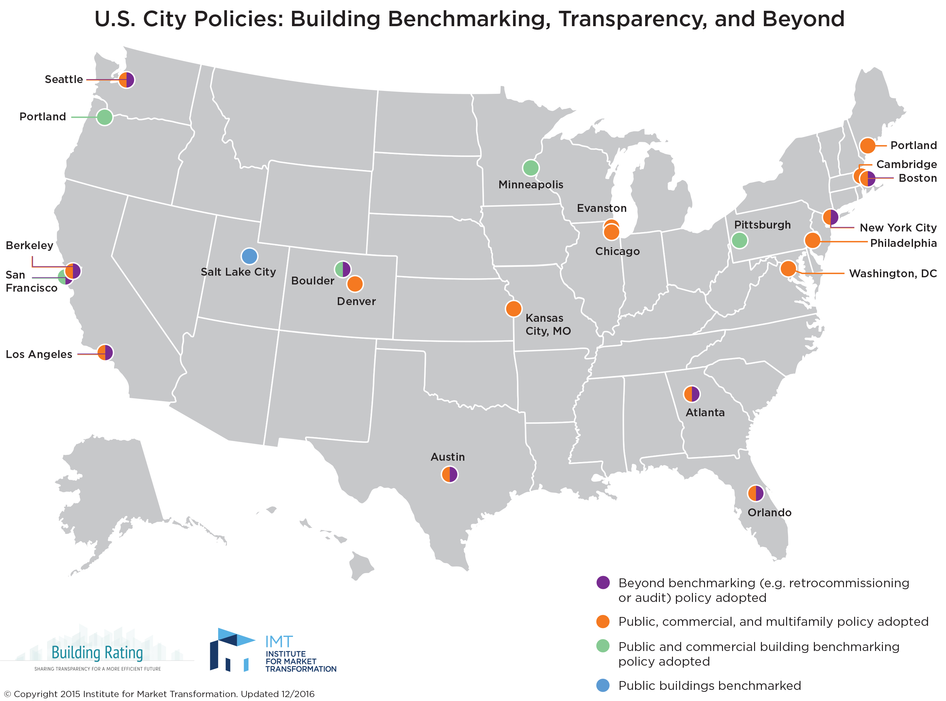

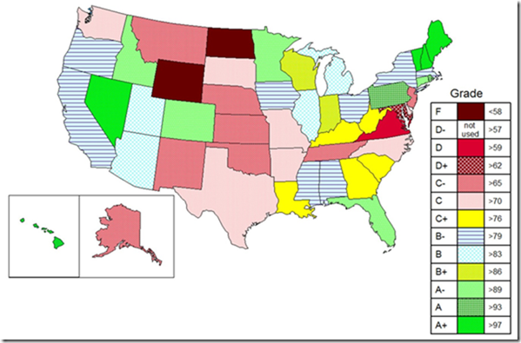

  - National energy performance flows up from state energy performance, which flows up from city/county energy performance
  - New focus on sectoral energy performance is needed, if anyone wants to be serious about reductions in energy or emissions
  - State performance and performance goals need to be established, progress toward goals should be measured over time, and ASHRAE needs to think about whether it wants a role in this type of performance measurement (commercial, residential, city, etc)

- US Initiatives
  - City Energy Project
Participating cities develop locally tailored plans comprising multiple integrated strategies to significantly reduce building energy use. The launch of the program in 2014 included Atlanta, Boston, Chicago, Denver, Houston, Kansas City, Los Angeles, Orlando, Philadelphia, and Salt Lake City. The program now includes 20 cities. New cities in conjunction with NRDC are Des Moines, Ft Collins, Miami-Dade County, Pittsburgh, Providence RI, Reno, San Jose, St Louis and St Paul. Each city sets its own goals. http://www.imt.org/
  - Landlord Tenant Program
Energy savings in tenant spaces have been difficult since landlords typically pass energy costs on to customers. Two new initiatives in this arena are programs sponsored by Institute for Market Transformation http://www.imt.org/ and NYSERDA https://www.nyserda.ny.gov/All-Programs/Programs/Commercial-Tenant-Program. The IMF has resources that are available nationwide. The NYSERDA program pays 50% of design costs or 100% of cost effective design modifications.
  - Energy Performance Measurement Institute (EPMI) report on US commercial sector energy performance
http://epminst.us/commercial/Understanding%20commercial%20and%20service%20sector%20energy%20use.pdf
Some key results
    - EUI of the entire commercial sector, kBtu/ft²/yr, in 2012 is not much better than in 1986, 177.7 vs 177.9, with increases to 180.3 in 1995 and 195.4 in 2003
    - The Professional/Business Services subsector (most Offices+Labs), Health, Education, and Food Services subsectors have the largest increases in source energy use from 1986 to 2012, accounting for about 60% of the increase over that time
    - EPMI estimate of total commercial sector floor area (not CBECS “incomplete” sector), in billion square feet, is: 65 in 1986, 82 in 1995, 89 in 2003, 98 in 2012, and 100 in 2016.
    - US has about 2.4 times the commercial floor area per capita as Europe
    - Electric space heating energy use in CBECS end-use breakout is low by about a factor of 10, about two quads of source energy, which means there are two quads total too much source energy in the categories of Other, computing, and office equipment
    - Should we focus more on total sectoral energy performance and tone down emphasis on green, zero energy, and high-performance showcases?
  - End-Use Results from EPMI report:
    - Energy use dependent on heating-degree-days and cooling-degree-days has increased dramatically since 1985, both more than doubling
    - Base load energy use (not degree-day dependent) has decreased dramatically over that same time, decreasing by 30%
    - Total sectoral floor area increased by about 50% over this time
    - In 2014, base load of the entire commercial sector is 4.7 quads of source energy, while HDD-dependent is 9.0 quads, and CDD-dependent energy use is 4.4 quads
    - Base load energy reductions appear to be mostly due to improvements in lighting
    - Increases in electric space heating contribute a lot to source energy increases
    - HVAC and refrigeration source energy have increased way more than floor area, while base load energy has decreased.
  - So what’s the ASHRAE impact? Economic malaise in 2012 may have been main cause of drop to 177.7, and increasing economic climate may lead to increase in energy use of entire sector.
  - ASHRAE is gathering information to estimate/support energy savings as a result of ASHRAE standards.
    - Report from Adam Hinge
    - Discussion

- International Initiatives
  - EU https://ec.europa.eu/jrc/en/publication/eur-scientific-and-technical-research-reports/survey-energy-audits-and-energy-management-systems-member-states
    - Assessment of the first National Energy Efficiency Action Plans under the Energy Efficiency Directive: Synthesis report
Member States, provides an overview of the national energy efficiency targets, outlines planned or implemented end-use and supply level measures and evaluates the energy savings resulting from the implementation of these measures.
    - Energy Efficiency in Data Centres: Best Practices and Results of the European Code of Conduct
The Data Centres Code of Conduct has been in operation since 2008 and so far more than 300 data centres of different size and IT service offerings have joined the Code of Conduct. The core of the programme is the commitment by the participant to carry out an initial energy audit to identify the major energy saving opportunities; to prepare an action plan; to implement the action plan; and to monitor energy consumption.

  - OPENEXP has been launched in Europe (http://openexp.eu/) to attempt to start the 4th Industrial Revolution as enhanced energy renovation of the building stock, especially residential (65% of total)
    - EU-28 market size is estimated to be over €100 Billion in 2015 (the UK is small part, so Brexit not really a big impact)
    - About 900,000 jobs
    - Need to move toward standardization of the renovation process (and much more coherence [standardization] in the regulatory process)
    - Climate goals will drive for now, but
    - Economic stabilization and growth may be more important drivers
    - Since European market so much larger than US (investment-wise), should we look for hints there on how to try to create a more standardized (and larger) energy renovation market (sectoral energy performance improvement market) in the US?
    - Note: ACEEE released a new report about “scaling up” residential efficiency retrofit programs (report A1605, October 2016), but it’s “thinking” is much smaller scale than OPENEXP

- EUI Task Group

  - RTAR for Alternate Expressions of EUI submitted and will be acted on in Long Beach
  - Has become Working Group 5 under SSPC 100 – meeting Sunday 12PM-2:00PM
  - May lead to changes in SPC 105 Standards Methods of Measuring, Expressing and Comparing Building Energy Performance
  - Two charges – stacked approaches for multi-use buildings and alternate expressions of EUI
  - Issue - Should we change the TPS of Standard 100 from energy efficiency to energy performance? Is Energy/sf the best metric?
  - What about standard reporting? Carbon reduction goals exclusive of energy goals obscure what is happening, so some type of requirement on energy reporting is needed to assure that energy reduction goals or requirements are always specified in energy units, and carbon goals cannot imply energy reductions are needed unless specific energy goals are included with any carbon goals
  - Look at ventilation load index.

ASHRAE Sessions of Interest
Sunday, January 29, 8:00 AM-9:00 AM WORKSHOP 3
Sitting Around Collecting Dust: Evaluating Industrial Dust Collector Performance
Sunday, January 29, 9:45 AM-10:45 AM Conference Paper Session 2
Modern Optimization Techniques for Hydronic Systems in Data Centers
Sunday, June 29, January 29, 9:45 AM-10:45 AM Seminar 3
Hydronic Flow Measurement

January 29, 9:45 AM-10:45 AM
Recent Action in Evaporative Cooling

January 29, 11:00 AM-12:30 PM Conference Paper Session 4
Improving Energy Exchange in HVAC&R

January 29, 11:00 AM-12:30 PM Seminar 8
Blue is the New Green: The Water-Energy “Next IS”?

January 29, 11:00 AM-12:30 PM Seminar 10
Performance of Chilled Water Pipe Insulation Systems in Humid Environments: Problems, Solutions, ASHRAE Research and the Use of Hygrothermal Analyses
January 29, 1:30 PM-3:00 PM SEMINAR 14
Data Driven Energy Auditing, Measurement and Verification
January 29, 1:30 PM-3:00 PM SEMINAR 15
Do Users Follow the Model?

Sunday, January 29, 3:15 PM - 4:45 PM Seminar 19
Walking the Walk: Delivering a Truly High Performance Building

Monday, January 30, 8:00 AM - 9:30 AM Conference Paper Session 9
Optimizing Energy and Water Efficiency in Buildings
Monday, January 30, 8:00 AM - 9:30 AM Seminar 23
The Road to Zero Energy Buildings Goes Through Energy Indices: What’s Fair and How Do We Get There?

Tuesday, January 31, 8:00 AM - 9:30 AM Conference Paper Session 14
Optimizing Energy and Ventilation in Residential Applications

Tuesday, January 31, 8:00 AM - 9:30 AM Conference Paper Session 15
Ventilation Systems and Their Impact on IAQ and Energy

Tuesday, January 31, 8:00 AM - 9:30 AM Seminar 37
Addressing Information Incompatibilities in Building Performance Monitoring

Tuesday, January 31, 9:45 AM-11:00 AM Seminar 40
Field Data and Ensuing Recommendations
Tuesday, January 31, 9:45 AM-11:00 AM Seminar 44
Toward a 21st Century Standard for Natural Ventilation: Review of Existing and Presentation of New Research
Tuesday, January 31, 9:45 AM-11:00 AM Seminar 46
What Do We Know About Energy Use in Agriculture Facilities

Tuesday, January 31, 11:00 AM - 12:00 PM Seminar 48
Did It Really Work?: Theory vs. Practice in Residential HVAC

Tuesday, January 31, 11:15 AM - 12:45 PM Conference Paper Session 16
Building Operation and Performance with Sustainability in Mind

Tuesday, January 31, 11:15 AM - 12:45 PM Seminar 53
Commissioning a Central Chilled Water Plant

Wednesday, February 1, 8:00 AM - 9:30 AM Seminar 62
Highlights of RP-1404: Measurement, Modeling, Analysis and Reporting Protocols for Short-term M&V of Whole Building Energy Performance

