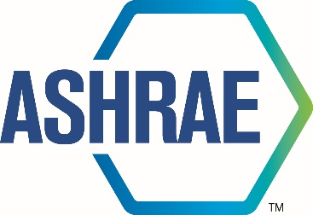

Agenda

TECHNICAL COMMITTEE

2026 Summer Meeting

June 30, 2026



180 Technology Parkway NW, Peachtree Corners, GA 30092
404-636-8400

TC/TG/MTG/TRG AGENDA COVER SHEET

(Minutes of all Meetings are to be distributed to all persons listed below within 60 days following the meeting.)

TC/TG/MTG/TRG No. 8.4 DATE 06/30/2026

TC/TG/MTG/TRG TITLE Air-to-refrigerant heat transfer equipment

DATE OF MEETING June 30, 2026 LOCATION Austin

MEMBERS PRESENT | YEAR APPTD | Attendance |  | VM
Christian Bach (Chair, VM) | 2024 | In-Person (vice chair starting 07/01) |  | X
Arindom Joardar (Vice Chair, VM) | 2024 | In-Person (chair starting 07/01) |  | X
Pedro Perez (Program & Standards Chair, VM starting 06/30/2025) | 2024 | In-Person |  | X
Kashif Nawaz (Handbook Chair, NV) | 2022 | In-Person |  | X
Kishan Padakannaya (Research Chair, VM) | 2021 | In-Person |  | X
Pratik Deokar (Webmaster, VM, serving as acting secretary for this meeting) | 2022 | In-Person |  | X
Matthew Baker (VM) | 2022 | In-Person |  | X
Vikrant C Aute (MTG Liaison, VM) | 2022 | In-Person |  | X
Lokanath Mohanta (new Secretary) | 2024 | Virtual |  | NA
Omar Abdelaziz (VM) | 2024 | In-Person |  | X
Min Che |  |  |  | X
Jun Li (VM) | 2022 | Virtual |  | X
DISTRIBUTION: All Members of TC/TG/MTG/TRG plus the following:
TAC Section Head: |  |  | SH0804@ashrae.net
All Committee Liaisons as Shown On TC/TG/MTG/TRG Rosters (Research, Standards, ALI, etc.) |  |  | See ASHRAE email alias list for needed addresses.
Steve Hammerling,  Assistant Manager of Research & Technical Services |  |  | AMORTS@ashrae.net

- CALL TO ORDER

The Chair called the meeting to order at: 3.32PM local time. Voting member attendance listed on cover sheet and Quorum was established.

Chair reminded everyone of the ASHRAE code of ethics.

>>
In ASHRAE meetings, we will act with honesty, fairness, courtesy, competence, inclusiveness and respect for others, which exemplify our core values of excellence, commitment, integrity, collaboration, volunteerism and diversity, and shall avoid all real or perceived conflicts of interest. Our culture is one of inclusiveness, acknowledging the inherent value and dignity of each individual. We celebrate diverse and inclusive communities, understanding that doing so fuels better, more creative and more thoughtful ideas, solutions and strategies for the Society and the communities our Society serves. We respect and welcome all.<<

- Review of Scope

>> TC 8.4 is concerned with design, performance, and application of heat transfer equipment in which a refrigerant, including water or brine, is used to transfer heat with air. <<

- SELF INTRODUCTIONS AND ATTENDENCE:

The Chair requested everyone present in-person and online to introduce themselves with names and affiliations. Attendance sheet was available in the meeting room to sign for those physically present. (10 voting members were present and 1 absent at the time of introduction and VM Kashif joined later)

- APPROVAL OF 2026 Winter Las Vegas MEETING MINUTES:
Pedro motioned to approve the meeting minutes from 2026 Winter meeting in Las Vegas, Vikrant seconded. The meeting minutes were approved with 10-0-0-1 votes.
- UPDATE FROM CHAIR’s BREAKFAST REPORT (Christian Bach)
Chair could not attend the research breakfast. However, the slides from the Chair’s breakfast meeting is attached for reference.
- RESEARCH BREAKFAST UPDATE

Carl Huber presented a brief update from research administrative committee.

- RESEARCH SUBCOMMITTEE REPORT (Kishan Padakannaya)

There is no active research project sponsored by TC8.04. Two recent co-sponsored project reports were published in 2025. Two RTAR are in preparation. RTAR2005- Work statement preparation is in progress. RTAR2102 is to be decided if to be submitted as RTAR with revision or PTAR.
Attached is the report from research subcommittee

- TAC SECTION HEAD REPORT (Kashif Nawaz)

- HANDBOOK SUBCOMMITTEE REPORT (Kashif Nawaz)

The TC8.4 is responsible for 3 chapters and all are coming up for revision. The chapters are 23, 27, 39. April 4h next year (2027) is the deadline for changes. Handbook chair needs to facilitate access to the reviewers on the handbook central. Any chapter revision needs to be approved by the TC., There is a submission form for this, even if no changes still need to upload form. The new handbook subcommittee liaison – Rupesh introduced himself.

- PROGRAMS SUBCOMMITTEE REPORT (Pedro Perez)
Subcommittee Chair provided an update on the programs. Mini tracks were proposed for future programs and potential seminars for winter 2027. Arindom motioned and 11 out 11 voting members voted yes for that. More details about the program’s update can be found in the attached file.
- MEMBERSHIP REPORT (Ratnesh Tiwari-Absent)
Roster changes were applied in spring and are available in the Spring minutes with the final changes/roster available from ASHRAE.

- STANDARDS SUBCOMMITTEE REPORT (Alfredo Oliveria)
The Standards subcommittee chair was not present and instead TC8.4 Chair provided a brief update. The are two Standards, below, that are actively being revised.
- SPC 33 – Ray Rite is chairing and the team is still working on this
- SPC25 – Omar is chairing this standard and he brought out that the team is struggling with SPC 25 since the members are not able to find time to due to time zone and other issues. Omar mentioned that if the team can meet at least once a quarter for 2 hours it will be sufficient to make progress. Any volunteers can reach out to Omar. He elaborated that the Standard 25 needs to be aligned with the latest version of its AHRI counterpart. It was mentioned that Sarah Churchill from AHRI is the right contact and Xudong Wang volunteered to help connect Omar to Sarah. standard was updated, bringing ASHRAE std to form that follows AHRI. Jim Bogart from API heat transfer volunteered to help SPC 25.
- MTG LIAISON REPORT (Vikrant Aute)
The LowGWP MTG is continuing its activities. RP-1806 still ongoing and progress is being made. MTG scope change proposed and up for voting on 7/1/2026 wherein the revised scope will be discussed. The Codes and standards committee has 40-50 slide presentations on this topic which is very informative and will be made available on basecamp.

- WEBMASTERS REPORT (Pratik Deokar)
Pratik Deokar relayed that the website was up to date.

- OLD BUSINESS
None.

- NEW BUSINESS
Request for co-sponsorship on RTAR “Verification of Nanofluids Impact on Chiller / Heat Pump Performance” from TC 3.1. Fluid is water and water-glycol enhanced by nanofluids, which is outside our scope. Propose we decline to co-sponsor the RTAR. ASHRAE 8.5 Liquid-to-Refrigerant Heat Exchangers appears a better fit as a co-sponsor.
Feedback: If expanded scope to include dry coolers, or if second project after this one we could entertain support.
- >>A discussion concerning the FOAC was held. The committee feels strongly that there is significant value in a face to face annual meeting – especially in the area of promoting ASHRAE Research, continued education credits (CEU) for professional engineers (PEs), and networking especially for young engineers (YEA) but understands the limitations with regard to cost, travel, etc. and agrees that some work can be done virtually. However, differences in time zones could limit participation of international members. The committee would request that the BoD more deeply study the effects on the society as a whole and extend its decision making timeline to hear more voices in the society. <<
  - Moved by Omar, Seconded by Kishan, 10-0-1-0, Kashif abstaining since section head, motion carries.

- ADJOURNMENT
Committee adjourned after completion of discussions. (Kashif motions and Min seconds)
Adjourned at 5:26 pm

- ATTENDANCE Sheets

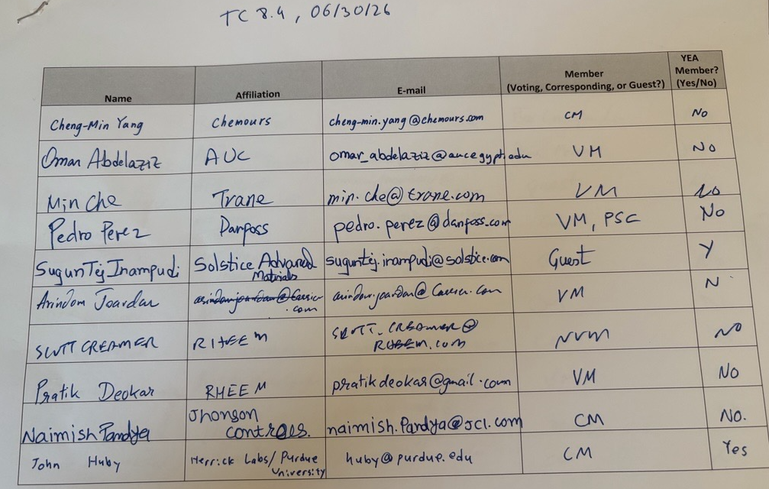

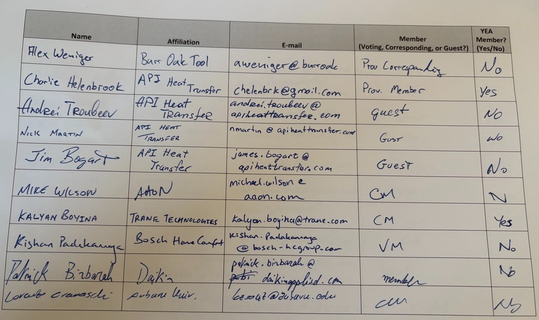

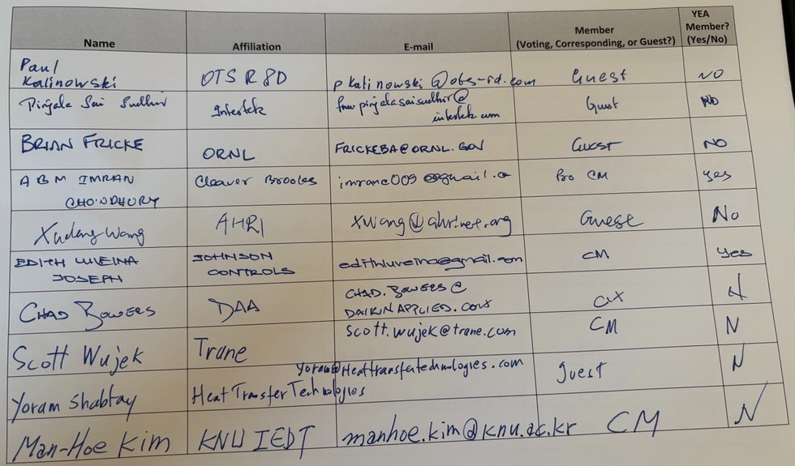

Sydney Walker (virtual)
Other virtual attendees see screenshot further below.


