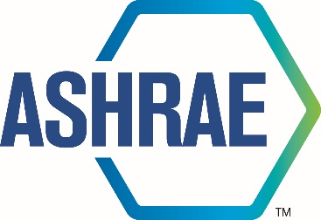

M I N U T E S

TECHNICAL COMMITTEE

2025 Annual Meeting

June 24, 2025



180 Technology Parkway NW, Peachtree Corners, GA 30092
404-636-8400

TC/TG/MTG/TRG MINUTES COVER SHEET

(Minutes of all Meetings are to be distributed to all persons listed below within 60 days following the meeting.)

TC/TG/MTG/TRG No. 8.4 DATE 06/27/2025

TC/TG/MTG/TRG TITLE Air-to-refrigerant heat transfer equipment

DATE OF MEETING June 24, 2025 LOCATION Phoenix

MEMBERS PRESENT | YEAR APPTD | Attendance |  | YEA?
Arindom Joardar (Vice Chair, VM) | 2024
Dhruv Hoysall (Secretary; needs to be corrected to Lokanath, NV) | 2025
Christian Bach (Chair, VM) | 2024 | In-Person
Pedro Perez (Program & Standards Chair, VM starting 06/30/2025) | 2024 | Virtual
Yang Zou (VM; timing out 06/30/2025) | 2021
Khaled Hassan Saleh (VM; timing out 06/30/2025) | 2021
Ratnesh Tiwari (Mem. SC Chair) | 2018
Antonio Oliveria (VM) | 2024 | Virtually
Kashif Nawaz (Handbook Chair, NV) | 2022 | In-Person
Kishan Padakannaya (Research Chair, VM) | 2021 | In-Person
Pratik Deokar (Webmaster, VM, serving as acting secretary for this meeting) | 2022 | In-Person
Matthew Baker (VM) | 2022 | Virtual
Vikrant C Aute (MTG Liaison, VM) | 2022 | In-Person
Lokanath Mohanta (new Secretary) | 2024 | Virtual
Omar Abdelaziz (VM) | 2024 | In-Person
Jun Li (VM) | 2022 | Virtual
Patrick Birbarah (PVCM) |  | In-Person
Amir Jokar (CM) |  | In-Person
ABM Imran Chowdhury (PVCM) |  | In-Person |  | Y
Kalyan Boyina (PVCM) |  | In-Person |  | Y
Rohit Dhumane (PVCM) |  | In-Person
Ray Rite (CM) |  | In-Person
Scott Wujek (CM) |  | In-Person
John S Jaher (Guest) |  | In-Person |  | Y
Man-Hoe Kim (CM) |  | In-Person
Carl Huber (Guest) |  | In-Person
Aaron Alexander (Guest) |  | In-Person
S. Ria Mossakui (Guest) |  | In-Person |  | Y
Yoram Shabtay (Guest) |  | In-Person |  | Y
Naomi Carmeli-Shabtai (Guest) |  | In-Person
Paul Kalinowski (Guest) |  | In-Person
Sarah Churchwell (Guest) |  | In-Person
Xudong Wang (Guest) |  | In-Person
Amrat Ranka (Guest) |  | Virtually
Jimmy Tancabel (Guest) |  | Virtually
Min Che (CM) |  | Virtually
Saqib Ayuob (Guest) |  | Virtually
Yirong Yang (CM) |  | Virtually
DISTRIBUTION: All Members of TC/TG/MTG/TRG plus the following:
TAC Section Head: |  |  | SH0804@ashrae.net
All Committee Liaisons as Shown On TC/TG/MTG/TRG Rosters (Research, Standards, ALI, etc.) |  |  | See ASHRAE email alias list for needed addresses.
Steve Hammerling,  Assistant Manager of Research & Technical Services |  |  | AMORTS@ashrae.net

Initially 1 Voting member was short of quorum.
- CALL TO ORDER

- Review of Scope

- SELF INTRODUCTIONS AND ATTENDENCE:

- The Chair requested everyone present in-person and online to introduce themselves with names and affiliations. Attendance sheet was available in the meeting room to sign for those physically present. Chair identified 1 voting member absent to get the quorum (as of 3:42pm 6 voting members present, 5 absent)

- APPROVAL OF 2025 Winter Orlando MEETING MINUTES:
The meetings were not approved with votes

- UPDATE FROM CHAIR’s BREAKFAST REPORT (Christian Bach)
Chair skipped detailed discussions of the chairs breakfast as the topic likely was covered multiple times for most members in other meetings. Chair breakfast notes attached.

- RESEARCH BREAKFAST UPDATE (Kishan Padakannaya)
- Kishan shared details of new RAC members, specifically for Section 2 and Section 4
- Carl Huber is still Section 8 head for RAC
- To date ASHRAE has sponsored 1009 projects with $87M in fundings
- There is new RAP, Research Advisory Panel, who came up with a new research strategy. RAP is asking input from everyone for what next research strategy should be.
- RP, Research Promotion, campaign has raised $2.3M, their goal is close to $2.7M
- The current research budget is $3.9M for 2024-25, but only one RTRAR was submitted. RAC is asking for more RTAR submissions.
- There is training for RTARs, PTARS, and WS. PES and PMS need mandatory training. The next training session is on Sep9.
- New ‘Research Portal’ is open to submit RTAR submission, to reduce manual work.
- Next RTAR submission deadline is August15
- Several awards are available
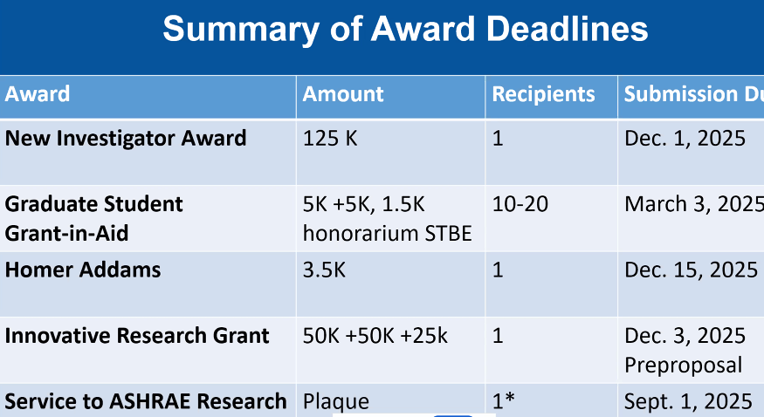
- RAC committee slides below for further detail:

- RESEARCH SUBCOMMITTEE REPORT (Kishan Padakannaya)

Currently there is no active research under TC 8.4.
- RP-1785 Charge project – TC 8.11 sponsoring.
  - TC 8.4 is co-sponsoring. Christian Bach is PI, Ray Rite is PMS chair. PMS is reviewing final report and will get back to the PI with comments after the ASHRAE meeting.
- RP-1683 Ammonia U-bend Project – TC 1.3 sponsoring
- RP-1785 Charge project – TC 8.11 sponsoring
  - TC 8.4 co-sponsoring. Ray Rite is PMS chair, Dr. Abbas (GIK Institute) is PI and Lorenzo Cremaschi is co-PI.
  - Project is complete. PMS has reviewed final report and had a meeting last month where few additions were requested. After completion of new additions, the TC 1.3 will vote to wrap up the project.

New Research:

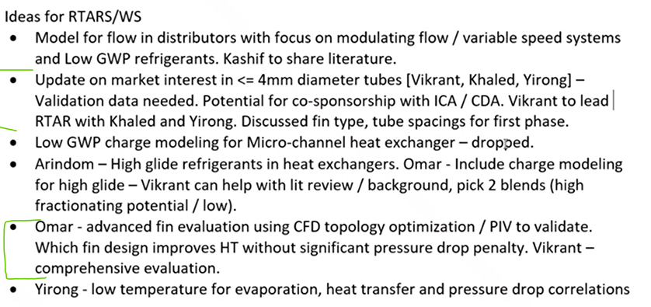
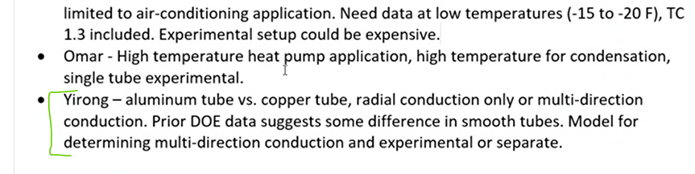
- Less than 4 mm diameter tube, Kishan P asked Vikrant Aute and Yirong Jiang to submit RTAR (Patrick B suggested if this project could be extended to microchannel tubes. Vikrant said that very small round tube diameter, <2mm, in fin and tube HX will have a very huge pressure drop compared to MCHX)
- Omar said he will work on RTAR on advanced fin evaluation using CFD topology.
- Did not hear back on Yirong’s Idea on low temperature evaporation, HTC and delP.
- Yirong has prepared an RTAR on Al tube vs Cu tube, radial conduction or multi-direction conduction, where HTC predictions had differences. The RTAR is sent to research liaison for feedback, after which we will email it to the voting members.

New Ideas:
- Pratik and Vikrant suggested a possible RTAR where open source literature for HTC and delP correlation and test data would be combined, and using AI create a ChatAgent that would suggest users which correlations could be used for their needed application. Help from Rohit Dhumane (VC of Gen AI MTG).

TAC SECTION HEAD REPORT (NA)
- HANDBOOK SUBCOMMITTEE REPORT (Kashif Nawaz)
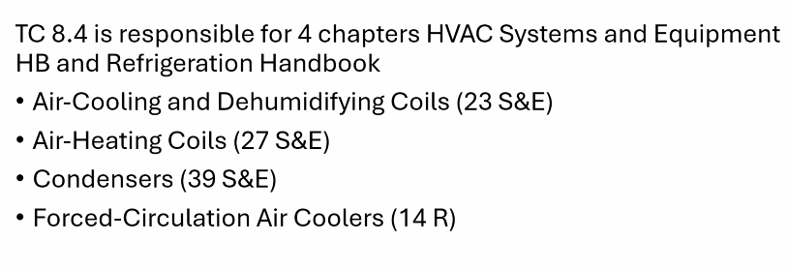
Kashif Nawaz said that Chapter 14 in Refrigeration handbook will stay as it is, and suggested to submit no-revision form for chapter 14

Omar Abdelaziz motioned to wait for 7 days after the no-revision request is submitted by Kashif for Chapter 14 of Refrigeration handbook, and Kashif to perform e-voting with TC member if there is a chapter revision requested by handbook committee.
Dr. Bach makes second motion.
Vote Count: (6-0-0) [6 yes, 5 absent]

Kashif will connect with below
Amir Jokar : Chapter 39
* Ray Rite: Chapter 14
* Chad Bowers: Chapter 23
* Omar Abdelaziz: Chapter 23 and 39
* Lokanath Mohanta: Chapter 23
* Dhruv Hoysall: Chapter 39
* Sankar Padhmanabhan: Chapter 23
Deadline year from now for ‘Systems and Application’ Handbook

- PROGRAMS SUBCOMMITTEE REPORT (Pedro Perez)
  - There are total of 111 sessions in 7 tracks in 2025 Phoenix session
  - TC 8.4 sponsored Seminar 34 was on Monday 6-23-2025, chair of this seminar was Dr. Vikrant Aute.
  - Program subcommittee chair’s report slides are available here:

  - Due date for Las Vegas Conference is Aug 1, 2025
  - Panel submission now require presentation abstract while submission.
  - Pedro also shared Tips to make successful program submission
New Program Ideas:
  - Omar Abdelaziz suggested dry coolers or hybrid adiabatic coolers in data centers. Omar would help with few speakers.
  - TC 6.9 has discussed topic on ‘environmental impacts of water usage’ which could see lot of interest at Las Vegas conference. TC 8.6 is also planning a similar topic with evaporative cooling with less water usage.
  - Omar said he can include a life cycle water consumption.
(Pratik did not capture all points well)
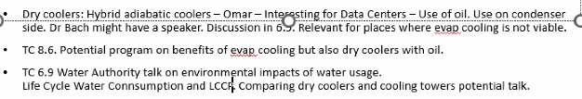
Vikrant Aute made motion, Omar seconded for below
  - Sponsorship on 1st session on ‘Dry Coolers’, with Pedro as chair.
  - Co-sponsorship on 2nd session ‘Risk Assessment of A3 Refrigerants’,
  - Vote Count: (6-0-0) [6 yes, 5 absent]

- MEMBERSHIP REPORT (Ratnesh Tiwari)
No report.

- STANDARDS SUBCOMMITTEE REPORT (Omar Abdelaziz)
    - SPC 25 did not meet, as vice-chair was needed.
    - Omar asked someone to volunteer as vice-chair
    - Omar, Kashif, Kisan, Arindom are current members on SPC. The current members are from ‘producer OEM’, while Omar is looking add more ‘user’ members on SPC.

- MTG LIAISON REPORT (Vikrant Aute)

MTG.LowGWP
- There are discussion whether to continue this MTG, or morph into something else.
- Dr. Vikrant asked TC 8.4’s for feedback, the feedback should include discussion like need for code and standards activity to make the MTG stay (This in turn will help MTG make decision).
- Other topic discussed in MTG was if there are any possible A3 transitions, that could let MTG stay.
- MTG also discussed possible leadership change.

- Omar Abdelaziz made a motion that TC 8.4 will like to keep MTG.LowGWP. Christian Bach seconded.
Vote Count: (6-0-0) [6 yes, 5 absent]

- WEBMASTERS REPORT (Pratik Deokar)
Pratik Deokar relayed that the website was up to date.

- OLD BUSINESS

- NEW BUSINESS

- ADJOURNMENT
Committee adjourned after completion of discussions. (Vikrant motions, C Bach seconds, all in favor)
Adjourned at 5:30 pm

- ATTENDANCE Sheets/Snapshots

- Approval of Phoenix meetings was completed remotely 07/07/2025 with the voting members applicable at that time 12-0-0-2 (yes, no, abstain, no response).



