ASHRAE MAIN MEETING

Technical Committee 2.1 – Physiology & Human Environment

Winter Conference 2026
Hybrid Meeting
Tuesday, Feb 3, 2026,
1:00 - 3:00 PM Pacific Standard Time (PST)
In-person: Caesars Palace, Octavius 21 (PS)
Virtual: (see below)
Meeting URL: | https://uni-sydney.zoom.us/j/81823790361
Meeting ID: | 81823790361
Passcode: | N/A

Committee and Meeting Information
Scope of TC 2.1
“TC 2.1 is concerned with the relationship of man's living environment, as altered by air-conditioning, heating and ventilating systems, to his comfort, health, and productivity.”
Approved in Sept. ’23 TAC meeting with minor change to the following:
“TC2.1 takes into account the interactions of human physiology and psychology with the built environment, and their impacts on comfort, health, well-being, and performance.”

ASHRAE Value Statement:
“In ASHRAE meetings, we will act with honesty, fairness, courtesy, competence, inclusiveness and respect for others, which exemplify our core values of excellence, commitment, integrity, collaboration, volunteerism and diversity, and shall avoid all real or perceived conflicts of interest. Our culture is one of inclusiveness, acknowledging the inherent value and dignity of each individual. We celebrate diverse and inclusive communities, understanding that doing so fuels better, more creative and more thoughtful ideas, solutions and strategies for the Society and the communities our Society serves. We respect and welcome all.”

See full Code of Ethics: https://www.ashrae.org/about-ashrae/ashrae-code-of-ethics.

Website
TC2.1 Homepage: http://tc0201.ashraetcs.org
TC2.1 Basecamp: https://3.basecamp.com/3106353/projects/10544072

Agenda Overview
- Call to order (approx. 15 min, start from in-person attendants)
- Research subcommittee meeting: During Main Meeting (~30 min)
- Program subcommittee meeting: During Main Meeting (~30 min)
- Handbook subcommittee meeting: During Main Meeting (~15 min)
- Membership (~5 min)
- Liaison reports (~15 min)
- Others (~ 5 min)

Call to order

Participant introduction and signup:

https://docs.google.com/spreadsheets/d/1od8AhIz0MjMGGP258Ow6KyVNc03-ePnwkAs_2dxtJpY/edit?usp=sharing

Members (7 Quorum + 1 Non-Quorum)

Quorum met: Yes_X_, No____
Name | Affiliation | Roll off | Presence
Thomas Parkinson | The University of Sydney | 6/30/27 | Yes
Meng Kong | Delos | 6/30/26 | Yes
Dennis Loveday | Loughborough University | 6/30/27 | Yes
Wilmer Pasut | Università Ca' Foscari | 6/30/27 | No
Mark Jackson | Daikin | 6/30/27 | No
Runming Yao | University of Reading | 6/30/29 | Yes
Iason Konstantzos | University of Nebraska – Lincoln | 6/30/29 | Yes
Shichao Liu (Non quorum) | Worcester Polytechnic Institute (WPI) | 6/30/29 | Yes

Rolling off in Summer 2026: Meng Kong (need to be reappointed as a VM this year or next?)

Notes:
- Quorum>1/2 all VM, excluding NQM; super majority >=2/3 VM present; simple majority>1/2 VM present
- The roster indicates Chandra Sekhar instead of Mark Jackson is the voting member through 2027

Officers
Name | Affiliation | Role | Presence
Thomas Parkinson | The University of Sydney | Chair | Yes
Meng Kong | Delos | Vice Chair | Yes
Iason Konstantzos | University of Nebraska - Lincoln | Secretary | Yes
John Elson | Ford | Handbook Subcommittee Chair | Yes
Jennifer Lather |  | Membership Subcommittee Chair
Nuria Casquero-Modrego | UC Berkeley | Program Subcommittee Chair | Yes
Runming Yao | University of Reading | Research Subcommittee Chair | Yes
Robert Bean | Indoor Climate Consultants Inc | Standards Subcommittee Chair | Yes
Iason Konstantzos | University of Nebraska - Lincoln | Webmaster | Yes
Brian Fricke | Oak Ridge National Laboratory | Research Liaison
Steven Hammerling | ASHRAE | Staff Liaison
Diana Fisler | ASHRAE | TAC Liaison | Yes

Note: Dolaana Khovalyg volunteered to take Jennifer Lather’s role as Membership Subcommittee Chair.

Rolling off in Summer 2026:
To be updated: John Elson, Jennifer Lather, Robert Bean, Iason Konstantzos (see Sections 8 to 11)

Approve minutes of past meetings (Summer 2025)
Meeting minutes of Summer meeting 2025
- Meeting minutes were circulated November 9, 2025
- Motion to approve __Dennis__, seconded __Nuria__ .
- Voting: 6 (For) – 0 (Against) – 0 (Abstain)- 02 (Not Voting) - Approved

Chair’s Report (Thomas Parkinson & Meng Kong)

Members Council DEI Standing Committee will launch in July; will oversee all of ASHRAE, including TAC and Technology Council

Goal: foster inclusive, welcoming committee culture

Special Projects Subcommittee: Oversees high-priority or externally funded research efforts that don’t fit traditional RAC paths

Research Advisory Panel Questionnaire:

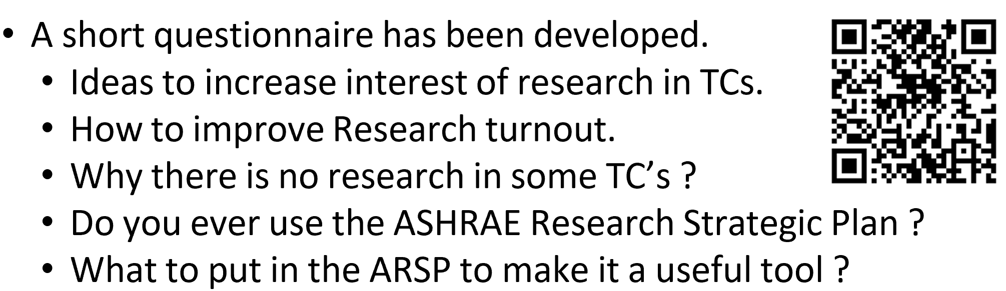

Global Technical Interaction Committee

ASHRAE administers five ISO technical committees (TCs 86, 205, 163, 59, 142)

TCs are encouraged to identify overlaps with ISO efforts and participate

Conference & Content Stats

Nine tracks in the current conference

175 session proposals submitted (panels, forums, seminars, workshops, debates)

85 accepted (~50% acceptance rate)

192 conference papers + 22 extended abstracts → included in 36 paper/poster sessions

Piloted remote presentation sessions prior to the conference with success

Annual Meeting in Austin: program submission deadline is February 25

Government Affairs Update

ASHRAE has an active Government Affairs team in D.C.

Technical committee input is critical for informing policy

186 government outreach events held in the past year

Tracking over 4,000 bills at state level

TC Activities:

Some TCs are responsible for maintaining or reaffirming ASHRAE standards

Important to respond to standards team emails regarding standard status

Research Subcommittee (Runming Yao)

Research Chair Breakfast update (Feb 2) (Meng):

Section 2: Brian Fricke

Current Research Portfolio: ASHRAE has 46 active research projects.

Research Access: ASHRAE members have free access to research reports.

ASHRAE provides its members with FREE digital downloads of all four Handbooks, which are the largest beneficiaries of ASHRAE research results

ASHRAE Published 2025–2028 ASHRAE Strategic Plan. New proposed research should align with the new strategic plan.

A Research Advisory Panel (RAP) has been formed to guide RAC and develop the research strategy. They are arranging focus groups. Reach out to rcharneux@pageaumorel.com or shammerling@ashrae.org if you are interested.

Research Funding & Promotion:

ASHRAE RESEARCH Budget SY 25-26 $4.012 M

3 RTAR, 3 WS, and 6 tentative projects

TCs are encouraged to nominate and recognize volunteers contributing to ASHRAE research.

RAC is developing a mentorship program to help developing RTAR/PTAR/WS, please share your ideas.

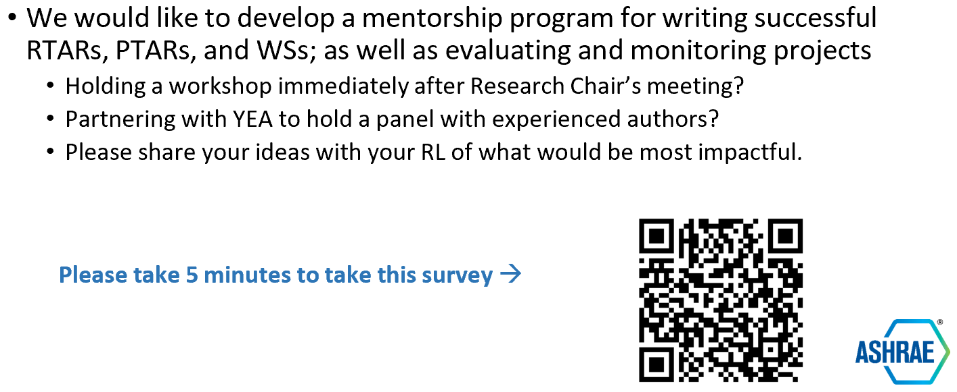

RTAR/WS submission have been converted to an online submission form.

RAC Schedule: RAC meets four times per year; submission deadlines are: March 15, May 15, August 15, and December 15

PES / PMS training

Updates on research
        - RP-1837:
          - The project has been completed and all reporting requirements met. Congratulation to Pawel and his team.
        - RTAR 1924
          - Katherine ; Torriani Giulia representing Babich Francesco and Runming Yao last year to discuss RTAR1924 WS. It was decided to separate into two, one focuses on Children’s heat and one on evaluation method for children’s thermal comfort. There is no further discussion.
          - Runming Yao et al recently published a review paper about the evaluation method for children’s thermal comfort. Evaluation methods and factors influencing the thermal comfort of children - A comprehensive literature review-Journal of Building Engineering, https://doi.org/10.1016/j.jobe.2024.110063
          - Katerine remains very interested in reactivating this RTAR. She has kept working on the topic of children occupants. She hopes to have time to work on the RTAR, later this year.
          - Runming is planning to lead a new RTAR and aiming to submit in March
        - WS 1931
          - The PI Meng Kong still working on the WS. The most recent update is that they are planning to merge part of the work (CO₂ and metabolic rate measurements for regular activities) into Yongchao's WS 1975 and restructure this WS to focus primarily on healthcare workers.
        - WS 1975 - Expanding the ASHRAE Metabolic rates Database for a complete lifespan.
          - The PI Yongchao Zhai and the team have finished the first version of the work statement.
          - They planned to submit the WS for March 15 Deadline.
        - RTAR 1979 - Development of a Residential Thermal Comfort Model for Decarbonization in North America
          - The is the most recent approved RTAR. PI Shichao is working on the WS.
          - Shichao aimed to submit it in March and no later than summer meeting time

New Proposals that were declined:
        - PI Pawel Wargocki: Metrics that can predict IEQ effects on productivity.
          - This RTAR was I unfortunately rejected. And Pawel did not have time to further work on it.
          - Pawel feels it is a very important topic, particularly when ASHRAE is moving into the area of IEQ. Runming also agree with this point. Hope we can discuss this in the upcoming meeting in LV.
        - Guangyu Cao: Innovative airflow distribution for operating rooms to enhance local air quality and thermal comfort for surgeons and patients
          - Updated application in response to the reviewers’ feedback from TC 2.1, particularly regarding issues related to personal thermal comfort and the thermal environment in ORs.
          - Presented RTAR concept within TC 9.6 meeting focusing on air quality of healthcare facilities; received positive feedback along with several some comments regarding necessity and solutions.
          - Two main concerns: whether there is a genuine need to address thermal comfort specifically in surgical settings, and whether existing solutions may already adequately resolve these challenges.
          - Addressed both of these points in the revised version of the RTAR
          - Guangyu will present their work online to the TC2.1 upcoming meeting.
          - PI Guangyu Cao’s revised version, based on voting members’ comments, was just received on 20th Jan.2026. They would like get co-sponsorship from 9.6 subcommittee. They contact them regarding presenting updates of the RTAR.
          - Runming circulated the updated version to Voting members.
        - Marianne proposed a new idea about overheating in buildings without mechanical ventilation and AC.
          - Anyone who is interested please reach out to Marianne.

Other Business
        - Research idea from TC5.10: IEQ Research Baseline Standard for Kitchens
        - Request from TC7.1 to evaluate TC 2.1’s interest in co-sponsoring an unsolicited research proposal.
          - Proposal title: Review on URP - Thermal Comfort and Occupant Behavior Database 2.0
          - The proposal was circulated to the voting members, and six voting members' comments were sent to the TC7.1 Bing Dong. The revised version based on VMs’ comments were circulated to the VMs for voting again.
        - IEA EBC Annex 87 evaluation for Personalized Environmental Control Systems (PECS/PCS)
          - Joyce Kim: created a stakeholder survey to understand how these devices should be evaluated across different industry roles
          - Would like to briefly introduce it

Program Subcommittee (Nuria Casquero-Modrego)

Seminar 16 Human-Centered IEQ: Advancing Health and Performance in Modern Spaces:
        - 1:30-3:00pm, Sunday, Feb 1
        - Caesars Palace, (P), Neopolitan III/IV
        - Chair: Meng Kong
        - Presenter: Young Joo Son, Pawel, Shichao & Xintong, Josephine, Xin & Jensen

Proposals for Austin, TX, USA (deadline Feb 25, 2026):
        - IEQ in kitchens (TC5.10 sponsoring)
        - Any new ideas?

Any new ideas?
        - Send ideas to Nuria
        - Seminar on extreme heat (Shichao); will submit again for Vegas
        - Can we put together a seminar on metabolic heat loads (Katherine and Shichao)? Maybe for Summer 2026 – let Katherine know if interested
        - Health implications in essential buildings (Nuria; sponsorship from TC4.3)

Website is open for program submissions for the 2026 ASHRAE Summer Conference, and will remain open until Wednesday, Feb 25 – you may submit through the link below: https://ashraem.confex.com/ashraem/s26/cfp.cgi

Handbook Subcommittee Update (John Elson)

TC2.1 is responsible for ASHRAE Handbook Fundamental Chapter 9 Thermal Comfort and Chapter 12 Odors (Meng). Former leadership please share your experience!
        - ASHRAE Fundamentals Handbook, Chap. 12 - "Odors"
        - Came from TC 2.3 a number of years ago, who don’t have the expertise to take it back.
        - Can we continue responsibility for this chapter, and update it during the next three years?
        - If we can no longer handle it, we need to write a request to Handbook (which can be an email addressed to Robert E. McFarlane) asking to have this chapter Deleted from the Handbook unless some other TC wants to take it over.

John Elson potentially looking to find a replacement as a Handbook Subcommittee Chair
        - I will continue it for the moment, it is a team effort, more below!
        - Anyone taking it on will need to attend Handbook Subcommittee meetings and learn how to upload to subcommittee chair
        - Happy to assistant anyone who takes it on

Fundamentals is due in 2028 for 2029 release
        - Currently have one chapter in Fundamentals under management (Thermal Comfort)
        - Chapter 12 (Odor) has been assigned to TC 2.3

The handbook is the fundamental resource it is detailed and a reference source for practicing engineers.
        - A good primer into topics of comfort and physiology; useful for interpreting and influencing Standard 55.
        - It could use a significant overhaul, or we can keep adding pieces here and there.
        - Should be updated with latest research in some sections

It needs to be a team effort! I need contributors to take on one or more sections of the Thermal Comfort chapter. Contact: Jelson3@ford.com

Standards (Robert Bean)

TC 2.1 is the cognizant TC for (Meng)

Guideline 45P, Measurement of Performance for Buildings Except Low-Rise Residential Building

Standard 55 Thermal Environmental Conditions for Human Occupancy

Standard 216 Methods of Test for Determining Application Data of Overhead Circulator Fans

Former leadership please share your experience!

A replacement for Robert is needed. Volunteer?

WebMaster (Iason Konstantzos)

Working with Basecamp only but hasn’t been updated recently

Nuria Casquero -Modrago is happy to help.

Jun is willing to take the role.

Membership (Jennifer Lather)

We may want to start cleaning the roster to remove inactive members.

Need to find a new subcommittee chair to replace Jennifer Lather – Dolaana Khovalyg will take this role.

Welcome to YEAs, New Provisional Corresponding Members, and New Corresponding Members

YAE info: https://www.ashrae.org/communities/young-engineers-in-ashrae-yea

Non-quorum voting members will roll off.

Subcommittee chairs

To join TC 2.01 please visit
- ASHRAE Members: https://tc0201.ashraetcs.org/membership.php
- Non-ASHRAE Members: https://www.ashrae.org/standards-research--technology/technicalcommittees/applying-for-membership-on-a-technical-committee-2015

Liaison Reports (Diana Fisler and Steven)

Diana:

Steven:

Other Business
- How can this committee be more visible and active (Pawel Wargocki)
  - Ideas and suggestions welcome
- TC2.1 LinkedIn Page – any updates?
Note: Since there was no interest in managing this, Tom is incluned to remove from the list unless someone nominates themselves in the next meeting.
- ASHRAE IEQ Resource: https://www.ashrae.org/technical-resources/ieq-resources
- 2026 Ralph G. Nevins Award:
  - No award given in 2025; confirmed with ASHRAE that it is possible to award retrospectively.
    - Nominations were forwarded to VMs on Jan 16th; voting to be closed by Jan 30th.
    - Same email also had 3 nominees for 2026 award
  - Future applicants:
    - A letter of recommendation from a person who knows the nominee and their work, nominating the person for the award, and outlining why the nominee should be considered for the award
    - The CV of the nominee
    - Annual deadline for submission: December 23rd
Ralph G. Nevins Physiology and Human Environment Award recognizes a promising investigator, preferably less than 40 years of age, for significant accomplishment in the general area of man's response to the environment, which may include thermal, moisture, visual, acoustical, toxic, allergic, olfactory, vibrational and microbiological effects on man's health, comfort and well-being. | 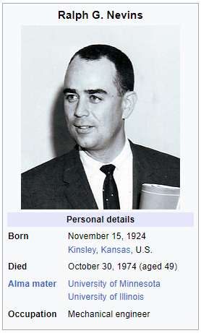

Future Meetings
  - 2026 Annual Conference June 27 - July 1, 2026 | Austin, TX
  - 2027 Winter Conference January 23 - January 27, 2027 | Chicago, IL
  - 2027 Annual Conference June 12-16, 2027 – New Orleans, LA
  - 2028 Winter Conference Feb 5-9, 2028 - Orlando, FL
  - 2028 Annual Conference June 24-28, 2028 – St. Louis, MO

Adjournment

Motion to Adjourn: __Dennis___, Second: __Shichao___; Meeting adjourned at 2:55PM

