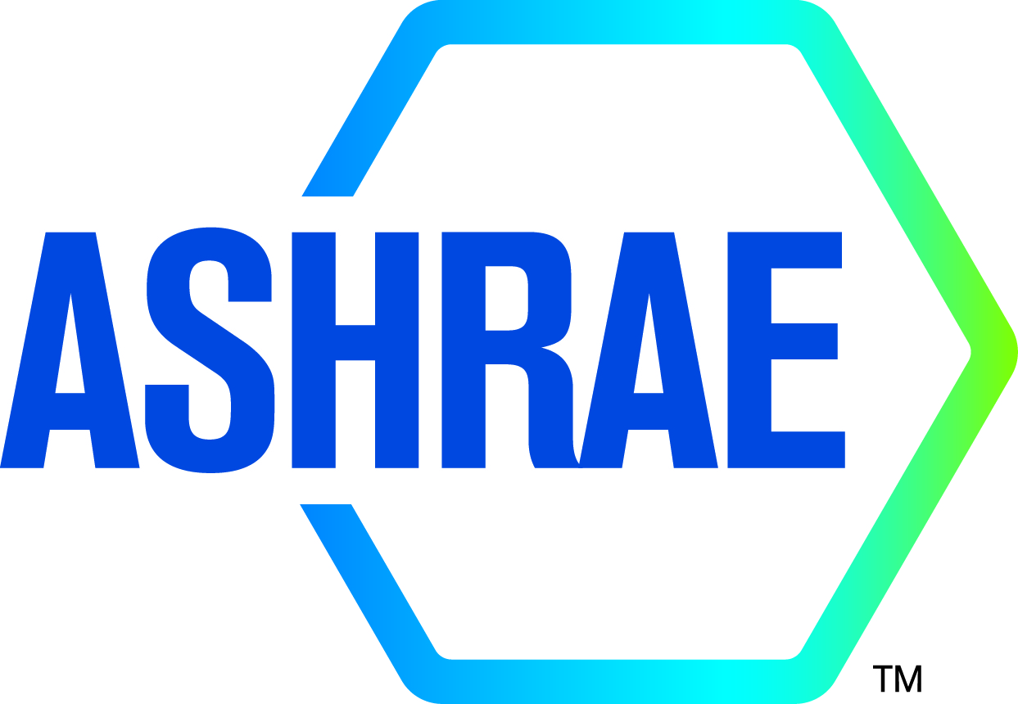

M I N U T E S

DRAFT

TC8.03 Absorption and Heat Operated Machines

2024 ASHRAE WINTER MEETING - CHICAGO
Hybrid

Main Committee [Hybrid]: Monday, January 22nd, 2024 at 1:00 PM – 3:00 PM CST
In Person Location: Marriott Marquis Chicago, Physiology(3)

TC8.03 Subcommittee Meeting (Research/Program/Handbook) – Thursday, January 11, 2024 at 12:00-2:00 PM (CST)
Location: Zoom

Minutes

- Call to order Fronk
Meeting was called to order at 1:10 p.m.

- Review Scope Fronk
Technical Committee 8.03 is concerned with the design, performance and application of equipment energized by a heat source and using a thermodynamic cycle to provide an air-conditioning, refrigerating or heating function; with the properties of absorbent solutions or special working fluids used in these cycles; and with components of the cycle requiring specific design characteristics.

- ASHRAE Code of Ethics Commitment Fronk
In this and all other ASHRAE meetings, we will act with honesty, fairness, courtesy, competence, integrity and respect for others, and we shall avoid all real or perceived conflicts of interests. (See full Code of Ethics: https://www.ashrae.org/about-ashrae/ashrae-code-of-ethics)

- Introductions All
  - Establishment of a Quorum Liu

VOTING MEMBERS FOR THIS MEETING (Need 4 for a Quorum)
VOTING MEMBERS FOR THIS MEETING
X | Douglas Davis (6/2025) |  | X | Saeed Moghaddam (06/2027)
X | Brian Fronk, Chair (6/2025) |  |  | Amit Vasta (06/2027)
 | Christopher Keinath (6/2024)
X | Jay Kohler  (6/2024)
X | Haotian Lui, Vice Chair (6/2024)

The TC presently has 7 voting members. A roll call of the voting members was taken, and a quorum was established with 4 of 7 Voting Members present with chair non-voting.

  - Total Attendees: 19 (In person) and 3 (online); 2 new member; YEA members: 0

- Agenda additions All
None.

- Liaison reports (as they arrive) Liaisons
TAC Section 8 Head Kashif Nawaz
- Request for straw poll on local ASHAE participation
RAC Liaison Section 8 Carl Huber
Handbook
- The Handbook liaison has sent a one-pager on updating Chapter 18. Deadlines and schedules for completion of updates to Chapter 18 will be needed this time next year.

- Minutes Approval Ziviani
Motion to approve the minutes from 2023 ASHRAE Summer Hybrid meeting made by Jay Kohler; Second: Haotian Liu
The motion passed. (4-0-0, CNV)

- Chair’s Report Fronk
  - Chair’s Closing Remarks
  - TC/TG/TRG/MTG Chairs’ Breakfast & Training Meeting (Sunday 01/21/2024 7-9am CST)
  - Research Subcomm Chair’s Breakfast (Monday 06/26/2023 7:00-9:30 am EDT)

TC Chair Breakfast:
- The Chair reported that there was not much information that was relevant to the TC discussed at the breakfast. The development of a Center of Excellence of decarbonization was discussed. There was also some discussion about getting involved with government advocacy. The Chair asked anyone interested to reach out to ASHRAE Government Affairs. The Chair noted that he will send the presentation out to the TC. There was a request from the breakfast for Chairs to do a straw poll of who participates in local chapter events. In the poll for the room, two attendees noted that they've attended at least one event in the last year. Finally, the Chair clarified that the ASHRAE year starts at the June meeting unless there's an emergency to do a change.

Research SubCom Breakfast:
- No update

- Membership/Roster Brian Fronk/Doug Davis
  - Brian Fronk continued to clean up the roster and update contacts.
  - Confirmed committee desire to continue fully virtual subcommittee meetings and hybrid full committee meetings as long as supported by ASHRAE
  - TC leadership and current positions held by various members were reviewed.
- Two voting members rolling off 06/24 (Chris Keinath and Jay Kohler)
- Bill Ryan
- Secretary position was vacant, Steve Kowalski volunteered and roster updated to roll on in 07/24
- Matthew Blaylock volunteered for Webmaster, roster updated to roll on in 07/24
- Amit Vatsa (currently voting member) nominated for Standards Subcommittee chair, roster updated to roll on in 07/24
- Several other attendees expressed interest in becoming voting members as future members roll off. Chair expressed desire to keep voting membership at 7 for near-future.

- Subcommittee reports
  - Programs Bill Ryan
. TC 8.3 submitted for Chicago Approved:
Seminar 24, “Thermally Driven Heat Pumps for Cooling and Heating”.
Monday, January 22nd 8:00 AM – 9:30 AM CST in Marriott Marquis Chicago, Water Tower B

For 2024 Annual Conference in Indianapolis:
Track 1: Fundamentals and Applications (Track Chair: Atilla Biyikoglu)
Track 2: HVAC&R Systems and Equipment (Track Chair: Ng Yong Kong)
Track 3: Research Summit (Track Chair: Kristin Cetin)
Track 4: Professional Development (Track Chair: Ahmed Abdelsalam)
Track 5: Electrification: Possibilities and Pitfalls (Track Chair: Kevin Brown)
Track 6: Artificial Intelligence and The Built Environment (Track Chair: Vinod Venugopal)
Track 7: Building Life Cycle Assessment (Track Chair: Money Khanna)
Track 8: Legislation, Standards, Codes and Guidelines (Track Chair: Cindy Callaway)

Program submission deadline 02/26/24
Extended abstract (research forum) deadline 03/15/2024

Subcommittee discussion: Consider a program for electrification track. Assess if interest in a program for research forum track. Another potential track is HVAC&R systems.

Committee discussion:
- Regarding Seminar 24, Dr. Ryan noted that four people signed up to present, but two canceled. Farzan Rah and Stephan Elbel both presented. Attendance was very good as the room was full. Dr. Ryan thought it was encouraging that people are interested in other technologies than electricity, solar, etc. The Seminar was co-listed with TC 1.10 - they didn't have another program this meeting.
- Dr. Ryan then noted that TC 6.2 is planning to put together a title and scope for a Track 5 seminar for the Indianapolis meeting that we could join with. It isn't necessarily including thermally-driven products, but it could do so.
- Dr. Ryan then asked for thoughts for sessions for Indianapolis that he could do a call for as we didn't discuss this at the subcommittee meeting.
- In addition, Brian Fronk then asked for other ideas or comments.
  - Jay Kohler noted that, with the world of electrification, assumption is that thermally-driven products go away. Would there be interest in where thermally-driven products could fit in with electrification?
  - We then had a short discussion of a past plan to have a panel rather than discussion.
  - Dr. Ryan noted that one paper in today's program was about the use of waste heat.
  - Saeed Moghaddam mentioned the discussion that we had in the research subcommittee meeting in October regarding the use of hydrogen. Dr. Moghaddam also mentioned discussion with Paul Glanville of GTI, which is one of the organizations working on a Biden administration program on hydrogen generation and use. This is evidence that heat-driven products have a future role. Dr. Moghaddam also summarized the discussion that Gunther Berthold had with the research subcommittee in October to discuss the use of hydrogen in Europe, specifically for 1) industrial applications and 2) to correct the issue that Europe cannot produce all the renewable energy that they'll need.
  - Kyle Gluesenkamp noted that we had a seminar one year ago in Atlanta to answer Brian's original question.
  - Dr. Gluesenkamp summarized our discussion into these categories: renewable fuels, hydrogen fuel cell waste heat, cycles that Dr. Moghaddam has worked on, using absorption for dehumidification using a heat pump, and absorption-driven dehumidification process with thermal storage.
  - Eric Smith noted that data centers produce heat and asked if the quality of the heat was sufficient to drive the cooling process. Dr. Moghaddam replied that temperatures are converging to 30 degrees C, which indicates that regeneration(?) wouldn't be possible, but the heat could be used for district heating with heat pumps.
  - Brian Fronk asked if anyone was interested in leading future seminars.
    - Potential speakers:
      - Bill Ryan - carbon metrics,
      - Kyle Gluesenkamp - regeneration of desiccants using waste heat and heat pump,
      - Gunther Berthold - the European perspective on the hydrogen-powered absorption.
  - Brian noted that the TC on load calculations did a seminar this morning as a crash course on load calculations and that this could an interesting way to create a program for thermally-driven absorption equipment for a seminar for the Orlando meeting.
  - Brian Fronk then asked if anyone would be interested to lead a seminar on the integration of electrification and heat-driven equipment. The tentative title is "Advancing heat driven equipment: strategies for decarbonization and electrification." We agreed that the three speakers and topics will be tentatively listed. Jay Kohler made a motion to approve a seminar for Indianapolis Track 5 with the final wording to be provided by Brian Fronk. Seconded by Haotian Liu. Passed 4-0-0 CNV.

  - Research Saeed Moghaddam
- Research Subcomm Chair’s Breakfast (Monday 01/22/2024 7:00-9:30 am CST)
  - Funding has been increased to $350,00 that can be approved at the RAC level.
  - There was not much update with respect to process. They discussed how projects are scored by proposal evaluation committee.
- Presentation of RTAR “Assessment of operation and efficiency of next generation ultra-efficient absorption cooling systems Phase I: absorbents characterizations, cycle configuration, and thermodynamics efficiency” for vote to submit to RAC
  - Dr. Moghaddam summarized the meeting series that we had since August, then discussed the RTAR on high efficiency absorption system enabled by ionic liquids. Too much was promised in the first draft, so it was divided into phases. Phase 1 will be characterization of liquids.
  - Brian Fronk summarized that we decided in Tampa to develop a research plan. We had good feedback from the whole committee. We tried to do a letter ballot, but didn't get the proper feedback from ASHRAE, so we need the committee to approve again.
  - Haotian Liu made a motion to approve RTAR for submission. Seconded by Saeed Moghaddam. The motion passed 4-0-0 CNV.
- Discussion of plan for RTAR focused on H₂ system
  - We tried to come up with a second RTAR on hydrogen but weren't successful. Question would be what the role of ASHRAE would be. Dr. Moghaddam will begin working with Paul Glanville on this and asked Gunther to be involved.
  - Dr. Moghaddam will continue talking to Paul Glanville and will send an email to the most recent roster to ask if anyone is interested in joining some upcoming discussions about the second research project.
  - Remote participant suggested that we should interact with the cogeneration TC on the RTAR.

  - Handbook Zhiyao Yang
- Application Guide for Absorption Cooling/Refrigeration Using Recovered Heat (1995) – RP-773
  - Zhiyao to review both publication and identify overlap between book and handbook to guide assessment.
  - Request from ASHARE Publications Committee to review publication using template. Brian Fronk noted that as the literature is of a certain age, we have to review it. Brian has sent the guide out to voting members and asked for comments.
  - He will then will go through the checklist with Zhiyao Yang to take the pulse of the committee whether to proceed with revisions.
  - Bill Ryan noted that when we discussed previously, we thought about only taking out reference to recovered heat from the title so that it's more of interest internationally
  - Jay Kohler noted that the details of the guide will require more detailed updates. Brian asked if we're duplicating the handbook in the Guide. Jay noted that Handbook Chapter 18 should address the topics, but the Guide could give more detailed information.
  - Brian asked if new information should be added. We agreed that new information could be added. Brian asked if we need to do research. We agreed that research to the state of the industry would be important. Identifying the bidders is a future step. For now, we only need answers to the checklist. Dr. Ryan noted that the CHP TC may be able to suggest someone who could work on the revisions. We also discussed that revisions to the CHP Design Guide could also be an option in that a chapter could be added to it.

- Chapter 18 (Absorption) in 2026 Handbook
  - Dr. Yang noted that there is misplacement of figures and that later developments of GAC systems and other systems could be added. We decided that we don't have to vote on doing the updates. Dr. Yang will notify Kevin (Mercer?) that we want to make changes.

  - Standards Jay Kohler
- Jay Kohler noted that SPCs for the two standards (40 and 182) that TC 8.3 is the cognizant TC for are meeting this meeting. The visitor from SMTI is on SPC 40 and went to the meeting. They missed a deadline but are getting to a point of public review. When that happens, we should inform TC 8.3 members. The SMTI visitor noted that he can make sure to send it around.
- Dr. Ryan asked if the new standard 182 was completed. We thought that the 2020 version has been completed. Amit Vatsa will lead the effort to try to add heat pumps to the scope of
182.

  - Website Chris Keinath
- Website is up-to-date
- New website coordinator identified (rolling on 07/24)
- Old Business
  - The Chair asked opinions from the members if anything is pending from old meetings.
None

- New Business
None

- Adjournment
Motion to adjourn made by Jay and seconded by Saeed.
    - Meeting was adjourned at 2:45 p.m. (CST)

