Meeting Location: In-Person Call in link - Join the meeting now, please only use if remote)
Meeting Date: Sunday, 02/01/2026 at 10:30 AM - 12:00 PM PST in the Caesars Palace, Genoa (P)

Programs Sponsored or Co-sponsored Winter 2026 – N/A

- Chair Welcome
  - Committee Scope
TC1.7 will educate the ASHRAE membership in business, management and general legal matters, which touch and concern the HVAC industry and its members. The committee will enable this education through the selection of speakers and offers for programs, and through the publication of articles and other educational materials.
  - Ethics Statement
In ASHRAE meetings, we will act with honesty, fairness, courtesy, competence, inclusiveness and respect for others, which exemplify our core values of excellence, commitment, integrity, collaboration, volunteerism and diversity, and shall avoid all real or perceived conflicts of interest. Our culture is one of inclusiveness, acknowledging the inherent value and dignity of each individual. We celebrate diverse and inclusive communities, understanding that doing so fuels better, more creative and more thoughtful ideas, solutions and strategies for the Society and the communities our Society serves. We respect and welcome all
Quorum Check– if highlighted they were in attendance.
Julia Timberman | Voting | Chair(6/26)
Robin Bryant | Non-voting | Vice-Chair
Lynndy Hedgcoth | Voting | Secretary/webmaster (6/28))
Jennifer Leach | Non-voting | Programs
Ken Fulk – Need to changed non-voting member | Voting | Member(6/27)
Mitchell Swann | Voting | Member(6/27)
Keith Hammelman | Voting | Member(6/28) - Programs
Scott Fanning | Voting | Member(6/28)
Muhammad Saeed | Voting | Member NonQuarum(6/26)
Mohammed El Hetamy | Voting | Member NonQuarum(6/28)

Satheesh Kulankara | Non-voting | TAC Chairman
Natascha Milesi-Ferretti | Non-voting | Section Head
Frank Rivera | Non-voting | Chapter Technology Transfer Chair
Ahmed Kashef | Non-voting | Research Liaison
Paolo Kashef | Non-voting | Standard Liaison
Steven Hammerling | Non-voting | Staff Liaison
- Approval of Minutes from prior meeting - TC Chairs Report
  - Roster Updates
  - TC Communications
    - Website https://tc0107.ashraetcs.org/
    - Basecamp https://3.basecamp.com/3106353/projects/1256953
- Sub-Committee Report
  - Program Subcommittee Report:
    - Next Conference is Austin, TX
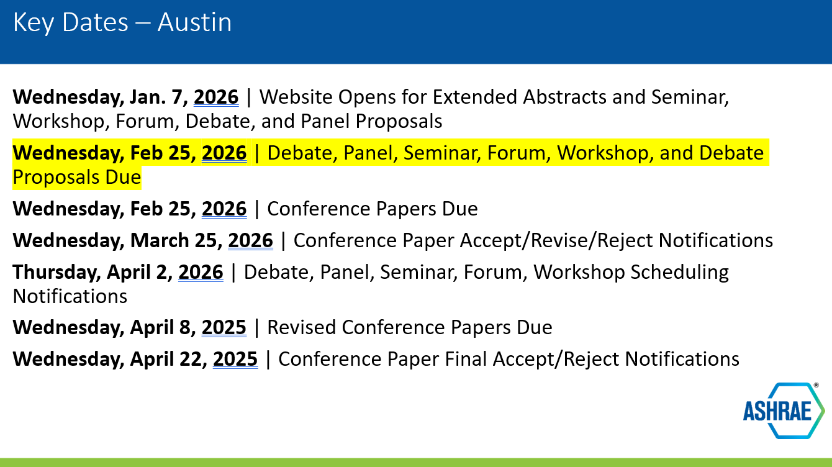
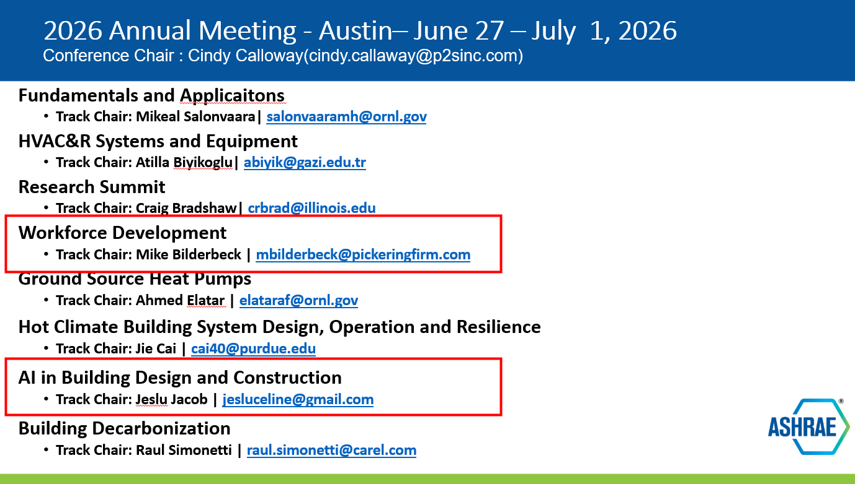
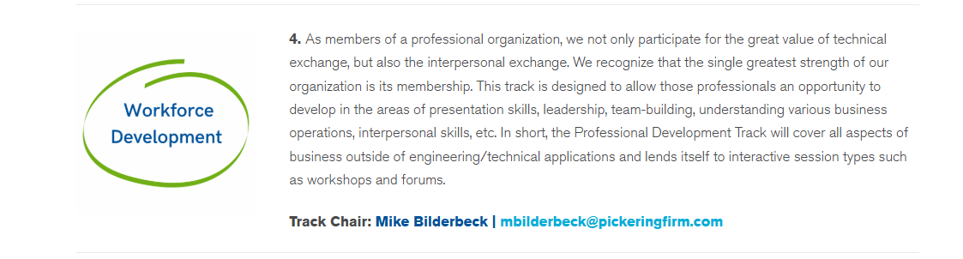
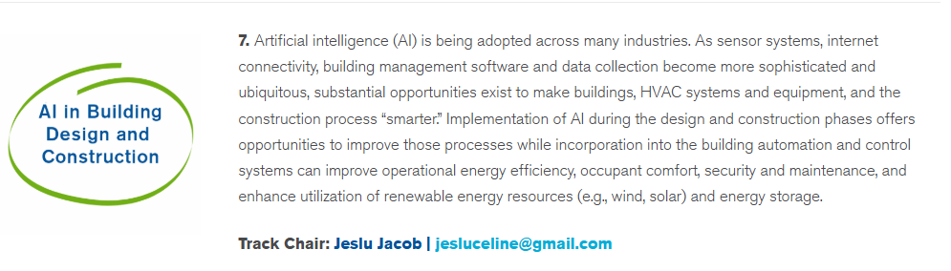

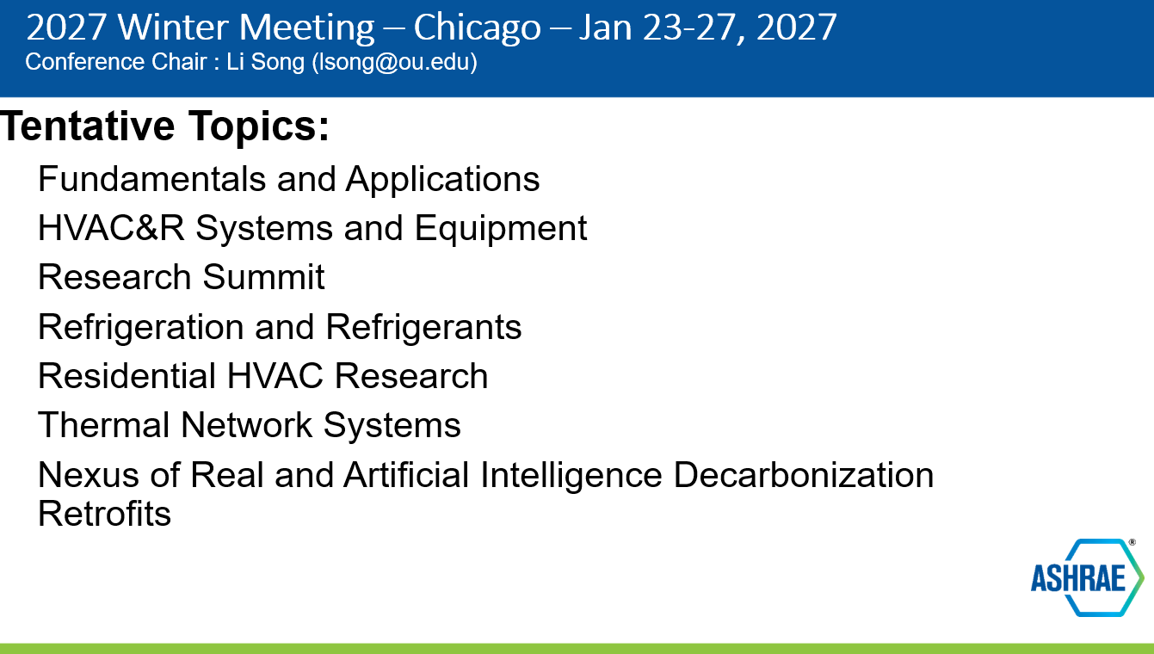

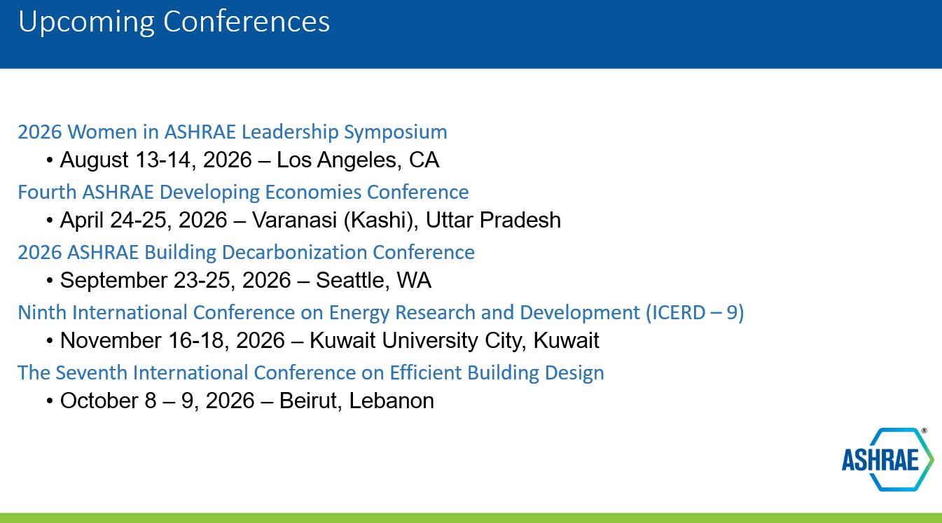
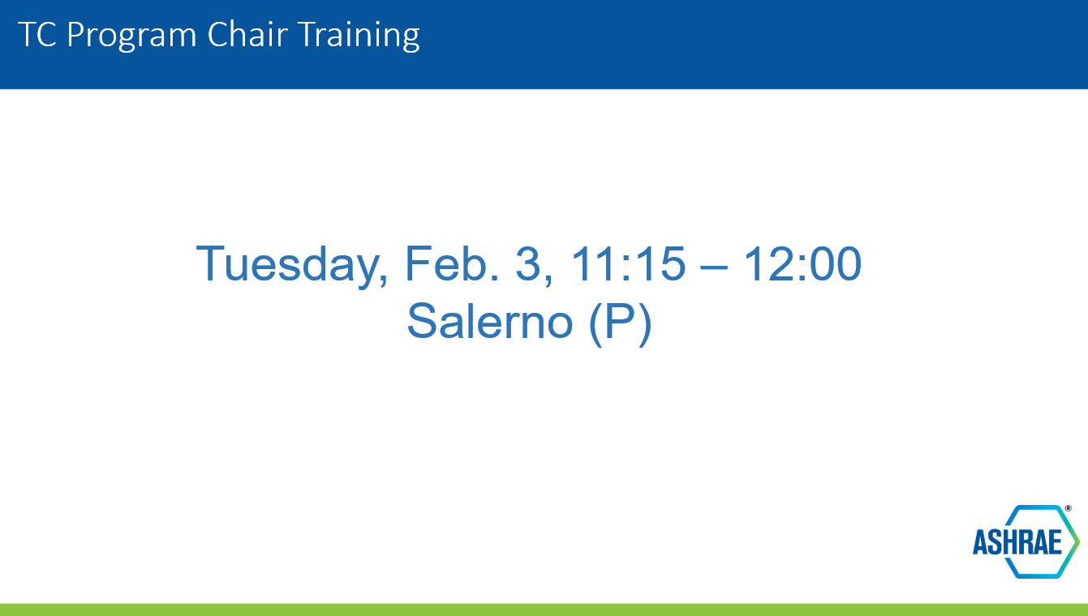
Conference Topics - Master Idea List
  - https://docs.google.com/document/d/1pzkNKlwoaprhk9ja- CtS1XQ07RLoFtZ1Z6S8lMC3dMg/edit
    - Jen will have a program call before the submission date
    - Workforce development
      - Tailored track for contractors in the industry for things like PM
      - AI courses brought on courses for public speaking that TEC wants 1.7 to help champion
      - Mike reached out to MPE people to try to teach as well
    - Summer tracks 2026
      - Ethics?
        - Mike Bilderbeck may become an ethics DL
        - Mike also has a column about dumb things in the industry called “did you know”
        - Drew Chaplain wants COF to do this column every month
        - Make a track for industry Did you know’s
          - COF’s and us to support
      - What each role in our industry does and what those tracks look like
        - Contracting vs design vs pm vs facilities etc
      - Do basics courses
        - Think LR schoolhouse
        - How/what to ask vendors for items etc
        - Focus on YEA and students?
        - “I wish I had known…”
          - Ask: Doug Zens, Chuck gullich,
          - Robin to chair
        - “who would have thought”
        - Steam basics
        - What are steps of design process
        - Who to collaborate with
        - How/what questions to ask
        - Basics course:
          - Julia to chair
          - Mfgs to present their trainings
          - Co sponsor? Have YEA chair? Have more TCs involved?
            - Tell them we were brainstorming and willing to help but don’t want to step on toes bc is not our domain
      - AI topic
        - Can I go to chatgpt?
          - And do what?
          - Where does that IP go?
        - Is CAD trustworthy? Think back to the 90s when it came out
          - NSPE judicated a case this summer about AI and their answer was yes you can use it but you have to be honest where it came from – CITE your sources
      - Design-Build projects
        - How to work with teams
        - DBIA may have some stuff
        - TC 7.2 is DB
        - Whats the value of DB and each role on those teams
        - When does it go bad? How? Whos fault? Where is the liability?
          - Whats in the contract
          - How to protect yourself
        - Alt product delivery basics:
          - Terminology
          - Types and how they fit together
          - How to create a successful partnership and best practices
          - Keith Hammelman to speak
      - PMing?
        - Different by corporate structures – not really broad enough
        - Do a panel about what this is?
          - 3 speakers – 3-4 tips per person
        - Layout how teams interact with each other?
        - Top 10 skills for PMs - Lynndy to Chair
          - Keith Hammelman
      - Ethics
        - Mike cant chair – will plan it
        - Isobel to chair
          - Mike
          - Jen
          - Kristin Schaeffer
          - Lynndy to backup if Kristin is unavailable
    - ALI RFP
      - Want a presenter to teach you how to present
      - Julia to send to Mitchell and Lynndy
      - Proposal due by Feb 23
      - Do get paid for this
- Old Business
- New Business – New Member Model will be voted on in June
  - YEA submitted a topic that we did not know about under 1.7
    - Workshop 4 – Tuesday 9:45
  - Jen to teach Keith how to be programs chair
    - Keith to take over in June
  - Mike B to become voting member
- Next Meetings
  - Next Meeting: Monday in Austin.
  - We will have a programs call in the next 2 weeks before the February 25 submission date.
- Adjourn

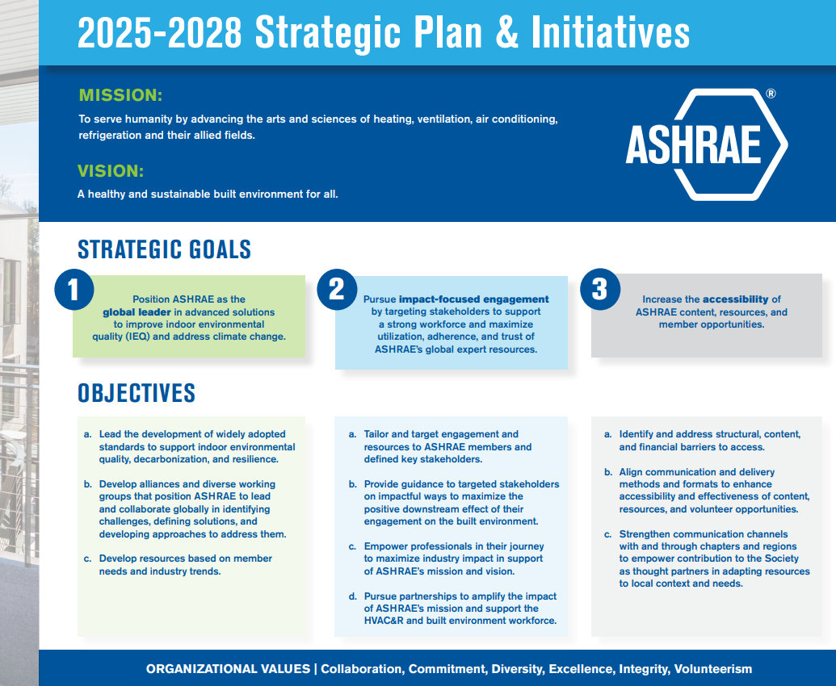

Topics Lists
Change Management – Different Strategies for Managing Change, Thinking in Different Ways & How to get your people to think differently.
Cyber Security and Intellectual property with AI
Where is the controls system going in the generation of AI.
Track – Future Proofing the Build Environment
Managing business expectations as resilience changes
Your liability for not future proofing a building
How does AI and resilience affect our standard of care
How do you design for resilience when resilience is always changing
Who’s liability is it when new equipment causes a project delay
Pit Falls of AI in Smart Building Design
When AI meets the Grids
Converged Networks
When you get hacked through your HVAC systems
The legal ramifications of using AI to monitor your controls systems.
Using AI to preemptively commission your building
How do design professionals work with AI in building automation
Clemson is looking at writing programs to monitor their buildings using AI in conjunction with ASHRAE.
The rate of change of technology in the build environment.

2025 Annual Conference Meeting Minutes
Meeting Location: In-Person
Meeting Date: Mon, 06/23/2025 at 10:30 AM - 12:00 PM CST in the Sheraton Phoenix Downtown, South Mountain (Level 2)

Programs Sponsored or Co-sponsored June 2025:
Sunday, June 22, 1:30 PM – 3:00 PM MST
Seminar 20: The Ethics of Delegated Design and Engineering for Non-Structural Systems
Co-sponsored with TC 2.7

Sunday, June 22, 3:15 PM – 4:45 PM MST
Seminar 22: Your Ethics Tool Box: Building a Framework for Ethical Decision – Making with Case Studies

Monday, June 23, 9:45 AM – 10:45 A PM MST
Seminar 30: Breaking Barrier, Silos and Ceilings with HVAC&R Careers: AEC Industry’s Most Sought After Talent.
Co-sponsored with TC 2.5

Tuesday, June 24, 9:45 AM – 10:45 A PM MST
Seminar 46: Get ‘Em and Keep ‘Em: A Consulting Engineers Guide

- Chair Welcome
  - Committee Scope
    - TC1.7 will educate the ASHRAE membership in business, management and general legal matters, which touch and concern the HVAC industry and its members. The committee will enable this education through the selection of speakers and offers for programs, and through the publication of articles and other educational materials.
  - Ethics Statement
    - In ASHRAE meetings, we will act with honesty, fairness, courtesy, competence, inclusiveness and respect for others, which exemplify our core values of excellence, commitment, integrity, collaboration, volunteerism and diversity, and shall avoid all real or perceived conflicts of interest. Our culture is one of inclusiveness, acknowledging the inherent value and dignity of each individual. We celebrate diverse and inclusive communities, understanding that doing so fuels better, more creative and more thoughtful ideas, solutions and strategies for the Society and the communities our Society serves. We respect and welcome all
Quorum Check– if highlighted they were in attendance.
Julia Timberman | Voting | Chair(6/26)
Robin Bryant | Non-voting | Vice-Chair(6/27)
Lynndy Hedgcoth | Voting | Secretary/webmaster (6/28))
Jennifer Leach | Non-voting | Member
Ken Fulk – Need to change to non-voting member | Voting | Member NonQuarum(6/27)
Mitchell Swann | Voting | Member(6/27)
Keith Hammelman – new program chair | Voting | Member(6/28)
Scott Fanning | Voting | Member(6/28)
Muhammad Saeed | Voting | Member NonQuarum(6/26)
Mohammed El Hetamy | Voting | Member NonQuarum(6/28)

Satheesh Kulankara | Non-voting | TAC Chairman
Natascha Milesi-Ferretti | Non-voting | Section Head
Frank Rivera | Non-voting | Chapter Technology Transfer Chair
Ahmed Kashef | Non-voting | Research Liaison
Paolo Kashef | Non-voting | Standard Liaison
Steven Hammerling | Non-voting | Staff Liaison

- Approval of Minutes from prior meeting - TC Chairs Report
  - Roster Updates
  - TC Communications
    - Website https://tc0107.ashraetcs.org/
    - Basecamp https://3.basecamp.com/3106353/projects/1256953
- Sub-Committee Report
  - Program Subcommittee Report:
    - Next Conference is Las Vegas
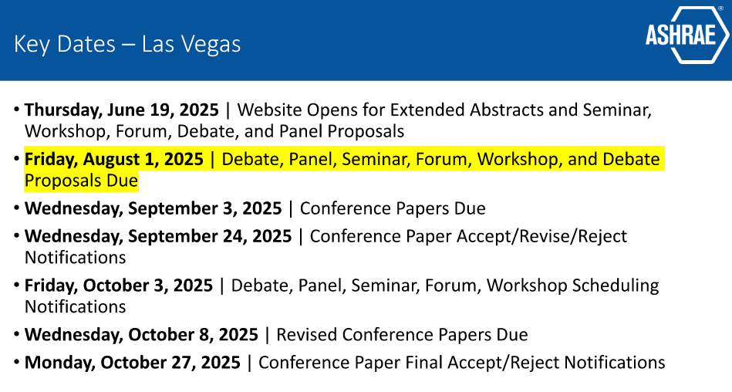
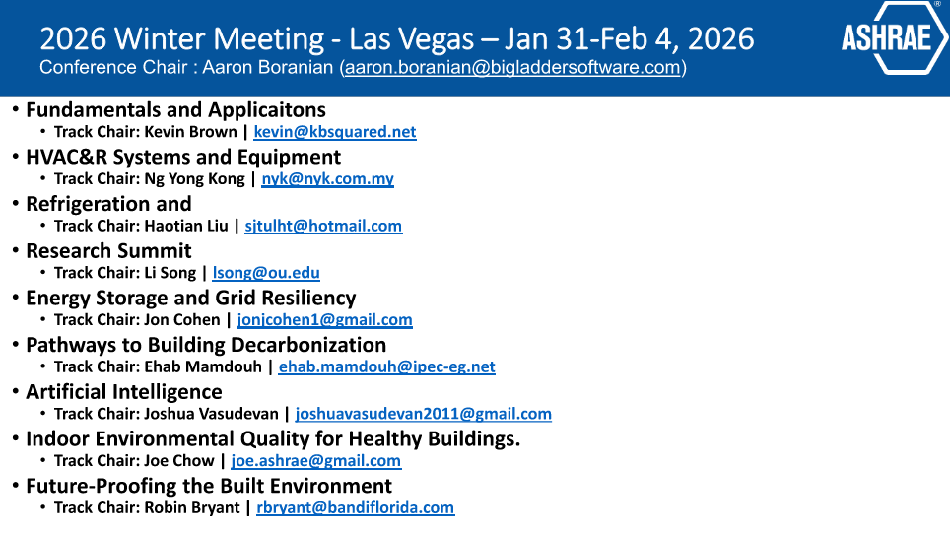

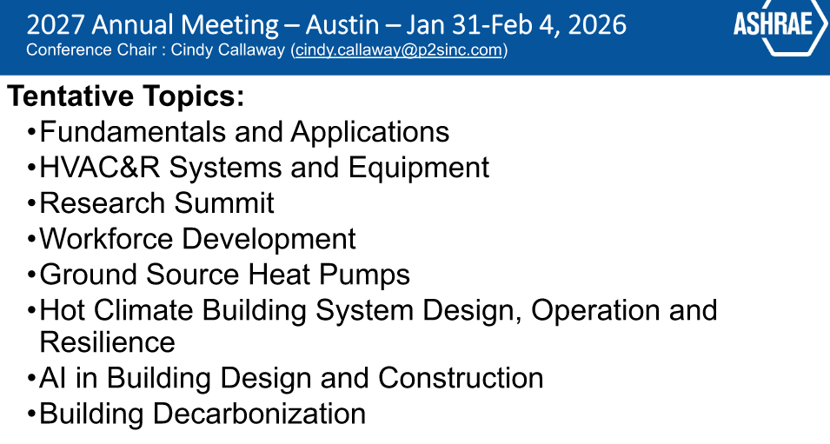Conference Topics - Master Idea List
  - https://docs.google.com/document/d/1pzkNKlwoaprhk9ja- CtS1XQ07RLoFtZ1Z6S8lMC3dMg/edit
      - Jen will have a program call before the submission date
- Old Business
- New Business – ASHRAE has a new strategic plan, please make sure you go read it. We want to make sure our programs align with the strategic plan.
- Next Meetings
  - Next Meeting: Monday in Las Vegas
  - We will have a programs call in the next couple of weeks.
- Adjourn

