

1791 Tullie Circle, N.E./Atlanta, GA 30329
404-636-8400
DRAFT Minutes

TC/TG/MTG/TRG MINUTES COVER SHEET

(Minutes of all Meetings are to be distributed to all persons listed below within 60 days following the meeting.)

TC/TG/MTG/TRG No. TC 8.8 DATE 1/23/2024

TC/TG/MTG/TRG TITLE Refrigerant System Controls and Accessories

DATE OF MEETING 01-23-2024 LOCATION Marriott Marquis Chicago, Henry Clarke (3)

Number of Voting Members Present |  |  |  |  |  | 6
Quorum |  |  |  |  |  | Yes
 |  |  | Term |  |  | Meeting Date
Member | Position | Status | Begin | End |  | 6/23/2023
Dr Christian Konrad Ludwig Bach | Chair | Voting | 7/1/2021 | 6/30/2024
Dr Vance Payne, PhD | Standards Subcommittee Chair | Voting | 7/1/2023 | 6/30/2027
Mr Duane A Wolf, PE | Program Subcommittee Chair | Voting | 7/1/2020 | 6/30/2024
Mr Michael D Ditello | Vice Chair | Voting | 7/1/2021 | 6/30/2024
Mr Nicholas G Zupp | Secretary | Voting | 7/1/2023 | 6/30/2027
Prof Robert R Bittle | Research Subcommittee Chair | Voting | 7/1/2021 | 6/30/2025
Mr Kirk Stifle, PE | Handbook Subcommittee Chair | CM
Mr Parveen Dhillon | Webmaster | CM
Brandon Lane |  | CM
Brenna Keely Erb |  | CM
Dr Bryan P Rasmussen |  | CM
Dr Pradeep Kumar Bansal |  | CM
Everardo Cano Juarez |  | CM
Matthew Spaunhorst |  | CM
Mr Arthur P Garbarino |  | CM
Mr Ben J Johnson |  | CM
Mr Don Schuster |  | CM
Mr Eric Chen |  | CM
Mr Glen L Steinkoenig |  | CM
 |  |  | Term |  | Meeting Date
Member | Position | Status | Begin | End | 1/23/2023
Mr Gurunarayana Ravi |  | CM
Mr Hans Ole Matthiesen |  | CM
Mr James L Jansen, PE |  | CM
Mr Jeffrey A Staub |  | CM
Mr Jeffrey Allen Alsobrook |  | CM
Mr Matthew I Wood |  | CM
Mr Mohsen Farzad |  | CM
Mr Peter G Malone |  | CM
Mr Richie Mohan |  | CM
Mr Robert A Jones, PE |  | CM
Mr Stuart L Dill PE |  | CM
Mr Thomas M Bourquin |  | CM
Mr William E Tinsley |  | CM
Ms Jing Zheng |  | CM
Prof Nick Griewahn |  | CM
Dr Kashif Nawaz, PhD | TAC Section Head | PCM | 6/28/2023 | 6/28/2025
Dr Zachary Siefker |  | PCM | 6/28/2022 | 6/28/2024
Miss Courtney Elise Araiza |  | PCM | 6/28/2022 | 6/28/2024
Mr Brad S Hanneken |  | PCM | 2/7/2023 | 2/7/2025
Mr Justin G Allemann |  | PCM | 2/7/2023 | 2/7/2025
Mr Pablo Cesar Bazan |  | PCM | 6/30/2022 | 6/30/2024
Mr Riyazuddin Shaik |  | PCM | 7/1/2028 | 7/18/2025
Gregory Kalinyak |  | Guest
Mr Carl F Huber, PE | Research Liaison
Mr Drake H Erbe | Handbook Liaison
Mr James W Bochat | ALI/PDC
Mr Philip J Naughton | Standard Liaison
Mr Steven J Hammerling | Staff Liaison
 |  |  | Total Attendees: |  | 14

Call To Order
At xx PM Central time, the meeting was brought to order by the Chair. Technical Committee (TC) 8.8 Title, Purpose, and Scope as well as ASHRAE Code of Ethics and diversity commitment were covered.

Committee Scope
TC 8.8 is concerned with refrigerant flow controls and other refrigerant control devices, including relief devices, check valves, condenser water regulators and oil separators.

Code of Ethics Commitment
This statement should be included on all agendas and read before all committee meetings:

In this and all other ASHRAE meetings, we will act with honesty, fairness, courtesy, competence, inclusiveness and respect for others, which exemplify our core values of excellence, commitment, integrity, collaboration, volunteerism and diversity, and we shall avoid all real or perceived conflicts of interests.

Diversity Commitment
ASHRAE is committed to providing a welcoming environment. Our culture is one of inclusiveness, acknowledging the inherent value and dignity of each individual. We proactively pursue and celebrate diverse and inclusive communities understanding that doing so fuels better, more creative and more thoughtful ideas, solutions and strategies for the Society and for the communities our Society serves. We respect and welcome all people regardless of age, gender, ethnicity, physical appearance, thought styles, religion, nationality, socio-economic status, belief systems, sexual orientation or education.

Voting member roll call completed for Quorum evaluation.
- x of 6 Voting Members present, Quorum established.

Liaison Reports
- TAC – James Bennett
- Carl Huber Research Liaison
  - Capillary Tube and Short Tube Performance for Lower GWP Refrigerants
    - 1937 Work statement returned with comments.

Approval of Winter 2024 Meeting Minutes
- Motion for approving minutes as written:
  - motioned for approval
  - seconded
  - Vote: ( Approved-0 Rejected-0 Abstained-0 Missing)

Next Meeting : Feb. 10-12, 2025 – Orlando, FL

TC Chair Breakfast – Chair

Slides as imbedded file:
- Code Interaction Subcommittee – place to go if we think codes should be changed.
- Technical Activities Committee
- TAC – some roster changes
- Center of Excellence Building Decarbonization (CEBD)
  - Special projects to support decarbonization that are too large to be a volunteer effort.
  - Example publications:
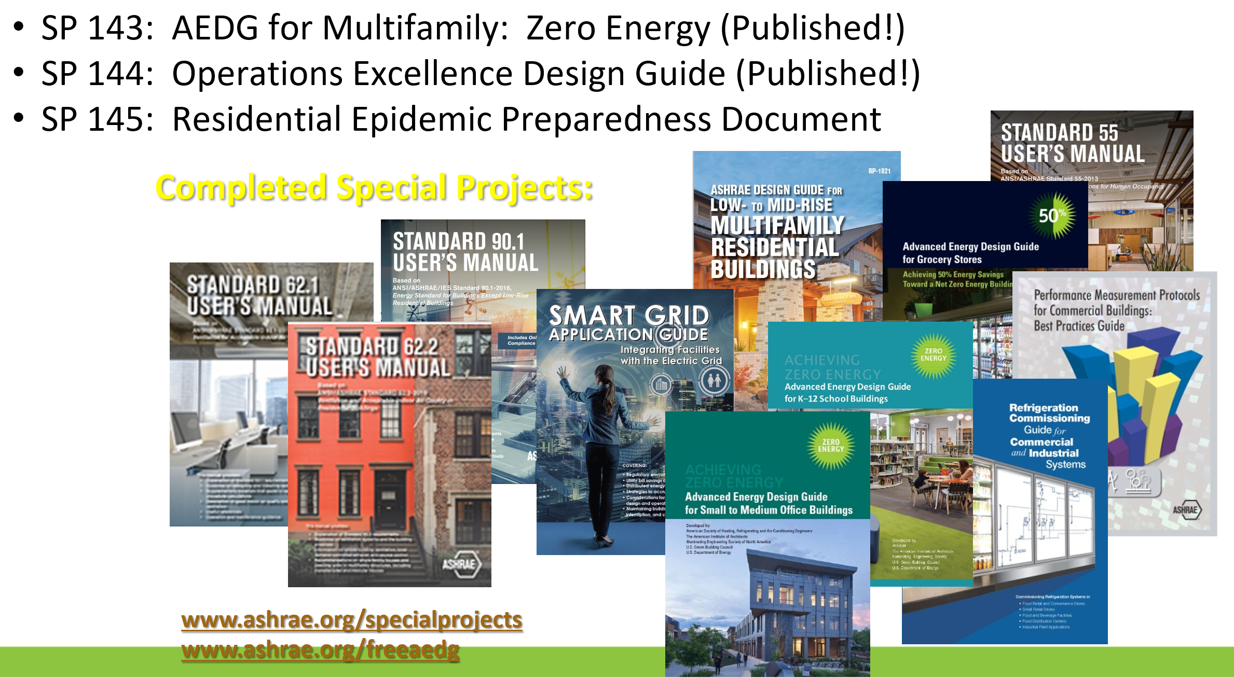
See also: AEDG - Advanced Energy Design Guides (ashrae.org) and Technical Resources (ashrae.org); “specialprojects” link of the slides does not work as of 06/24/2024

- Global Technical Interactions Committee (GTIC), goals, Credit: breakfast presentation:
S.No | Goals
1. | Mine the membership survey and identify the tasks to be undertaken to TAC & RAC
2. | Hold a program at ASHRAE Winter Meeting on International Standards & ASHRAE work relating to de-carbonization
3. | Reach out to TC Chairs and discuss & promote if they need members from International chapters for participation
4. | Implementation of ASHRAE-UNEP cooperation plan
5. | Set-up bridge between 2-3 countries/regions and work for adoption/development of De-carbonization Standards

Note: ANSI is only representative in US, ASHRAE serves as accredited Secretariat for several ISO areas.

- Residential Buildings Committee (RBC) Update
  - Website: https://www.ashrae.org/communities/committees/standing-committees/residential-building-committee-rbc
  - Develop materials to support residential building – topics since ASHRAE’s focus traditionally was on commercial side.
  - Relevance to ASHRAE Strategic Plan: Outreach, Placing ASHRAE as THE source of expertise, Decarbonization, IEQ, Resilience.
  - Request for DL that can talk on residential topics.
  - Request for nominations for RB service award.
- Writing RTARS/ PTARS/WS/WSP
  - PTAR - WSP: Publication development. Need PTAR to coordinate RAC/Publications committee efforts.
  - WS: Identify who could work on the project.
  - Separate presentation on likely upcoming changes:
    - Soft “should” requirement to include co-sponsorship with specific contact name of the potential co-sponsor, as well as a support letter on first draft of WS.
    - Need to include potential bidders, list them on WS form, and confirm that they are aware and have some interest to bid and suitable qualifications.
    - Guidelines on budgeting under development. Budgets should at least include categories.
    - Online database for WS development is under development.
- Breakout session
  - Not available for TC 8.8 chair due to remote participation
Subcommittee Reports
- Handbook – Kirk Stifle
  - Next revision is 2026 Handbook
  - Will form subcommittee 2 yrs before due
  - Add section on ejectors with Stefan Elbel and Dr. Lawrence
  - Send all updates through the authoring portal
  - Heather Kennedy can assist with access if needed
- Membership - Christian Bach
  - To join TC 8.8 or other TCs s a Provisional Corresponding Member, go to www.ashrae.org/joinatc.
  - Need to get creative to get more young engineers to join TC’s
  - Moved Everardo Cano to corresponding member. He can no longer participate. He joined Rinnai (Water heaters; ecjuarez@rinnai.us).
  - Need to fix membership date roster bugs for Kirk and Parveen.
Table 1, Roster as of 01/20/2023
Named (VM, position) – Action for start of 2024 Society Year | Year appointed to Year Roll Off
Christian Bach (currently VM, chair) – Move to secretary | 07/01/2021 to 06/30/2024
Kirk Stifle (non-voting; Handbook Subcommittee Chair) - Roll on to Voting member | 07/01/2021
Nicholas Zupp (VM, Secretary) - Move to Vice chair | 07/01/2023 to 06/30/2027
Vance Payne (VM, Standards Subcommittee Chair) | 07/01/2023 to 06/30/2027
Duane Wolf (VM, Program Sub Chair) Move to chair – Move to Chair | 07/01/2020 to 06/30/2024
Parveen Dhillon (non-voting, Webmaster) | 07/01/2022
Robert Bittle (VM, Research Subcommittee Chair)) | 07/01/2021 to 06/30/2025
Mike Ditello (VM) – Roll Off as Voting Member to Corresponding Member | 07/01/2020 to 06/30/2024

- Website – Parveen Dhillon
  - Website -
- Research – Robert Bittle -
  - RTAR 1937 Capillary Tube and Short Tube Orifice Performance for Lower GWP Refrigerants (co-sponsored with TCs TC 1.3, TC 8.11, TC 10.6, TC 10.7)
    - Working on Work Statement
      - Asking for additional members to help write the WS
    - Awaiting good example of an experimental heavy Work Statement
    - Needs help estimating cost of the research (Christian Provided)
    - Discussion on direction (reduce scope vs. high cost)
  - Request for research of 4-way reversing valve thermodynamic, heat transfer, and fluid flow characteristics (Now RP-1969)
    - Received input from Bo Shen (ORNL), Duane Wolf (Sanhua), and Andy Hjortland (JCI).
    - No progress on work statement.

- Standards – Vance Payne (needs edits)
  - Standard 17 – Method of Test (MOT) for Thermostatic Expansion Valves – No action needed this year
  - Standard 28 MOT Flow Capacity Cap Tubes – Shortly to come up for review
  - Std 153 – MOT for Four-way Refrigerant Reversing Valves – Next to be revised
  - Std 158.1 MOT Capacity of Refrigerant Solenoid Valves – No action needed this year
  - Std 158.2 MOT Capacity of Pressure Regulating Valves – No action needed this year

- Program – Duane Wolf
  - Ideas
    - Forum for 4-way Reversing Valves?
    - Ejectors Seminar ?
    - Should do a basics seminar every 3 to 4 years for new engineers
Old Business
- Obtain feedback from committee members on participation in their regional chapter(s). Do we engage on national as well as local level?
  - Only 2 members engage in local activities of those present (14)

New Business
- Complete technical activities form during meeting

Motion to Adjourn
- made motion to adjourn
- Seconded by
- Vote: ( Approved-0 Rejected-0 Abstained- 0 Missing)

