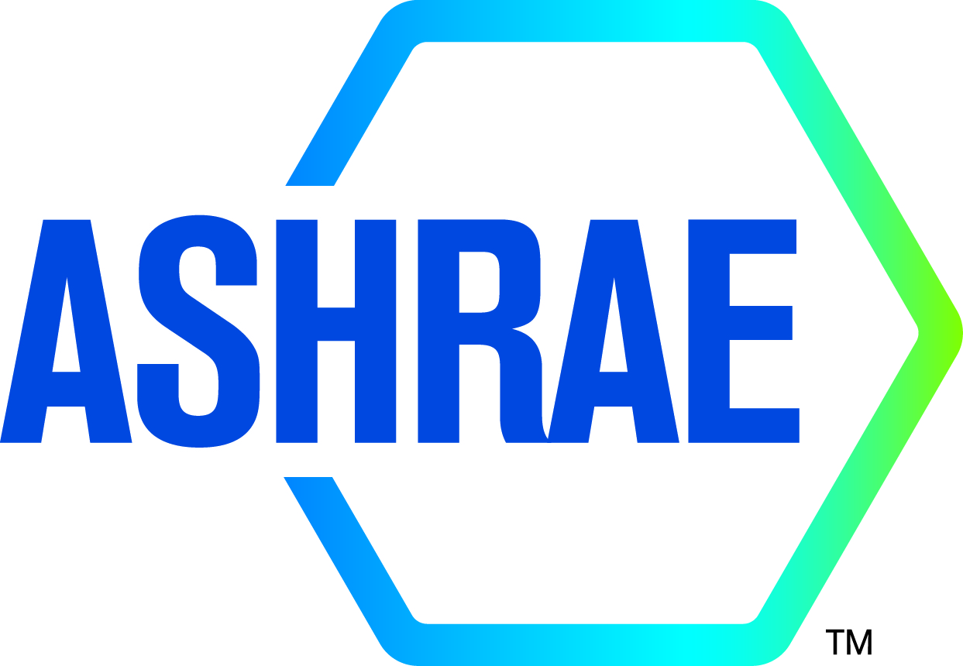

M I N U T E S

APPROVED

TC8.03 Absorption and Heat Operated Machines

2023 ASHRAE ANNUAL MEETING - TAMPA
Hybrid

Main Committee [Hybrid]: Monday, June 26th, 2023 at 1:00 PM – 3:00 PM EDT
In Person Location: Tampa Marriott Waterside, Meeting Room 10(3)

TC8.03 Subcommittee Meeting (Research/Program/Handbook) – Monday, June 19, 2023 at 1:00-3:00 PM (ET)
Location: Zoom

Minutes

- Call to order Ziviani
Meeting was called to order at 1:10 p.m.

- Review Scope Ziviani
Technical Committee 8.03 is concerned with the design, performance and application of equipment energized by a heat source and using a thermodynamic cycle to provide an air-conditioning, refrigerating or heating function; with the properties of absorbent solutions or special working fluids used in these cycles; and with components of the cycle requiring specific design characteristics.

- ASHRAE Code of Ethics Commitment Ziviani
In this and all other ASHRAE meetings, we will act with honesty, fairness, courtesy, competence, integrity and respect for others, and we shall avoid all real or perceived conflicts of interests. (See full Code of Ethics: https://www.ashrae.org/about-ashrae/ashrae-code-of-ethics)

- Introductions All
  - Establishment of a Quorum Fronk

VOTING MEMBERS FOR THIS MEETING (Need 4 for a Quorum)
VOTING MEMBERS FOR THIS MEETING
 | Douglas Davis (6/2025)
X | Brian Fronk (6/2024) |  |  | Juergen Scharfe
X | Kyle Gluesenkamp (6/2024) |  | x | Davide Ziviani, Chair (6/2023)
X | Christopher Keinath (6/2024) |  |  | Saeed Moghaddam, UFL (from 07/2023)
X | Jay Kohler (6/2024) |  |  | Will Ryan (from 07/2024)

The TC presently has 5 voting members. A roll call of the voting members was taken, and a quorum was/was not established with 4 of 6 Voting Members present with chair non-voting.

  - Total Attendees: 17 (In person) and 5 (online); 2 new member; YEA members: 2

- Agenda additions All
[Davide Ziviani] Basecamp TC8.3

- Liaison reports (as they arrive) Liaisons
TAC Section 8 Head Charles Henck
RAC Liaison Section 8 Carl Huber

Charles Henck briefly reported on updates from TAC

- Minutes Approval Ziviani
Motion to approve the minutes from 2023 ASHRAE Winter Hybrid meeting made by Jay Kohler; Second: Jay
The motion passed. (4-0-0-1, CNV)

- Chair’s Report Ziviani
  - Chair’s Closing Remarks
  - TC/TG/TRG/MTG Chairs’ Breakfast & Training Meeting (Sunday 06/25/2023 7-9am EDT)
  - Research Subcomm Chair’s Breakfast (Monday 06/26/2023 7:00-9:30 am EDT)

TC Chair Breakfast:
- Task Force Building Decarbonization updates: embodied carbon
  - California by July 1, 2025, whole life carbon reporting
  - TFBD is extended till 2023-24; need to engage TC liaisons in these working fluids
    - Expedite technical resources that deliver and operate low-carbon buildings
    - Whole-life carbon
    - Coordinate task force activities with TCs
  - Technical resources available
  - Education:
    - Building decarbonization 101 is available.
    - 100 series seminars in the fall
    - Multiple ALI courses (3 hours)
    - Request for proposals for trainings; RFP issued in August 2023
    - www.ashare.org/decarb
  - TC Liaisons to TFBD:
    - Identify liaisons to be familiar with decarbonization activities and take leadership
    - WG Chair may request engagement from TCs
- Government Affairs Department (Alice Yates, Director of Government Affairs)
  - Build relationships between the society, and all levels of government in the US and the appropriate international community representations.
  - Facilitate the transfer of technical counsel and assistance
  - Bi-weekly updates; outreach events, tracking legislation/regulations; support webinars, briefings, and hearings for policy makers
  - GAC to Member Council
  - Letters, Testimony, Responses to RFIs, etc.
  - www.ashare.org/government-affairs
- ASHRAE Strategic Plan and DEI:
  - Reevaluate and restructure Functional Groups (FGs)
  - Collaborations between different TCs (formal structure will be forthcoming)
  - Embrace activities for sustainable and high performance building
  - DEI:
    - Training material on DEI: https://www.ashrae.org/about/diversity-equity-and-inclusion-dei
    - Panel 2: DEI Within Your Organization
- Activity Forms: 9PM June 27th

Research SubCom Breakfast:
- 0 RTAR; 6 WSs; 1 accepted with comments; 5 returned; 4 contractor selections for 4 projects
- RAC Membership Bill Murphy (Chair SY2023-24)
- Awards:
  - GIA 43 candidates; 20 awards
  - Service to ASHRAE Award submission deadline September 1, 2023
  - ASHRAE NIA Dr. Ziviani
  - ASHRAE IRG not awarded due to no blue sky ideas
- RAC Expenditure:
  - $5.0M in SY2019-20, …, $5.5M in SY2022-23. RAC increased max funding to $250k to $350k due to COVID inflation.
    - Students 12 months/20hr week $100k-140k; 2 years $250k-330k
    - Students 3 years, $350k-450k total
  - Lots projects with 0 bids
  - Find cost share from other organizations (e.g., pay for RAs or else) upfront
- RTAR: before end of year, online RTAR submission portal. Then we will transition to WS
- PTAR:
  - Approximately 10% of research budget
  - Design guides/manuals etc.
  - Commercial needs and too much effort for volunteers
  - Requirements:
    - Publication needs
    - Target audience
    - Why funded vs volunteer
    - Goes to MORTS; Publication Committee
    - If approved, WSP (Work Statement for Publication which has proposed table of contents instead of Scope/Technical Approach
- ASHRAE’s Research Strategic Research Plan

- Membership/Roster Doug Davis
  - Davide Ziviani continued to clean up the roster and update contacts.
  - TC leadership and current positions held by various members were reviewed.
- [Suggested Amit] Jay is rolling off 06/2024 and looking for a replacement. Discussions at 2024 ASHRAE Winter Meeting in Chicago
- Brian Fronk, Chair
- Haotian Liu, Vice-Chair
- Saeed Moghaddam, Research SubCom. Chair.

- Subcommittee reports
  - Programs Bill Ryan
.
TC 8.3 submitted for Tampa and not approved:
Seminar proposal (Intermediate), “Thermally Driven Heat Pumps for Low Carbon Grid Resilience. Track: Future-Proofing the Built Environment.
For 2024 Winter Conference in Chicago:
Track 1: Fundamentals and Applications (Track Chair: Craig Bradshaw)
Track 2: HVAC&R Systems and Equipment (Track Chair: Ng Yong Kong
Track 3: Refrigeration & Refrigerants (Track Chair: Atilla Biyikoglu)
Track 4: Decarbonization & Climate Change (Track Chair: Som Shrestha)
Track 5: Hydronic Systems (Track Chair: Joe Chow)
Track 6: Ventilation, Indoor Air Quality and Air Distribution Systems (Track Chair: Ahmed H. Abdel Salam)
Track 7: Comfort, Indoor Environmental Quality and Energy Efficiency (Track Chair: Kristen Cetin)
Track 8: HVAC&R Controls (Track Chair: Alekhya Kaianabhatta)
Track 9: Project Delivery Methods (Track Chair: Ehab Mamdouh Abu Taleb)

Subcommittee discussion: TC6.2 & TC1.10 (Main Comm 6/27) on hydronic systems/district heating systems (Amit possible speaker district heating by absorption heat pump/case studies in Europe); potential resubmission (Tracks 1/2/5) and tweak the title (Thermally Driven Heat Pumps for ….).
[DZ] Working fluid pairs (Track 3 – Saeed / S. Garimella / Kyle)

Seminar proposal: Track 2 “(tentative) Thermally-driven heat pump for cooling and heating” Speakers: Saeed(?)/Amit / Stefan Elbel [Motion by Davide Ziviani; second by Brian Fronk 4-0-0-1 CNV]

Motion: co-sponsor a program proposed by TC 6.2 or TC1.10 for 2024 Winter Conference Chicago [Motion by Davide Ziviani; second by Brian Fronk 4-0-0-1 CNV]

  - Research Kyle Gluesenkamp
Ongoing RTAR/WS/TRP:
    - WS-1796: Application Guide for Absorption Chillers and Heat Pumps Submit as PTAR [Kyle Gluesenkamp to check on the procedure for applying]
      - Looking for volunteers to draft the PTAR; Davide Ziviani will check PTAR process and bidding rules. Report to 2024 ASHRAE Winter Meeting in Chicago
    - WS-1842: Development of Co-Generation Tools for Building Designers (eQuest) Dropped
    - New topics:
- H2/H2-mix combustion: design vs. application vs. energy carrier; performance is not much different, but it is challenge for combustion side. Potential for HX optimization and compact design
- [Saeed] H2 potentially for storage. Assessment/trade-offs study
- [Jay] Heating appliance needs?
- [Paul] If H2 comes along, what are the implications? Electricity distribution (e.g., more electricity produced with grid at capacity)
- [Zhiyao] hydrogel with embedded salt with high uptake and waste heat with regeneration temperature 50/60 C. Check on vapor pressure and hydrogen bond [Saeed]
- Saeed/Ziviani/Fronk: schedule a meeting for discussing research and roadmapping in the fall.

  - Handbook Juergen Sharfe
[Davide Ziviani] Two manuscripts:
      - Application Guide for Absorption Cooling/Refrigeration Using Recovered Heat (1995) – RP-773
Notes from Subcomm. meeting: seeking for support on drafting PTAR proposal. Doug volunteered to help Davide. Proposed a new title “Application Guide for Thermal Cooling and Refrigeration Systems”

Fundamentals Chapter 2 needs to be reworked.

  - Standards Jay Kohler
[David Scearce, Chair] Update on SPC40
    - We have combined all sections into a complete document.
    - We are working to include Subsection 8.6.3 to cover indirectly heated systems.
    - We are investigating whether to reference ASHRAE 41.13 in subsection 8.6.1 and remove the table that lists heating values of various fuels.
    - In Tampa, we will start going through the complete document to resolve any outstanding comments. Once that is completed, we will be ready for public review.
    - [David Scearce] A few paragraphs to update and then go for public review in a few months.

[Amit Vatsa] SPC 182R “Standard 182-2020, Method of Testing Absorption Water-Chilling and Water-Heating Packages”
    - [Amit/Jay] Schedule meeting in Chicago and possibly a virtual kick-off before Chicago. Contact Liaison from Standards Committee. Kick-off at some point in August and in-person meeting in Chicago.

  - Website Chris Keinath
- Website is up-to-date
- Research Projects have been updated by Kyle and will be reflected on the website.
- Old Business
  - The Chair asked opinions from the members if anything is pending from old meetings.
None

- New Business
None

- Adjournment
Motion to adjourn made by Brain and seconded by Jay.
    - Meeting was adjourned at 2:30 p.m. (ET)

