

- Call to Order
T.C. 6.8 FULL COMMITTEE MEETING DRAFT MINUTES
Tuesday, January 23, 2024
TC 6.8 Ground Source Heat Pump and Energy Recovery Applications
2024 Winter Hybrid Meeting Location: McCormick Place West, W180 (1)
3:00 PM CDT

- Welcome, Introductions, and Sign-In
CURRENT VOTING MEMBERS
- Dr. Michel Bernier (20)
- Craig Buschur (23)
- Steve Carlson (19)
- Brendan Hall (24)
- Steve Hamstra (23)
- Howard Newton (24)
- Carl Huber (20)
- Dr. Xiaobing Liu (20)
- Lisa Meline (23)
- Harrison Skye (23)

Rolling off 6/30/24
- Dr. Michel Bernier
- Steve Carlson
- Carl Huber
- Dr. Xiaobing Liu

Rolling on 7/1/24
- Robert Brown
- Mike Filler
- Matt Mitchell
- Gary Phetteplace
- Roshan Revankar
- Visitor Welcome: 1st timers and YEA
- Review Voting Members & Determination of Quorum
  - Need 7/12 without members non-quorum
- Approval of minutes from Winter 2023 Meeting – Tampa, FL
  - Harrison Skye 1st motion
  - Carl Huber 2nd
  - Unanimous vote: 10/0/0 Y/N/A
- Announcements from ASHRAE
  - Section Head – Doug Reindl
    - Programs advice for approval
    - ASHRAE strategic plan requested
    - Membership changes will happen after Indy
  - Liaisons
    - Staff – Steven J Hammerling
    - Standards – Paolo M Tronville
    - Research – Stefan Elbel
    - Handbook – Dhamshala (S)/Werman (A)
    - TAC – Craig S Messmer
    - ALI/PDC –
    - Codes - Steve Ferguson
    - Chapter Technology Transfer Chair – Elizabeth M Zakelj
- Announcements from the Chair
  - New software for membership coming
  - Officers
    - Chair: Howard Newton
    - Vice Chair: Roshan Revankar
    - Secretary: Brenden Hall
    - New Voting Members to replace those rolling off (4)

Subcommittee chairs –all present
    - Research: Harrison Skye
    - Geothermal handbook: Matt Mitchell
    - Applied heat recovery: Mike Filler
    - Standards: Bob Brown
    - Programs & Education: Steve Kavanaugh
    - Membership: Lisa Meline and Craig Buschur
    - Webmaster: Craig Buschur

Subcommittee Reports:

  - Research - Harrison Skye
TC 6.8 Ground Source Heat Pump and Energy Recovery Applications
2024 Winter Hybrid Meeting Location: McCormick Place West, W180 (1)
    - Grants back to full strength from ASHRAE
    - Work statements and RTARs
      - WS 1890 Update
        - Completed literature research search
        - Made test model with vertical, horizontal, tees, elbows, dead legs, etc.
        - Next step to pipe size variations up to 12”
        - Good progress is being made with the project
        - Meetings to be public so link will be shared online
      - RTAR 1953 Thermal Energy Storage with geothermal
        - Being developed currently and looking for more support
      - Draft RTAR Grout Research study with Lisa Meline
        - Research Literature collection first step of the project
        - Comparing to water wells
        - Not practical to current installation requirement creating unnecessary cost addition to installations
        - Referring to the Nebraska grout study, which mostly focused on water well grout and made some general state
        - 6-9 months duration period
        - Committee Vote
          - Lisa Meline 1st with addition of comments received
          - Steve Hamstra 2nd
          - Vote unanimous 10/0/0 Y/N/A
  - Kirk T. Mescher Award – Lisa Meline
    - No interest and looking for feedback to the award modification
      - Sharable Document and perhaps something to pass around
      - Available on website
      - Extend to Indy award in May
  - Geothermal Handbook - Matt Mitchell chapter 35
    - Handbook submitted in mid-April and updated to ASHRAE should be updated soon
    - Next cycle comments are due again in April 2026
    - Looking for a new handbook subcommittee chair
    - Piping update
  - Applied Heat Recovery – Mike Filler chapter 9
    - More membership addition requested
    - Virtual or in person being discussed
    - Handbook chapter 2028
      - Refrigerant updates
      - Newer systems updates
      - Thermal Energy Storage

  - Standards – Bob Brown
    - ASHRAE 13256-1 being replaced with AHRI 600 and then will be sunset approx. 2-3 years
      - AHRI 600
      - Data map testing points of performance map
        - Full load and part loads

        - External static is factored in
TC 6.8 Ground Source Heat Pump and Energy Recovery Applications
2024 Winter Hybrid Meeting Location: McCormick Place West, W180 (1)
        - Heat exchanger penalty still exist
      - Data is applied to IEER formula ICOP
        - Watts from tower, pump, and entire system wattage included
      - Residential section is under development : SEER HSPF SCORE AND SHORE
      - 13256-2 Water to Water to be replace by AHRI 660 to begin development and then sunset
      - IRA also mentions DOE Nov 2024 will require IEER and ICOP
      - 90.1
        - Minimum efficiency product development coming
        - Hoping for IEER
        - Shawn Hern is chair of 90.1 committee
          - PSC Motors are being replaced by ECM motor requirements
      - CSA 448 Jeff Hammonds
        - Late Spring 2024 for public review
  - Programs - Steve Kavanaugh
    - Publications update
    - Programs
      - 2 submissions and 0 were approved in Chicago
        - Bob Brown and Steve Carlson to put together presentation
        - Lisa Meline CSA 448 presentation
        - Mike Filler IRA tax Credit on geothermal working on speakers
        - Thermal Energy Storage would like us to cosponsor
          - Hybrid battery
          - Ice bank storage project in NY
          - Heat pump thermal storage
        - Xiaobing Liu Thermal Energy Storage Integration with geothermal
          - Steve Carlson 1st motion
          - Xiaobing Liu second motion

Vote: 10/0/0 Y/N/A
        - Decarbonization strategies
          - Direct Exchange updates new refrigerants and update CO2
          - Craig Buschur chair with Bob Brown for more speakers
        - Feb 26,2024 deadline for submissions
        - Lisa Meline 1st
        - Steve Hamstra 2nd
        - Vote: 10/0/0 approved Y/N/A
      - Seminar 19 co-sponsored ground source heat pump
      - We are hoping to share on Base Camp – Eric Peterson will post there
      - Beneficial Electrification
  - Membership - Lisa Meline and Craig Buschur
    - Updates and added corresponding members, new software program coming, working to correct the mistaken dropping off of corresponding members

  - Webmaster - Craig Buschur
TC 6.8 Ground Source Heat Pump and Energy Recovery Applications
2024 Winter Hybrid Meeting Location: McCormick Place West, W180 (1)
    - Minutes & Virtual meeting agenda
    - New person to fill webmaster position
      - Scott Martin volunteered to fill webmaster position

6. Industry Liaison Reports:
  - IGSHPA – Jeff Hammond
    - May 28-30 Research Conference in Montreal
    - March 2025 next IGSHPA annual conference
    - Board expansion
    - Training modules are being updated
    - Greg Kurtz new training chairmen
  - GEO – Ryan Daughtery
    - IRA inclusion
      - IRS still publishing content
      - Direct pay entity to access the tax credits
        - IRS workshops coming to help out
    - Comments posted on geothermal third party ownership comments
    - DOE GSHP Employment impacts report
    - GEO EXCHANGE and IGSHPA are collaborating together and growing

Old Business
  - Use of TC 6.8 Base Camp – If you would like to be added to the list to access our TC 6.8 Base Camp, please email Howard Newton at howard.newton@iegmep.com and in the Subject Line enter TC 6.8 Base Camp – Add Me

New Business
  - TC 5 Electrification and hydronic heat with geothermal heat pumps co-sponsor with TC6.8
- Harrison Skye 1st motion
- Craig Buschur 2nd motion
- Vote in favor of co-sponsorship 10/0/0 Y/N/A Speakers needed
  - Programs Subcommittee to update… Electrification & DE carbonization with Hydronics – Draft Title
- Adjourn

TC 6.8 Geothermal Heat Pump and Energy Recovery Applications
2024 Winter Hybrid Meeting – Chicago, Il Location: McCormick Place West, W180 (1)

TC 6.8 Energy Recovery Subcommittee Tuesday, January 16, 2024 at 11 am EDT over MS Teams
2024 Winter Meeting Minutes
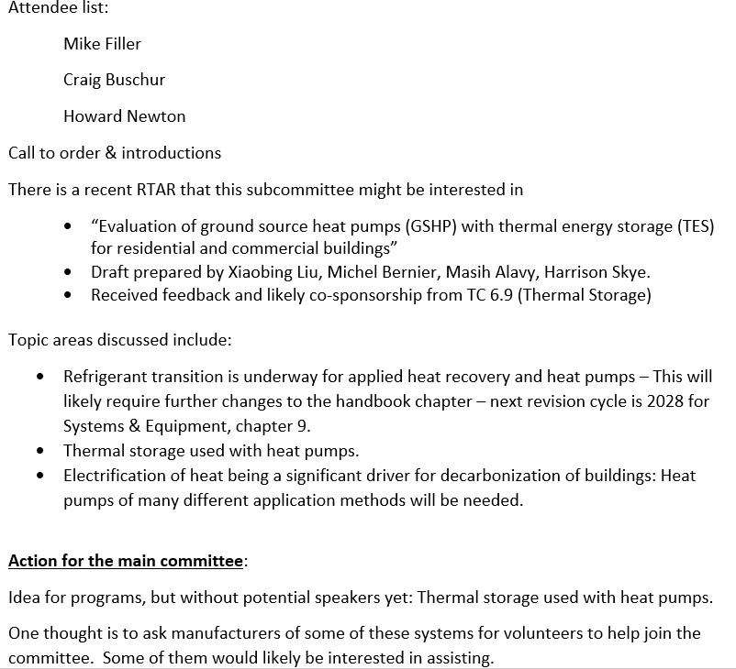

New Research Chair
T.C. 6.8 Research Subcommittee Meeting Minutes
Thursday, June 20, 2024
11:00 AM-12:00 PM (Eastern)
TC 6.8 Geothermal Heat Pump and Energy Recovery Applications
2024 Summer Meeting in Indianapolis, IN Location: JW Marriott, Room 107 (1)
Agenda prepared by chair, Harrison Skye (harrison.skye@nist.gov)

- Incoming: Matt Mitchell, Outgoing: Harrison Skye

Active Research Projects
- 1890-RP “Minimum flow velocities for purging air and debris from hydronic piping systems.“
  - Contractor: PurgeRite (P.I. Russel Buras)
  - Timeline: April 2023 – May 2025
  - Co-sponsors TC 6.1 & 6.2
  - Meetings are open to the public, and posted on Basecamp!
  - Status:
    - PMS last met with contractor on April 26, 2024.
    - Contractor completed design of “complex” design using 6-in. clear PVC pipe and has some preliminary data.
    - Preliminary data show the debris seems to have 2 modes of travel based on orientation of the debris, e.g., bolts will move differently through the vertical column depending on orientation.
    - So far the data are falling in line with contractors experience and recommendations in the field. They recommend 5 ft/s, and that is enough to clear all the debris so far. Some people use 3 ft/s because it can be difficult to get high velocities in large pipe.
    - Haven’t done any air purging yet, so far they are focused on Debris.
    - They are planning to test sand & mud at a later date, after they have a handle on the solid debris.
    - Some unexpected results of material hang-up on a lip of a PVC 90-degree elbow.
    - PMS suggested contractor post videos of material movement on YouTube.
    - Next steps
      - Complete construction of 6 in. steel testing apparatus.
      - Compare CVPC vs. steel results.
      - Determine best video data collection.
      - Finalize all data points to measure.
  - Project Monitoring Subcommittee: Lance MacNevin, Lisa Meline, Gary Phetteplace, Howard Newton, Steve Tredinnick, Harrison Skye (Chair)

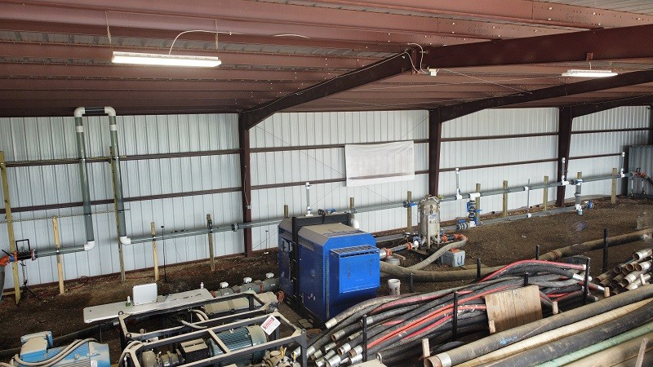
Picture of the 6-in. PVC pipe test setup.
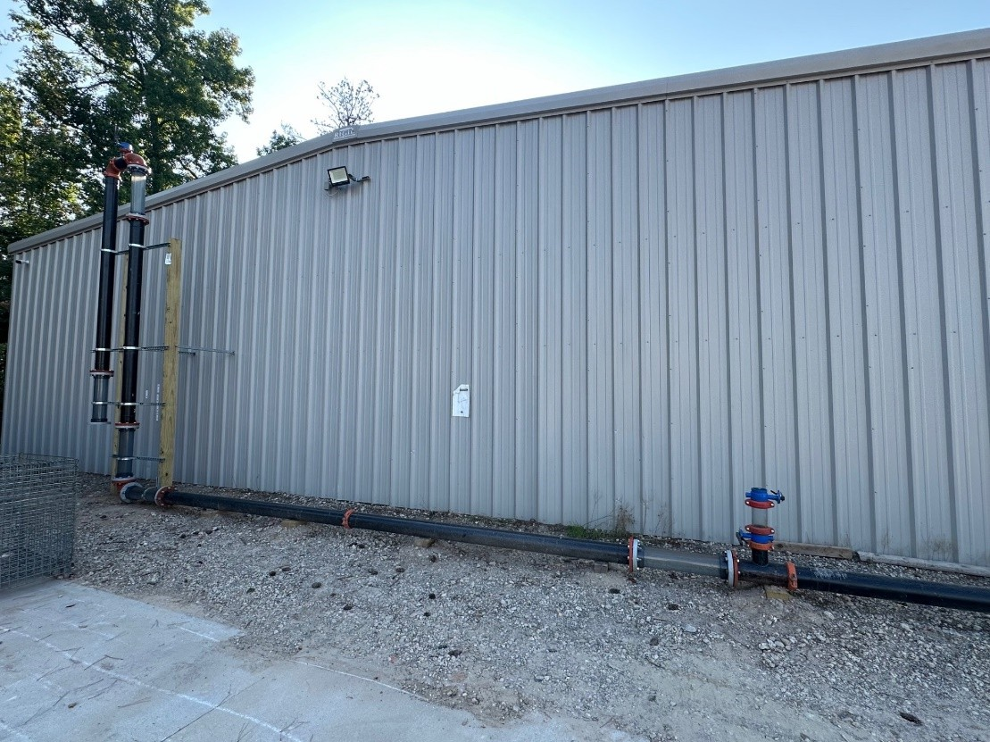
Picture of the 6-in steel pipe test setup.

Tentative Research Projects (approved for bidding)
- None

Work Statements (WS)
- “Evaluation of ground source heat pumps (GSHP) with thermal energy storage (TES) for residential and commercial buildings”
  - Approved by RAC with comments.
  - Work statement drafted by Xiaobing Liu, Masih Alavy, Michel Bernier, Rick Clemenzi, Eckhard Groll
- “Study of Current Ground Heat Exchanger Grout Technologies”
  - RTAR approved with comments in May of 2024.

  - WS development under way by: Lisa Meline, Rick Clemenzi, Craig Buschur, Tyler Harbeck, Steve Kavanaugh, Howard Newton, Matt Mitchell, Roshan Revnakar, Harrison Skye.
  - Committee met on June 17, 2024 for WS development kickoff.

T.C. 6.8 Informal meeting about Work Statement WS-1970 “Study of Current Ground Heat Exchanger Grout Technologies”
TC 6.8 Geothermal Heat Pump and Energy Recovery Applications
2024 Summer Meeting in Indianapolis, IN Location: JW Marriott, Room 107 (1)
Monday, June 17, 2024 11:00 AM-12:00 PM (Eastern)
Minutes prepared by chair, Harrison Skye (harrison.skye@nist.gov)

Attendance
  - Approx. 6 members attended the virtual meeting. See screenshot at end for list of names (please include affiliation in screen name).
  - Rick Clemenzi, Tyler Harbeck, Jeff Hammond, Howard Newton, Lisa Meline, Roshan Revankar, Harrison Skye

Brief discussion of WS topic, to orient newcomers
•

RAC comments on RTAR
  - RAC approved the RTAR “with comments” that need to be addressed in the WS.
  - Praise from RAC:
    - “Background is clearly defined, and this research is important since GSHP are a very efficient technology.”
    - “Grouting background is well described for ground source applications with the appropriate supporting documentation.”
    - “The need for the study is justified via what is happening in California and Utah with new requirements and the lack of up-to-date information on new grout materials.”
    - “As described the research is needed to clarify the situation on grouts used in GSHP.”
    - “This research is needed to keep the high-quality standard of this technology and avoid ground water contamination by surface water.”
    - “The research would benefit ASHRAE, by helping the Geothermal Industry produce more efficient applications which align the goal of reducing carbon emissions.”
    - “This research highlights an area where ASHRAE can be responsive to the needs of industry with practical research.”
    - “The objectives are clear.”
  - Critical RAC comments:
    - Category - Administrative
      - “Provide reasons for the absentee or no votes.”
        - Response: There were no absentee or “no” votes.
      - “MORTS and the RAC Liaison were not consulted or contacted for submission.”
        - Response: The RAC liaison reviewed the RTAR and submitted the RTAR.
    - Category - Document Structure
      - “There is no description in the approach section, however, much of the objective section is approach.”
        - Response: This issue will be addressed in the WS.
      - “While the information provided in the objective section is useful, it reads more like approach. My suggestion is to craft a one or two sentence objective and move most the information presented in objection section to approach.”
        - Response: This issue will be addressed in the WS.

    - Category - Project Scope & Budget
      - “Duration seems to be too short.”
        - Response: Currently 6-9 months. We can make it 9-12 months.
      - “Budget seems low.”
        - Currently $50-75k. We can increase to $100k.
        - Could ask Jeff Spitler. (Harrison)
          - Harrison checked the ASHRAE Research slides from 2023 that gave pricing for University Researchers. A 2 year project with experimental tests costs $250-330k. This project is only 1 year, and doesn’t require experimental tests. The ASHRAE slides show that for 1 year, the professional salary cost is about $20k, student salary cost is about $60k, travel is $3k, and indirect costs adds 50
%, for a total of about $125k (($20k + $60k)*1.5 = $124.5 k).
        - Jeff Hammond could ask Andy Stump at University of Illinois.
          - Andy could also be a bidder.
        - Rick - $100k seems too high.
      - “It may be unlikely this literature study but itself will meet the stated need of "provide authoritative grout performance data that all states can use to make … standards .." and that subsequent in-situ experimental testing will be required to achieve the need. If this is true, perhaps a complete project should be proposed rather than funding a first phase, knowing it has limited value until the second phase is complete.”
        - Response:
          - Tyler - Literature data should include documentation about the tests, expansion/contraction, soil data. EPRI data from late 1990s and 2000s should have this information available.
          - Lisa – researcher should be contacting grout manufacturer for data and supporting research information. Cost to do experimental texting will be 10x this project, maybe prohibitive through ASHRAE.
          - Decided to keep as a literature survey.
      - “The objectives are aligned with the needs. There long-term performance, stability and settling of grouts should also be looked at.”
        - Response: all grout used for these applications, are designed to be impermeable (the 1x10-7 cm/s number) so that would imply long-term performance and stability. The grout manufacturer’s must have some test they put the grout through to make sure this is achieved. It would be a good question to ask.
      - “Co-funding by grout manufacturers may imply bias and should be avoided, however geothermal and drilling contractors would be reasonable.”
        - Discussion
          - Orca Energy possibly interested in contributing.
          - IGSHPA may be interested in co-sponsoring.
          - Jeff - Geo-exchange may be interested.
      - “This proposed budget of $50-75k is probably too small to justify EPRI paperwork.”
        - Response: The advice is well taken, we will not request EPRI to cosponsor this work. However, if the work shows gaps in the data, TC 6.8 may sponsor a follow-on project to collect data on grout performance, and the scope and budget of that effort would be much larger. For this follow-on work EPRI may be an appropriate sponsor.

Brainstorming for WS development
  - What information is available on grout requirements with respect to groundwater contamination from EPA and EPRI? Can we include it in the WS?
    - 1 x 10^-7 cm/s (1.24 in/yr) permeability requirement comes from EPA, used by IGSHPA. Applies to water wells and GSHPs. Not sure where the value 1 x 10^-7 comes from.
    - Grouts are still being tested to meet this standard.
    - Measure of how long surface leak takes to get into soil & groundwater.
  - Howard – Oil & Gas industry likely has information that can be used here. Should be included in the research.
    - Halliburton, Schlumberger, etc. Maybe they can provide data.
  - Harrison will help with writing the Technical Approach.
  - Rick – in WS, make sure to require a full spectrum of grouts.

Other
  - Craig Buschur – problems in Iowa. Everything (grout, pipe, etc.) below 40 ft needed to be NSF certified. Didn’t apply to horizontal systems. Refrigerant can’t be NSF certified. Only Propylene Glycol is NSF certified.
    - Lisa – for water-based systems, both the pipe and grout are NSF certified.
    - NSF standard 60
    - Tyler – if material is in contact with groundwater, it must be NSF certified. Approved products are labeled with NSF symbol.
    - This issue may be mostly a problem for “DX” (direct exchange) GSHP systems where refrigerant goes directly into ground.
    - Craig – PFAS. Facing potential bans of all geothermal systems because of PFAS concerns. PFAS are in the refrigerants and plastic pipes.
  - Goal is to get WS submitted for the August 15 RAC deadline. Will do letter/email ballot after ASHRAE conference.
  - Advertise the WS using Basecamp, solicit comments.
  - For ASHRAE in Indianapolis, ask who would be interested in serving on PES, PMS.

Adjourn

- Useful links
  - ASHRAE Research website: https://www.ashrae.org/technical-resources/research

Common ASHRAE & GSHP abbreviations
  - ASHRAE – American Society of Heating, Refrigerating, and Air-conditioning Engineers
  - GHX – Ground heat exchanger
  - GSHP – Ground-source heat pump
  - TES – Thermal energy storage
  - TRP – Tentative Research Project (ASHRAE-funded research project approved for bidding)
  - RAC – Research Administration Committee (ASHRAE committee that governs the allocation of ASHRAE research funding)
  - RP – Research Project (active ASHRAE-funded research project)
  - RTAR – Research Topic Acceptance Request (1st stage of ASHRAE funded research project proposal. Short proposal that is sent to RAC for preliminary project approval). should illustrate support of the ASHRAE Research Strategic Plan. Show state of the art, need, how will ASHRAE benefit. Must present convincing argument about project benefit.

  - WS – Work Statement (2nd stage of ASHRAE funded research project proposal. A more detailed list of requirements of the research project that is used for bidding purposes. The WS must be approved by RAC before soliciting bids). More detailed, with no specific page limit, with clear objectives, tasks, deliverables. Project and scope need to be well defined. This minimizes no-cost extensions, which are burdensome to ASHRAE, PI. Could be submitted without RTAR for time-critical research, though approval is more difficult. Few WS approved on 1st submission. But can be re-submitted next ASHRAE meeting.


Handbook Publication Dates

Hi Howard—

Certainly! The target date for the 2027 publication update is currently 15 April, 2026, with a hard deadline of 31 July of that year.

If you have changes you want made before then, Handbook Online supplements are always available – there is no due date for those, but the turnaround time depends heavily on staff workload and time of year. (If we’re neck deep in finalizing that year’s volume, for instance, out-of-publication-sequence updates will go on the back burner until that volume is wrapped.)

We may be rearranging target dates soon: the idea is to spread the workload so staff doesn’t get all the chapters in one fell swoop, but some of the target dates are impractical. Probably the safest goal woul be to plan for the chapter to be circulated and ready to vote on by the summer 2025 meeting, which would allow a good chunk of time to make any required changes and fill out the chapter approval checklist.

I hope this helps! If you have further questions, please let me know. Kind regards,
--Heather
(aka Moli; they/them/Mx)

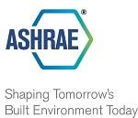

Heather Kennedy
Editor, ASHRAE Handbook

180 Technology Parkway Peachtree Corners, GA 30092 Tel: 678-539-1168
hkennedy@ashrae.org
ashrae.org
ashrae.org/newhq

