TC 1.13 Optimization
Agenda for ASHRAE 2026 Winter Conference
Sunday, Feb 1st, 2026
Las Vegas, NV, and hybrid-remote
http://tc0113.ashraetcs.org/

TC 1.13 meetings

Main Committee Meeting (hybrid)
Sunday, Feb 1st, 2026, 1:00 – 3:00 PM PST
Caesars Palace Las Vegas
Room: Salerno (P)
MS Teams

Agenda:

1. Call to Order and welcome all members and visitors Rohit Dhumane

2. Roll Call / Introductions / Record Attendance Rohit Dhumane
Record attendance use this link by PC, or use QR code by phone


3. ASHRAE Code of Ethics Commitment Rohit Dhumane
In this and all other ASHRAE meetings, we will act with honesty, fairness, courtesy, competence, integrity and respect for others, and we shall avoid all real or perceived conflicts of interests. (See full Code of Ethics: https://www.ashrae.org/about-ashrae/ashrae-code-of-ethics.)

3. Introduction of ASHRAE Liaisons on Arrival Rohit Dhumane
We will have a new Section Head in this meeting.

4. Establishment of Quorum Rohit Dhumane
Zhenning cannot attend this meeting due to national lab travel policy, but will attend subsequent meetings.
Zheng O’Neill notified Zhenning Li that she will be late but she will definitely attend this meeting.
X of 6 voting members presented.
Quorum is established?

Voting members for this meeting (Las Vegas)
Position | Present | Voting member | Proposed interest category
Chair | X | Zhenning Li | Gov & Res
Vice chair | ✓ | Rohit Dhumane | Industry
Voting Member | ✓ or X | S A Sherif | Academic
Program | ✓ | Zheng O’Neill | Academic
Research | ✓ or X | Omar Abdelaziz | Academic
Voting Member | ✓ or X | Vikrant Aute | Academic

The new roster update deadline for Zhenning Li is 03/03/2026 and the new roster will be effective as of 07/1/2026 based on the discussion in this meeting if there is any role change.

We need the section head’s help to update the voting member list. Currently, Zhenning, Rohit, Zheng and Vikrant show up in voting member list as shown below, we need to add Omar and Sherif in the list.
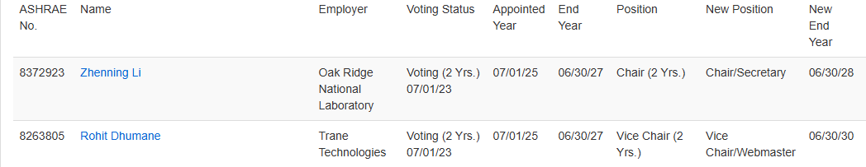
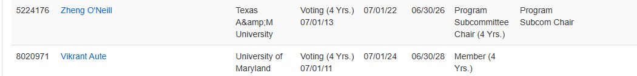

Julia Ho became the research sub-committee chair.
Until January 30, 2026, we have 67 members in total. Since 2025 June, 4 more members requested to join this TC through TC’s website. We would like to actively invite more members to join.

5. TC 1.13 Purpose Statement Rohit Dhumane
TC 1.13 is concerned with identifying, developing, and disseminating optimization techniques that enhance the performance of HVAC&R components, systems, and building systems that are not application or tool specific. The committee is focused on the fundamentals of optimization techniques including mathematical formulation, constraints handling, multi-objective optimization, approximation techniques, and robust optimization. These fundamentals are the foundation of data-driven, machine learning (ML), and artificial intelligence (AI) methods.

6. Approval of previous meeting minutes Rohit Dhumane
Zhenning Li has uploaded approved old meeting minutes from Pheonix to TC 11.13 website and sent to members via email. Please review and approve the Pheonix meeting minutes.

7. Chairman’s Overview and Report Rohit Dhumane
Rohit successfully established the seminar below in Las Vegas meeting,

Seminar 44: Next-Gen AI Diagnostics: How Surrogate Model Based Techniques are Revolutionizing HVAC Fault Detection and Diagnostics
Chair: Rohit Dhumane, Ph.D.
Tuesday, February 3 11:00 AM – 12:30 PM PST
Caesars Palace Las Vegas, P, Milano V/VI

- Current State of the Art of AI Assisted Fault Detection in HVAC Systems
Presenting Author: Rohit Dhumane, Trane Technologies
- Enhancing Thermodynamic Data Quality for Refrigerant Mixtures: Domain-Informed Anomaly Detection and Removal
Presenting Author: Christopher Laughman, Mitsubishi Electric Research Lab
- Fault Detection of Dynamic Vapor Compression Systems in Julia
Presenting Author: Ranjan Anantharaman, JuliaHub
- On the Efficacy of Quantization and Distillation for Surrogate Model-Based Fault Detection in Embedded HVAC Applications
Presenting Author: Ibrahim Ahmed, Trane Technologies
- Surrogate Models for Fault Detection in Wshps and Heat Island Effects in Data Center Chiller Plants
Presenting Author: Kaustubh Phalak, Trane Technologies

8. Subcommittee Reports

a. Program Zheng O’Neill
Brainstorm TC 1.13 Seminars for 2027 Austin Summer Conference.

1. Identify Key Research Gaps and Industry Needs
- We should be more active in submitting RTAR (Research Topic Acceptance Request).
- Engage with other relevant ASHRAE TCs, e.g. energy modeling (TC 4.7), controls (TC 1.4), and building performance (TC 7.5), Thermal energy storage (TC 6.9)
2. Potential topics
- HVAC component and system design optimization (most of our previous seminars related to this)
- Machine Learning and AI for Building Optimization (like Rohit chaired upcoming seminar)
- Energy and Cost Optimization
- Advanced Controls and Control related Optimization

2026 Las Vegas tracks:
https://www.ashrae.org/conferences/2026-annual-conference-austin/2026-annual-conference-technical-program

- Fundamentals and Applications (Track Chair: Mikael Salonvaara, salonvaaramh@ornl.gov)
- HVAC&R Systems and Equipment (Track Chair: Atilia Biyikoglu, abiyik@gazi.edu.tr)
- Research Summit (Track Chair: Craig Bradshaw, crbrad@illinois.edu)
- Workforce Development (Track Chair: Mike Bilderbeck, mbilderbeck@pickeringfirm.com)
- Ground Source Heat Pumps (Track Chair: Ahmed Elatar, aelatar@ornl.gov)
- Hot Climate Building System Design, Operation and Resilience (Track Chair: Jie Cai, cai40@purdue.edu)
- AI in Building Design and Construction (Track Chair: Jeslu Jacob, jesluceline@gmail.com)
- Building Decarbonization (Track Chair: Raul Simonetti, raulsimonetti@carel.com)
Key deadline: February, 25, 2026 Debate, Panel, Seminar, Forum, Workshop, and Debate proposals for Las Vegas are due.

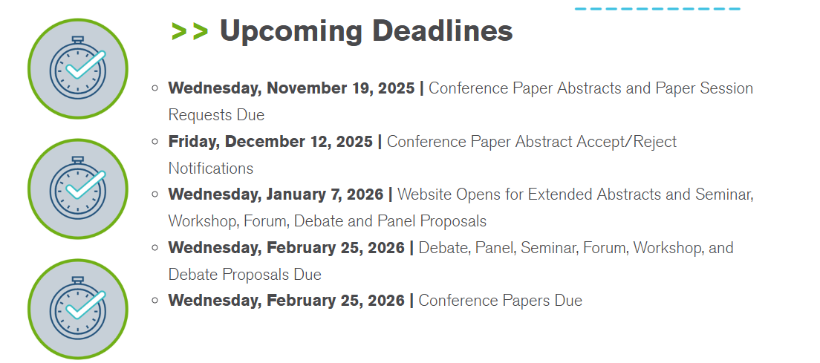

b. Research Julia Ho
In last meeting, Rohit discussed RTAR with TC 4.7 data-driven modeling, but no active or proposed RTARs were identified for co-sponsorship.
(Just a suggestion: Julia can share thoughts if she attends research chair training meeting.)

c. Handbook Rohit Dhumane
Members can share thoughts if anyone attends the handbook chair training sections.
d. Standards David Yashar

e. Membership Rohit Dhumane
Zhenning and Ivy are currently YEA.

f. TC Website Rohit Dhumane
Zhenning has kept it updated.

9. Old Business All
Request approval for previous meeting minutes. Zhenning Li has sent old meeting minutes to all members via email before this meeting. Members can also download the draft meeting minutes for Pheonix meeting from http://tc0113.ashraetcs.org/.

10. New Business All

11. Next subcommittee and committee meetings Rohit Dhumane
June 28th, 2026, Sunday. 1-3 pm Austin TX Local Time

12. Adjourn All

