1791 Tullie Circle, N.E./Atlanta, GA 30329
404-636-8400

TC/TG/MTG/TRG MINUTES COVER SHEET

(Minutes of all Meetings are to be distributed to all persons listed below within 60 days following the meeting.)

TC/TG/MTG/TRG No. 6.1 DATE Feb 2, 2020

TC/TG/MTG/TRG TITLE Hydronic and Steam Equipment and Systems

DATE OF MEETING Feb 2, 2020 LOCATION Orlando, Florida

 | MEMBERS PRESENT | YEAR APPTD | MEMBERS ABSENT |  | YEAR APPTD | EX-OFFICIO MEMBERS AND ADDITIONAL ATTENDANCE
 | David Lee | 2019
 | Jessica Mangler | 2019
 | Jennifer Leach | 2019
 | Tom Cappellin | 2017
 | Stan Kutin | 2018
 | Mark Hegberg | 2017
 | Viral Dharaiya | 2019
DISTRIBUTION: All Members of TC/TG/MTG/TRG plus the following:
TAC Section Head: |  |  |  | Dawen Lu
All Committee Liaisons As Shown On TC/TG/MTG/TRG Rosters (Research, Standards, ALI, etc.) |  |  |  | Chapter Tech. Transfer – Andrew Babler  Research – Omar Abdelaziz  2020 HB Systems – Caroline Calloway  2021 HB Fundamentals – Stephanie Mages
Mike Vaughn,  Manager Of Research & Technical Services |  |  |  | MORTS@ashrae.net

- Call to Order:

Chair Lee called the meeting to order at 1:00 pm. Chair Lee welcomed all in attendance and self-introductions were made. An attendance sheet was passed and signed by those in attendance. A roll call of voting members was conducted, and a quorum was present with 7 of 7 voting members.

Technical Committee 6.1 is concerned with all aspects of hydronic and steam systems. This includes the application of boilers, chillers, terminal units, and all accessories and controls making up the total system as well as the design of the integrated system. In addition to comfort applications of both heating and cooling, snow melting systems are included. Cooperation with other TCs is recognized in areas such as control, noise and vibration, refrigeration, pumps and hydronic and service water piping.

Chair Lee read the ASHRAE Code of Ethics, “In this and all other ASHRAE meetings, we will act with honesty, fairness, courtesy, competence, integrity and respect for others, and we shall avoid all real or perceived conflicts of interests.” (See full Code of Ethics at www.ashrae.org/about-ashrae/ashrae-code-of-ethics)

- Setting of the Agenda:

The Chair passed out an updated Agenda. There were no objections to the Agenda.

- Approval of Atlanta Meeting Minutes:

Motion by Jennifer Leach, second by Jessica Mangler to approve the past meeting minutes. Motion passed 6-0-1 CNV.

- Recognition of Liaisons:

No liaisons were identified in advance,

- Chair’s Report

Chair Lee summarized the key items from the Section 6 Breakfast.
  - Joint All TC section breakfast discussed TCs, MTGs and TRGs if they wanted to continue.
  - Six TCs have merged into three. ASHRAE would like to continue consolidation per Jennifer Leach. 3.2+3.3 8.10+8.12, 9.8+9.12 merged provisionally but a vote is scheduled for tomorrow.
  - Roster Updates and Schedule will be handled by Bob
  - There is a new TC Collaborative Workspace.
  - CEC standing request for program suggestions. They sent out a survey about potential research programs.

- Sub-Committee Reports

  - Programs: Jennifer Leach (Chair).
    - Mark will work with Jennifer on creating a seminar on valve authority for Austin. Viral has volunteered to be a second speaker.
    - There were some ideas for Chicago: case study with 9.7. Does snow melt violate 90.1? Electrification of buildings vs fossil fuel.
    - We have a program at this meeting tomorrow morning “don’t get stumped by pumps”.
  - Research: Jessica Mangler (Chair).
    - 1890-WS: Minimum Flow Velocities for Purging Air and Debris from Hydronic Piping Systems
      - This is an active Work Statement that our TC is co-sponsoring with TC 6.08. TC 6.08 is the originally author and is looking for reviewers from TC 6.1. Jessica Mangler & Mike Trantham volunteered to be reviewers.
      - TC 6.8 anticipates that this Work Statement will be issued to ASHRAE RAC in 1-2 months.
      - Jessica anticipates that TC 6.2 will co-sponsor this WS as well.
    - 1196-RP: Development of Software to calculate the Application Seasonal Efficiency of Commercial Space Heating Boiler Systems Based on ASHRAE Standard 155P
      - RAC is pushing the TC to vote to pull the plug on this RP since there has been no movement for several years.
      - Omar (Section 6 RAC) showed up to the main committee meeting to discuss.
      - The RP is on hold because Standard 155P hasn’t been finished.
      - Tom Butcher stated that he will work with the PI (Dr. Nelson, who’s retired from Iowa State University) to deliver the software deliverable to MORTS with Jessica and Omar copied. Omar stated then that RAC will close out the project. There was discussion of whether the payments would be completed, but the committee did not make a stance on how payments should be closed out.
Motion from Mark Hegberg that 6.1 should recommend to RAC the contractor to be paid for work done and the project be closed out on delivery of the software. Motion seconded by Jennifer Leach. From RAC representative if the TC accepts the software as the final deliverable, then it is the final deliverable. Motion 5-0-2 CNV.
    - 1843-WS: Validation of Low-Order Acoustic Models of Combustion Driven Oscillations on Residential Fire Tube Water Heaters
      - This is an active Work Statement that our TC is co-sponsoring with TC 6.06. Jessica was unable to connect with the TC 6.06 Research Subcommittee Chair for an update on this WS.
    - New RTAR on Pressure Loss Coefficients for Copper Pipe Fittings
      - The first draft for a potential RTAR was presented to the subcommittee by Mark Hegberg. Aaron Stotko volunteered to co-author. They are planning on working offline together, to fine-tune the RTAR.
      - Aaron stated that TC 6.06 will co-sponsor this RTAR.
      - Mark & Aaron will issue the revised RTAR to Jessica when complete. If the timing is appropriate, Jessica will issue to the voting members for a vote ahead of the March 15, 2020 deadline.

  - Handbook: Viral Dharaiya (Chair).
    - Chapter 13 of Systems past due from March of 2019. We will proceed with no changes. There was a proof sent out with changes but that will be ignored. Motion by Viral to have no changes to Chapter 13 of Systems and Equipment at this time seconded by Mark 5-0-2 CNV.
    - Chapter 22 due June 28th change on Page 7 has changes about grooved mechanical joints. Also two paragraphs from 90.1 were added. Table 22 recommends pipe velocities for several applications, and the paragraphs elaborate on where these velocities are applicable. These sizings are prescriptive but they can be over-ridden by modelling. We will request an extension to be able to vote at the Summer meeting.

  - Chilled Water Plant Sub Committee: Steve Tredinnick (Chair).
    - Formed to do programs. There are a lot of programs so the decision was to write a chapter. Steve and Stan have worked on the chapter. Volunteers to edit the chapter are welcome to log in on the Authoring Portal.

  - Membership: Bob Walker (Chair).
    - Mike will be a voting member after the Austin meeting
    - We are interested in more voting members who are consultants
    - Please update your email on the ASHRAE website
    - Visitors are invited to log in to ASHRAE and join the committee as provisional corresponding members.
    - Viral has taken over as Handbook SC Chair and VM

  - Standards: Frank Myers (Chair).
    - Standard 90.1
      - DOE sees the new version saving 5% over the old version at the expense of more complexity
      - January DOE updated pump minimum efficiency standards. This does not include double suction or sub-fractional hp pumps. Per Stan. DOE requirements are echoed in 90.1.
    - Standard 155P committee met on Sunday, and continued to craft Independent Substantive Changes responding to the most recent public review.
    - There will be confirmation tests by AHRI and PG&E to make sure the standard does what it is intended to do.
    - SPC 155 P is making great progress in moving the document to consensus and publication.

- Liaison Reports from other TC’s and Organizations.
- 6.2 Jessica Mangler no updates.
- 6.5 Michael O’Rouke working on a radiant design guide. Ongoing effort to revise all the handbook chapters that are due. Not much else is relevant to 6.1
  - Post occupancy “oops I did it again”
  - Track 7 resilient prefabricated with radiant
  - Unique radiant applications
- 6.6 Frank is a member but they had nothing relevant
- 6.10 Fuels and Combustion haven’t met yet. Section in handbook almost ready. A couple of RTARs Boot Tee k-factors. Ventilation of appliances.
- Hydronic Industry Alliance (Aaron) looking for members. Breakfast tomorrow at AHR Expo 9-10 am Room W-305b. “VRFRejected.org” “H2Oaccepted.org” Building efficiency selection tool. HIC website. HIA-C.org.
- 11.71 RP high performance chilled water sequences. Mark is on the PMS. It’s very control oriented. The trouble is they’re writing thing that don’t account for the design side of the water system.

- Old Business:
- SPC 208 Mark needs two more members to finish publication.

- New Business:
- Motion to continue TC6.1 as a technical committee with no changes by Mark Hegberg, seconded by Jennifer Leach. Motion passed 6-0-1 CNV
- Decarbonization of buildings is a new initiative in many states. What does our TC recommend? Mark Hegberg moves to remain neutral. Stan Kutin seconds. Motion by Jennifer Leach TC 6.1 has no position on the decarbonization of buildings. 4-2-0 CNV motion carries. Follow-up motion from Mark Hegberg to recommend to Section 6 head to delegate this to the appropriate committee(s) to create a position on decarbonization of buildings. Second by Viral. Passed 6-0-1 CNV.
- Charlie Henke PDC three self-directed learning courses
  - Water system design: there were some issues with the SI version. Mark would like to participate.
  - Steam system design: Kevin Summers volunteers to review.
  - Heating system design: Done according to the contract, but Mark recommends that it be further reviewed.
- We remember Tricia Bruen. She had been a member of the TC for 13 years.

- Meeting Adjournment:
Motion by Chair Lee to adjourn the meeting. No second or vote required. Meeting adjourned at 3:12 pm.

Submitted by,
Mike Trantham.
TC 6.1 Secretary

Sign-In Sheet
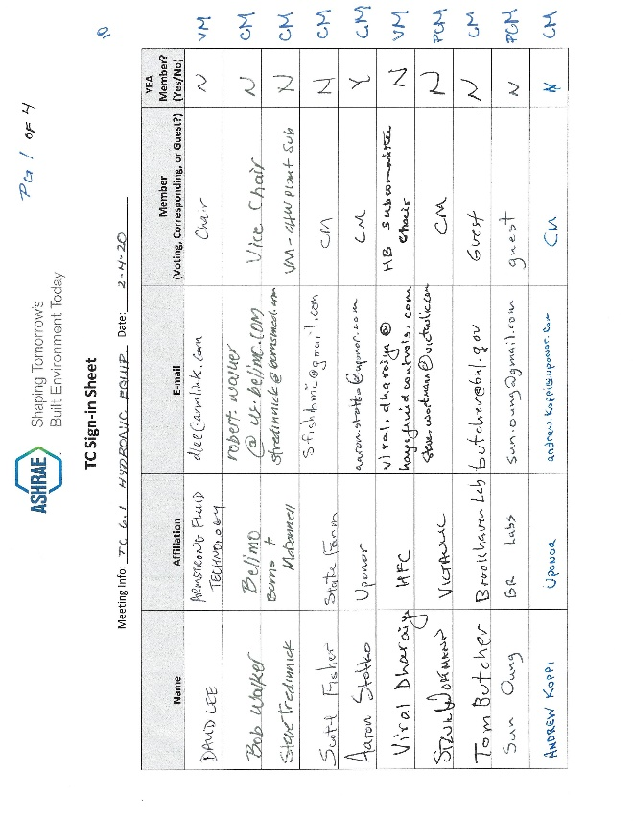 | 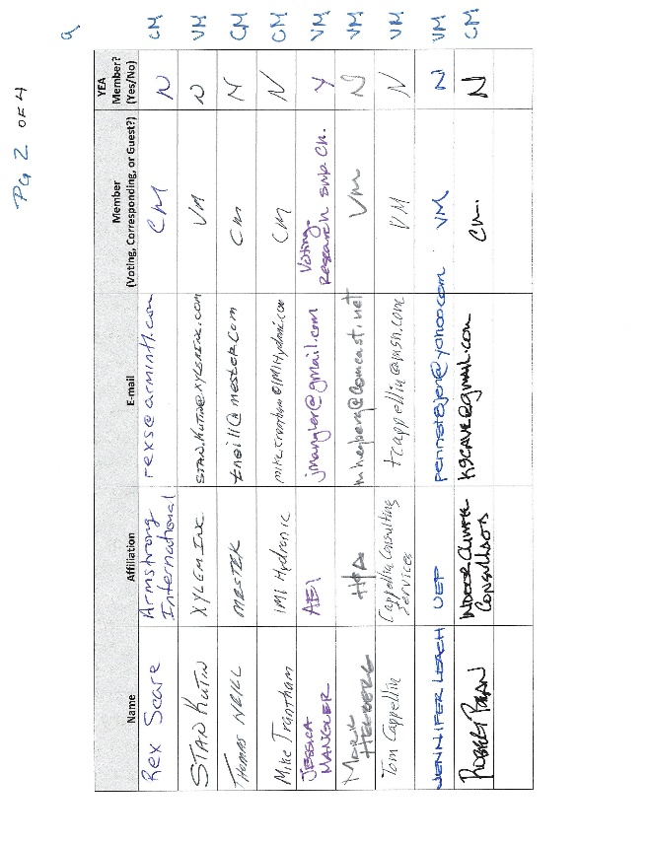
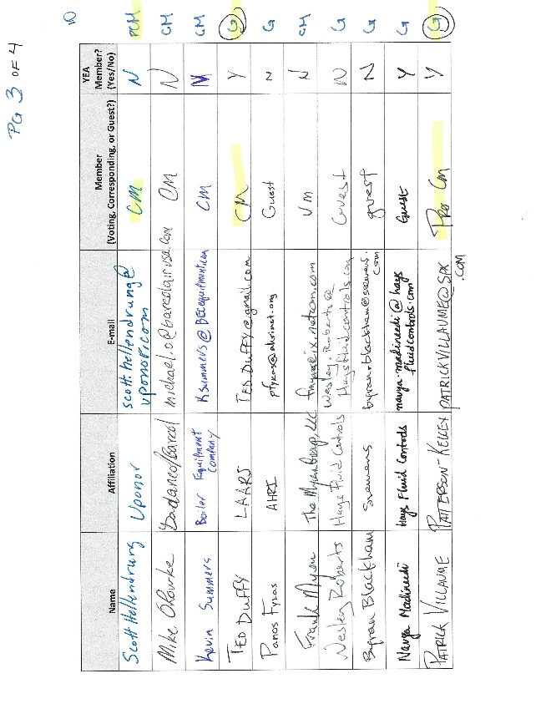 | 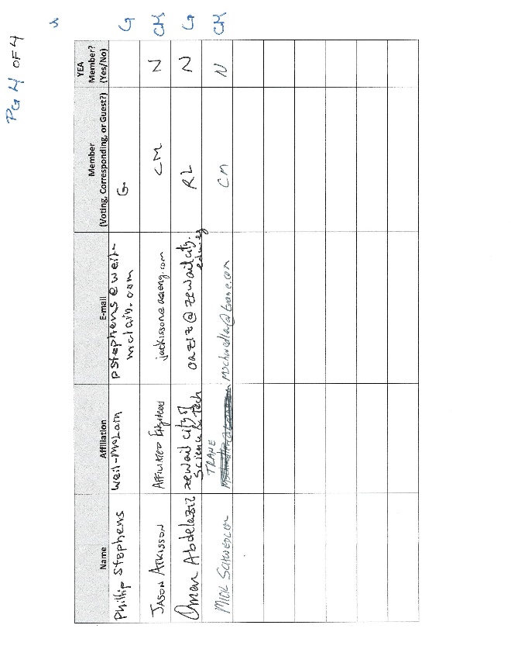

David Lee
Bob Walker
Steve Tredinnick
Scott Fisher
Aaron Stotko
Viral Dharaiya
Steve Wortmann
Tom Butcher
Sun Oung
Andrew Koppi
Rex Scare
Stan Kutin
Thomas Neill
Mike Trantham
Jessica Mangler
Mark Hegberg
Tom Cappellin
Jennifer Leach
Robert Bean
Scott Hellendrung
Mike O’Rourke
Kevin Summers
Panos Fykas
Frank Myers
Wesley Roberts
Byran Blackham
Navga Madineedi
Patrick Villaume
Phillip Stephens
Jason Atkisson
Omar Abdelaziz
Mark Schwedler

